UNITED STATES
SECURITIES AND EXCHANGE COMMISSION
Washington, D.C. 20549

FORM 8-K

CURRENT REPORT
Pursuant to Section 13 or 15(d) of the Securities Exchange Act of 1934

Date of Report (Date of earliest event reported) | December 10, 2013

Oil-Dri Corporation of America
(Exact name of registrant as specified in its charter)

Delaware |  | 001-12622 |  | 36-2048898
(State or other jurisdiction of incorporation) |  | (Commission File Number) |  | (IRS Employer Identification No.)

410 North Michigan Avenue  Suite 400  Chicago, Illinois | 60611-4213
(Address of principal executive offices) | (Zip Code)

Registrant’s telephone number, including area code | (312) 321-1515

(Former name or former address, if changed since last report.)

Check the appropriate box below if the Form 8-K filing is intended to simultaneously satisfy the filing obligation of the registrant under any of the following provisions (see General Instruction A.2. below):

o Written communications pursuant to Rule 425 under the Securities Act (17 CFR 230.425)

o Soliciting material pursuant to Rule 14a-12 under the Exchange Act (17 CFR 240.14a-12)

o Pre-commencement communications pursuant to Rule 14d-2(b) under the Exchange Act (17 CFR 240.14d-2(b))

o Pre-commencement communications pursuant to Rule 13e-4(c) under the Exchange Act (17 CFR 240.13e-4(c))

Item 5.07 Submission of Matters to a Vote of Security Holders.

Oil-Dri Corporation of America (the “Registrant”) held its annual meeting of stockholders on December 10, 2013. See the Registrant’s Proxy Statement for more information on the proposals presented at the meeting, the relevant portions of which are incorporated herein by reference.

ITEM 1: ELECTION OF DIRECTORS

The stockholders elected all of the Board’s nominees for director. The voting results were as follows:

Director |  | For |  |  |  | Withheld |  |  |  | Broker Non-Votes
J. Steven Cole |  |  | 23,594,962 |  |  |  | 88,837 |  |  |  | 617,922
Daniel S. Jaffee |  |  | 22,468,457 |  |  |  | 1,215,342 |  |  |  | 617,922
Richard M. Jaffee |  |  | 22,393,631 |  |  |  | 1,290,168 |  |  |  | 617,922
Joseph C. Miller |  |  | 21,652,871 |  |  |  | 2,030,928 |  |  |  | 617,922
Michael A. Nemeroff |  |  | 22,272,980 |  |  |  | 1,410,819 |  |  |  | 617,922
Allan H. Selig |  |  | 23,551,998 |  |  |  | 131,801 |  |  |  | 617,922
Paul E. Suckow |  |  | 23,610,295 |  |  |  | 73,504 |  |  |  | 617,922
Lawrence E. Washow |  |  | 23,610,274 |  |  |  | 73,525 |  |  |  | 617,922

ITEM 2: RATIFICATION OF THE APPOINTMENT OF INDEPENDENT AUDITOR

The stockholders ratified the appointment of PricewaterhouseCoopers LLP as independent auditor for the fiscal year ending July 31, 2014. The voting results were as follows:

For |  |  | 24,232,763
Against |  |  | 66,213
Abstain |  |  | 2,745

Item 7.01 Regulation FD Disclosure

On Tuesday, December 10, 2013, members of the Registrant's management made a presentation at the 2013 annual meeting of Stockholders. A copy of the presentation materials is attached as Exhibit 99.1 to this Form 8-K.

The information presented herein under Item 7.01 shall not be deemed “filed” under the Securities Exchange Act of 1934, as amended, nor shall it be deemed incorporated by reference in any filing under the Securities Act of 1933, as amended, except as may be expressly set forth by specific reference in such a filing.

Forward Looking Statements

Except for the historical information contained herein, certain of the matters discussed in this communication constitute “forward-looking statements” within the meaning of the Securities Act of 1933 and the Securities Exchange Act of 1934, both as amended by the Private Securities Litigation Reform Act of 1995. Words such as “expect,” “outlook,” “forecast,” “would,” “could,” “should,” “project,” “intend,” “plan,” “continue,” “seek,” “estimate,” “anticipate,” “believe,” “may,” “will,” “target,” “assume” and words and terms of similar substance used in connection with any discussion of future plans, actions, or events identify forward-looking statements. These forwardlooking statements include, but are not limited to, statements regarding anticipated future financial and operating performance and results, and estimates for growth overall and in particular business lines. These statements are based on the current expectations of management of Oil-Dri Corporation of America (“the Company”). There are a number of risks and uncertainties that could cause actual results to differ materially from the forward-looking statements included in this presentation, and we encourage you especially to review the ones that were identified in Item 1A (Risk Factors) of the Company’s most recent Annual Report on Form 10-K and other reports filed with the Securities and Exchange Commission. Other unknown or unpredictable factors could also have material adverse effects on future results, performance or achievements of the Company. You are cautioned not to place undue reliance on forward-looking statements in this communication. Except to the extent required by law, the Company does not have any intention or obligation to update publicly any forward-looking statements contained in this communication, whether as a result of new information, future event, changes in assumptions, or otherwise.

Item 8.01 Other Events.

Also on December 10, 2013, the Registrant’s Board of Directors declared quarterly cash dividends of $0.19 per share of the Registrant’s Common Stock and $0.1425 per share of the Registrant’s Class B Stock. The dividends will be payable on March 7, 2014, to stockholders of record at the close of business on February 21, 2014. A copy of the Registrant’s press release announcing these matters is attached as Exhibit 99.1 and the information contained therein is incorporated herein by reference.

Item 9.01 Financial Statements and Exhibits.

(d) Exhibits

Exhibit  Number |  | Description of Exhibits
99.1 |  | Presentation Made at Annual Stockholder Meeting
99.2 |  | Press Release dated December 11, 2013 (Cash Dividends)

SIGNATURES

Pursuant to the requirements of the Securities Exchange Act of 1934, the Registrant has duly caused this report to be signed on its behalf by the undersigned hereunto duly authorized.

 | OIL-DRI CORPORATION OF AMERICA
 | By: | /s/ Douglas A. Graham
 |  | Douglas A. Graham
 |  | Vice President and General Counsel
Date: December 11, 2013

Exhibit Index

Exhibit  Number |  | Description of Exhibits
99.1 |  | Presentation Made at Annual Stockholder Meeting
99.2 |  | Press Release dated December 11, 2013 (Cash Dividends)

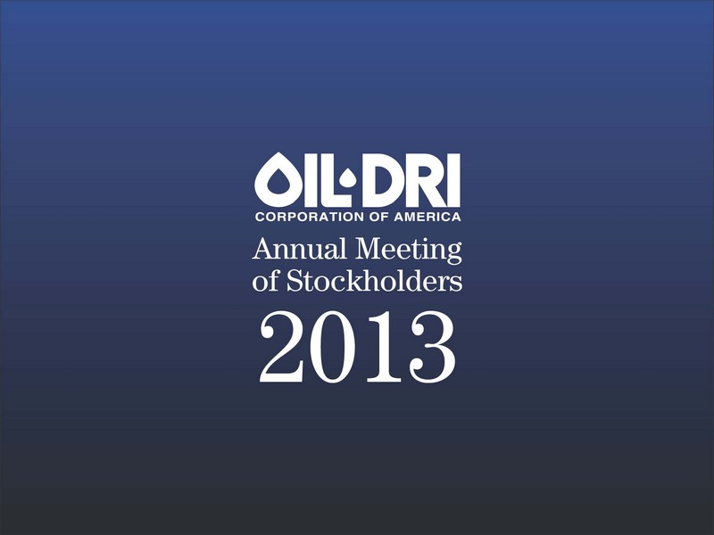

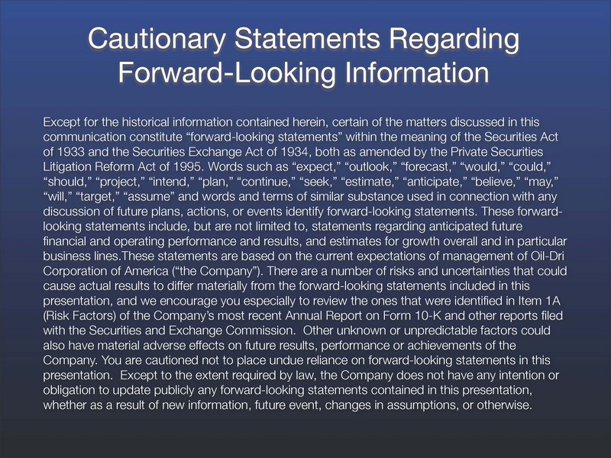



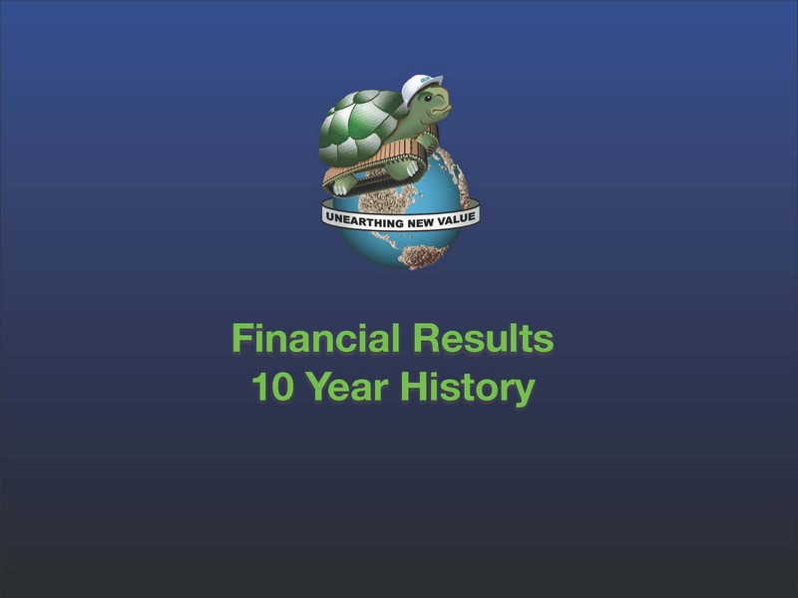

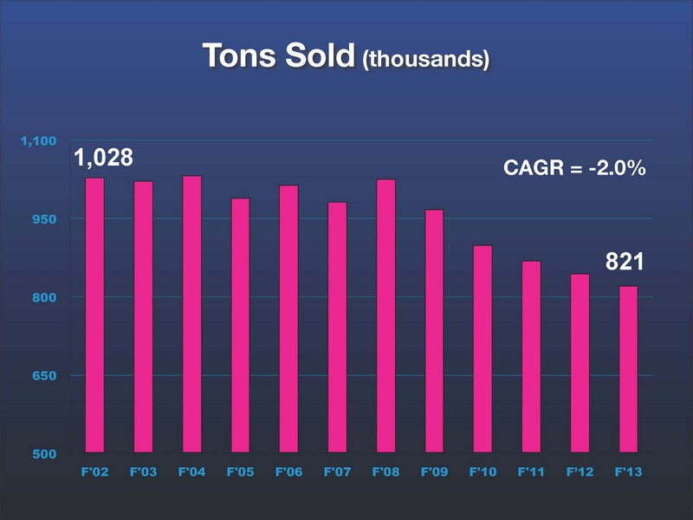

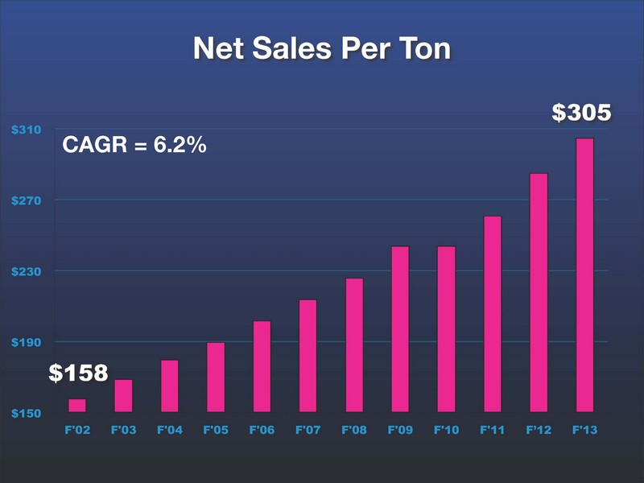

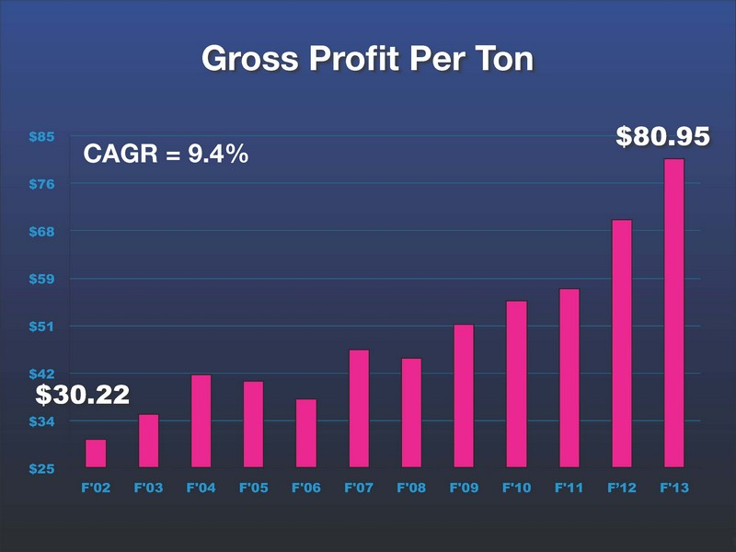

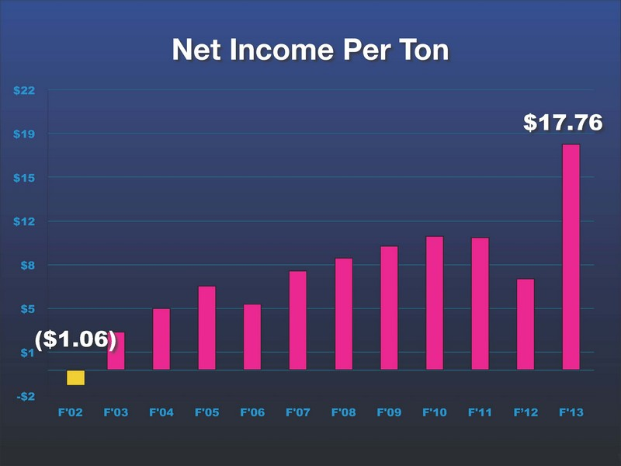

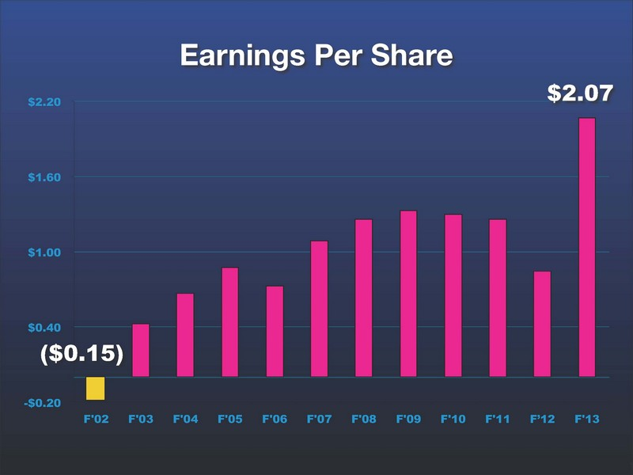

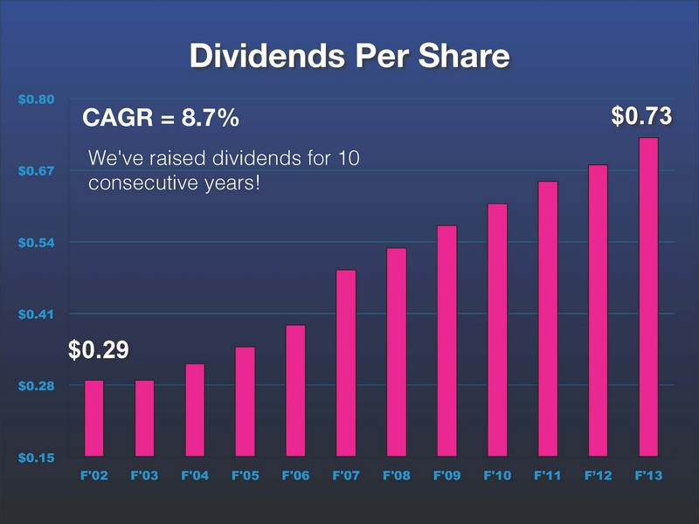

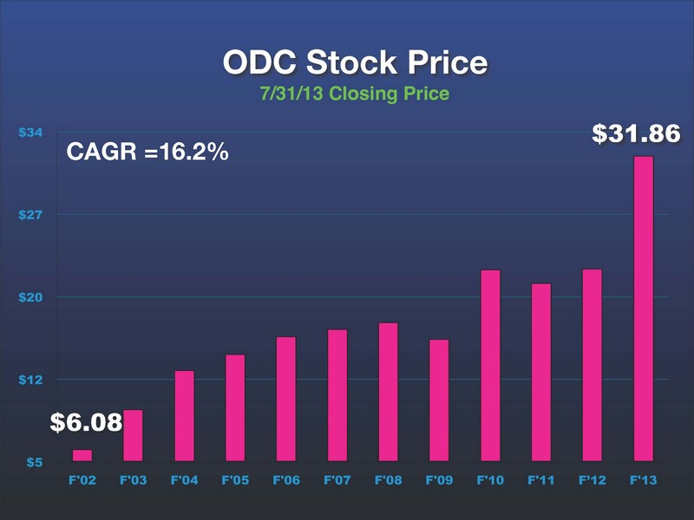

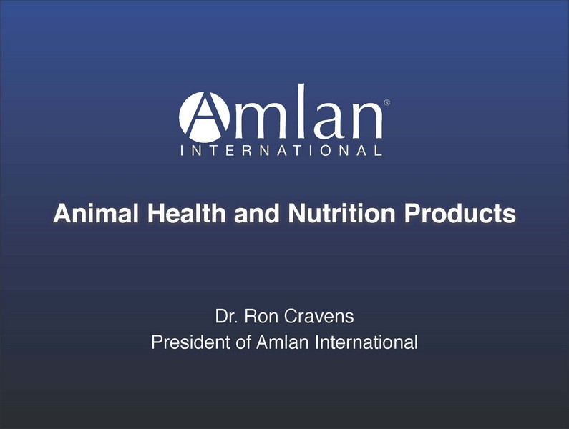

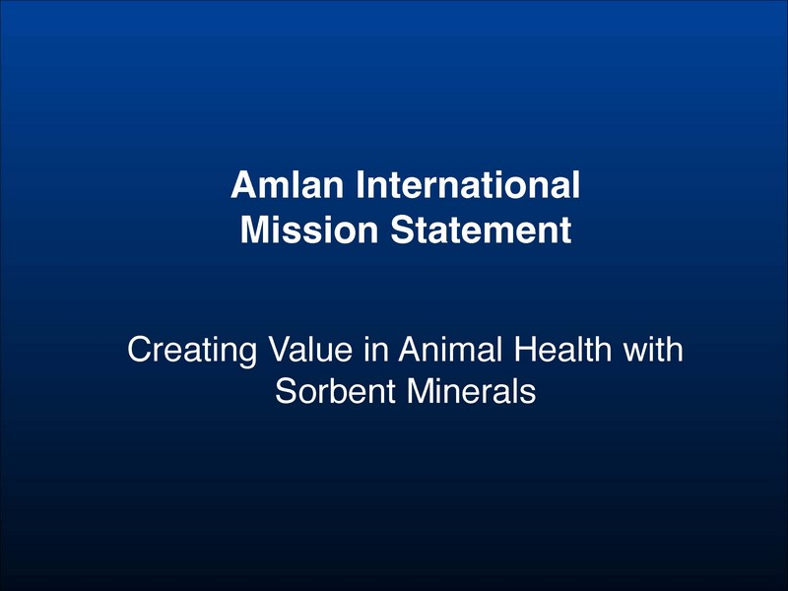

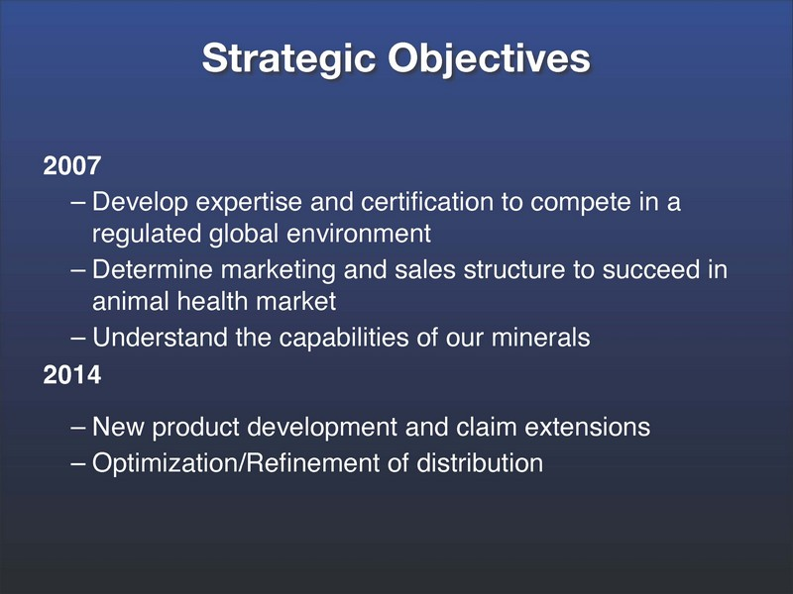

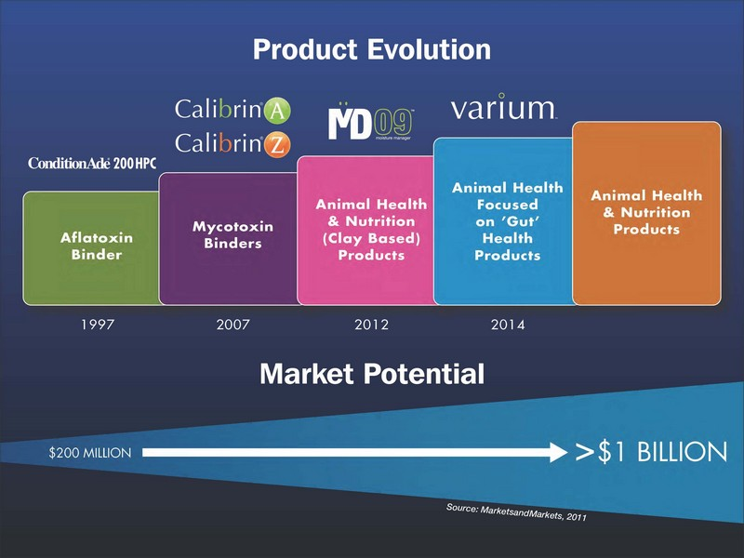

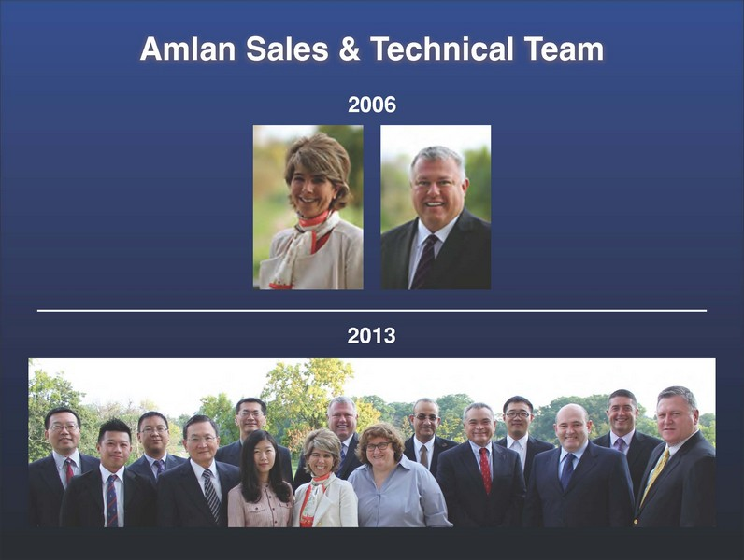



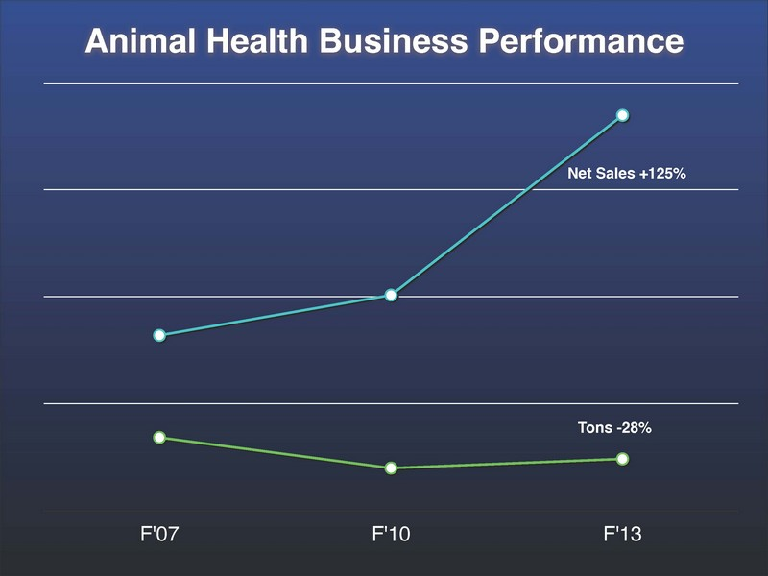

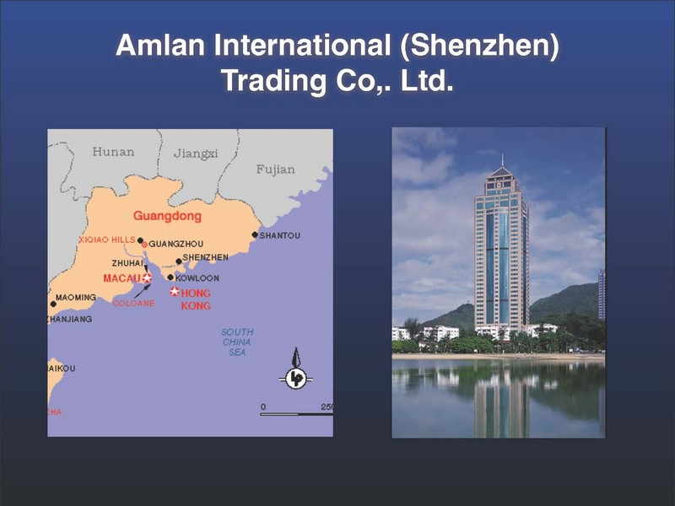

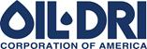

410 N. Michigan Ave. Chicago, Illinois 60611, U.S.A

News Announcement
For Immediate Release

Exhibit 99.2

Oil-Dri Board of Directors Declares Quarterly Dividends

CHICAGO—(December 11, 2013)—The Board of Directors of Oil-Dri Corporation of America (NYSE: ODC) yesterday declared quarterly cash dividends of $0.19 per share of the Company’s Common Stock and $0.1425 per share of the Company’s Class B Stock.

The dividends declared on December 10, 2013 will be payable in the third quarter of fiscal 2014, on March 7, 2014, to stockholders of record at the close of business on February 21, 2014. The Company has paid cash dividends continuously since 1974 and has increased dividends annually for each of the last ten years.

###

Oil-Dri Corporation of America is a leading supplier of specialty sorbent products for industrial, automotive, agricultural, horticultural and specialty markets and the world’s largest manufacturer of cat litter.

Reagan Culbertson
Investor Relations Manager
reagan.culbertson@oildri.com
(312) 706 3256

