UNITED STATES
SECURITIES AND EXCHANGE COMMISSION
Washington, D.C. 20549

FORM 8-K

CURRENT REPORT
Pursuant to Section 13 or 15(d) of the Securities Exchange Act of 1934
Date of Report (Date of earliest event reported) |  |  | October 4, 2023

OIL-DRI CORPORATION OF AMERICA
(Exact name of the registrant as specified in its charter)

Delaware 001-12622 36-2048898
(State or other jurisdiction of incorporation or organization) |  |  |  |  |  | Commission File Number |  |  |  |  |  | (I.R.S. Employer Identification No.)

410 North Michigan Avenue, Suite 400 60611-4213
Chicago, Illinois (Zip Code)
(Address of principal executive offices)

Registrant's telephone number, including area code (312) 321-1515

Not applicable
(Former name or former address, if changed since last report.)

Check the appropriate box below if the Form 8-K filing is intended to simultaneously satisfy the filing obligation of the registrant under any of the following provisions (see General Instruction A.2. below):
 |  |  | ☐ |  |  | Written communications pursuant to Rule 425 under the Securities Act (17 CFR 230.425)
 |  |  | ☐ |  |  | Soliciting material pursuant to Rule 14a-12 under the Exchange Act (17 CFR 240.14a-12)
 |  |  | ☐ |  |  | Pre-commencement communications pursuant to Rule 14d-2(b) under the Exchange Act (17 CFR 240.14d-2(b))
 |  |  | ☐ |  |  | Pre-commencement communications pursuant to Rule 13e-4(c) under the Exchange Act (17 CFR 240.13e-4(c))

Indicate by check mark whether the registrant is an emerging growth company as defined in Rule 405 of the Securities Act of 1933 (§230.405 of this chapter) or Rule 12b-2 of the Securities Exchange Act of 1934 (§240.12b-2 of this chapter).
Emerging growth company ☐

If an emerging growth company, indicate by check mark if the registrant has elected not to use the extended transition period for complying with any new or revised financial accounting standards provided pursuant to Section 13(a) of the Exchange Act. ☐

Securities registered pursuant to Section 12(b) of the Act:
Title of each class |  |  | Trading Symbol(s) |  |  | Name of each exchange on which registered
Common Stock, par value $0.10 per share |  |  | ODC |  |  | New York Stock Exchange

 |  |  | Item 8.01 |  |  | Other Events.
At its regular meeting on October 4, 2023, the Board declared quarterly cash dividends of $0.29 per share of the Company’s Common Stock and $0.218 per share of the Company’s Class B Stock. The dividends will be payable on November 24, 2023, to stockholders of record at the close of business on November 10, 2023. A copy of the Company’s press release announcing these matters is attached as Exhibit 99.1 and the information contained therein is incorporated herein by reference.

The information in this Item 8.01 and Exhibit 99.1 shall not be deemed “filed” for purposes of Section 18 of the Securities Exchange Act of 1934, as amended (the “Exchange Act”), or otherwise subject to the liabilities of that section. This information shall not be deemed to be incorporated by reference in any filing under the Securities Act of 1933, as amended, or the Exchange Act, except as shall be expressly set forth by specific reference to such disclosure in this Form 8-K in such a filing.

 |  |  | Item 9.01 |  |  | Financial Statements and Exhibits.

(d)Exhibits
Exhibit  Number |  |  |  |  |  | Description of Exhibits
99.1 |  |  |  |  |  | Press Release dated October 4, 2023

SIGNATURES

Pursuant to the requirements of the Securities Exchange Act of 1934, the Company has duly caused this report to be signed on its behalf by the undersigned hereunto duly authorized.

 |  |  | OIL-DRI CORPORATION OF AMERICA
 |  |  | By: |  |  | /s/ Laura G. Scheland
 |  |  |  |  |  | Laura G. Scheland
 |  |  |  |  |  | Vice President, Strategic Partnerships and General Counsel & Secretary
Date: October 4, 2023

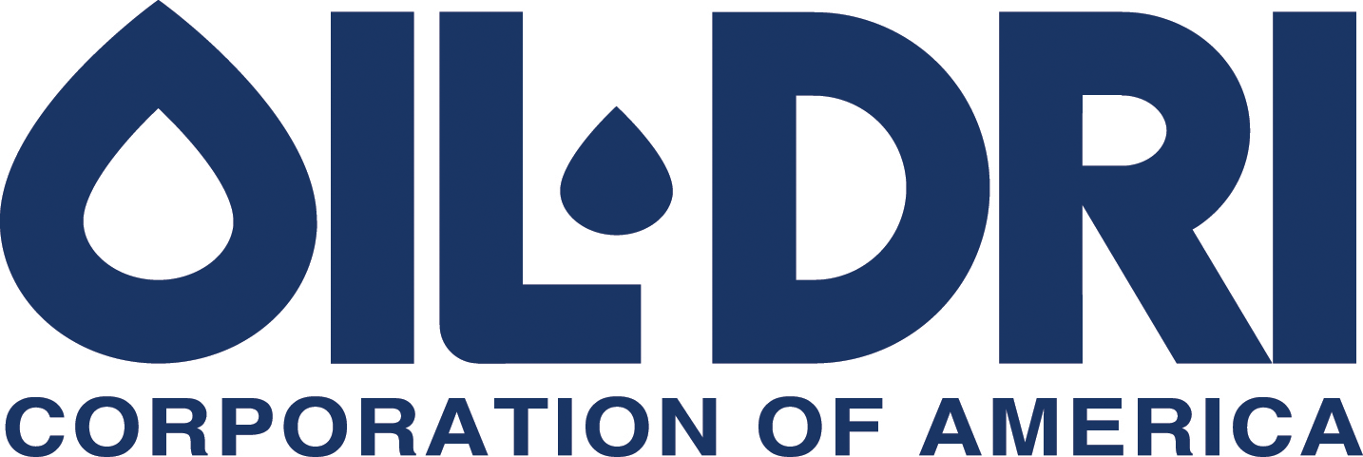

410 N. Michigan Ave. Chicago, Illinois 60611, U.S.A

News Announcement
For Immediate Release
Exhibit 99.1

Oil-Dri Board of Directors Declares Quarterly Dividends

CHICAGO—(October 4, 2023)— The Board of Directors of Oil-Dri Corporation of America (NYSE: ODC) today declared quarterly cash dividends of $0.29 per share of the Company’s Common Stock and $0.218 per share of the Company’s Class B Stock.

The dividends declared will be payable on November 24, 2023 to stockholders of record at the close of business on November 10, 2023. The Company has paid cash dividends continuously since 1974 and has increased dividends annually for twenty consecutive years.

###

Oil-Dri Corporation of America is a leading manufacturer and supplier of specialty sorbent products for the pet care, animal health and nutrition, fluids purification, agricultural ingredients, sports field, industrial and automotive markets. Oil-Dri is vertically integrated which enables the Company to efficiently oversee every step of the process from research and development to supply chain to marketing and sales. With over 80 years of experience, the Company continues to fulfill its mission to Create Value from Sorbent Minerals. To learn more about the Company, visit oildri.com.

Category: Dividends

Contact:
Leslie A. Garber
Manager of Investor Relations
Oil-Dri Corporation of America
InvestorRelations@oildri.com
(312) 321-1515

Leslie A. Garber
Investor Relations Manager
InvestorRelations@oildri.com
(312) 321-1515

