UNITED STATES
SECURITIES AND EXCHANGE COMMISSION
Washington, D.C. 20549

FORM 8-K

CURRENT REPORT
Pursuant to Section 13 or 15(d) of the Securities Exchange Act of 1934
Date of Report (Date of earliest event reported) |  |  | December 13, 2023

OIL-DRI CORPORATION OF AMERICA
(Exact name of the registrant as specified in its charter)

Delaware 001-12622 36-2048898
(State or other jurisdiction of incorporation or organization) |  |  |  |  |  | Commission File Number |  |  |  |  |  | (I.R.S. Employer Identification No.)

410 North Michigan Avenue, Suite 400 60611-4213
Chicago, Illinois (Zip Code)
(Address of principal executive offices)

Registrant's telephone number, including area code (312) 321-1515

Not applicable
(Former name or former address, if changed since last report.)

Check the appropriate box below if the Form 8-K filing is intended to simultaneously satisfy the filing obligation of the registrant under any of the following provisions (see General Instruction A.2. below):
 |  |  | ☐ |  |  | Written communications pursuant to Rule 425 under the Securities Act (17 CFR 230.425)
 |  |  | ☐ |  |  | Soliciting material pursuant to Rule 14a-12 under the Exchange Act (17 CFR 240.14a-12)
 |  |  | ☐ |  |  | Pre-commencement communications pursuant to Rule 14d-2(b) under the Exchange Act (17 CFR 240.14d-2(b))
 |  |  | ☐ |  |  | Pre-commencement communications pursuant to Rule 13e-4(c) under the Exchange Act (17 CFR 240.13e-4(c))

Indicate by check mark whether the registrant is an emerging growth company as defined in Rule 405 of the Securities Act of 1933 (§230.405 of this chapter) or Rule 12b-2 of the Securities Exchange Act of 1934 (§240.12b-2 of this chapter).
Emerging growth company ☐

If an emerging growth company, indicate by check mark if the registrant has elected not to use the extended transition period for complying with any new or revised financial accounting standards provided pursuant to Section 13(a) of the Exchange Act. ☐

Securities registered pursuant to Section 12(b) of the Act:
Title of each class |  |  | Trading Symbol(s) |  |  | Name of each exchange on which registered
Common Stock, par value $0.10 per share |  |  | ODC |  |  | New York Stock Exchange

 |  |  | Item 5.07 |  |  | Submission of Matters to a Vote of Security Holders.
The Company held its annual meeting of stockholders on December 13, 2023. See the Company’s 2023 Proxy Statement for more information on the proposals presented at the meeting, the relevant portions of which are incorporated herein by reference.

PROPOSAL 1: ELECTION OF DIRECTORS

The stockholders elected all of the nominees for director recommended by the Company’s Board of Directors (the “Board”). The voting results were as follows:

Director |  |  |  |  |  | For |  |  |  |  |  | Withheld |  |  |  |  |  | Broker Non-Votes
Ellen-Blair Chube |  |  |  |  |  | 22,878,476 |  |  |  |  |  | 1,745,334 |  |  |  |  |  | 574,854
Paul M. Hindsley |  |  |  |  |  | 21,786,063 |  |  |  |  |  | 2,837,747 |  |  |  |  |  | 574,854
Daniel S. Jaffee |  |  |  |  |  | 23,319,672 |  |  |  |  |  | 1,304,138 |  |  |  |  |  | 574,854
Michael A. Nemeroff |  |  |  |  |  | 22,609,684 |  |  |  |  |  | 2,014,126 |  |  |  |  |  | 574,854
George C. Roeth |  |  |  |  |  | 23,449,202 |  |  |  |  |  | 1,174,608 |  |  |  |  |  | 574,854
Amy L Ryan |  |  |  |  |  | 21,776,443 |  |  |  |  |  | 2,847,367 |  |  |  |  |  | 574,854
Patricia J. Schmeda |  |  |  |  |  | 24,553,031 |  |  |  |  |  | 70,779 |  |  |  |  |  | 574,854
Allan H. Selig |  |  |  |  |  | 23,307,978 |  |  |  |  |  | 1,315,832 |  |  |  |  |  | 574,854
Lawrence E. Washow |  |  |  |  |  | 23,114,099 |  |  |  |  |  | 1,509,711 |  |  |  |  |  | 574,854

PROPOSAL 2: RATIFICATION OF THE APPOINTMENT OF INDEPENDENT AUDITOR

The stockholders ratified the appointment of Grant Thornton LLP as independent auditor for the fiscal year ending July 31, 2024. The voting results were as follows:

For |  |  | 25,108,509
Against |  |  | 83,823
Abstain |  |  | 6,332

PROPOSAL 3: ADVISORY VOTE ON EXECUTIVE COMPENSATION

The stockholders voted to approve, on an advisory basis, the compensation of the named executive officers disclosed in the Proxy Statement. The voting results were as follows:

For |  |  | 24,036,678
Against |  |  | 564,589
Abstain |  |  | 22,543
Broker Non-Votes |  |  | 574,854

PROPOSAL 4: ADVISORY VOTE ON THE FREQUENCY OF FUTURE ADVISORY VOTES ON EXECUTIVE COMPENSATION

The stockholders voted to select, on an advisory basis, the frequency of future advisory votes on the compensation of the named executive officers. The voting results were as follows:

3 Years |  |  | 22,357,461
2 Years |  |  | 9,687
1 Year |  |  | 2,253,011
Abstain |  |  | 3,651
Broker Non-Votes |  |  | 574,854

PROPOSAL 5: APPROVAL OF THE AMENDED AND RESTATED OIL-DRI CORPORATION OF AMERICA 2006 LONG TERM INCENTIVE PLAN

The stockholders voted to approve the Amended and Restated Oil-Dri Corporation of America 2006 Long Term Incentive Plan. The voting results were as follows:

For |  |  | 22,629,721
Against |  |  | 1,984,053
Abstain |  |  | 10,036
Broker Non-Votes |  |  | 574,854

 |  |  | Item 8.01 |  |  | Other Events.
At its regular meeting on December 13, 2023, the Board declared quarterly cash dividends of $0.29 per share of the Company’s Common Stock and $0.218 per share of the Company’s Class B Stock. The dividends will be payable on March 8, 2024, to stockholders of record at the close of business on February 23, 2024. A copy of the Company’s press release announcing these matters is attached as Exhibit 99.1 and the information contained therein is incorporated herein by reference.

The information in this Item 8.01 and Exhibit 99.1 shall not be deemed “filed” for purposes of Section 18 of the Securities Exchange Act of 1934, as amended (the “Exchange Act”), or otherwise subject to the liabilities of that section. This information shall not be deemed to be incorporated by reference in any filing under the Securities Act of 1933, as amended, or the Exchange Act, except as shall be expressly set forth by specific reference to such disclosure in this Form 8-K in such a filing.

 |  |  | Item 9.01 |  |  | Financial Statements and Exhibits.

(d)Exhibits
Exhibit  Number |  |  |  |  |  | Description of Exhibits
99.1 |  |  |  |  |  | Press Release dated December 14, 2023

SIGNATURES

Pursuant to the requirements of the Securities Exchange Act of 1934, the Company has duly caused this report to be signed on its behalf by the undersigned hereunto duly authorized.

 |  |  | OIL-DRI CORPORATION OF AMERICA
 |  |  | By: |  |  | /s/ Laura G. Scheland
 |  |  |  |  |  | Laura G. Scheland
 |  |  |  |  |  | Vice President, Strategic Partnerships and General Counsel & Secretary
Date: December 14, 2023

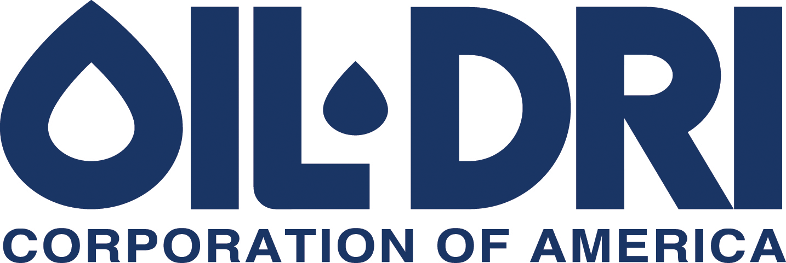

410 N. Michigan Ave. Chicago, Illinois 60611, U.S.A

News Announcement
For Immediate Release
Exhibit 99.1

Oil-Dri Board of Directors Declares Quarterly Dividends

CHICAGO—(December 14, 2023)— The Board of Directors of Oil-Dri Corporation of America (NYSE: ODC) yesterday declared quarterly cash dividends of $0.29 per share of the Company’s Common Stock and $0.218 per share of the Company’s Class B Stock.

The dividends declared will be payable on March 8, 2024 to stockholders of record at the close of business on February 23, 2024. The Company has paid cash dividends continuously since 1974 and has increased dividends annually for twenty consecutive years.

The Company expects to release earnings for its second quarter of fiscal 2024 after the close of the U.S. stock market on Thursday, March 7, 2024 and to host an earnings discussion via webcast on Friday, March 8, 2024. Participation details will be posted on the Events page of the Company’s website approximately one week prior to the call.

###

Oil-Dri Corporation of America is a leading manufacturer and supplier of specialty sorbent products for the pet care, animal health and nutrition, fluids purification, agricultural ingredients, sports field, industrial and automotive markets. Oil-Dri is vertically integrated which enables the Company to efficiently oversee every step of the process from research and development to supply chain to marketing and sales. With over 80 years of experience, the Company continues to fulfill its mission to Create Value from Sorbent Minerals. To learn more about the Company, visit oildri.com.

Category: Dividends

Contact:
Leslie A. Garber
Manager of Investor Relations
Oil-Dri Corporation of America
InvestorRelations@oildri.com
(312) 321-1515

Leslie A. Garber
Investor Relations Manager
InvestorRelations@oildri.com
(312) 321-1515

