UNITED STATES
SECURITIES AND EXCHANGE COMMISSION
Washington, D.C. 20549

SCHEDULE 14A

Proxy Statement Pursuant to Section 14(a) of
the Securities Exchange Act of 1934
(Amendment No. )
Filed by the Registrant x |  |  |  |  |  | Filed by a Party other than the Registrant o
Check the appropriate box:
x |  |  | Preliminary Proxy Statement
o |  |  | Confidential, for Use of the Commission Only (as permitted by Rule 14a-6(e)(2))
o |  |  | Definitive Proxy Statement
o |  |  | Definitive Additional Materials
o |  |  | Soliciting Material Under § 240.14a-12

Oil-Dri Corporation of America
(Name of Registrant as Specified in Its Charter)
(Name of Person(s) Filing Proxy Statement, if other than the Registrant)
Payment of Filing Fee (Check the appropriate box):
x |  |  |  |  |  | No fee required.
o |  |  |  |  |  | Fee paid previously with preliminary materials.
o |  |  |  |  |  | Fee computed on table in exhibit required by Item 25(b) per Exchange Act Rules 14a-6(i)(1) and 0-11.

PRELIMINARY PROXY STATEMENT—SUBJECT TO COMPLETION
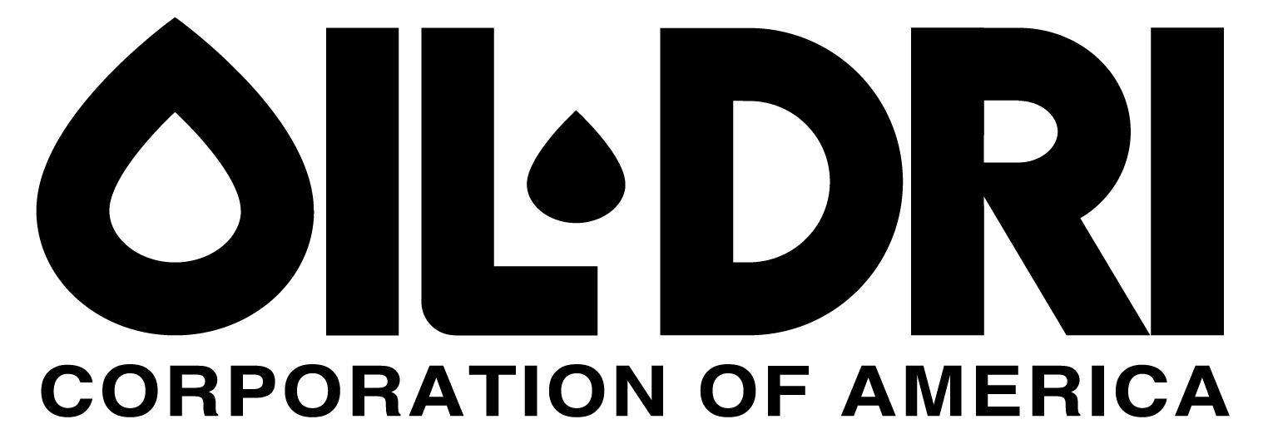

October , 2024

Dear Stockholder:
The Board of Directors and all of us on the management team of Oil-Dri Corporation of America cordially invite you to attend the 2024 Annual Meeting of Stockholders, which will be held virtually on Wednesday, December 11, 2024, at 9:30 a.m., Central Time. You will be able to attend and participate in the Annual Meeting online, vote your shares electronically, and submit your questions during the meeting by visiting www.virtualshareholdermeeting.com/ODC2024.
The matters expected to be acted on at the meeting are described in the attached Proxy Statement. We are recommending a slate of nine directors to be elected to our Board of Directors. Their biographies and qualifications appear in the Proxy Statement. In addition, we ask that you ratify the appointment of Grant Thornton LLP as our independent auditor for the fiscal year ending July 31, 2025. We are also asking that you approve an amendment to our Certificate of Incorporation to increase the number of authorized shares of Common Stock in order to enable us to effect a 2:1 stock split in the form of a stock dividend.
We encourage you to read our Annual Report on Form 10-K for the fiscal year ending July 31, 2024 that is available at www.proxyvote.com. It includes information on our operations, markets, products, services, and known risk factors, as well as our audited consolidated financial statements.
We will be holding the Annual Meeting virtually this year, as we believe the virtual format enables greater stockholder attendance and participation, improved meeting efficiency, increases our ability to communicate effectively with our stockholders, and reduces the cost of the Annual Meeting. You will not be able to attend the Annual Meeting in person.
Immediately following adjournment of the Annual Meeting, we will review with attendees the results of the past year and look at some of the potential opportunities that lie ahead.
We look forward to your participation in the Annual Meeting. Whether you plan to attend the Annual Meeting or not, you can be sure your shares are represented at the Annual Meeting by voting over the Internet or by telephone, as instructed in the Notice Regarding Availability of Proxy Materials or proxy card. If you received a Notice Regarding the Availability of Proxy Materials in the mail, you may also request a paper copy of the Proxy Materials and proxy card to submit your vote by mail if you prefer.

Sincerely,
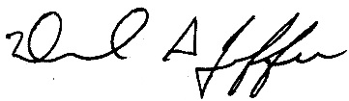
DANIEL S. JAFFEE
Chairman of the Board of Directors and President and Chief Executive Officer

This proxy statement is dated October , 2024 and is being made available to stockholders via the Internet on or about October , 2024.

Table of Contents
NOTICE OF ANNUAL MEETING OF STOCKHOLDERS |  |  | ii
GENERAL INFORMATION |  |  | 1
Commonly Asked Questions and Answers |  |  | 2
CORPORATE RESPONSIBILITY AND ESG |  |  | 10
PROPOSALS |  |  | 14
1. Election of Directors |  |  | 14
2. Ratification of Appointment of Independent Auditor |  |  | 19
3. Approval of an Amendment to the Certificate of Incorporation |  |  | 20
4. Other Matters for the Annual Meeting |  |  | 22
CORPORATE GOVERNANCE MATTERS |  |  | 22
Controlled Company Status |  |  | 22
Director Independence |  |  | 23
Executive Sessions of Non-Management Directors |  |  | 23
Board of Directors Committee Membership and Meetings |  |  | 24
Director Nominations |  |  | 28
Board Leadership Structure and Role in Risk Oversight |  |  | 29
Communication with the Board of Directors |  |  | 31
Director Compensation |  |  | 31
Director Compensation Table |  |  | 32
Directors’ Option Awards Outstanding Table |  |  | 33
Corporate Governance Guidelines and Code of Ethics |  |  | 33
Certain Relationships and Related Party Transactions |  |  | 34
Report of the Audit Committee of the Board of Directors |  |  | 36
EXECUTIVE OFFICERS |  |  | 37
EXECUTIVE COMPENSATION |  |  | 38
Summary Compensation Table |  |  | 38
All Other Compensation Table |  |  | 38
Narrative Disclosure to Summary Compensation Table |  |  | 39
Outstanding Equity Awards at Fiscal 2024 Year End |  |  | 43
Nonqualified Deferred Compensation for Fiscal 2024 |  |  | 45
Benefits upon Termination or Change in Control |  |  | 46
STOCK OWNERSHIP |  |  | 48
Principal Stockholders |  |  | 48
Security Ownership of Management |  |  | 50
OTHER INFORMATION |  |  | 52
APPENDIX A - Proposed Amendment to the Certificate of Incorporation |  |  | 54

i
OIL-DRI CORPORATION OF AMERICA
NOTICE OF ANNUAL MEETING OF STOCKHOLDERS
To be held virtually on December 11, 2024

To Our Stockholders:

The 2024 Annual Meeting of Stockholders of Oil-Dri Corporation of America, a Delaware corporation (the “Company”), will be held virtually at 9:30 a.m., Central Time, on Wednesday, December 11, 2024, at www.virtualshareholdermeeting.com/ODC2024.
The meeting will be held for the following purposes:
1. To elect nine directors;
2. To ratify the appointment of Grant Thornton LLP as the Company’s independent auditor for the fiscal year ending July 31, 2025;
3. To approve an amendment to our Certificate of Incorporation to increase the number of authorized shares of Common Stock; and
4. To transact such other business as may properly come before the meeting and any adjournment thereof.
Our Board of Directors has determined that only holders of record of outstanding shares of Common Stock and Class B Stock at the close of business on Monday, October 14, 2024 are entitled to notice of, and to vote at, the meeting and any adjournment thereof.
A list of stockholders will be available for examination by any stockholder at the Annual Meeting and at our corporate headquarters, located at 410 North Michigan Avenue, Suite 400, Chicago, IL 60611, for a period of ten days prior to the Annual Meeting.
Your vote is very important. Whether you intend to attend the virtual meeting or not, you are encouraged to vote, as promptly as possible, over the Internet or by telephone, as instructed in the Notice Regarding the Availability of Proxy Materials or proxy card. If you received a Notice Regarding the Availability of Proxy Materials in the mail, you may also request a paper proxy card to submit your vote by mail if you prefer.
For further information relating to the meeting, please see the following pages.
By Order of the Board of Directors,
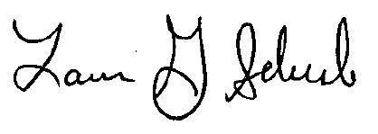
LAURA G. SCHELAND
Secretary
Chicago, Illinois
October , 2024

ii
Notice of Internet Availability of Proxy Materials: The Company is pleased to take advantage of the United States Securities and Exchange Commission rules that allow issuers to furnish proxy materials to their stockholders via the Internet. These rules allow the Company to provide you with the information you need while lowering the costs and environmental impact associated with printing and mailing proxy materials for the Annual Meeting. Our proxy materials, including our Proxy Statement, 2024 Annual Report on Form 10-K for the fiscal year ended July 31, 2024 and proxy card, are available on the Internet at http://www.oildri.com/proxymaterials. On or about October , 2024, we will mail to most of our stockholders a notice containing instructions on how to access this proxy statement and our annual report and to vote via the Internet or by telephone.

Online Attendance of the Annual Meeting: You are entitled to attend and participate in the meeting if you were a stockholder of record as of the close of business on October 14, 2024. To attend and participate in the meeting, you will need the 16-digit control number included on your Notice of Internet Availability of Proxy Materials, proxy card, or voting instruction form. You may also ask questions, vote online, and examine our stockholder list during the meeting by following the instructions provided at www.virtualshareholdermeeting.com/ODC2024 during the meeting. Please see “Virtual Meeting Format” beginning on page 1 of the accompanying Proxy Statement for details regarding the virtual annual meeting.

OIL-DRI CORPORATION OF AMERICA
410 North Michigan Avenue
Suite 400
Chicago, Illinois 60611-4213
______________
PROXY STATEMENT
______________
GENERAL INFORMATION
This Proxy Statement is delivered on behalf of the Board of Directors (“Board”) of Oil-Dri Corporation of America, a Delaware corporation (the “Company”), in connection with the solicitation by the Board of proxies to be voted at the virtual 2024 Annual Meeting of Stockholders (the “2024 Annual Meeting”) to be held at 9:30 a.m., Central Time, on Wednesday, December 11, 2024, and at any postponements or adjournments thereof. The Notice Regarding the Availability of Proxy Materials (the “Notice”) is being distributed, and the Notice of Annual Meeting of Stockholders, this Proxy Statement and form of proxy are being made available on the Internet, on or about October , 2024. In addition, we encourage you to review our Annual Report on Form 10-K that was filed on October 10, 2024. Unless expressly stated herein, our Form 10-K should not be deemed to be part of this Proxy Statement.
As a stockholder, you are invited to attend the virtual 2024 Annual Meeting and are requested to vote on the items of business described in this Proxy Statement. This Proxy Statement includes information that we are required to provide to you under rules and regulations promulgated by the United States Securities and Exchange Commission (“SEC”) and is designed to assist you in voting your shares. Whenever we refer in this Proxy Statement to the “2024 Annual Meeting,” we are also referring to any meeting that results from an adjournment of the 2024 Annual Meeting. Except as otherwise indicated herein or as the context otherwise requires, references to the “Company,” “we,” “us” or “our” refer to Oil-Dri Corporation of America under the rules promulgated by the SEC.
In 2018, the SEC adopted amendments that raised the threshold for qualifying as a “smaller reporting company” (“SRC”). Oil-Dri met the qualifications of an SRC as of January 31, 2023 and qualified as an SRC for the fiscal year ended July 31, 2024; therefore, this Proxy Statement reflects several of the scaled disclosure requirements that SRCs may utilize.
Virtual Meeting Format
Similar to 2023, we have decided to hold the 2024 Annual Meeting virtually via live webcast. There will not be a physical location for the 2024 Annual Meeting and you will not be able to attend in person. We believe hosting a virtual annual meeting will enable stockholders to attend and participate fully and equally, improve meeting efficiency and our ability to effectively communicate and engage with our stockholders and provide for cost savings to the Company and our stockholders.
We have designed the virtual 2024 Annual Meeting to provide the same rights and opportunities to participate as you would have at an in-person meeting. Stockholders will be able to attend and participate online and submit questions during the 2024 Annual Meeting by visiting www.virtualshareholdermeeting.com/ODC2024.
1
To attend and participate in the 2024 Annual Meeting, you will need the 16-digit control number included on your Notice of Internet Availability of Proxy Materials, proxy card, or voting instruction form. The 2024 Annual Meeting will begin promptly at 9:30 a.m. Central Time. We encourage you to access the 2024 Annual Meeting prior to the start time. Online access will begin at 9:15 a.m. Central Time.
If you do not have a 16-digit control number, you may still attend the meeting as a guest in “listen-only” mode. To attend as a guest, please access www.virtualshareholdermeeting.com/ODC2024 and enter the information requested on the screen to register as a guest. Please note that if you participate as a guest, you will not have the ability to ask questions, vote, or examine the list of stockholders during the meeting. After the meeting, an archived copy of the audio webcast will be posted on our website at www.oildri.com/investors and will remain available for at least one year following the meeting.
The virtual 2024 Annual Meeting platform is fully supported across browsers (Microsoft Edge, Firefox, Chrome, and Safari) and devices (desktops, laptops, tablets, and cell phones) running the most updated version of applicable software and plugins. Stockholders should ensure that they have a strong internet connection if they intend to attend and/or participate in the 2024 Annual Meeting. Attendees should allow plenty of time to log in and ensure that they can hear streaming audio prior to the start of the 2024 Annual Meeting.
If you encounter any difficulties accessing the virtual 2024 Annual Meeting during the check-in or meeting time, please call technical support at (844) 986-0822 (US) or (303) 562-9302 (International) for assistance. Technical support will be available beginning at 9:00 a.m. Central Time on December 11, 2024 through the conclusion of the 2024 Annual Meeting.

Commonly Asked Questions and Answers
1. Why am I receiving these materials?
The Notice is being delivered to all stockholders of record as of the close of business on October 14, 2024 (the “Record Date”) in connection with the solicitation of proxies on behalf of our Board for use at the 2024 Annual Meeting on December 11, 2024.
2. Why did I receive a notice in the mail regarding the Internet availability of proxy materials instead of a full set of proxy materials?
Pursuant to rules adopted by the SEC, we may furnish proxy materials, including this Proxy Statement, our Annual Report, and the proxy card or a voting instruction form for the Annual Meeting (collectively, “proxy materials”), to our stockholders by providing access to such documents on the Internet instead of mailing printed copies. Accordingly, we are mailing the Notice to our stockholders of record and beneficial owners as of the Record Date and making the proxy materials available on the Internet.
3. How can I access the proxy materials over the Internet?
The Notice and proxy card or voting instruction card contain instructions on how to view the proxy materials on the Internet, vote your shares on the Internet, and request electronic delivery of future proxy materials. Electronic copies of this Proxy Statement and Annual Report are available at www.proxyvote.com. If you received a Notice and would like to receive a paper copy of the proxy materials free of charge, please follow the instructions in the Notice.
2
4. Why is the Company holding a virtual annual meeting?
Hosting the annual meeting virtually allows for increased and broader stockholder attendance and participation, improves meeting efficiency and our ability to effectively communicate and engage with our stockholders and provides for cost savings to the Company and our stockholders. We believe that we are observing best practices for virtual shareholder meetings, including by providing a support line for technical assistance and addressing as many stockholder questions as time allows.
5. Do I need to register in advance to attend the virtual meeting?
You do not have to register in advance to attend the virtual meeting.
6. Who is entitled to vote at the 2024 Annual Meeting?
Our Board has established the close of business on Monday, October 14, 2024 as the Record Date for the 2024 Annual Meeting. Only stockholders of record as of the close of business on the Record Date are entitled to receive notice of, and to vote at, the 2024 Annual Meeting. A list of stockholders will be available for examination by any stockholder at the Annual Meeting and at our corporate headquarters, located at 410 North Michigan Avenue, Suite 400, Chicago, IL 60611, for a period of ten days prior to the Annual Meeting.
Holders of Common Stock are entitled to one vote per share and holders of Class B Stock are entitled to ten votes per share (on a non-cumulative basis for each director to be elected when voting for the election of directors) and vote together without regard to class (except that any amendment to our Certificate of Incorporation changing the number of authorized shares or adversely affecting the rights of holders of Common Stock or Class B Stock requires the separate approval of the affected class as well as the approval of both classes voting together). Holders of Class B Stock are entitled to convert any and all of their shares into Common Stock on a share-for-share basis at any time. Shares of Class B Stock are also subject to mandatory conversion under certain circumstances. As of the Record Date, 5,134,478 shares of Common Stock and 2,155,407 shares of Class B Stock were outstanding.
Registered Stockholders. If your shares are registered directly in your name with our transfer agent, Computershare Trust Company, N.A. (“Computershare”), you are considered the stockholder of record with respect to those shares, and the Notice was provided to you directly by us. As the stockholder of record, you have the right to grant your voting proxy directly to the individuals listed on the proxy card or to vote at the virtual 2024 Annual Meeting.
Beneficial Stockholders. If your shares are held in a stock brokerage account or by a bank or other nominee, you are considered the beneficial owner of shares held in “street name,” and the Notice was forwarded to you by your broker or nominee, who is considered, with respect to those shares, the stockholder of record. As the beneficial owner, you have the right to direct your broker or nominee how to vote your shares (see Question 9 (“How do I cast my vote?”) and Question 12 (“How are broker non-votes and abstentions counted?”) below for more information). Beneficial owners are also invited to attend the 2024 Annual Meeting. However, because you are not the stockholder of record, you may not vote your shares or ask questions at the virtual 2024 Annual Meeting unless you follow your broker’s procedures for obtaining a legal proxy. If you request a printed copy of the proxy materials by mail, your broker or nominee will provide a voting instruction card for you to use.
3
7. What proposals are being voted on at the 2024 Annual Meeting?
Stockholders are being asked to vote upon the following items of business at the 2024 Annual Meeting:
1.the election of nine directors, each to hold office for a one-year term ending at our 2025 Annual Meeting of Stockholders;
2.the ratification of the appointment of Grant Thornton LLP (“Grant Thornton”) as our independent auditor for the fiscal year ending July 31, 2025 (“fiscal 2025”);
3.the approval of an amendment to our Certificate of Incorporation to increase the number of authorized shares of Common Stock in order to enable us to effect a 2:1 stock split in the form of a stock dividend; and
4.to transact such other business as may properly come before the 2024 Annual Meeting.
Our Board knows of no other items of business that will be presented for consideration at the 2024 Annual Meeting other than those described in this Proxy Statement. In addition, no stockholder proposal or nomination was received prior to the deadline specified in our Amended and Restated By-Laws (“By-Laws”), so no such matters may be brought to a vote at the 2024 Annual Meeting.
8. What are the voting recommendations of the Board?
Our Board recommends that you vote your shares as follows:
•“FOR” the election of each of the nine nominees to the Board;
•“FOR” the ratification of the appointment of Grant Thornton as the Company’s independent auditor for fiscal 2025; and
•“FOR” the approval of the amendment to our Certificate of Incorporation to increase the number of authorized shares of Common Stock.
9. How do I cast my vote?
If you are a stockholder of record as of the Record Date, you may vote in several different ways:
Online at the 2024 Annual Meeting
Registered stockholders and beneficial owners may vote online during the 2024 Annual Meeting. You will need the 16-digit control number included on your Notice of Internet Availability of Proxy Materials, proxy card or voting instruction form to log in to the virtual meeting platform at www.virtualshareholdermeeting.com/ODC2024. Beneficial owners will need to follow their brokers’ procedures for obtaining a legal proxy in order to vote online during the 2024 Annual Meeting. Voting electronically online during the 2024 Annual Meeting will replace any previous votes.
By Internet (prior to the 2024 Annual Meeting)
You may vote using the Internet by submitting your voting instructions at www.proxyvote.com. You should have the Notice or your proxy card available when you go online. If you vote on the Internet, you may also request electronic delivery of future proxy materials. Internet voting for stockholders of record will be available until 11:59 p.m., Eastern Time, on December 10, 2024.
By Telephone
4
You may vote by calling 1-800-690-6903. Please have your proxy card in hand when you call and use any touch-tone phone to transmit your voting instructions. Telephone voting for stockholders of record will be available until 11:59 p.m., Eastern Time, on December 10, 2024.
By Mail
You may vote by mail by requesting a paper copy of the proxy materials, which will include a proxy card, and then completing, signing, dating and returning the proxy card in the postage-paid envelope provided with the paper copy of the proxy materials.
If you are a beneficial stockholder (see Question 6 “Who is entitled to vote at the 2024 Annual Meeting?” above for more information), you must provide instructions to your bank, broker or other nominee as to how your shares should be voted. Your bank, broker or other nominee will usually provide you with the appropriate voting instruction form at the time you receive this Proxy Statement. The availability of telephone and Internet voting for beneficial owners of shares held in “street name” will depend on your bank, broker or other nominee. We recommend that you follow the voting instructions on the materials you receive from that entity. Your shares may be voted on certain matters even if you do not provide voting instructions because banks, brokers and nominees generally have the authority under New York Stock Exchange (“NYSE”) rules to vote on “routine matters.” The proposal to ratify the appointment of our independent auditor is considered a routine matter. The election of directors and the approval of the amendment to the Certificate of Incorporation to authorize additional shares of Common Stock are considered non-routine matters. Unless you decide to change your vote, use only one method to send us your vote. If you requested a printed set of the proxy materials and voted by telephone or by Internet, you do not have to return your proxy card or voting instruction form. Even if you plan to virtually attend the 2024 Annual Meeting, we recommend that you vote your shares in advance so that your vote will be counted if you later decide not to attend the virtual meeting.
If you vote by proxy, the individuals named as proxyholders will vote the shares as instructed. If no contrary instructions are indicated in the proxy, each proxy will be voted “FOR” the election of the nine nominees to our Board named below, “FOR” the ratification of the appointment of Grant Thornton as our independent auditor for fiscal 2025 and “FOR” the approval of an amendment to the Certificate of Incorporation to increase the number of authorized shares of Common Stock. In their discretion, the proxy holders named on the proxy are authorized to vote on any other matters that may properly come before the 2024 Annual Meeting.
10. Can I change my vote and/or revoke my proxy?
Yes, if you vote by proxy, you may revoke that proxy at any time before it is voted at the 2024 Annual Meeting. If you are the stockholder of record, you may do this by:
•voting again on the Internet or by telephone prior to 11:59 p.m., Eastern Time, on December 10, 2024;
•signing another proxy card with a later date and delivering it to Broadridge Financial Solutions, Inc., 51 Mercedes Way, Edgewood, New York 11717, prior to the 2024 Annual Meeting; or
•voting online at the 2024 Annual Meeting (see “How do I cast my vote?” above).
If you are a beneficial stockholder and you have instructed your bank, broker or other nominee to vote your shares, you may revoke those instructions by following the directions received from your bank, broker or other nominee to change those instructions. Your attendance at the 2024 Annual Meeting itself will not revoke your proxy unless you vote online at the virtual 2024 Annual Meeting.
5
11. What constitutes a quorum at the 2024 Annual Meeting?
A majority of all outstanding shares of Common Stock and Class B Stock entitled to vote at the 2024 Annual Meeting constitutes a quorum, which is the minimum number of shares that must be present or represented by proxy at the 2024 Annual Meeting to transact business. Once a share is represented for any purpose at the 2024 Annual Meeting, it will be deemed present for quorum purposes for the remainder of the meeting (including any meeting resulting from an adjournment of the 2024 Annual Meeting, unless a new record date is set).
12. How are broker non-votes and abstentions counted?
A broker non-vote occurs when shares held as of record by a broker are not voted with respect to a particular proposal because the broker does not have discretionary authority to vote on the matter and has not received voting instructions from its clients. If your broker holds your shares as of record in its name and you do not instruct your broker how to vote, your broker will only have discretion to vote your shares on “routine” matters. Where a proposal is not “routine,” a broker who has not received instructions from its clients does not have discretion to vote its clients’ uninstructed shares on that proposal. At the 2024 Annual Meeting, the only routine matter is the proposal to ratify the appointment of our independent auditor. Therefore, absent directions from you, your broker will not have discretion to vote on the election of directors or the approval of the amendment to the Certificate of Incorporation to increase the number of authorized shares of Common Stock. Broker non-votes and abstentions will be counted towards determining whether or not a quorum is present at the 2024 Annual Meeting. However, on matters other than the election of directors, abstentions will have the effect of a vote “against” such matters, and broker non-votes generally will have no effect on the outcome of such matters, other than the proposal to amend the Certificate of Incorporation as described below.
13. How many votes are needed to approve the proposals?
Directors are elected by a plurality of votes cast. Accordingly, we count proxies and ballots marked for all nominees listed (including executed proxies submitted by stockholders who request to receive paper copies of the proxy materials that are not marked regarding the election of directors, which will be voted for all listed nominees), or those voting for some but not all nominees that specify votes withheld for one or more designated nominees, to determine the total number of votes cast for each nominee. The nine nominees who receive the largest number of votes will be elected. Broker non-votes will have no effect on the outcome of the election of directors.
An affirmative majority of the votes present at the 2024 Annual Meeting or represented by proxy and entitled to vote is necessary for ratification of the appointment of Grant Thornton as our independent auditor for fiscal 2025. Any abstention by those present or represented by proxy has the same legal effect as a vote against this proposal. Because the proposal for ratification of the appointment of Grant Thornton as our independent auditor for fiscal 2025 is considered a routine matter under the rules of the NYSE, banks, brokers and other nominees are able to vote on this matter even if no voting instructions are provided by the beneficial owner.
An affirmative vote of the holders of a majority of the voting power of our outstanding Common Stock, voting separately as a class, in addition to an affirmative vote of the holders of a majority of the voting power of our outstanding Common Stock and Class B Stock, voting together as a single class, is necessary to approve the amendment to our Certificate of Incorporation to increase the number of authorized shares of Common Stock. Abstentions and broker non-votes will have the same effect as a vote “AGAINST” this proposal.
14. Who will count the vote?
6
We have retained Broadridge Financial Solutions, Inc. (“Broadridge”) to tabulate the vote and act as Inspector of Election. Information about Broadridge is available at www.broadridge.com. Proxies and ballots that identify the votes of individual stockholders are kept confidential from the Company’s management and directors. Only Broadridge, as the proxy tabulator and Inspector of Election, has access to the ballots, proxy cards and voting instruction forms. Broadridge will disclose information taken from the ballots, proxy cards and voting instruction forms only in the event of a proxy contest or as otherwise required by law.
15. How do I ask questions during the virtual 2024 Annual Meeting?
Stockholders may submit questions during the 2024 Annual Meeting. If you wish to submit a question, you may do so by logging into the virtual meeting platform at www.virtualshareholdermeeting.com/ODC2024, typing your question into the “Ask a Question” field, and clicking “Submit.”
Questions pertinent to the 2024 Annual Meeting that comply with the meeting Rules of Conduct will be answered during the 2024 Annual Meeting, subject to time constraints. Questions regarding personal matters or matters not relevant to meeting matters will not be answered.
16. Where can I find the voting results of the 2024 Annual Meeting?
We intend to announce preliminary voting results at the 2024 Annual Meeting. Within four business days following the adjournment of the 2024 Annual Meeting, we intend to disclose the final voting results of each proposal being voted on at the 2024 Annual Meeting in a Current Report on Form 8-K.
17. How does a stockholder propose actions for consideration at next year’s annual meeting of stockholders?
For your proposal to be considered for inclusion in our proxy statement for next year’s annual meeting, we must receive your written proposal no later than July 1, 2025. In addition, to comply with the universal proxy rules, stockholders who intend to solicit proxies in support of director nominees other than the Company’s nominees must provide notice that sets forth the information required by Rule 14a-19 under the Securities Exchange Act of 1934, as amended (the “Exchange Act”), which notice must be postmarked or transmitted electronically to the Company at its principal executive offices no later than 60 calendar days prior to the anniversary date of the annual meeting (for the 2025 annual meeting of stockholders, no later than October 12, 2025). However, if the date of the 2025 annual meeting is changed by more than 30 calendar days from such anniversary date, then notice must provided by the later of 60 calendar days prior to the date of the 2025 annual meeting of stockholders or the 10th calendar day following the day on which public announcement of the date of the 2025 annual meeting of stockholders is first made.
Your proposal should be addressed to the Corporate Secretary, Oil-Dri Corporation of America, at the Company’s principal executive offices at 410 North Michigan Avenue, Suite 400, Chicago, Illinois 60611-4213. Further, be aware that your proposal must comply with SEC regulations regarding inclusion of stockholder proposals in company-sponsored proxy materials and other applicable laws. Although our Board will consider all proposals, it has the right to omit any proposals it is not required to include. Proposals submitted in writing between July 1, 2025 and July 31, 2025 (assuming the meeting is held not more than 30 days from December 11, 2025) may be considered at next year’s annual meeting but will not be included in our proxy statement. All proposals should be addressed to the Corporate Secretary, Oil-Dri Corporation of America, 410 North Michigan Avenue, Suite 400, Chicago, Illinois 60611-4213. In addition, the proposal must satisfy all of the other requirements set forth in our By-Laws and all applicable laws.
7
18. Can I elect to receive future proxy solicitations via mail or online?
Yes, you may either request to receive printed copies of all future proxy statements, proxy cards and annual reports in the mail or request to receive all such future proxy materials via e-mail or the Internet. If you request to receive all future proxy materials via e-mail or the Internet, you will not receive paper copies of these stockholder communications in the mail. To sign up for electronic delivery, follow the instructions on the form of proxy card under the heading “ELECTRONIC DELIVERY OF FUTURE PROXY MATERIALS” to indicate that you agree to receive or access stockholder communications electronically in future years. If you hold your shares through a bank, broker or other nominee, contact that entity for information as to whether and how you can elect electronic delivery.
19. Why did I receive more than one package of proxy materials?
This means that you have multiple accounts holding shares of Common Stock or Class B Stock. These may include accounts with our transfer agent, Computershare, and accounts with a bank, broker or other nominee. Please complete, sign, date and return (or vote via the Internet or telephone with respect to) each proxy card and voting instruction form that you receive with each package of proxy materials to ensure that all of your shares are voted.
20. Can I receive future proxy statements, annual reports and certain other stockholder information in a single package per household?
If you have elected to receive paper copies of the proxy materials and your household received more than one copy of the Company’s Annual Report on Form 10-K and Proxy Statement, and you wish to reduce the number you receive, you may enroll in householding online at www.proxyvote.com or you may check the “yes” box on the proxy card next to the statement “Please indicate if you consent to receive certain future investor communications in a single package per household.” By checking this box, you are consenting to the mailing of the proxy statements, annual reports and certain other stockholder information in a single package per household. Please note that each registered stockholder in your household will need to consent to this option in order for the household delivery to take effect for such stockholder’s mailings. Despite signing up for household delivery of certain stockholder mailings, the Company will continue to separately mail a proxy card for each registered stockholder account.
You may revoke your consent at any time by calling (866) 540-7095 or writing to Broadridge Financial Solution, Attn: Householding Department, 51 Mercedes Way, Edgewood, NY 11717. If you revoke your consent, the Company will begin sending you individual copies of these documents within 30 days after receipt of your revocation notice.
21. Who may solicit proxies?
Our directors, officers and employees may solicit proxies on behalf of our Board via mail, telephone, facsimile, e-mail and personal contact. Our directors, officers and employees will receive no additional compensation for soliciting proxies.
8
22. Who pays for the cost of this proxy solicitation?
We will bear the cost of this proxy solicitation, including reimbursing banks, brokers and other nominees for reasonable expenses of sending out proxy materials to beneficial stockholders. We have retained Broadridge to assist us with the distribution of proxy materials, host the virtual Annual Meeting, tabulate the vote, and act as the Inspector of Election at the Annual Meeting. We estimate we will pay Broadridge customary fees and expenses for these services of approximately $43,000.
23. What if I have additional questions not addressed here?
You may call our Investor Relations department at (312) 321-1515 or e-mail InvestorRelations@oildri.com.

9
CORPORATE RESPONSIBILITY & ESG

Our Values
Oil-Dri is committed to doing business in a sustainable and socially responsible manner, which we believe will drive long-term value creation for our company and all of its stakeholders, as well as managing the risks and opportunities that are presented by Environmental, Social, and Governance (“ESG”) issues. At the heart of everything we do are our “WE CARE” values. These values apply not only to our employees, who we refer to as our “teammates,” and our relationship with the communities and properties where our mines, offices, and production facilities are located, but we also seek to engage with customers, vendors, and other stakeholders who align with our values as well as those reflected in the communities in which we live and work.

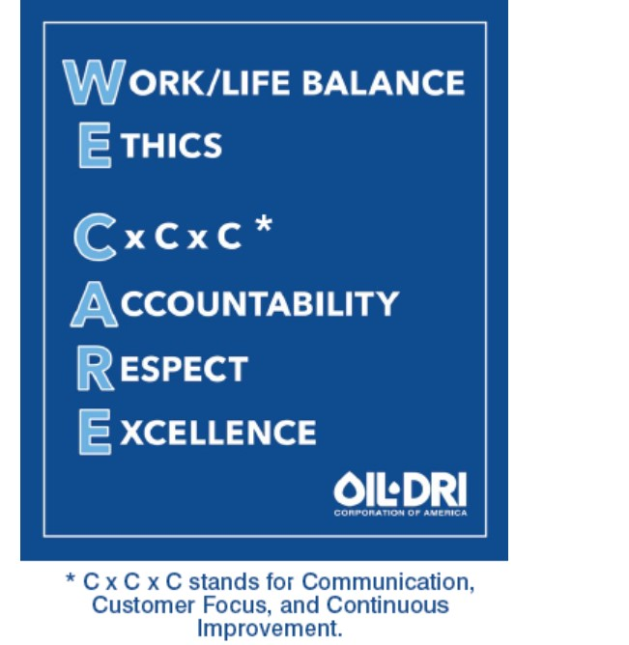

Our Approach
In keeping with the Company’s values, we formally launched an ESG program in 2021. However, much of the positive impact made in relation to ESG initiatives goes back many years, and in some cases, decades. Whenever possible, our ESG approach is designed to align with the Sustainability Accounting Standards Board (“SASB”).
We also maintain a webpage dedicated to the Company’s ESG and other corporate responsibility practices and accomplishments on the Company’s website, which can be found at https://www.oildri.com/responsibility/. The information provided on the Company’s website is referenced in this Proxy Statement for information purposes only. The information on the Company’s website shall not be deemed to be a part of or incorporated by reference into this Proxy Statement or any of the Company’s other SEC filings.

Environmental
In terms of Oil-Dri’s Environmental impact, we are proud of our organization’s long-term land reclamation and restoration successes at our mining locations. Our teams replant indigenous trees and plants at many of our reclaimed locations and maintain an active forestry plan across approximately 4,000 acres in Georgia. As part of Oil-Dri’s history of land reclamation, the Company was the recipient of the Environmental Award in 2018 for Outstanding Achievement in Land Reclamation from the Georgia Mining Association.
10
Certain of our products themselves have environmental benefits and/or support federal and state environmental programs. This is shown through our antibiotic alternative mineral based feed additives; the logistics and transportation benefits of lightweight cat litter, which were recognized by our customer Walmart Inc. with their Responsibility Award for positive impact on consumers’ lives; and our adsorbent clay products sold to customers participating in federal and state renewable fuel programs that are intended to reduce greenhouse gas emissions and expand the nation’s renewable fuel sectors.
Our production facilities are focused on minimizing energy consumption while continuing to support sales growth. The Company has implemented an array of energy programs, including solar power, upgraded compressed air systems, highly efficient LED lights to reduce electricity use, and is in the process of replacing all diesel forklifts used at our facilities with electric forklifts.
Social
From a Social perspective, Oil-Dri’s culture and values, along with our teammates, are our most valuable assets. Our “WE CARE” culture helps drive the Company’s focus on the well-being of our teammates, from compensation and benefits to community outreach to safety. A clear outgrowth of our “WE CARE” values is the Diversity, Equity, and Inclusion (“DEI”) team, comprised of a diverse group of teammates across locations, functions and communities.
The Company believes our success is enhanced by a workforce that reflects the diversity of the communities and countries in which we live and work. Diverse perspectives are encouraged and needed in order to help our company achieve its vision and to continue to grow. We are committed to cultivating and preserving a culture of inclusion. The DEI team strives to bring awareness and understanding of human diversity as a corporate imperative by engaging teammates in pertinent conversation, training, and education through a variety of ongoing initiatives.
Our focus on cultivating and preserving a culture of inclusion starts from the top, with our Board. We seek to foster a boardroom environment and culture that promotes new perspectives, innovation, and deliberation. The composition of our directors with respect to tenure and gender diversity are shown below:

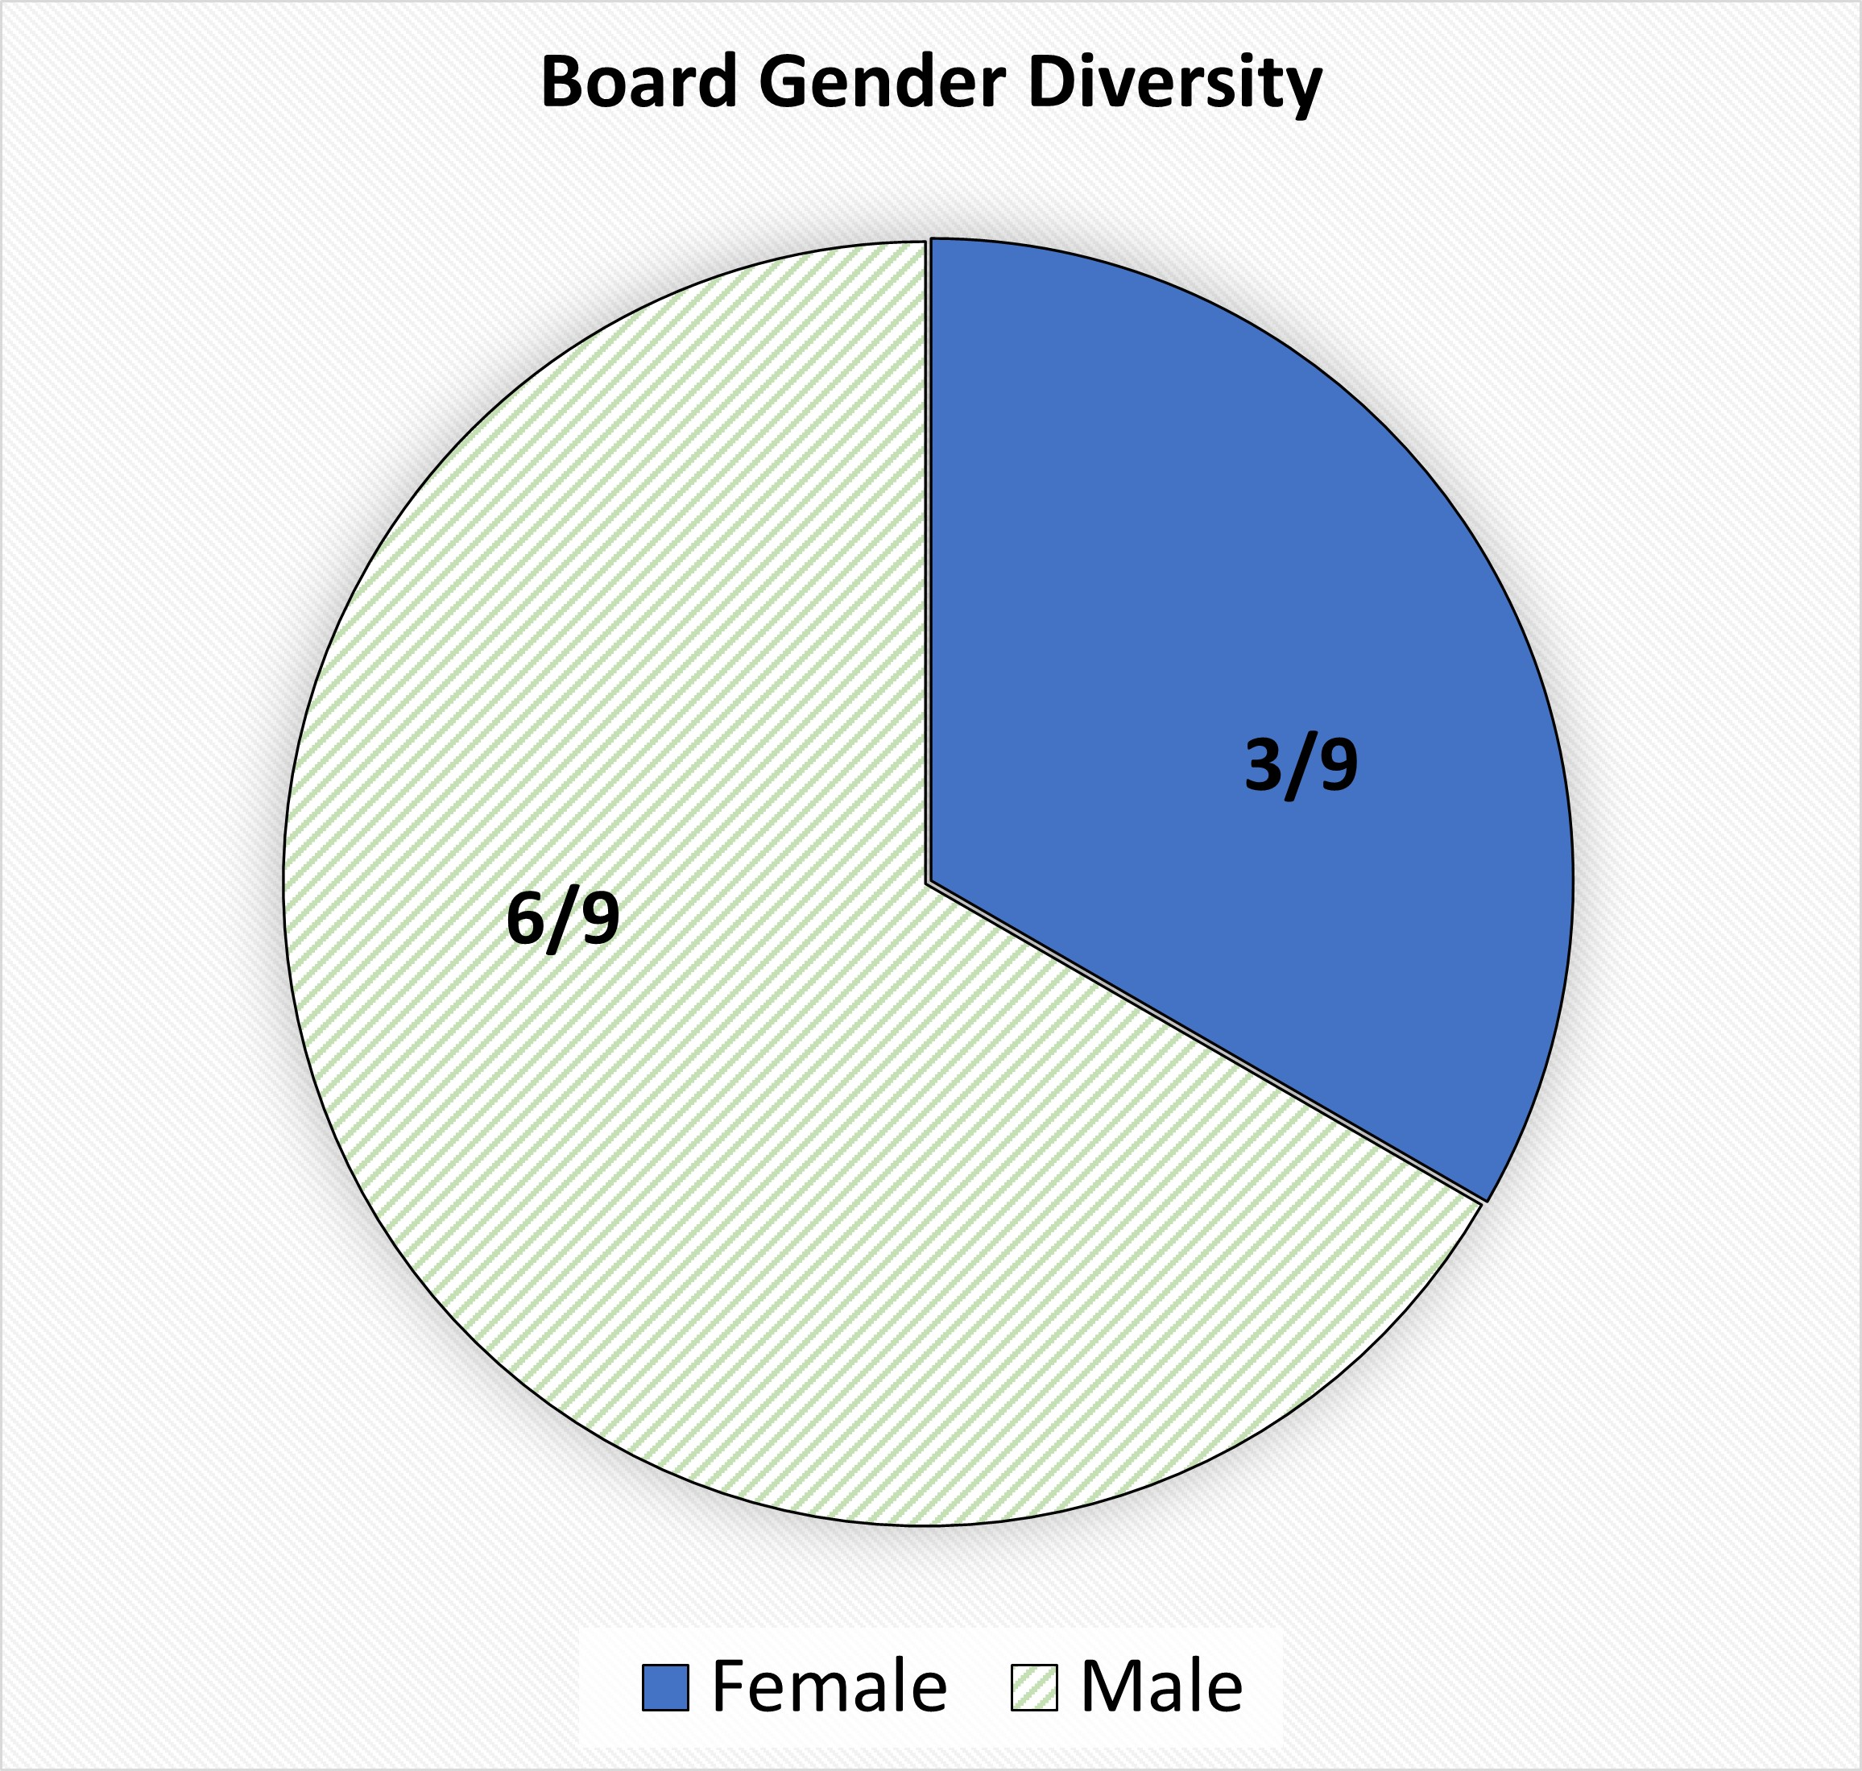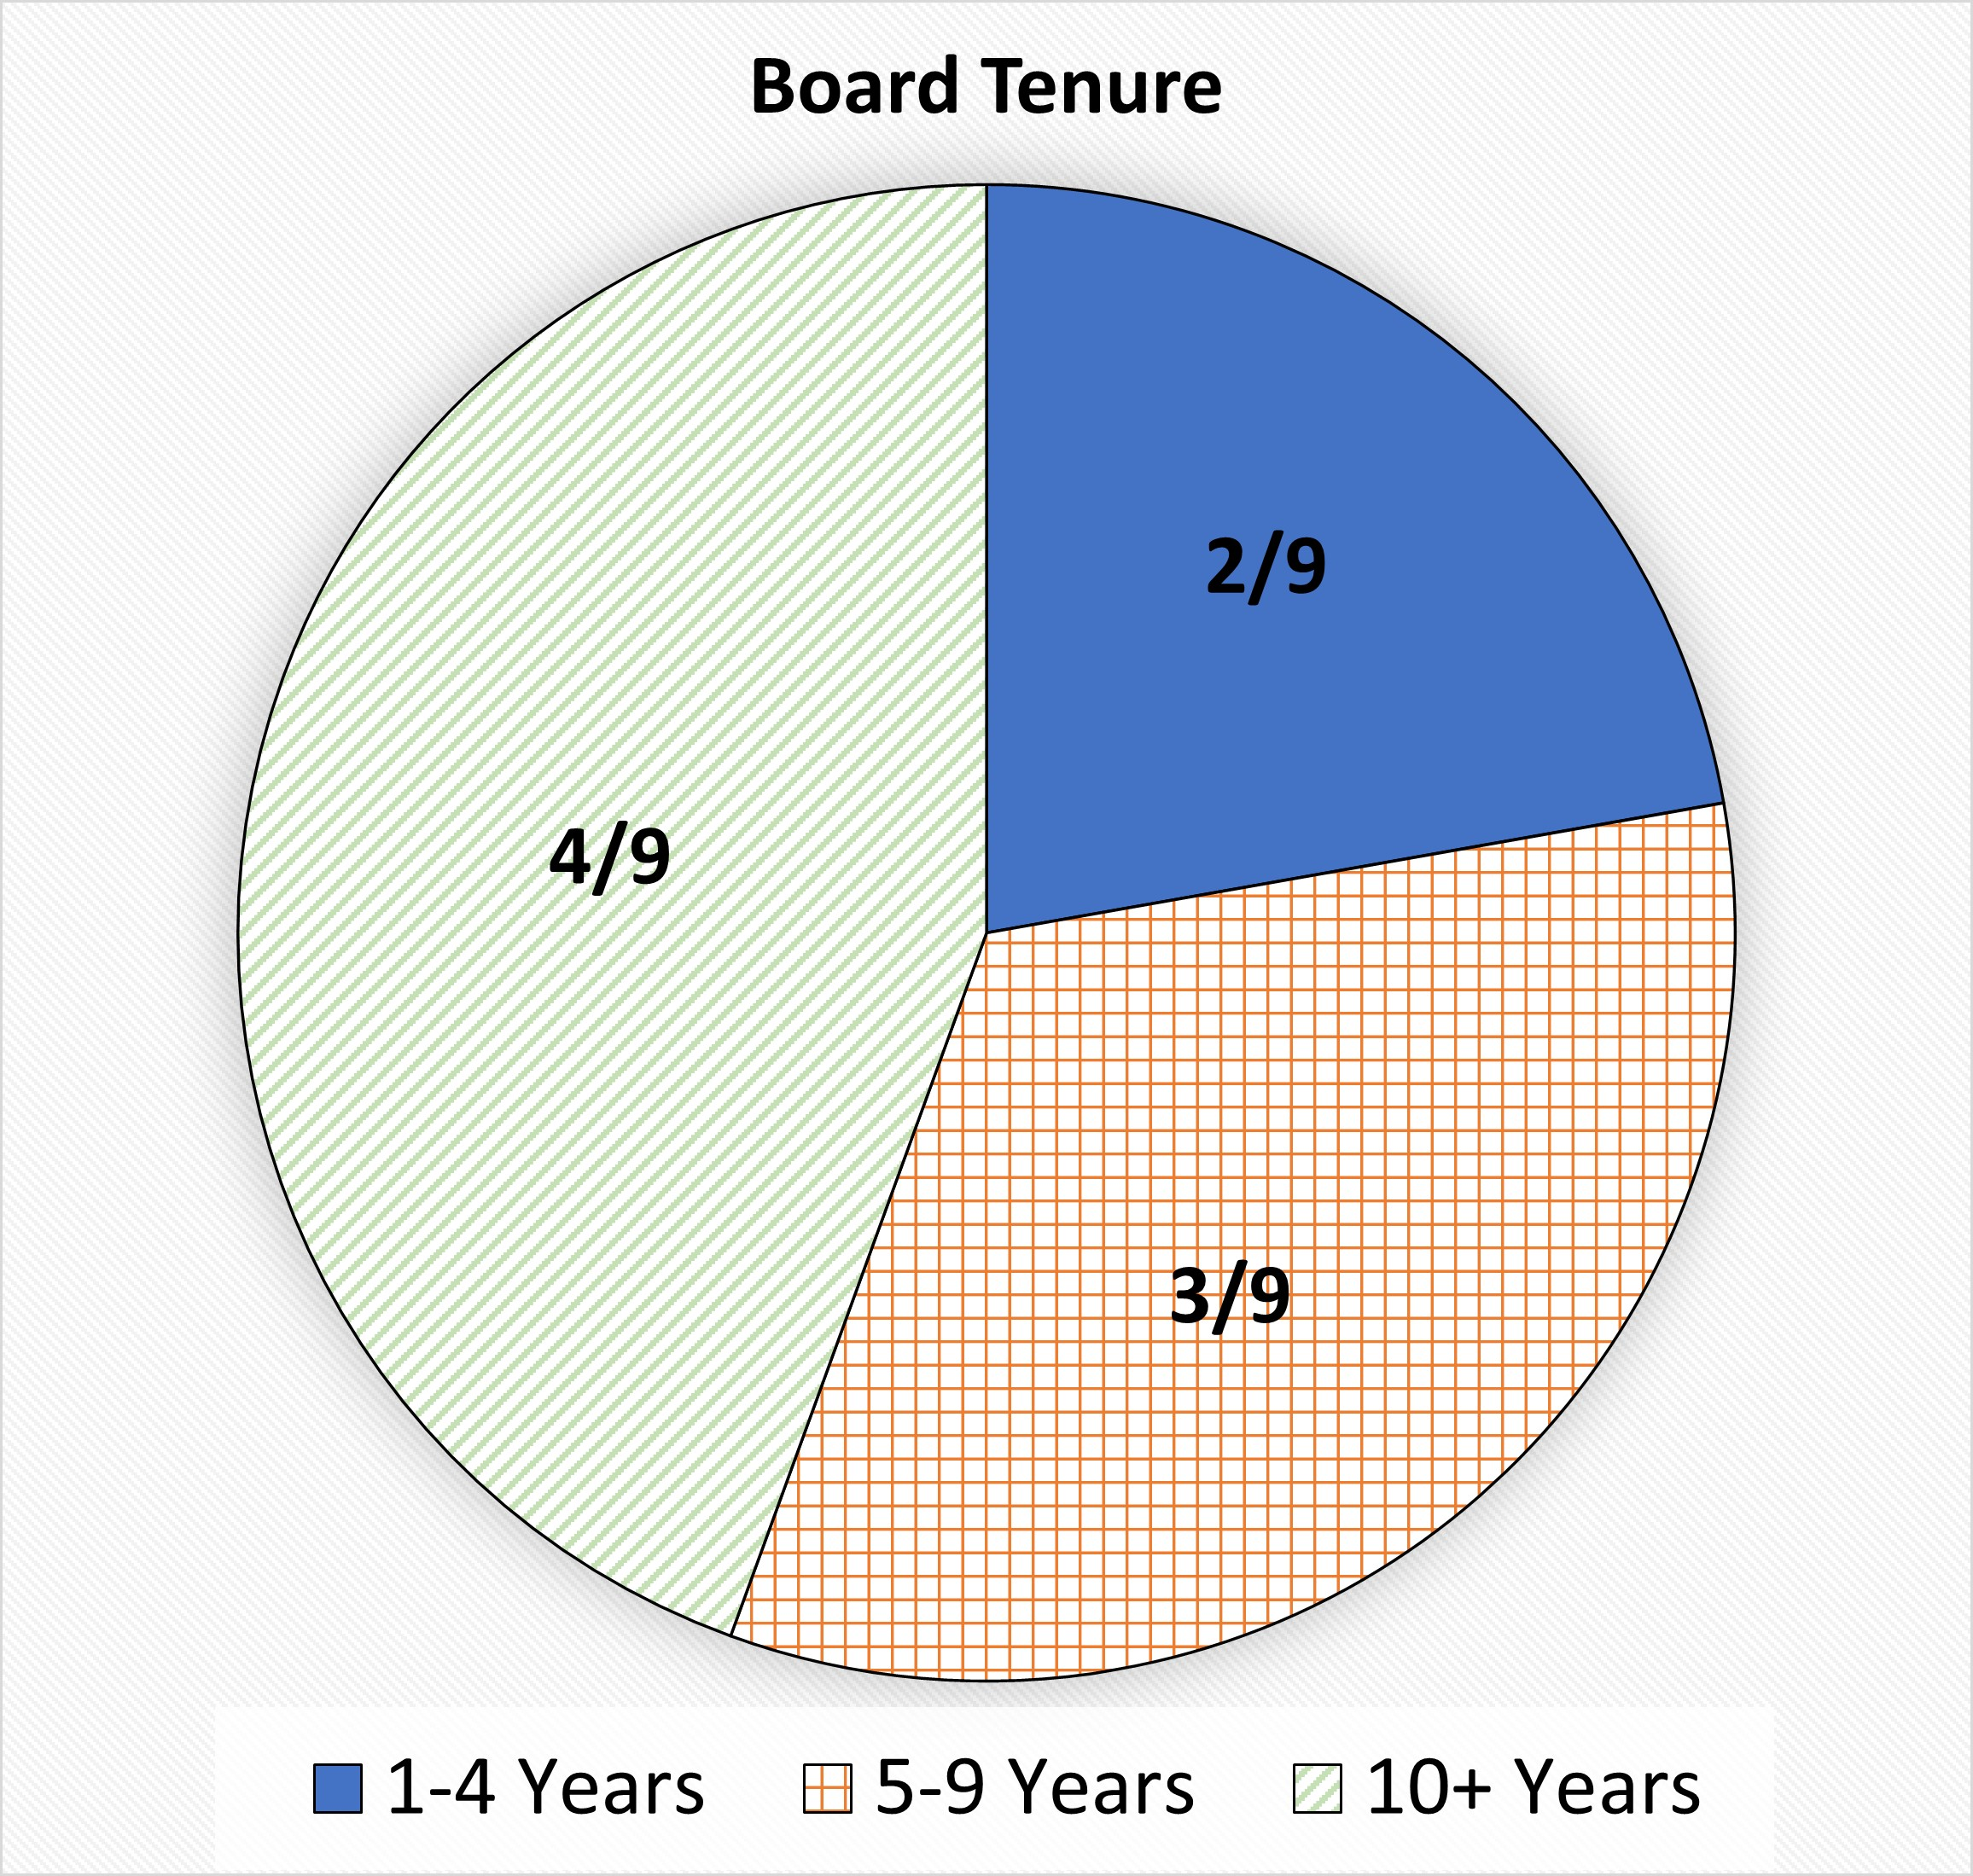

11
The Company also has a strong history of gender diversity at all levels of its teammates with women comprising approximately 36% of all salaried staff; 43% of all staff who are director level and above; and 33% of our executive officers.

Governance & Compliance
In the area of corporate Governance and Compliance, we take pride in our culture that emphasizes high moral and ethical values and conducting business with honesty, integrity, and a passion for excellence. The first “E” in “WE CARE” stands for Ethics, and the Company believes in the importance of reinforcing our ethical policies and procedures with the “tone from the top.” The Company has adopted policies and procedures, including, among others, a Code of Ethics and Business Conduct (which was updated in 2020), a Whistleblower Response Policy, a Human Rights Policy modeled after suggestions from the United Nations, and a Supplier Code of Conduct. Our compliance training emphasizes the necessity of whistleblower procedures, protection, and zero tolerance for retaliation. This training is given within the first few months of hire to new teammates with sales and/or leadership roles who interact with customers and/or teammates outside the U.S. Additionally, compliance training is repeated annually at our Global Sales Meeting for all attending teammates; including sales teams across the globe, as well as all Oil-Dri leadership personnel and other teammates in roles that support sales. We continue to provide clear messaging supporting the need for compliance and ethics in the executive and leadership levels. Our CEO has been recognized for his focus on ethical leadership and is asked to speak on this topic at local business schools, including the Kellogg School of Management at Northwestern University and Marquette University.
Additionally, under the direction of the Compliance Director, the Company’s compliance program ensures adherence to the highest ethical standards and regulatory requirements, including but not limited to the Foreign Corrupt Practices Act (FCPA), the Company’s Code of Ethics and Business Conduct, Whistleblower Protection, and other applicable public company standards.

As part of the Company’s corruption risk mitigation, we perform mandatory and thorough third-party due diligence processes on high risk third parties, including international distributors and agents. These third parties are also required to attest to the Company’s anti-corruption regulatory compliance contract language before business can commence. As part of the focus on addressing potential risks and ensuring a global understanding of the various applicable policies and requirements, we have also translated our Code of Ethics and Business Conduct and our Supplier Code of Conduct into French, Mandarin and Spanish. Our Board of Directors also annually attests to our Code of Ethics and Business Conduct.
The Company works with a third-party anonymous whistleblower hotline available on our website where teammates and third parties across the globe can reach out via phone or internet with any concerns they may have and be ensured of anonymity in reporting if they so desire. The Company has documented and implemented procedures to ensure the protection of whistleblowers’ employment status as well as protection from harassment in the workplace. Our anti-corruption training emphasizes the necessity of whistleblower procedures, protection, and zero tolerance for retaliation.
Additionally, as part of the Company’s commitment to operating under sound corporate governance practices, the Board has a Nominating Committee, which is chaired by independent director, Ellen-Blair Chube, and which is responsible for assisting in and overseeing the process of recruiting and identifying candidates for nomination as directors. See also “Corporate Governance Matters—Corporate Governance Guidelines and Code of Ethics” for a further discussion of the Company’s corporate governance practices.
12
The Board has also been focused on maintaining a refreshed Board and regularly bringing in new viewpoints. As a result of such ongoing Board refreshment, the Company has added two new directors to the Board since 2021, providing for fresh perspectives along with continuity in the Board’s composition. Most recently, as part of the Board’s commitment to maintaining a refreshed Board, as well as to further the Company’s cyber security initiatives, the Board appointed Patricia J. Schmeda, an accomplished information technology executive, as a director.
As described further in this Proxy Statement, we take pride in being a company that emphasizes high moral and ethical values and conducts business with honesty, integrity and a passion for excellence and we have a long history of operating under sound corporate governance practices. Please see the discussion of those practices under “CORPORATE GOVERNANCE MATTERS—Corporate Governance Guidelines and Code of Ethics.”

13
PROPOSALS

Proposal 1 - Election of Directors
Our Board currently consists of nine members, each of whose term of office expires at the 2024 Annual Meeting: Ellen-Blair Chube, Paul M. Hindsley, Daniel S. Jaffee, Michael A. Nemeroff, George C. Roeth, Amy L. Ryan, Patricia J. Schmeda, Allan H. Selig and Lawrence E. Washow.

The Company proposes that the following nine individuals be elected to our Board. Each nominee currently serves as a director. If any nominee should be unable or unwilling to serve, which is not now contemplated, the proxy holders may, but will not be bound to, vote for a substitute nominee.

THE BOARD RECOMMENDS A VOTE “FOR”
THE ELECTION OF THE FOLLOWING NOMINEES AS DIRECTORS.

 |  |  | Daniel S. Jaffee |  |  | Age 60 |  |  | Director since 1992
Chairman of the Board of Directors and
President and Chief Executive Officer of the Company
 |  |  | Mr. Jaffee graduated from Georgetown University in 1986. Mr. Jaffee joined the Company in 1987 after a year with the accounting firm now known as PricewaterhouseCoopers LLP. He was a product manager in the Industrial and Agricultural divisions of the Company until 1989. In 1990, he became Chief Financial Officer of the Company, a position he held until 1995. From 1990 to 1995, he also held group vice presidential positions in the areas of Canadian and domestic operations, finance, management, information systems and
consumer products. He was Chief Operating Officer from 1995 to 1997. Mr. Jaffee became President in 1995, Chief Executive Officer in 1997 and Chairman of the Board of Directors in 2018. Mr. Jaffee received an M.B.A. from the Kellogg Graduate School of Management of Northwestern University in 2004. Mr. Jaffee’s civic activities include serving as a member of the Board of Directors of the Anti-Cruelty Society of Chicago and as a Trustee of the Chicago History Museum.

Mr. Jaffee’s individual qualifications include extensive strategic Company and sorbent minerals industry experience gained through his long service to the Company in various operational, management and executive positions. His deep knowledge of the sorbent minerals industry is augmented by the special perspective he brings to the Board as a third-generation family stockholder. In addition, his previous experience on the Board of Directors of Elkay Manufacturing Company and his active involvement in the local community in advisory roles for several not-for-profit organizations add to his perspective on effective management and strategy for the long-term success of the Company.

14
 |  |  | Lawrence E. Washow |  |  | Age 71 |  |  | Director since 2013
Vice Chairman of the Board of the Company
Chairman, Aspire Brands, Inc.
Board Member, Turn Technologies, Inc.
 |  |  | Mr. Washow received a bachelor’s degree from Miami University in Oxford, Ohio and earned a Master of Business Administration from the Kellogg Graduate School of Management of Northwestern University. Mr. Washow began his career at American Colloid Company (which subsequently became a subsidiary of AMCOL International
Corporation (“AMCOL”), now Mineral Technologies Inc.) Mr. Washow became President and Chief Executive Officer of AMCOL in 2000 and served in these positions and as a director of AMCOL until 2010. He became Vice Chairman of the Oil-Dri Board of Directors in October 2020. He serves as a board member of Aspire Brands, Inc., and a board member of Turn Technologies, Inc. In addition, he is a private investor and advisor for a number of early-stage companies.

Mr. Washow’s individual qualifications include his extensive global experience in minerals, mining, manufacturing and distribution. Mr. Washow is an “audit committee financial expert” within the meaning of SEC rules and brings to the Board his strong business acumen and broad experience in management, operations, public company governance and compliance obtained through the leadership positions that he has held with public corporations, including president, chief executive officer and board member.
 |  |  | George C. Roeth |  |  | Age 63 |  |  | Director since 2016
 |  |  | Lead Director of the Board of the Company
 |  |  | Mr. Roeth received a Bachelor of Science in Business Administration from the University of California at Berkeley in 1983 and earned a Master of Business Administration from the Kellogg Graduate School of Management of Northwestern University in 1987. From 1987 to 2014, Mr. Roeth held various positions at The Clorox Company (“Clorox”). Most recently, from 2013 to 2014, he served as Chief Operating Officer of Lifestyle, Household and Global Operating Functions of Clorox. Previously, he served as Senior Vice President
and General Manager, during which time he was also Chairman of the Board for the Clorox and Procter & Gamble Glad Products Joint Venture. Prior to that, Mr. Roeth served in several senior-level marketing and operations roles at Clorox, including Senior Vice President and General Manager, Vice President of Growth and Marketing, and Vice President of Brand Development, among others. In 2015, Mr. Roeth joined the Board of Directors of Central Garden & Pet Company (“Central Garden & Pet”) and served as President and Chief Executive Officer of Central Garden & Pet from June 2016 until his retirement on September 28, 2019. Mr. Roeth was appointed as Lead Director of the Oil-Dri Board of Directors in April 2019. Mr. Roeth also served as a Board Member for GP Act III Acquisition Corp. from February 2021 until December 2023. He currently serves as a Trustee of the Committee for Economic Development as part of The Conference Board and also serves on the Executive Advisory Board for Gryphon Investors.

Mr. Roeth’s individual qualifications include his proven track record of delivering profitable growth in challenging and highly competitive business environments and his success in simultaneously driving global sales, lowering costs and improving customer satisfaction during his tenure at Clorox and Central Garden & Pet. He also brings to the Board his extensive experience in, and his comprehensive understanding of, the consumer products industry.
15
 |  |  | Ellen-Blair Chube |  |  | Age 43 |  |  | Director since 2018
 |  |  | Former Managing Director & Client Service Officer, William Blair & Company
 |  |  | Ms. Chube graduated from Northwestern University in 2002 with a Bachelor of Arts in political science and earned a Juris Doctorate degree from Georgetown University in 2005. Ms. Chube began her career in public service working for Congressman Harold Ford Jr. as a senior advisor in the House of Representatives, as well as on the 2006 Senate campaign. Following her time with Congressman Ford, Ms. Chube became an associate in the government affairs practice of Brownstein Hyatt Farber Schreck, LLP. In 2009, Ms. Chube
became the Staff Director for the Senate Banking Subcommittee on Security, International Trade and Finance. In this role, she was responsible for financial services and economic policy for former Senator Evan Bayh, including his legislative priorities in the Dodd-Frank financial regulatory reform bill enacted in July 2010. In 2011, Ms. Chube became the Vice President and Chief of Staff to John W. Rogers Jr., Chairman and CEO of Ariel Investments. After four years at Ariel Investments, Ms. Chube served as a Partner, the Managing Director and Client Service Officer at William Blair & Company through 2023. She also serves as a member of the Board of Trustees and the Nominating and Corporate Governance Committee and Audit Committee of Equity Commonwealth (NYSE: EQC). Ms. Chube’s civic activities include serving as the Chair of the Board of Directors of Uniting Voices Chicago and as a Trustee of the Museum of Contemporary Art in Chicago.

Ms. Chube’s individual qualifications include her expertise and commitment to delivering exceptional client service worldwide as well as her wealth of business and financial services knowledge she has acquired throughout her time at William Blair, Ariel Investments and her notable public service career. In addition, Ms. Chube brings to the Board finance, regulatory, audit committee and human resources committee experience.

 |  |  | Paul M. Hindsley |  |  | Age 65 |  |  | Director since 2019
 |  |  | Senior Director, Investment Banking, William Blair & Company
 |  |  | Mr. Hindsley received a bachelor’s degree in Management Science from Duke University in 1981 and earned a Master of Management from the Kellogg Graduate School of Management of Northwestern University in 1986. He began his career at Harris Trust and Savings Bank and served as Vice President, Commercial Banking from 1981 to 1989. From 1989 to 1997, Mr. Hindsley was Director of Investment Banking at BMO Capital
Markets. He joined William Blair & Company in 1997 and is currently Senior Director of Investment Banking, specializing in mergers and acquisitions and equity and debt financing transactions.

Mr. Hindsley’s individual qualifications include his financial expertise and extensive experience in public and private mergers and acquisitions and equity and debt financing transactions, having closed over 300 transactions for a wide range of consumer and industrial focused clients. From his experience, he brings to the Board a strong financial perspective on the consumer products and packaging industries. In addition, Mr. Hindsley is an “audit committee financial expert” within the meaning of SEC rules.

16
 |  |  | Michael A. Nemeroff |  |  | Age 61 |  |  | Director since 2006
 |  |  | President and Chief Executive Officer, Vedder Price P.C.
 |  |  | Mr. Nemeroff received a bachelor’s degree from the State University of New York at Binghamton in 1985 and earned a J.D. from George Washington University in 1988. He joined the law firm of Vedder Price P.C. (“Vedder Price”) in 1988 and has been the Chairman of the firm’s Finance & Transaction Group and an equity shareholder since 1995. Since 1998, he has served on the firm’s Board of Directors. Since 2005, Mr. Nemeroff has served as President and CEO of Vedder Price and a member of the Executive Committee of the firm’s Board of Directors. Vedder Price regularly provides services to the Company.
Mr. Nemeroff serves on the Executive Advisory Board of The Edgewater Funds, a Chicago based private equity firm. He also serves as an Executive Committee and Board of Directors member of Uniting Voices Chicago, a not-for-profit organization making a difference in the lives of children through musical excellence, and Executive Committee Chair of The Wallis Annenberg Center for the Performing Arts in Beverly Hills, CA.

Mr. Nemeroff’s individual qualifications include his expertise as a corporate and transactional attorney advising clients on corporate governance, mergers and acquisitions and executive compensation as well as the financial underpinnings of these complex practice areas. In addition, Mr. Nemeroff brings to the Board risk management, finance and business operations experience gained in the various management positions he has held at Vedder Price, including the position of President and Chief Executive Officer of that international law firm.
 |  |  | Amy L. Ryan |  |  | Age 45 |  |  | Director since 2021
 |  |  | Founder and Chief Circular Economist, ESGStrategies
 |  |  | Ms. Amy Ryan graduated from the University at Albany in 2003 with a Bachelor of Science in Earth and Atmospheric Science and earned a Master’s degree in Business Management from Harvard University in 2020. Ms. Ryan began her 20-year career in Environmental, Social, and Governance (“ESG”) through risk management and environmental, health and safety (“EHS”) compliance roles. From 2004-2018, Ms. Ryan held various environmental management positions within large consulting firms, such
as ERM and WSP (formerly The Louis Berger Group), in addition to Corporate EHS and operational excellence roles at Aramark Corporation. For over a decade, Ms. Ryan led industry agnostic operational risk assessments and audits gaining valuable hands-on experience as well as operational insight within a diverse range of industries, including mining & extractives, industrial manufacturing, and government. She is a Certified Environmental Auditor and Registered Environmental Manager, and from 2018-2020, she supported facilities compliance roles within the pharmaceutical and research industries. Ms. Ryan currently is the Founder and Chief Circular Economist of ESGStrategies, a business consultancy dedicated to the creation of business growth strategies and development of operational frameworks to implementing ESG solutions from within. Ms. Ryan is also an adjunct professor at the University of Albany’s School of Business. Ms. Ryan serves as Vice-Chairwoman of the EU’s Circular Economy Alliance Strategic Foresight Board, and as a Director on several executive boards including Harvard Alumni Association Disaster and Preparedness Response Teams, LifeWorks Community Action of Saratoga County, and Capital District YMCA’s Camp Chingachgook in New York. She is also a guest lecturer at Harvard University, Hult International Business Schools, and the International Business School of Americas.

Ms. Ryan brings to the Board strong qualifications on circular economics and ESG principles. In addition, Ms. Ryan has significant experience in corporate risk management, compliance assessment, and strategic solution development for corporations, government, and academic institutions.
17
 |  |  | Patricia J. Schmeda |  |  | Age 58 |  |  | Director since 2023
 |  |  | Global Chief Information Officer, Wahl Clipper Corporation
 |  |  | Ms. Schmeda graduated from University of Illinois Chicago with a Bachelor of Arts in Economics in 1990 and earned a Master of Business Administration in Operations and Logistics from Benedictine University in Lisle, Illinois in 2006. In 1991, Ms. Schmeda began her career in Information Technology and held many roles of increasing responsibility within the discipline at both Stenograph L.L.C. and TCF Bank. In 1999, Ms.
Schmeda joined A. M. Castle & Co where she assumed many leadership positions over an 11-year period, culminating in Vice President of Information Technology & Chief Information Officer. From 2010-2022, Ms. Schmeda was Chief Information Officer & Vice President of Information Technology at Elkay Manufacturing Company. Ms. Schmeda currently serves as Global Chief Information Officer at Wahl Clipper Corporation where she leads all strategies and efforts related to information technology focused on enterprise solutions, business intelligence, and cybersecurity framework. Ms. Schmeda is a member of the CIO Professional Network, an executive volunteer for i.c. stars, and a volunteer mentor at WOMEN Unlimited, Inc.

Ms. Schmeda brings to the Board strong qualifications in information technology, digital transformations, enterprise project management and cybersecurity governance.
 |  |  | Allan H. Selig |  |  | Age 90 |  |  | Director since 1969
Commissioner Emeritus of Major League Baseball
President and Chairman of the Board, Selig Leasing Company Inc.
President, AHS Investments, LLC
 |  |  | Commissioner Emeritus Selig received a bachelor’s degree from the University of Wisconsin in 1956. After two years in the United States Army, he joined Selig Ford, Inc. He served as President of Selig Ford (which became Selig Chevrolet in 1982) from 1959 until 1990. Since 1970, he has served as Chairman of the Board and President of Selig Leasing Company Inc. He became President and Chief Executive Officer of the Milwaukee
Brewers Baseball Club, Inc. in 1970 and served in that capacity until 1998, when he was elected to the position of Commissioner of Major League Baseball (“MLB”). He also served as Chairman of the Executive Council of MLB from 1992 to 1998. He now holds the position of Commissioner Emeritus of MLB following his retirement as Commissioner in January of 2015. He is a director of Marcus Corporation and a director emeritus of the Green Bay Packers, Inc. In addition, he is a director of the Greater Milwaukee Committee, the Milwaukee Club, the University of Wisconsin Foundation and Ixonia Bancshares, Inc. and a trustee of the Boys and Girls Clubs of Greater Milwaukee. He is a founder and vice chairman of Athletes for Youth and co-founder of the Child Abuse Prevention Fund. Mr. Selig was inducted into the Baseball Hall of Fame on July 30, 2017 in Cooperstown, NY. Commissioner Emeritus Selig’s individual qualifications include sound judgment, integrity and business management skills gained through his management of several businesses, including his long tenure in his positions as MLB Commissioner, as Chief Executive Officer of the Milwaukee Brewers Baseball Club and as President and Chairman of his family’s automobile businesses. His unique ability to manage by consensus brought change and growth in baseball despite economic and political challenges both inside and outside of baseball. In addition, he is a community leader and an active advisor to several philanthropic organizations.

18
Proposal 2 - Ratification of Appointment of Independent Auditor
The Audit Committee is directly responsible for the selection, appointment, evaluation and oversight of the independent auditor retained to audit the Company’s financial statements. The Audit Committee annually reviews its independent registered public accounting firm's performance and independence from management.
The Audit Committee of the Board appointed Grant Thornton as the Company’s independent auditor for fiscal 2025 at its meeting on October 8, 2024 and has further directed that we submit the appointment of the independent auditor for ratification by the stockholders at the 2024 Annual Meeting. Grant Thornton audited the Company’s consolidated financial statements for the fiscal year ended July 31, 2024. A representative of Grant Thornton is expected to be present at the 2024 Annual Meeting and will have an opportunity to make a statement if he or she so desires and will be available to respond to appropriate questions.
Stockholder ratification of the appointment of Grant Thornton as the Company’s independent auditor is not required by the Company’s By-Laws or otherwise; however, our Board is submitting the appointment of Grant Thornton to stockholders for ratification as a matter of responsible corporate practice. If the stockholders fail to ratify the appointment, our Audit Committee will reconsider whether to retain that firm. Even if the appointment is ratified, our Audit Committee in its discretion may direct the appointment of a different independent auditor at any time during the year if our Audit Committee determines that such a change would be in the best interests of the Company and its stockholders.
THE BOARD RECOMMENDS A VOTE “FOR” RATIFICATION OF THE
APPOINTMENT OF GRANT THORNTON LLP AS INDEPENDENT AUDITOR.
Other Matters Relating to the Independent Auditor
Auditor Fees
The following table shows the aggregate fees for professional services rendered by Grant Thornton for the audit of the Company’s annual financial statements for the years ended July 31, 2024 (“fiscal 2024”) and July 31, 2023 (“fiscal 2023”), and fees billed during those periods for other services rendered by Grant Thornton.
Type of Fees |  |  |  |  |  | 2023 |  |  |  |  |  | 2024
Audit fees (1) |  |  |  |  |  | $799,395 |  |  |  |  |  | $872,932
Audit-related fees (2) |  |  |  |  |  | $3,200 |  |  |  |  |  | $0
Tax fees (3) |  |  |  |  |  | $0 |  |  |  |  |  | $0
All other fees (4) |  |  |  |  |  | $0 |  |  |  |  |  | $0
Total |  |  |  |  |  | $802,595 |  |  |  |  |  | $872,932

(1) Audit fees consist of fees for audit services provided in connection with the audit of our annual financial statements and review of our quarterly financial statements and audit services provided in connection with other statutory or regulatory filings. Audit fees for fiscal 2023 reflect fees invoiced by Grant Thornton, after the completion of fiscal 2023, for services related to such fiscal year.
(2) Audit-related fees consist of assurance and related services reasonably related to the performance of the audit or review of our financial statements that are not reported under the heading Audit fees above. Audit-related fees for
19
fiscal 2023 reflect fees invoiced by Grant Thornton, after the completion of fiscal 2023, for services related to such fiscal year.
(3) Tax fees consist of fees for tax compliance and statutory filing preparation (“tax compliance”) and fees for tax planning and advice, both international and domestic (“tax planning”).
(4) This category consists of fees for other miscellaneous items.
Pre-Approval of Independent Auditor Services
No services specifically prohibited by the Sarbanes-Oxley Act of 2002 will be provided to the Company by the independent auditor. The Audit Committee has adopted a policy that requires the Audit Committee or a member of the Audit Committee to pre-approve all engagements with the Company’s independent auditor. These services include audit services, audit-related services and tax services. In addition, under the terms of its pre-approval policy, the Audit Committee will approve, if necessary, any changes in terms, conditions and fees resulting from changes in audit scope, Company structure or other matters. In accordance with its pre-approval policy, the Audit Committee or its chair pre-approved the engagement of the independent auditor for fiscal 2024 and also pre-approved services to be performed by the independent auditor during fiscal 2024, with certain changes in fees subsequently approved by the Audit Committee.

Proposal 3 - Approval of an Amendment to the Certificate of Incorporation to Increase the Number of Authorized Shares of Common Stock
We are asking stockholders to approve an amendment to our Certificate of Incorporation, as amended (the “Charter”), to increase the number of authorized shares of Common Stock, par value $0.10 per share, from 15 million to 30 million (the “Share Increase Proposal”) to implement a stock split of our Common Stock and Class B Stock in the form of a stock dividend as further described below. The Board has determined that the Charter amendment is advisable and in the best interests of the Company and its stockholders and has approved the Share Increase Proposal, subject to stockholder approval.
The Share Increase Proposal would amend Article Fourth, Section A of the Charter as follows (additions are shown as double underlined and deletions are shown as struck through):

A. AUTHORIZED CAPITAL STOCK

The total number of shares of all classes of capital stock which the Corporation shall have authority to issue is fifty-two million (52,000,000) sixty seven million (67,000,000) shares, consisting of fifteen million (15,000,000) thirty million (30,000,000) shares of Common Stock, par value $.10 per share (the "Common Stock"), thirty million (30,000,000) shares of Class A Common Stock, par value $.10 per share (the "Class A Common Stock") and seven million (7,000,000) shares of Class B Stock, par value $.10 per share (the "Class B Stock").

The above summary is qualified in its entirety by reference to the full text of the Certificate of Amendment to the Charter (the “Certificate of Amendment”), a form of which is attached to this proxy statement as Appendix A.

The primary purpose of increasing the number of authorized shares of our Common Stock is to facilitate our previously announced two-for-one stock split (the “Stock Split”) in the form of a one-time special stock dividend. On October 9, 2024, our Board approved the Stock Split, subject to and contingent
20
upon stockholder approval and the effectiveness of the Certificate of Amendment to our Charter. As of the close of business on October 14, 2024, there were 5,134,478 shares of Common Stock and 2,155,407 shares of Class B Stock outstanding, approximately 633,734 shares of Common Stock and Class B Stock reserved and available for issuance under the Long Term Incentive Plan, and 2,155,407 shares of Common Stock reserved for issuance in the event of conversions of the Class B Stock. Class B Stock is convertible by the holders thereof on a share-by-share basis into Common Stock at any time, and is subject to mandatory conversion under certain circumstances. This leaves approximately 7,076,381 shares of Common Stock remaining available for issuance, which number is not sufficient to effectuate the Stock Split.

The Share Increase Proposal would increase the number of authorized shares of Common Stock from 15 million to 30 million. The additional 15 million shares would be a part of the existing class of Common Stock and, if and when issued, would have rights identical to currently outstanding shares of Common Stock of the Company. The Share Increase Proposal will not increase or otherwise amend the number of authorized shares of Class A Common Stock, none of which is outstanding, or the authorized shares of Class B Stock.

The Board believes the Stock Split is in the best interests of the Company. The trading price of our Common Stock has risen significantly over the past couple of years. We believe the Stock Split would help reset the market price of the Common Stock, which would give employees and investors more flexibility in managing their shares and make our Common Stock more accessible to a broader range of potential investors.

If the Share Increase Proposal is approved and the Stock Split implemented, each stockholder of record at the close of business on December 20, 2024 (the “Stock Split Record Date”) will receive on January 3, 2024, the anticipated distribution date for the Stock Split (the “Distribution Date”), one additional share of Common Stock for each share of Common Stock held by such stockholder and one additional share of Class B Stock for each share of Class B Stock held by such stockholder as of the Stock Split Record Date. All shares issued in connection with the Stock Split will be issued in book-entry form, either through the Direct Registration System (“DRS”) or as a credit to an existing account of a stockholder of record.

In connection with the Stock Split, and pursuant to the anti-dilution adjustment provisions in Company’s Long Term Incentive Plan, proportionate adjustments will be made to the number of shares that remain available for issuance pursuant to the Long Term Incentive Plan, as well as to the outstanding awards under the Long Term Incentive Plan. Specifically, the number of shares that remain available for issuance pursuant to the Long Term Incentive Plan as well as the limit on the number of shares that may be granted annually to any participant set forth in the Long Term Incentive Plan will double and the number of shares subject to outstanding awards under the Long Term Incentive Plan will also double.

Future issuances of shares of Common Stock could have a dilutive effect on the shareholdings of current stockholders. In addition, the availability of additional shares of Common Stock for issuance could, under certain circumstances, discourage or make more difficult any efforts to obtain control of the Company. We do not believe, however, that the Share Increase Proposal and Stock Split would have an anti-takeover effect, and we have not proposed the increase in the authorized number of shares of Common Stock with the intention of using the additional shares for anti-takeover purposes.

21
If stockholders approve the Share Increase Proposal at the annual meeting, we intend to file the Certificate of Amendment with the Delaware Secretary of State following the 2024 Annual Meeting, at which time the increase in the number of authorized shares of Common Stock would become effective.

If the Board proceeds with the Stock Split, stockholders of record as of the Stock Split Record Date will receive one additional share of Common Stock for each share of Common Stock held and one additional share of Class B Stock for each share of Class B Stock held, which would be expected to be distributed after market close on the Distribution Date. The Company’s Common Stock would be expected to begin trading on a post-split basis at the market open on the first trading day after the Distribution Date, currently expected to be January 6, 2024.

The Board reserves the right, notwithstanding stockholder approval of the Share Increase Proposal and without further action by the stockholders, to elect not to proceed with the Stock Split if the Board determines that the Stock Split is no longer in the best interests of the Company and its stockholders. In such event, the Share Increase Proposal will not be implemented and the Certificate of Amendment will not be filed with the Delaware Secretary of State or, if filed, rescinded.

For the foregoing reasons, our Board believes that approving the Share Increase Proposal would be in the best interests of the Company and its stockholders.

THE BOARD RECOMMENDS A VOTE “FOR” THE APPROVAL OF THE AMENDMENT TO THE CERTIFICATE OF INCORPORATION TO INCREASE THE NUMBER OF AUTHORIZED SHARES OF COMMON STOCK.

Proposal 4 - Other Matters for the Annual Meeting
At this time, our Board is not aware of any matters not referred to herein that might be presented for action at the 2024 Annual Meeting; however, if any other business should properly come before the meeting, votes may be cast in respect to such matters in accordance with the best judgment of the person or persons acting under the proxies.

CORPORATE GOVERNANCE MATTERS

Controlled Company Status
Our Board has determined that the Company is a “controlled company” within the meaning of the NYSE Corporate Governance Standards. This determination is based on the fact that Class B Stock having more than 50% of the aggregate voting power of our Common Stock and Class B Stock is owned by Daniel S. Jaffee and the Jaffee Investment Partnership, L.P., a Delaware limited partnership of which Daniel S. Jaffee is a general partner. The remaining three general partners of the Jaffee Investment Partnership, L.P. are all siblings of Daniel S. Jaffee. Daniel S. Jaffee has 11 of the 20 total votes of the general partners.
As a “controlled company” we are entitled to rely on exemptions from the NYSE Corporate Governance Standards that would otherwise require the Company to: (a) have a board of directors the majority of which is comprised of independent directors; (b) have a nominating and governance committee comprised entirely of independent directors with a written charter addressing the committee’s purpose and responsibilities; and (c) have a compensation committee comprised entirely of independent
22
directors with a written charter addressing the committee’s purpose and responsibilities. From time to time in the past, we have elected to rely on all of these exemptions. Currently, a majority of our Board is comprised of independent directors, so we are only relying on exemptions (b) and (c) above.

Director Independence
Our Board has determined that the directors listed below are independent from our management within the meaning of the NYSE Corporate Governance Standards:

Ellen-Blair Chube |  |  | Patricia J. Schmeda
Paul M. Hindsley |  |  | Allan H. Selig
George C. Roeth |  |  | Lawrence E. Washow
Amy L. Ryan

While our Board has not adopted any categorical standards for independence, in making these determinations the Board noted that none of Ms. Chube, Ms. Ryan, Ms. Schmeda and Messrs. Hindsley, Roeth, Selig and Washow:
(a)receives direct compensation from the Company other than director annual retainers and meeting fees (and expense reimbursement), and from time to time equity awards;
(b)has any relationship with the Company or a third party that would preclude independence under the NYSE Corporate Governance Standards; or
(c)has any other material relationship with the Company and its management.
In the last three years, we have not made any contributions in excess of $1 million or 2% of our consolidated gross revenues to any tax-exempt organization in which an independent director serves as an executive officer.

Executive Sessions of Non-Management Directors
Non-management directors meet in executive sessions of our Board in which Mr. Jaffee, a management director, and other members of management do not participate. These sessions are scheduled for non-management directors at all regular meetings of our Board. Under our Corporate Governance Guidelines, an independent lead director (the “Lead Director”) (or in the event there is no Lead Director, the director serving as Chair of our Audit Committee) presides at all executive sessions of non-management and independent directors unless otherwise determined by the directors attending any given executive session.

23
Board of Directors Committee Membership and Meetings
The following table sets forth the current membership of the committees of our Board.
Name |  |  |  |  |  | Audit |  |  |  |  |  | Compensation |  |  |  |  |  | Nominating |  |  |  |  |  | Retirement Plans |  |  |  |  |  | Executive
Ellen-Blair Chube |  |  |  |  |  |  |  |  |  |  |  | X* |  |  |  |  |  | X*
Paul M. Hindsley |  |  |  |  |  | X |  |  |  |  |  |  |  |  |  |  |  | X
Daniel S. Jaffee |  |  |  |  |  |  |  |  |  |  |  |  |  |  |  |  |  |  |  |  |  |  |  | X* |  |  |  |  |  | X*
Michael A. Nemeroff |  |  |  |  |  |  |  |  |  |  |  | X
George C. Roeth |  |  |  |  |  |  |  |  |  |  |  |  |  |  |  |  |  |  |  |  |  |  |  |  |  |  |  |  |  | X
Amy L. Ryan |  |  |  |  |  |  |  |  |  |  |  |  |  |  |  |  |  | X
Patricia J. Schmeda |  |  |  |  |  | X
Allan H. Selig |  |  |  |  |  |  |  |  |  |  |  | X
Lawrence E. Washow |  |  |  |  |  | X* |  |  |  |  |  |  |  |  |  |  |  | X |  |  |  |  |  |  |  |  |  |  |  | X
Number of Meetings in Fiscal 2024 |  |  |  |  |  | 4 |  |  |  |  |  | 2 |  |  |  |  |  | — |  |  |  |  |  | — |  |  |  |  |  | —
* Chair
During fiscal 2024, our Board held four meetings. All directors attended 100% of the aggregate total number of meetings of our Board and the committees on which he or she served. The Board may, from time to time, establish other committees on a temporary or standing basis to conduct varying duties and services on behalf of the Board.
Audit Committee
The Audit Committee Charter sets out the duties and responsibilities of our Audit Committee. Those duties include, without limitation:
•selection and appointment of the independent auditor, review of its independence and of other services provided by it, and of the fees and other arrangements regarding its services;
•review with the independent auditor and management of the scope of the audit, and of significant financial reporting issues and judgments;
•review with the independent auditor and management of the annual audited financial statements and of the quarterly financial statements and press releases;
•review with the independent auditor and management of the quality and adequacy of internal controls;
•preparation of the report required by SEC rules to be included in this Proxy Statement;
•establish and oversee procedures for the receipt, retention and treatment of complaints received by the Company regarding accounting, internal accounting controls or auditing matters and the confidential, anonymous submission by Company employees of concerns regarding questionable accounting or auditing matters;
24
•review and discuss with management and the internal audit department the risks faced by the Company and the policies, guidelines and process by which management assesses and manages the Company's risks, including the Company's major financial risk exposures and the steps management has taken to monitor and control such exposures;
•review the Company's compliance with applicable laws and regulations and to review and oversee the Company's policies, procedures and programs designed to promote and monitor legal, ethical and regulatory compliance; and to review and approve the hiring or dismissal of the Director of Compliance;
•monitor compliance with the Company's Code of Ethics and Business Conduct (the "Code"), to investigate any alleged breach or violation of the Code, and to enforce the provisions of the Code;
•review, with the General Counsel and outside legal counsel, legal and regulatory matters, including legal cases against or regulatory investigations of the Company and its subsidiaries, that could have a significant impact on the Company's financial statements;
•review with management and the Board, the Company’s ESG goals, policies, processes and other ESG related matters, that could impact the Company’s financial reporting; and
•review and discuss with management and the Board, the Company’s risk, general practices, guidelines, policies and processes related to cybersecurity and other related IT controls.
A copy of our Audit Committee Charter is available on our website at www.oildri.com and will be provided without charge to any person upon request submitted to Investor Relations, Oil-Dri Corporation of America, 410 North Michigan Avenue, Suite 400, Chicago, Illinois 60611-4213.
Our Board has determined that each member of our Audit Committee meets the independence and experience requirements of the NYSE. Our Board also has determined that Mr. Washow and Mr. Hindsley are each an “audit committee financial expert” within the meaning of SEC rules and that each member meets the accounting or related financial management expertise standard required by NYSE rules.
Compensation Committee
Our Compensation Committee is responsible for review and general oversight of our compensation programs, including all programs in which our executive officers participate. Specifically, our Compensation Committee is responsible for, without limitation:
•determining the compensation, including benefits, of our Chief Executive Officer (“CEO”);
•determining the reasonableness of and approving the compensation of our other executive officers as recommended by our CEO (subject to our CEO’s authority to make changes in compensation under certain circumstances during the course of a fiscal year);
•reviewing and approving the reasonableness of performance measures and payout ranges under our annual incentive plan as these relate to our executive officers (subject to our CEO’s authority to make changes to such performance measures and payout ranges under certain circumstances during the course of a fiscal year except as such apply to the CEO) and setting payout ranges for our CEO;
•administration of our equity incentive plans with assistance from our human resources staff, granting awards under those plans to employees, including our executive officers, and to non-
25
employee directors, and determining whether performance goals for performance awards have been achieved; and
•making recommendations to our Board or, as needed, to stockholders on compensation-related matters.
In carrying out these responsibilities, our Compensation Committee acts on recommendations from and consults with our CEO. In addition, our Compensation Committee retained an executive compensation consultant, Semler Brossy Consulting Group (“Semler Brossy”), during fiscal 2023 to perform a compensation review for our executive officers and provide recommendations regarding their compensation.
In conjunction with the Company’s management, our Compensation Committee has also assessed the Company’s compensation policies and practices for its employees as they relate to the Company’s risk management and risk-taking incentives. Our Compensation Committee has concluded that the Company’s compensation policies and practices for its employees do not create risks or risk-taking incentives that are reasonably likely to have a material adverse effect on the Company.
As allowed by the “controlled company” exemption from the NYSE Corporate Governance Standards, our Compensation Committee is not comprised entirely of independent directors; one member, Mr. Nemeroff, was not determined by our Board to be an independent director. As also allowed by this “controlled company” exemption, our Compensation Committee does not have a written charter.
Two members of our Compensation Committee, Ms. Chube and Mr. Selig, are non-employee directors within the meaning of Rule 16b-3 under the Exchange Act, and are authorized to act collectively with respect to awards made under our equity incentive plans to individuals subject to Section 16 of that Act, including our executive officers and directors.
Nominating Committee
In 2021, the Board established a Nominating Committee, which continues to hold responsibility for assisting in and overseeing the process of recruiting and identifying candidates for nomination as directors. As part of these responsibilities, the Nominating Committee identifies individuals qualified to become board members, consistent with criteria approved by the Board, and to select, or to recommend that the board select, the director nominees for the next annual meeting of stockholders. The Nominating Committee assisted in the process that resulted in the appointment of the Company’s newest director, Patricia J. Schmeda.
Our Board has determined that each of the members (including the chair) of the Nominating Committee meets the independence requirements of the NYSE. The Nominating Committee does not have a written charter.
Retirement Plans Committee
Our Retirement Plans Committee acts as administrator and named fiduciary of the Company’s defined contribution retirement plan. One director is currently on the committee. The committee also includes certain employees of the Company who do not receive additional compensation in connection with their service on the committee.
Executive Committee
Our Executive Committee has all of the powers and authority of our Board in the management of our business and other affairs, subject only to any limitations provided for in our Certificate of
26
Incorporation and our By-Laws (each as amended from time to time) or imposed by applicable law or the NYSE Corporate Governance Standards.
Our Executive Committee does not have a written charter. Our Executive Committee did not hold any meetings during fiscal 2024 and historically has only exercised its authority to act on behalf of the Board in limited circumstances.

27
Director Nominations
It had historically been our practice that our Chairman recommends to the entire Board candidates for nomination to the Board. In 2021, the Board established a Nominating Committee, which continues to take responsibility for assisting in and overseeing the process of recruiting and identifying candidates for nomination as directors. See “—Board of Directors Committee Membership and Meetings – Nominating Committee,” above, for more information regarding the Nominating Committee. Our Nominating Committee, and/or the Board as a whole, may solicit ideas for possible candidates for formal recommendation by the Chairman from a number of sources, including our executives, individuals personally known to members of the Board and executive search firms.
We also will consider recommendations from stockholders of potential candidates for service on our Board. Stockholder recommendations of candidates for possible nomination to our Board must be in writing and must be given either by personal delivery or by United States mail, postage prepaid, to our Corporate Secretary no later than 90 days prior to the anniversary of the filing date of our proxy statement for the preceding year’s annual meeting. The recommendation must set forth the candidate’s name, age, business address and residence address; the candidate’s principal occupation or employment; the number of shares of our Common Stock that are beneficially owned by the candidate; a description of all arrangements or understandings between the stockholder making such recommendation and the candidate and any other person or persons (naming such person or persons) pursuant to which the recommendation is being made by the stockholder; detailed biographical data and qualifications and information regarding any potential conflicts of interest that might prevent or otherwise limit the candidate from serving as an effective member of our Board; and any other information relating to such candidate that would be required to be disclosed in solicitations of proxies for elections of directors, or would otherwise be required, pursuant to SEC rules.
The recommendation must also include the name and address, as they appear in our stock records, of the stockholder making the recommendation; the class and number of shares of our stock beneficially owned by the stockholder and the date such shares were acquired by the stockholder; any material interest of the stockholder in such nomination; any other information that would be required to be provided by a proponent of a stockholder proposal pursuant to SEC rules; and a statement from the recommending stockholder in support of the candidate, references for the candidate and an indication of the candidate’s willingness to serve, if elected. These director candidate recommendation materials must be sent to the Corporate Secretary at Oil-Dri Corporation of America, 410 North Michigan Avenue, Suite 400, Chicago, Illinois 60611-4213. Properly submitted stockholder recommendations will be given the same consideration and evaluated with the same criteria as internal recommendations.
In evaluating candidates for director, our Board seeks directors who will best represent the long-term interests of our stockholders. The view of our Board is that all directors should possess the highest personal and professional ethics, integrity and values. In evaluating the suitability of the candidates, the Board takes into consideration such factors as it deems appropriate. These factors may include, among other things, issues of character, judgment, independence, age, expertise, diversity of experience, absence of conflicts of interest, length of service and other commitments. Our Board evaluates these factors, among others, and considers each individual candidate in the context of the current perceived needs of our Board as a whole and of committees of the Board.
28
Although we do not have a formal diversity policy, our Board considers diversity in evaluating candidates for membership to the Board. As outlined in our Corporate Governance Guidelines, the Board’s objective in choosing candidates is to assemble membership for each committee of the Board and our Board as a whole that represents diverse viewpoints that will guide the Company effectively in pursuit of its strategic goals.
Our Corporate Governance Guidelines fix the director retirement age at 72 at the date of election, absent a waiver by the Board. In connection with a director reaching such retirement age, the Board may, from time to time in its discretion, by majority vote, designate such director as a Director Emeritus or, in the case of a former Chairman of the Board, a Chairman Emeritus, in accordance with the terms of the Company’s By-Laws. The Board may make an exception to this requirement if it affirmatively determines that a director’s skills, experience or other relevant factors merit extended service as a director. At its meeting on October 9, 2024, the Board granted a waiver from the fixed retirement age to Mr. Selig due to his skills and experience, which the Board determined merited extended service as director.

Board Leadership Structure and Role in Risk Oversight
Independent Lead Director
Our Board does not have a policy regarding the separation of the roles of Chairman of the Board and Chief Executive Officer. Currently the roles are combined, but they have been separate in the past. Under our Corporate Governance Guidelines, we believe that the determination of the separation or combination of the role of Chairman and Chief Executive Officer is primarily a part of the larger succession planning process and that it is in the best interests of the Company for the Board to make a specific determination in light of an impending vacancy or in the event either office becomes vacant or the needs of the Company change.
The Board has determined that it is in the best interests of the Company and its stockholders to designate an independent Lead Director. In 2019, the Board appointed George Roeth, an independent director, as Lead Director. The Board believes that having a Lead Director allows Mr. Jaffee to focus on the Company’s strategy, business and operations, while retaining the benefits of having a single focal point for Company leadership in the combined Chairman of the Board and Chief Executive Officer. The Lead Director, who must be independent, is elected by the independent directors.
As noted above under “Executive Sessions of Non-Management Directors,” non-management directors meet in executive sessions of our Board in which Mr. Jaffee, a management director, and other members of management do not participate and which are led by the Lead Director. Additionally, the Lead Director consults with the Chairman of the Board, oversees the flow of information to the Board and acts as a liaison between the non-management directors and management. These sessions are scheduled for non-management directors at all regular meetings of our Board. Under our Corporate Governance Guidelines, the Lead Director (or in the event there is no Lead Director, the director serving as Chair of our Audit Committee) presides at all executive sessions of non-management and independent directors unless otherwise determined by the directors attending any given executive session.
Risk Oversight
The entire Board oversees the Company’s risk management process. The Company relies on a comprehensive enterprise risk management (“ERM”) program to aggregate, monitor, measure and manage risks. Our Board provides input to the process through annual collection of their perceived organizational risks, and receives regular reports from our CEO, executive officers and other members of senior
29
management regarding areas of significant risk to the Company identified not only by the Board, but by organizational leadership as well. Risk areas include operational, strategic, legal, regulatory, financial and other categories of risks. This approach to ERM is designed with the intent to enable the Board to establish a mutual understanding with management of the effectiveness of the Company’s risk management practices and capabilities, to review the Company’s risk exposure and to elevate certain key risks for discussion at the Board level as appropriate. As part of this process, progress on individual risk mitigation is reported out to both the Board and to organizational leadership through the Company’s Management Business Review process.
Our internal audit function helps identify risk and reports to both the Audit Committee and senior management, who in turn report significant developments to the full Board. In addition, under its charter, the Audit Committee discusses with management and our independent auditor our risk assessment and risk management policies, as well as our major financial risk exposures and the steps taken to monitor and control such exposures. Similarly, our human resources staff, which identifies and manages compensation risk company-wide, reports out to both the Compensation Committee and senior management, who in turn report significant developments to the full Board.
In furtherance of its the efforts to identify and manage risks, the Company has established a risk committee, which is responsible for overseeing and monitoring our risk strategy and implementing risk management-related actions. This risk committee, which is comprised of members of senior leadership, reports on its progress to our Audit Committee, which assists the Board in the oversight of the Company’s risks. The Company undertakes a risk assessment process that solicits input from each functional area leader and all commercial leaders. Risks are then evaluated for severity and likelihood and are assigned resources and leadership review of mitigation efforts based on the risk score that results.
In connection with the Company’s ongoing focus on cybersecurity risks, the Company undertakes risk mitigation efforts and seeks to use and to maintain robust practices regarding information security. For example, our procedures are modeled on the National Institute of Standards and Technology (NIST) 800-53 policy framework. Some key safeguards taken by the Company include, but are not limited to: mandatory annual enhanced security awareness training and quarterly phishing exercises for all employees, staff and contractors who are users of the Company’s information systems and periodic testing and enhancement of organizational information systems.
Management briefs the Audit Committee (which has been charged with supporting the Board’s oversight of the Company’s cybersecurity risks) quarterly on cybersecurity matters and periodically reports directly to the Board as part of the Board’s oversight of the Company’s risks. Annually a third-party contractor performs a cybersecurity gap analysis to assist Oil-Dri in determining the difference in our current state of information security to an industry standard and provide recommendations based on their findings. In addition to the Company’s cybersecurity risk mitigation efforts, the Company maintains a cybersecurity risk insurance policy, which would potentially defray certain costs associated with a breach.

30
Communication with the Board of Directors
Our annual meeting of stockholders provides an opportunity each year for stockholders to ask questions of, or otherwise communicate directly with, members of our Board. It has been our practice, as reflected in our Corporate Governance Guidelines, that all directors attend in person each annual meeting of stockholders (and virtually at the 2024 Annual Meeting). All members of the then Board attended the 2023 annual meeting virtually.
In addition, any stockholder or other interested party may communicate in writing with our Board, our Audit Committee, our non-management directors, or a particular director by sending a letter addressed to: Board of Directors, Audit Committee, Non-Management Directors or a particular director (as applicable) at Oil-Dri Corporation of America, c/o Corporate Secretary, 410 North Michigan Avenue, Suite 400, Chicago, Illinois 60611-4213. Stockholders may also report concerns anonymously in this manner.
All communications directed to the “Board of Directors” are provided to the Chairman of the Board or Secretary. The Chairman and/or the Secretary, in turn, determines whether the communications should be forwarded to the appropriate members of the Board and, if so, forwards them accordingly. For communications addressed to a particular director, however, the Chairman or Secretary forwards those communications directly to the person in question.

Director Compensation
We seek to provide a competitive compensation program to attract and retain quality non-management directors. The compensation received by our non-management directors consists of an annual cash retainer of $30,000 and a $3,000 fee for each Board or committee meeting attended in person or virtually when virtual attendance is the only option ($1,500 for attendance by phone when in-person attendance is an option). In addition, for calendar year 2024, Mr. Washow received an annual cash retainer of $15,000 as Chair of our Audit Committee, Ms. Chube received an annual cash retainer of $7,500 as Chair of our Compensation Committee and an annual cash retainer of $7,500 as Chair of our Nominating Committee. Mr. Roeth received an annual retainer of $25,000 as Lead Director for calendar year 2024. Non-management directors may also from time to time receive additional fees for the provision of services on additional committees or Board initiatives. Management directors do not receive additional compensation for their service on our Board. Directors are also reimbursed for expenses incurred in connection with their services to the Company and their attendance at meetings.

31
The following table sets forth information about compensation paid to our directors for their service in fiscal 2024.
Director Compensation Table
Name |  |  |  |  |  | Fees Earned or Paid in Cash  ($)(1) |  |  |  |  |  |  |  |  | Stock Awards  ($)  (2) |  |  |  |  |  | Option Awards  ($)  (3) |  |  |  |  |  | Non-Equity  Incentive  Compensation  ($) |  |  |  |  |  | Change in Pension Value and Nonqualified Deferred Compensation Earnings  ($)  (4) |  |  |  |  |  | All Other  Compensation  ($) |  |  |  |  |  | Total  ($)
Daniel S. Jaffee (5) |  |  |  |  |  | $ | — |  |  |  |  |  |  |  | $ | — |  |  |  |  | $ | — |  |  |  |  | $ | — |  |  |  |  | $ | — |  |  |  |  | $ | — |  |  |  |  | $ | —
Ellen-Blair Chube |  |  |  |  |  | $ | 60,000 |  | (6) |  |  |  |  |  | $ | 68,890 |  |  |  |  | $ | — |  |  |  |  | $ | — |  |  |  |  | $ | — |  |  |  |  | $ | — |  |  |  |  | $ | 128,890
Paul M Hindsley |  |  |  |  |  | $ | 59,000 |  | (7) |  |  |  |  |  | $ | 68,890 |  |  |  |  | $ | — |  |  |  |  | $ | — |  |  |  |  | $ | — |  |  |  |  | $ | — |  |  |  |  | $ | 127,890
Michael A. Nemeroff |  |  |  |  |  | $ | 45,000 |  |  |  |  |  |  |  | $ | 68,890 |  |  |  |  | $ | — |  |  |  |  | $ | — |  |  |  |  | $ | — |  |  |  |  | $ | — |  |  |  |  | $ | 113,890
George C. Roeth |  |  |  |  |  | $ | 67,000 |  | (8) |  |  |  |  |  | $ | 68,890 |  |  |  |  | $ | — |  |  |  |  | $ | — |  |  |  |  | $ | 20,236 |  |  |  |  | $ | — |  |  |  |  | $ | 156,126
Amy L. Ryan |  |  |  |  |  | $ | 47,000 |  | (7) |  |  |  |  |  | $ | 68,890 |  |  |  |  | $ | — |  |  |  |  | $ | — |  |  |  |  | $ | — |  |  |  |  | $ | — |  |  |  |  | $ | 115,890
Patricia J. Schmeda |  |  |  |  |  | $ | 54,000 |  |  |  |  |  |  |  | $ | 68,890 |  |  |  |  | $ | — |  |  |  |  | $ | — |  |  |  |  | $ | — |  |  |  |  | $ | — |  |  |  |  | $ | 122,890
Allan H. Selig |  |  |  |  |  | $ | 42,000 |  |  |  |  |  |  |  | $ | 68,890 |  |  |  |  | $ | — |  |  |  |  | $ | — |  |  |  |  | $ | — |  |  |  |  | $ | — |  |  |  |  | $ | 110,890
Paul E. Suckow |  |  |  |  |  | $ | 6,000 |  | (9) |  |  |  |  |  | $ | — |  |  |  |  | $ | — |  |  |  |  | $ | — |  |  |  |  | $ | — |  |  |  |  | $ | — |  |  |  |  | $ | 6,000
Lawrence E. Washow |  |  |  |  |  | $ | 74,000 |  | (10) |  |  |  |  |  | $ | 68,890 |  |  |  |  | $ | — |  |  |  |  | $ | — |  |  |  |  | $ | — |  |  |  |  | $ | — |  |  |  |  | $ | 142,890
(1) The Company has historically paid non-management directors meeting fees, which varied depending on whether such directors attended a Board meeting in-person or virtually. Since 2020, as a result of the COVID-19 pandemic, directors were paid at the in-person meeting rate for meetings that were held virtually. Further, the compensation received by our non-management directors consists of an annual cash retainer of $30,000.
(2) The amounts reported reflect the grant date fair value of awards computed in accordance with Financial Accounting Standards Board Accounting Standards Codification Topic 718 (“ASC 718”). For stock awards, the grant date fair value is the number of shares granted multiplied by the closing price of our Common Stock on the award date.
(3) There were no option awards to directors in fiscal 2024, and our directors did not hold any options to purchase shares of our Common Stock as of July 31, 2024.
(4) The amounts shown consists of interest earned in excess of 120% of the applicable federal rate on the aggregate balances in our executive deferred compensation plan. Deferrals under this plan earn a return equal to our long-term cost of borrowing plus 1%.
(5) Directors who are also employees do not receive additional compensation for their service on our Board. See the Summary Compensation Table that is a part of the Executive Compensation section of this Proxy Statement for information regarding Mr. Jaffee’s compensation as our President and Chief Executive Officer.
(6) Includes an annual retainer of $7,500 for serving in the role of Chair of our Compensation Committee and $7,500 for serving in the role of Chair of our Nominating Committee.
(7) Includes a $5,000 fee for service on the Nominating Committee.
(8) Includes an annual retainer of $25,000 for serving in the role of Lead Director.
(9) Mr. Suckow did not stand for reelection at the 2023 Annual Meeting of Stockholders held on December 13, 2023.
(10) Includes an annual retainer of $15,000 for serving in the role of Chair of our Audit Committee and a $5,000 fee for service on the Nominating Committee.

32
Directors’ Option Awards Outstanding Table
As of July 31, 2024, our directors did not hold any options to purchase shares of our Common Stock.

Corporate Governance Guidelines and Code of Ethics
We have adopted Corporate Governance Guidelines and a Code of Ethics and Business Conduct. The Code of Ethics and Business Conduct applies to all of our employees, officers and directors. The Corporate Governance Guidelines and the Code of Ethics and Business Conduct are both available on our website at www.oildri.com. We will also provide without charge a copy of either or both documents to any person upon request submitted to Investor Relations, Oil-Dri Corporation of America, 410 North Michigan Avenue, Suite 400, Chicago, Illinois 60611-4213, telephone (312) 321-1515. As allowed by the “controlled company” exemption from the NYSE Corporate Governance Standards, we do not have a corporate governance committee.
We take pride in being a company that emphasizes high moral and ethical values and conducts business with honesty, integrity and a passion for excellence. Our approach is centered on collaboration, communication, and transparency, and we believe in the value of an open and accessible corporate structure. We have a long history of operating under sound corporate governance practices, including the following:
ü |  |  | Annual Election of All Directors. |  |  |  |  |  | ü |  |  | Confidential Voting.
ü |  |  | A Majority of Board is Independent. |  |  |  |  |  | ü |  |  | An Independent Lead Director.
ü |  |  | Non-Management Directors Meet Regularly in Executive Session Without Management. |  |  |  |  |  | ü |  |  | Board Meeting Agenda. All directors may contribute to the agenda for Board meetings.
ü |  |  | Board Meeting Attendance. All of our directors attended 100% of the meetings of the Board during the time such directors served in the fiscal year. |  |  |  |  |  | ü |  |  | Regular Board and Audit Committee Self-Evaluation Process. The Board and the Audit Committee evaluates their performance each year.
ü |  |  | Qualifications of Audit Committee. The majority of the Audit Committee members are “financial experts,” as SEC rules define that term. |  |  |  |  |  | ü |  |  | Strong Codes of Ethics and Commitment to Integrity. We are committed to operating our business with the highest level of integrity and have adopted a Code of Ethics and Business Conduct that applies to all of our employees, officers and directors.
ü |  |  | Stockholders May Take Action by Written Consent.
ü |  |  | Special Meetings. Stockholders have the right to call special meetings.
The Company has a formal policy prohibiting our officers, directors and employees to engage in transactions that hedge or offset, or are designed to hedge or offset, any decrease in the market value of our equity securities. Historically, our management and directors have not engaged in hedging transactions with respect to our equity securities.

33
Certain Relationships and Related Party Transactions
Our policy concerning related party transactions is included in our Code of Ethics and Business Conduct. It provides that every employee, officer and director has an obligation to conduct business in a manner that avoids actual or potential conflicts of interest with the Company. Our Code of Ethics and Business Conduct explains what may constitute a conflict of interest, including transactions in which an employee, officer, director or a member of his or her family receives personal benefits as a result of his or her position with the Company; transactions between the Company and an employee, officer, director or family member or a firm in which an employee, director or family member has a significant ownership interest; loans to, or guarantees of obligations of, employees, directors or family members; or the acceptance of gifts or special consideration related to our business.
All employees or directors who have any influence on transactions involving purchases, sales, contracts or leases are required by our Code of Ethics and Business Conduct to disclose to a senior officer of the Company or to our general counsel the existence of any actual or potential conflict of interest.
Each transaction is then evaluated at an appropriate management level to determine if it is in the best interest (or not contrary to the best interest) of the Company, taking into account factors such as whether the transaction is on terms no less favorable than terms generally available to an unaffiliated third party under the same or similar circumstances and the extent of the related person’s interest in the transaction. In addition, under our contract approval policy, all contracts obligating the Company to make an individual payment or aggregate payments greater than $100,000 must be reviewed and approved by our CEO.
As a company “controlled” by the family of its founder, from time to time we employ family members of current and former employees or directors, but only if they are at least as qualified as other applicants. All offers of employment made to family members of current employees must be approved by our CEO.
We employ Karen Jaffee Cofsky on a part-time basis as Vice President of Benefits. She is the sister of Daniel S. Jaffee, our current Chairman of our Board and President and CEO of the Company. Mrs. Cofsky’s compensation is based on her education, experience and the responsibilities of her position. For fiscal 2024, Mrs. Cofsky received a salary of $117,612.85 and an annual incentive bonus award of $55,072 under our annual incentive plan and an executive deferred bonus of $22,029.
We employ Thomas F. Cofsky on a full-time basis as the Vice President of Global Infrastructure. He is the spouse of Karen Jaffee Cofsky, and the brother-in-law of Daniel S. Jaffee, our current Chairman of our Board and President and CEO of the Company. Mr. Cofsky’s compensation is based on his education, experience and the responsibilities of his position. For fiscal 2024, Mr. Cofsky received a salary of $341,000 and an annual incentive bonus award of $223,542 under our annual incentive plan and an executive deferred bonus award of $127,739.
Michael A. Nemeroff, a member of our Board and of its Compensation Committee, is the President and Chief Executive Officer as well as a director and shareholder of Vedder Price P.C., a law firm that regularly provides services to the Company. During fiscal 2024, we paid Vedder Price P.C. $1,980,213 for fees and cost reimbursements in connection with services provided to the Company.
George C. Roeth, a member of our Board, retired from the role of President and Chief Executive Officer of Central Garden & Pet Company (“Central Garden”), which is a customer of the Company, on September 28, 2019. Mr. Roeth is currently party to a post-employment consulting agreement with Central Garden. Before Mr. Roeth joined Central Garden and before Mr. Roeth became a member of our Board,
34
Central Garden was a customer of the Company. Total net sales to Central Garden and its subsidiaries were $192,282 in fiscal 2024.

35
Report of the Audit Committee of the Board of Directors
The Audit Committee is a standing committee of the Board of Directors comprised solely of independent directors in compliance with the NYSE Corporate Governance Standards. In accordance with its written charter (which is available on our website at www.oildri.com), the Audit Committee assists the Board of Directors in fulfilling its responsibility for monitoring the integrity of our accounting, auditing, financial reporting and internal control practices, and our compliance with legal and regulatory requirements.
Our management is primarily responsible for our financial statements and reporting process, including compliance with accounting and financial reporting principles, internal control over financial reporting and disclosure controls and procedures. Grant Thornton, our independent registered public accounting firm, is responsible for auditing our consolidated financial statements in accordance with the auditing standards of the Public Company Accounting Oversight Board (United States) (the “PCAOB”) and for issuing a report on those statements. Grant Thornton is also responsible for expressing an opinion on the effectiveness of our internal control over financial reporting. The Audit Committee oversees the financial reporting process on behalf of the Board of Directors. The Audit Committee relies on the expertise and knowledge of our management, internal auditors and independent auditor in carrying out its oversight responsibilities.
The Audit Committee reviewed and discussed our audited consolidated financial statements and related footnotes for fiscal 2024 and our independent auditor’s report on those financial statements with our management and internal audit manager.
Auditing Standard No. 16 adopted by the PCAOB regarding “Communications with Audit Committees” requires certain matters to be discussed between the Audit Committee and the Company’s independent registered public accounting firm. The Audit Committee and Grant Thornton have satisfied this requirement.
The Audit Committee has received the written disclosures and the letter from Grant Thornton required by the applicable requirements of the PCAOB regarding the independent auditor’s communications with the Audit Committee concerning independence and has discussed with Grant Thornton its independence.
Based on the foregoing, the Audit Committee recommended to the Board of Directors that our audited consolidated financial statements for fiscal 2024 be included in our Annual Report on Form 10-K for fiscal 2024 filed with the SEC.

AUDIT COMMITTEE
Lawrence E. Washow, Chairman
Paul M. Hindsley
Patricia J. Schmeda

36
EXECUTIVE OFFICERS
The following table gives certain information with respect to our current executive officers.
Name |  |  | Principal Occupation for Last Five Years |  |  | Age
Daniel S. Jaffee (1) |  |  | President & Chief Executive Officer of the Company since 1997. |  |  | 60
Susan M. Kreh |  |  | Chief Financial Officer and Chief Information Officer of the Company since December 2018; Chief Financial Officer and VP, Information Technology, of the Power Solutions business of Johnson Controls International plc from 2010 to 2017. |  |  | 62
Christopher B. Lamson |  |  | Group Vice President of Retail & Wholesale of the Company since January 2022; Senior Vice President and General Manager, Pet Home Essentials, Central Garden and Pet from 2019-2021; Senior Vice President, Corporate Strategy and General Manager, Breeder’s Choice Pet Food, Central Garden and Pet from 2018-2019; Vice President and General Manager, Walmart Global Team, Kimberly-Clark from 2017-2018. |  |  | 52
Aaron V. Christiansen |  |  | Vice President of Operations of the Company since May 2022; Vice President of Manufacturing of the Company from 2019 to 2022; Vice President of Manufacturing - Consumer Packaged Goods of the Company from 2015 to 2019. |  |  | 47
Laura G. Scheland |  |  | Chief Legal Officer and Vice President & General Manager of Consumer Products Division of the Company and Secretary since November 2023; Vice President, Strategic Partnerships and General Counsel & Secretary of the Company from September 2022 to October 2023; Vice President, General Counsel & Secretary of the Company from December 2017 to September 2022; Assistant General Counsel and Assistant Secretary of the Company from April 2013 to November 2017. |  |  | 45
Walter W. Robey |  |  | Vice President of Agriculture, Oil-Dri Corporation of America and President of Amlan International since December 2022; Vice President of Agriculture & Amlan Marketing in May 2022; Vice President, Marketing and Product Development for Amlan International in 2021; Executive Director, Autonomy & General manager – DOT Technology Corporation, Raven Industries in 2016. |  |  | 63
All of our executive officers are appointed annually and serve at the pleasure of our Board.
(1) Of the persons in this table, only Mr. Jaffee is also a director.

37
EXECUTIVE COMPENSATION
The Company is a smaller reporting company (“SRC”) under the rules promulgated by the SEC and complies with the disclosure requirements specifically applicable to SRCs. This section and the tables contained herein reflect the scaled disclosure obligations available to SRCs.
In this Executive Compensation section, we discuss compensation of the Company’s named executive officers (each, a “NEO”). The Company’s NEOs and their titles as of the end of fiscal 2024 are:
Name |  |  |  |  |  | Title
Daniel S. Jaffee |  |  |  |  |  | President and Chief Executive Officer (CEO)
Susan M. Kreh |  |  |  |  |  | Chief Financial Officer (CFO) and Chief Information Officer (CIO)
Christopher B. Lamson |  |  |  |  |  | Group Vice President of Retail and Wholesale

Summary Compensation Table
The following table summarizes the total compensation earned by the named executive officers for services provided to the Company during the years detailed below. None of the named executive officers were awarded stock options during the years detailed below.
Name and Principal Position |  |  |  |  |  | Fiscal Year |  |  |  |  |  | Salary  ($) |  |  |  |  |  | Bonus  ($) |  |  |  |  |  | Stock Awards  ($)  (1) |  |  |  |  |  |  |  | Non-Equity  Incentive Plan  Compensation  ($)  (2) |  |  |  |  |  | Nonqualified Deferred Compensation Earnings  ($)  (3) |  |  |  |  |  | All Other  Compensation  ($)  (4) |  |  |  |  |  | Total  ($)
Daniel S. Jaffee |  |  |  |  |  | 2024 |  |  |  |  |  | $ | 870,000 |  |  |  |  |  |  |  |  |  |  | $ | 7,973,750 |  |  |  |  |  |  | $ | 1,466,559 |  |  |  |  | $ | 51,057 |  |  |  |  | $ | 242,150 |  |  |  |  | $ | 10,603,516
President and CEO |  |  |  |  |  | 2023 |  |  |  |  |  | $ | 840,533 |  |  |  |  | $ | — |  |  |  |  | $ | — |  |  |  |  |  |  | $ | 1,512,959 |  |  |  |  | $ | 46,574 |  |  |  |  | $ | 896,957 |  |  |  |  | $ | 3,297,023
Susan M. Kreh |  |  |  |  |  | 2024 |  |  |  |  |  | $ | 500,000 |  |  |  |  | $ | — |  |  |  |  | $ | 255,160 |  |  |  |  |  |  | $ | 655,550 |  |  |  |  | $ | 9,473 |  |  |  |  | $ | 99,483 |  |  |  |  | $ | 1,519,666
CFO and CIO |  |  |  |  |  | 2023 |  |  |  |  |  | $ | 468,500 |  |  |  |  | $ | — |  |  |  |  | $ | 68,775 |  |  |  |  |  |  | $ | 655,900 |  |  |  |  | $ | 5,941 |  |  |  |  | $ | 135,955 |  |  |  |  | $ | 1,335,071
Christopher B. Lamson |  |  |  |  |  | 2024 |  |  |  |  |  | $ | 400,000 |  |  |  |  | $ | — |  |  |  |  | $ | 255,160 |  |  |  |  |  |  | $ | 449,520 |  |  |  |  | $ | 1,471 |  |  |  |  | $ | 96,285 |  |  |  |  | $ | 1,202,436
Group Vice President of Retail and Wholesale |  |  |  |  |  | 2023 |  |  |  |  |  | $ | 372,834 |  |  |  |  | $ | — |  |  |  |  | $ | 68,775 |  |  |  |  |  |  | $ | 447,400 |  |  |  |  | $ | 35 |  |  |  |  | $ | 64,295 |  |  |  |  | $ | 953,339
(1) The amounts reported reflect the grant date fair value of awards computed in accordance with ASC 718. The grant date fair value is the number of shares granted multiplied by the closing price of our Common Stock on the award date. The grant date fair value of an award reflects the accounting expense and may not represent the actual value that will be realized. Stock awards granted to the named executive officers during fiscal 2024 are reflected herein.
(2) The 2024 amounts reflect: (i) annual incentive awards equal to 187.3% of target cash bonuses; (ii) executive deferred bonuses equal to 187.3% of target bonus to our named executive officers (other than our CEO); and (iii) a cash award equal to 187.3% of target bonus to our CEO intended by our Compensation Committee to be an award comparable to the executive bonus award our CEO would have received had he been a participant in the executive deferred bonus award portion of our annual incentive plan for fiscal 2024. Cash bonuses are paid following the completion of the specified fiscal year. Executive deferred bonuses are awarded during the specified fiscal year and generally vest (become payable) according to a vesting schedule established by our Compensation Committee. Executive deferred bonus awards awarded for fiscal 2024 are deferred and will be paid in full at the end of three years (July 31, 2027), provided the named executive officer is still employed by the Company at that time.
(3) The amounts shown represent earnings from our executive deferred compensation plan that exceed 120% of the applicable federal rate.

(4) The amounts shown in this column for fiscal 2024 are described in the following table:
38
All Other Compensation Table
Name |  |  | Perquisites  ($)  (A) |  |  | Dividends on Unvested Restricted Stock  ($)  (B) |  |  | Interest Earned  on Executive  Deferred Bonus  ($)  (C)(D) |  |  |  |  | 401(k) Plan Company Matching Contributions  ($) |  |  | Deferred Compensation Matching Contributions ($)  (E) |  |  |  |  | Total  ($)
Daniel S. Jaffee |  |  | $ | 92,819 |  | $ | 130,800 |  | $ | — |  |  |  | $ | 18,531 |  | $ | — |  |  |  | $ | 242,150
Susan M. Kreh |  |  | $ | 7,500 |  | $ | 25,520 |  | $ | 9,203 |  |  |  | $ | 20,000 |  | $ | 37,260 |  |  |  | $ | 99,483
Christopher B. Lamson |  |  | $ | 10,800 |  | $ | 36,540 |  | $ | 7,324 |  |  |  | $ | 20,435 |  | $ | 21,186 |  |  |  | $ | 96,285
(A) Perquisites for the named executive officers generally consist of auto allowances, paid parking, directed charitable donations, airline executive club memberships, remote Internet access costs and periodical subscriptions. The amounts shown reflect the actual cost to us for providing these perquisites. The perquisites received by Mr. Jaffee consisted of the following, which were paid by the Company: auto allowance of $5,768, directed charitable donations of $86,000 and the remainder constituting remote access and related fees, airline club membership and periodical subscriptions. The perquisites received by Ms. Kreh are related to directed charitable donations paid by the Company. The perquisites received by Mr. Lamson are related to directed charitable donations paid by the Company as well as an executive physical exam and medical concierge service paid for by the Company.
(B) The amounts shown represent dividend payments on unvested shares of restricted stock held by the named executive officers that are reportable as either dividends or ordinary income.
(C) Executive deferred bonuses awarded under our annual incentive plan earn interest at a rate equal to our long-term cost of borrowing plus 1%. Any amounts shown are the interest earned on all unvested executive deferred bonus awards that do not exceed 120% of the applicable federal rate, regardless of the fiscal year in which the awards were earned.
(D) The amount shown for Mr. Jaffee was zero because he requested to not be eligible for executive deferred bonus awards.
(E) The amounts represent discretionary Company contributions provided to eligible participants of the deferred compensation plan to help maximize their retirement savings. See "Nonqualified Deferred Compensation for Fiscal 2024" below.

Narrative Disclosure to Summary Compensation Table
The Company’s NEOs’ compensation in fiscal 2024 was comprised of base salary, an annual performance-based cash incentive award, retirement benefits, health and welfare benefits and perquisites. Additionally, the Company maintains a long-term equity incentive plan. The Company’s executive compensation structure is intended to attract, retain and reward key leaders who drive both near-term and long-term value for our stockholders. The Company also aims to, among other things, provide compensation programs for executive officers and other key employees, including NEOs, to reward both Company and individual performance and align employee interests with stockholders’ interests.
Employment Agreements and Base Salary.
We employ all executives at-will, without written employment agreements or a prospective severance plan. The base salaries of our NEOs are reviewed annually.
39
Annual Incentive Plan.
The Company’s annual incentive plan is comprised of opportunities for performance-based cash incentive awards and executive deferred bonus awards (with the latter available for senior managers, including the Company’s executive officers).
At the beginning of each fiscal year, our CEO presents to our Compensation Committee his proposal for the annual company-wide performance measures, targets and payout ranges that will determine the calculation of the performance-based cash incentive awards for that year. Our Compensation Committee has the general authority to review and determine the reasonableness of the performance measures, targets and payout ranges (and any changes thereto) as they relate to the total compensation of our executive officers. If we do not fully achieve our corporate financial performance target but meet certain financial performance thresholds, generally, a bonus of less than 100% of target bonus may be paid. If we exceed our corporate financial performance target, generally bonuses above 100% of target may be paid; however, no employee can receive a bonus greater than 200% of target under this plan. Non-exempt employees would earn 100% of their target bonus at the threshold level and at the other applicable levels.
The Company’s annual incentive plan also provides the Company’s CEO the discretion to adjust performance measures, targets and payout ranges used for incentive purposes for executives and employees other than the CEO. Such adjustments may only be made if the CEO determines such change is desirable in the interest of equitable treatment of the Company’s employees and the Company as a result of, among other things, extraordinary or nonrecurring events, a corporate reorganization or any other change in circumstances or event, or, further, to address retention objectives and/or reward individual achievement.
The performance measure under the annual incentive plan for fiscal 2024 was our adjusted pre-tax, pre-bonus income as compared with our fiscal 2024 adjusted corporate budget set at the beginning of the 2024 fiscal year. Our fiscal 2024 corporate financial performance met the threshold for payment of a performance-based cash incentive award and exceeded the target achievement level approved by the Compensation Committee. Our adjusted, pre-tax, pre-bonus income resulted in payment of cash incentive awards equal to 187.3% of target bonus, as adjusted by our CEO for certain individuals’ performance per the discretionary provisions of our annual incentive plan.
Our annual incentive plan also provides the opportunity for our senior managers, including our executive officers, to earn executive deferred bonus award. Our fiscal 2024 corporate financial performance also met the threshold level for earning executive deferred bonus awards and exceeded the approved target achievement level. Our adjusted, pre-tax, pre-bonus income resulted in executive deferred bonus awards to our executive officers (other than our CEO, who has elected not to participate in the executive deferred bonus award portion of the Company’s annual incentive plan) for fiscal 2024 at 187.3% of target bonus.
Executive deferred bonus awards awarded for fiscal 2024 performance are deferred and will be paid in full at the end of three years (July 31, 2027), provided the named participant is still employed by the Company at that time.
40
As in the past, our CEO chose not to be a participant in the executive deferred bonus award portion of our annual incentive plan for 2024. However, in past years, our Compensation Committee has typically awarded him a cash award equal to the dollar value of an executive deferred bonus award that the CEO would have received had he been a participant in that portion of our annual incentive plan in order to provide him with a comparable award. For fiscal 2024, the Compensation Committee awarded our CEO with a cash award for fiscal 2024 equal to 187.3% of the target executive deferred bonus that would have been applicable to our CEO if he were a participant in the “Executive Deferred Bonus” portion of the Company’s annual incentive plan in lieu of such deferred bonus. The award is reflected in the Summary Compensation Table but was paid following the completion of the fiscal year.
Equity Incentive Awards.
During fiscal 2024, Mr. Jaffee, Ms. Kreh and Mr. Lamson received equity incentive awards under the terms of the Oil-Dri Corporation of America 2006 Long Term Incentive Plan (as amended, the “Long Term Incentive Plan”).
Mr. Jaffee received a grant of 125,000 restricted shares of Class B Stock on September 6, 2023 under the terms of the Long Term Incentive Plan. The 125,000 restricted shares are scheduled to vest as follows on the anniversaries of October 19, 2023: (i) 16,000 shares on each of the first and second anniversaries; and (ii) 31,000 shares on each of the third, fourth and fifth anniversaries.
Ms. Kreh received a grant of 4,000 restricted shares of Common Stock on September 6, 2023 under the terms of the Long Term Incentive Plan. The 4,000 restricted shares are scheduled to vest on October 19, 2027.
Mr. Lamson received a grant of 4,000 restricted shares of Common Stock on September 6, 2023 under the terms on the Long Term Incentive Plan. The 4,000 restricted shares are scheduled to vest on October 19, 2027.
Retirement and Other Benefits.
We provide health and welfare benefits, including medical and dental coverage and life and long-term disability insurance, which are available to our executive officers on the same terms as they are available to other employees. We provide limited perquisites to the NEOs to assist them in carrying out their duties. As noted in the “All Other Compensation” column of the Summary Compensation Table, these perquisites may include a car allowance, and directed charitable donations.
The Company maintains a 401(k) retirement savings plan in which its executive officers are eligible to participate. We make a matching contribution of one hundred percent (100%) of the first six percent (6%) of compensation contributed by an employee that vests one hundred percent (100%) after two (2) years of service with the Company.
The Company also maintains a nonqualified deferred compensation plan that is offered to certain eligible employees, including our named executive officers. During the fiscal year, the Company matched contributions of up to 6% of eligible compensation above annual tax code limits. Such contributions are discretionary. For more information, see “Nonqualified Deferred Compensation for Fiscal 2024” section.
41
The matching terms of the 401(k) plan were enhanced in 2020 and the vesting terms of the 401(k) plan were enhanced in 2021 in connection with the Company’s freezing of its defined benefit pension plan and termination of the supplemental executive retirement plan, both of which were previously offered to our executives. Similarly, the Company instituted discretionary matching contributions to the nonqualfied deferred compensation plan for participants to benefit from tax advantages by deferring a greater percentage of their compensation (and current income taxes) than is allowed by the IRS in a qualified retirement plan, such as our 401(k) plan, following the freezing and termination of the Company’s pension and supplemental executive retirement plan, respectively.
In connection with the termination of the Company’s pension plan, all participants’ accrued benefits were fully vested (to the extent not already vested) and participants received a lump sum payment option to the extent permitted under applicable law. Following the termination of the pension plan and the settlement of the plan’s obligations, the Company elected to make profit sharing contributions from the terminated pension plan’s surplus assets to the 401(k) accounts of the pension plan participants based on years of service with the Company.
Compensation Consultant
From time to time, the Compensation Committee has engaged a compensation consultant in connection with its compensation decisions. At the end of fiscal 2023, the Compensation Committee engaged Semler Brossy to advise the Committee and provide surveys and other information with respect to the compensation of the Company’s executive officers. Semler Brossy assisted the Compensation Committee in benchmarking executive officer compensation for a peer group of companies comparable to Oil-Dri Corporation of America.
Compensation Updates Following the 2024 Fiscal Year End - Fiscal Year 2025 Compensation Plan Changes
At its September 4, 2024 meeting, our Compensation Committee conducted its annual review of our CEO’s performance. The Compensation Committee’s annual review included a review of the total direct compensation our CEO received in fiscal 2024 (base salary and cash incentive awards) and past stock incentive awards. Based on such review, our Compensation Committee approved an increase of our CEO’s base salary effective August 1, 2024 to $904,800, a 4% increase. As discussed above, our Compensation Committee approved a cash award for our CEO for fiscal 2024 in lieu of any award Mr. Jaffee could receive under the executive deferred bonus portion of our annual incentive plan.
At its meeting on September 4, 2024, the Compensation Committee approved restricted grants of stock for 3,500 shares of the Company’s Common Stock to each of the following executive officers: Aaron V. Christiansen, Susan M. Kreh, Christopher B. Lamson, and Laura G. Scheland. These restricted shares will be granted on October 19, 2024 and are scheduled to vest on October 19, 2028.
Although, as in past years, our CEO has chosen not to be a participant in the executive deferred bonus award portion of our annual incentive plan for fiscal 2025, our Compensation Committee intends to grant him, at a meeting following the end of the Company’s fiscal year 2025, an award of either cash or restricted shares of the Company’s Class B Stock under the terms of the Long Term Incentive Plan.

42
Outstanding Equity Awards at Fiscal 2024 Year End
The following table provides information on the unvested restricted stock held by the named executive officers as of July 31, 2024. None of the named executive officers held any unexercised stock options or equity incentive plan awards as of July 31, 2024.
 |  |  |  |  |  |  |  | Stock Awards
Name |  |  |  |  |  |  |  |  |  |  |  |  |  | Number of Shares or Units of Stock That Have Not Vested  (#) |  |  |  |  |  |  |  |  | Market Value of Shares or Units of Stock That Have Not Vested  ($)  (1)
Daniel S. Jaffee |  |  |  |  |  |  |  |  |  |  |  |  |  | 175,000 |  |  | (2) |  |  |  |  |  | $ | 11,392,500
Susan M. Kreh |  |  |  |  |  |  |  |  |  |  |  |  |  | 11,500 |  |  | (3) |  |  |  |  |  | $ | 748,650
Christopher B. Lamson |  |  |  |  |  |  |  |  |  |  |  |  |  | 30,500 |  |  | (4) |  |  |  |  |  | $ | 1,985,550
(1) Market value of our Class B Stock and Common Stock has been calculated using the closing sale price of our Common Stock on July 31, 2024, the last trading day of fiscal 2024, which was $65.10.
(2) Restricted shares of Class B Stock that are scheduled to vest on the anniversaries of October 19, 2023 as follows: (i) 41,000 shares on the first and second anniversaries and (ii) 31,000 shares on the third, fourth, and fifth anniversaries.
(3) Restricted shares of Common Stock that are scheduled to vest on the anniversaries of October 19, 2023 as follows: (i) 2,500 shares on the first anniversary, (ii) 5,000 shares on the second anniversary, and (iii) 4,000 shares on the fourth anniversary.
(4) Restricted shares of Common Stock that are scheduled to vest as follows: (i) 6,000 shares on January 20, 2025, (ii) 6,000 shares on January 20, 2026, (iii) 2,500 shares on October 19, 2026, (iv) 12,000 shares on January 20, 2027, and (v) 4,000 shares on October 19, 2027.

Pay Versus Performance
The following Pay Versus Performance (“PVP”) information presents the compensation of our NEOs in the Summary Compensation Table as well as Compensation Actually Paid (“CAP”) to our NEOs and certain performance measures prepared in accordance with Item 401(v) of Regulation S-K for each of fiscal years 2024, 2023 and 2022 (each, a “Covered Year”). In reviewing this information, please note that the CAP amounts do not necessarily represent actual compensation earned or realized by our NEOs in a given year but instead reflect the SEC’s particular view or formulation of a combination of realized pay (primarily for cash amounts) and realizable or accrued pay (primarily for equity awards).
Year (a) |  |  | Summary Compensation Table ("SCT") Total for PEO  ($)(b)(1) |  |  | Comp. Actually Paid to PEO  ($)(c)(1)(2) |  |  | Average SCT Total for Non-PEO NEOs  ($)(d)(1) |  |  | Average Comp. Actually Paid to Non-PEO NEOs  ($)(e)(1)(2) |  |  | Value of Initial Fixed $100 Investment Based on Total Shareholder Return  ($)(f)(3) |  |  | Net Income  ($)(g)
2024 |  |  | $ | 10,603,516 |  | $ | 10,942,016 |  | $ | 1,361,051 |  | $ | 1,437,356 |  | $ | 199.44 |  | $ | 39,425,959
2023 |  |  | $ | 3,297,023 |  | $ | 6,560,023 |  | $ | 1,144,205 |  | $ | 2,374,405 |  | $ | 189.08 |  | $ | 29,551,441
2022 |  |  | $ | 1,770,610 |  | $ | 1,091,860 |  | $ | 1,171,918 |  | $ | 1,007,843 |  | $ | 87.80 |  | $ | 5,674,097

(1) Daniel S. Jaffee was our principal executive officer (“PEO”) for the full year for each of the Covered Years. Our non-PEO NEOs were Susan M. Kreh and Christopher B. Lamson for each of the Covered Years.
43
(2) For each Covered Year, in determining both the CAP for our PEO and the average CAP for our Non-PEO NEOs for purposes of this PVP Table, we deducted from or added back to the total amount of compensation reported in column (b) and column (d) for such Covered Year the following amounts:
Item and Value Added (Deducted) |  |  | 2024 |  |  | 2023 |  |  | 2022
For PEO:
SCT Total for PEO |  |  | $ | 10,603,516 |  | $ | 3,297,023 |  | $ | 1,770,610
- SCT “Stock Awards” column value |  |  | $ | (7,973,750) |  | $ | — |  | $ | —
- SCT “Option Awards” column value |  |  | $ | — |  | $ | — |  | $ | —
+ year-end fair value of outstanding equity awards granted in Covered Year |  |  | $ | 8,137,500 |  | $ | — |  | $ | —
+/- change in fair value of outstanding equity awards granted in prior years |  |  | $ | 116,500 |  | $ | 2,447,250 |  | $ | (543,000)
+ vesting date fair value of equity awards granted and vested in Covered Year |  |  | $ | — |  | $ | — |  | $ | —
+/- change in fair value of prior-year equity awards vested in Covered Year |  |  | $ | 58,250 |  | $ | 815,750 |  | $ | (135,750)
- prior year-end fair value of prior-year equity awards forfeited in Covered Year |  |  | $ | — |  | $ | — |  | $ | —
+ includable dividends / earnings on equity awards during Covered Year |  |  | $ | — |  | $ | — |  | $ | —
Compensation Actually Paid to PEO |  |  | $ | 10,942,016 |  | $ | 6,560,023 |  | $ | 1,091,860

Item and Value Added (Deducted) |  |  | 2024 |  |  | 2023 |  |  | 2022
For Non-PEO Named Executive Officers (Average):
Average SCT Total for Non-PEO NEOs |  |  | $ | 1,361,051 |  | $ | 1,144,205 |  | $ | 1,171,918
- SCT “Stock Awards” column value |  |  | $ | (255,160) |  | $ | (68,775) |  | $ | (596,500)
- SCT “Option Awards” column value |  |  | $ | — |  | $ | — |  | $ | —
+ year-end fair value of outstanding equity awards granted in Covered Year |  |  | $ | 260,400 |  | $ | 156,925 |  | $ | 527,450
+/- change in fair value of outstanding equity awards granted in prior years |  |  | $ | 39,610 |  | $ | 913,640 |  | $ | (95,025)
+ vesting date fair value of equity awards granted and vested in Covered Year |  |  | $ | — |  | $ | — |  | $ | —
+/- change in fair value of prior-year equity awards vested in Covered Year |  |  | $ | 31,455 |  | $ | 228,410 |  | $ | —
- prior year-end fair value of prior-year equity awards forfeited in Covered Year |  |  | $ | — |  | $ | — |  | $ | —
+ includable dividends / earnings on equity awards during Covered Year |  |  | $ | — |  | $ | — |  | $ | —
Total |  |  | $ | 1,437,356 |  | $ | 2,374,405 |  | $ | 1,007,843

(3) For each covered year, our cumulative total shareholder return (“TSR”) was calculated by dividing the sum of the cumulative amount of dividends for the measurement period, assuming dividend reinvestment, and the difference between the share price at the end and the beginning of the measurement period; by the share price at the beginning of the measurement period. The TSR assumed a fixed investment of $100 at July 31, 2021 and reinvestment of quarterly dividends at the closing price the date the dividends were paid throughout each covered fiscal year. Because the covered fiscal years are presented in the table in reverse chronological order (from top to bottom), the table should be read from bottom to top for purposes of understanding cumulative returns over time.
The following charts provide, across the Covered Years, descriptions of the relationships between (1) the CAP for the PEO and the average CAP for our Non-PEO NEOs (in each case as set forth in the PVP Table above) and (2) each of the performance measures set forth in columns (f) and (g) of the PVP Table above.

44
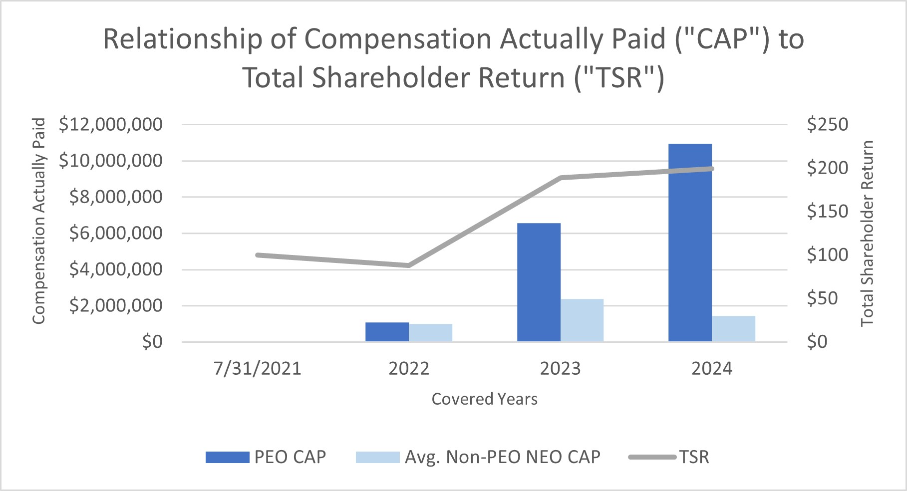
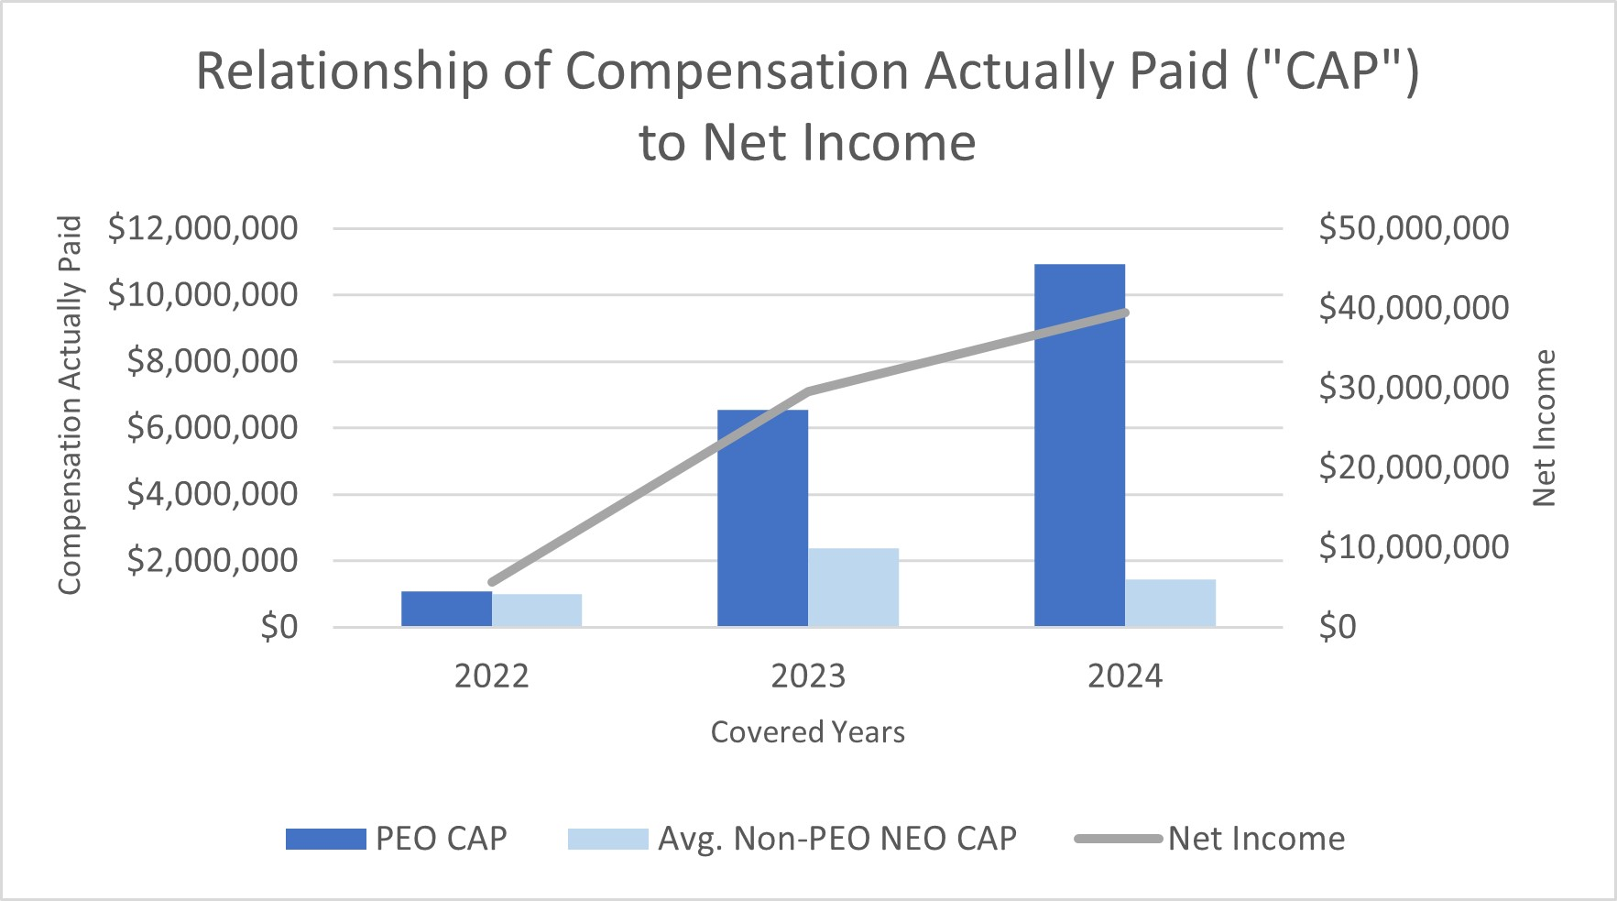

Nonqualified Deferred Compensation for Fiscal 2024
We provide an executive deferred compensation plan in which all executive officers and other senior managers are eligible to participate. Participating executives may defer up to 50% of base salary and 100% of annual cash incentive bonus into the plan. Executives’ deferrals earn interest at a rate equal to our long-term cost of borrowing plus 1%. Participants are entitled to receive a distribution from their account balances at the earlier of the end of their elected deferral period or upon death or termination of
45
employment prior to age 55. Accounts are distributed in a single lump sum, or in certain circumstances, annual installments over a period of up to 15 years as elected by the participant.
In the event of an unforeseen emergency, a participant may apply to the administrative committee of the plan for payment of an amount from the participant’s account balance sufficient to satisfy the emergency need. Further, as described above, the Company may make voluntary matching contributions on behalf of the participants in this deferred compensation plan. The plan will terminate upon a change in control of the Company. Immediately prior to such a change in control, or as soon as possible following a change in control, each participant will be paid his account balance. Our executive deferred compensation plan is unfunded and subject to the claims of our creditors.
In June 2020, the Board adopted an amendment to the Company’s deferred compensation plan, which provides for discretionary employer contributions to the accounts of eligible plan participants. The amount of the Company contribution under the deferred compensation plan is determined by the Company in its sole discretion and such Company contributions may vary from participant to participant. In fiscal 2024, the Company offered contributions of up to six percent (6%) of a participant’s total compensation in fiscal 2024 less the amount of matched dollars to the participant under the Company’s 401(k) plan in the year. In fiscal 2024, the Company contributed $0 to Mr. Jaffee, $37,260 to Ms. Kreh and $21,186 to Mr. Lamson.

Benefits upon Termination or Change in Control
The following summaries and table set forth potential payments to the named executive officers upon termination of their employment or a change in control of the Company. None of the named executive officers meet the qualifications for normal or early retirement benefits, so those termination scenarios are not shown.
We do not have a prospective severance plan that covers any of the named executive officers and generally have no employment or prospective severance agreements with the named executive officers.
The only other benefits upon termination of employment or change in control provided to our NEOs are set forth in existing compensation plans and apply to all participants in those plans.
•Our annual incentive plan provides for immediate vesting, as allowed by law, of a participant’s executive deferred bonus award account upon the participant’s death, disability, or change in control of the Company. Upon retirement, a participant’s executive deferred bonus award account shall become immediately vested if the following conditions are met: (i) the participant’s age plus years of service is equal to or greater than 80, (ii) the participant is eligible for an immediate benefit from the Company’s pension plan, and (iii) there is reasonable anticipation of no further services or services of less than 20% of the participant’s pre-retirement level to the Company.
•Our Long Term Incentive Plan and the agreements issued under it provide for immediate vesting of restricted stock and immediate vesting and exercisability of stock options upon a participant’s death, disability or a change in control of the Company. Generally, upon retirement, all stock options or restricted stock, as applicable, become immediately vested and, in the case of stock options, exercisable if the following conditions are met: (i) the participant’s age plus years of service is equal to or greater than 80 and (ii) there is reasonable anticipation of no further services or services of less than 20% of the participant’s pre-retirement level to the Company. With respect to stock options, upon any of these termination events, the
46
participant, or his beneficiary in the case of the participant’s death, may exercise any outstanding stock options for a period of three years or until their expiration dates, whichever occurs first.
In September 2018 and September 2023, the Company granted restricted stock to Mr. Jaffee that is subject to immediate vesting upon Mr. Jaffee’s death or disability. Such restricted stock shall also immediately vest upon the following: (i) Mr. Jaffee’s termination without cause or termination of his employment for good reason (in which case, the next tranche of unvested restricted shares scheduled to vest shall vest and the remaining shall be forfeited), (ii) Mr. Jaffee’s retirement after having reached age 65, or (iii) a change of control followed by Mr. Jaffee’s termination due to his death or disability, or his termination without cause or for good reason.
The table below does not include amounts payable to the named executive officers under plans that are generally available on the same basis to all of our salaried employees, such as payments under the 401(k) plan, the life insurance plan, the disability insurance plan and payment of prorated annual incentive compensation.
The table also does not include balances under our executive deferred compensation plan. The circumstances under which the named executive officers may receive distributions from that plan are disclosed in the Nonqualified Deferred Compensation section above.
Unless otherwise noted, the amounts shown below assume that each named executive officer’s employment terminated on July 31, 2024, the last day of our most recently completed fiscal year, and when applicable, the closing sale price of our Common Stock on July 31, 2024, the last trading day of fiscal 2024, which was $65.10.
Name |  |  |  |  |  | Annual Incentive Plan Deferred Bonus Account  ($)  (1) |  |  |  |  |  | 2006 Long Term  Incentive Plan  ($)  (2) |  |  |  |  |  | Total  ($)
Daniel S. Jaffee
Change in Control, Death, Disability |  |  |  |  |  | $ | — |  |  |  |  | $ | 11,392,500 |  |  |  |  | $ | 11,392,500
Susan M. Kreh
Change in Control, Death, Disability |  |  |  |  |  | $ | 295,428 |  |  |  |  | $ | 748,650 |  |  |  |  | $ | 1,044,078
Christopher B. Lamson
Change in Control, Death, Disability |  |  |  |  |  | $ | 156,457 |  |  |  |  | $ | 1,985,550 |  |  |  |  | $ | 2,142,007
(1) The amounts shown reflect each named executive officer’s balance in his or her executive deferred bonus account of our annual incentive plan. As explained above, our annual incentive plan provides for immediate vesting and payment, as allowed by law, of a participant’s executive deferred bonus award account upon the participant’s death, disability, retirement under certain circumstances, or change in control of the Company.
(2) The amounts shown represent the market price of any unvested shares of restricted stock as of July 31, 2024. None of the named executive officers had any unvested stock options as of July 31, 2024, the last trading day of fiscal 2024. As explained above, previously unvested shares of restricted stock and stock options become immediately vested upon the events listed and subject to the conditions described above.

47
STOCK OWNERSHIP

Principal Stockholders
The following table sets forth information as of October 14, 2024, except as noted below, regarding beneficial ownership of our Common Stock and Class B Stock by each person or group known to us to hold more than five percent of either class. See “Security Ownership of Management” below for information on beneficial ownership of our Common Stock and Class B Stock by our directors and named executive officers.
 |  |  |  |  |  |  |  |  |  |  |  | Amount and Nature of Beneficial Ownership (1)
Name and Address of Beneficial Owner |  |  |  |  |  | Title of Class |  |  |  |  |  | Number of Shares of  Common Stock and  Class B Stock |  |  |  |  |  |  |  |  |  |  |  | Percentage of  Outstanding  Stock of Class |  |  |  |  |  | Percentage of  Aggregate  Voting Power of  Common Stock and  Class B Stock
Daniel S. Jaffee |  |  |  |  |  | Common Stock |  |  |  |  |  | — |  |  |  |  |  |  |  |  |  |  |  | — |  |  |  |  |  | —
410 N. Michigan Avenue |  |  |  |  |  | Class B Stock |  |  |  |  |  | 619,620 |  |  |  |  |  | (2)(3) |  |  |  |  |  | 28.75 |  | % |  |  |  | 23.22 |  | %
Chicago, IL 60611
Jaffee Investment Partnership, L.P. |  |  |  |  |  | Common Stock |  |  |  |  |  | — |  |  |  |  |  |  |  |  |  |  |  | — |  |  |  |  |  | —
410 N. Michigan Avenue |  |  |  |  |  | Class B Stock |  |  |  |  |  | 1,250,000 |  |  |  |  |  | (4) |  |  |  |  |  | 57.99 |  | % |  |  |  | 46.84 |  | %
Chicago, IL 60611
BlackRock, Inc. |  |  |  |  |  | Common Stock |  |  |  |  |  | 260,000 |  |  |  |  |  | (5) |  |  |  |  |  | 5.06 |  | % |  |  |  | 0.97 |  | %
55 East 52nd Street |  |  |  |  |  | Class B Stock |  |  |  |  |  |  |  |  |  |  |  |  |  |  |  |  |  | — |  |  |  |  |  | —
New York, NY 10055
Dimensional Fund Advisors LP |  |  |  |  |  | Common Stock |  |  |  |  |  | 375,047 |  |  |  |  |  | (6) |  |  |  |  |  | 7.30 |  | % |  |  |  | 1.41 |  | %
Building One |  |  |  |  |  | Class B Stock |  |  |  |  |  | — |  |  |  |  |  |  |  |  |  |  |  | — |  |  |  |  |  | —
6300 Bee Cave Road
Austin, TX 78746
GAMCO Asset Management Inc. et al. |  |  |  |  |  | Common Stock |  |  |  |  |  | 530,406 |  |  |  |  |  | (7) |  |  |  |  |  | 10.33 |  | % |  |  |  | 1.99 |  | %
One Corporate Center |  |  |  |  |  | Class B Stock |  |  |  |  |  | — |  |  |  |  |  |  |  |  |  |  |  | — |  |  |  |  |  | —
Rye, NY 10580
Needham Investment Management L.L.C. |  |  |  |  |  | Common Stock |  |  |  |  |  | 260,000 |  |  |  |  |  | (8) |  |  |  |  |  | 5.06 |  | % |  |  |  | 0.97 |  | %
250 Park Avenue, 10th Floor |  |  |  |  |  | Class B Stock |  |  |  |  |  |  |  |  |  |  |  |  |  |  |  |  |  | — |  |  |  |  |  | —
New York, NY 10117
Renaissance Technologies LLC |  |  |  |  |  | Common Stock |  |  |  |  |  | 262,446 |  |  |  |  |  | (9) |  |  |  |  |  | 5.11 |  | % |  |  |  | 0.98 |  | %
800 Third Avenue |  |  |  |  |  | Class B Stock |  |  |  |  |  | — |  |  |  |  |  |  |  |  |  |  |  | — |  |  |  |  |  | —
New York, NY 10022
48
 |  |  |  |  |  |  |  |  |  |  |  | Amount and Nature of Beneficial Ownership (1)
Name and Address of Beneficial Owner |  |  |  |  |  | Title of Class |  |  |  |  |  | Number of Shares of  Common Stock and  Class B Stock |  |  |  |  |  |  |  |  |  |  |  | Percentage of  Outstanding  Stock of Class |  |  |  |  |  | Percentage of  Aggregate  Voting Power of  Common Stock and  Class B Stock
The Vanguard Group |  |  |  |  |  | Common Stock |  |  |  |  |  | 274,420 |  |  |  |  |  | (10) |  |  |  |  |  | 5.34 |  | % |  |  |  | 1.03 |  | %
100 Vanguard Blvd. |  |  |  |  |  | Class B Stock |  |  |  |  |  | — |  |  |  |  |  |  |  |  |  |  |  | — |  | % |  |  |  | — |  | %
Malvern, PA 19355
(1) Beneficial ownership is determined according to SEC rules and generally includes any shares over which a person possesses sole or shared power to vote or to direct the disposition of a security as well as any shares that such person has the right to acquire within 60 days of October 14, 2024, including through the exercise of options or other rights or the conversion of another security. Unless otherwise indicated, all beneficial ownership in this table indicates sole voting and investment power. The applicable percentage ownership for each person listed below is based upon 5,134,478 shares of Common Stock and 2,155,407 shares of Class B Stock outstanding as of the close of business on October 14, 2024. Shares of Common Stock and Class B Stock subject to options, warrants or other rights that are exercisable or convertible within 60 days after October 14, 2024, are deemed outstanding for the purpose of calculating the percentage ownership of the person holding those options, warrants or other rights but are not treated as outstanding for the purpose of calculating the percentage ownership of any other person.
(2) Does not include shares beneficially owned by Jaffee Investment Partnership, L.P.
(3) Consists of: (i) 557,476 shares of Class B Stock directly owned by Mr. Jaffee (175,000 of which are restricted shares); (ii) 5,625 shares of Class B Stock he owns as trustee for his children; (iii) 24,893 shares of Class B Stock he owns as trustee for the Daniel Jaffee Children's GST Exempt Trust u/a/d 07/12/1993; and (iv) 31,626 shares of Class B Stock he owns as trustee for Daniel Jaffee GST Non-Exempt Trust u/a/d 06/21/1974. 130,000 of the shares of Class B Stock held directly by Mr. Jaffee are pledged to a bank as collateral for a personal loan. The 175,000 restricted shares of Class B Stock will become non-forfeitable as follows: (a) 41,000 shares on each of the subsequent anniversaries of October 19th during the years 2024-2025, and (b) 31,000 shares on each of the anniversaries of October 19th during the years 2026-2028.
(4) Jaffee Investment Partnership, L.P. is managed by its general partners, generally acting by a majority vote. Mr. Jaffee has a majority of the general partner votes and therefore, generally has voting control of all of the Oil-Dri shares owned by the partnership. As a result, Mr. Jaffee, might be deemed to have, but disclaims, beneficial ownership of the partnership’s shares, which are not reflected in his share ownership shown in this table.
(5) Information is as provided by the reporting persons in a Schedule 13G filed with the SEC on January 26, 2024. Such Schedule 13G filed by BlackRock, Inc. (“BlackRock”) reports that BlackRock has sole voting power over 356,751 shares of Common Stock and sole dispositive power over 363,650 shares of Common Stock.
(6) Information is as provided by the reporting persons in a Schedule 13G/A filed with the SEC on February 9, 2024. Based on such Schedule 13G/A, Dimensional Fund Advisors LP (“Dimensional”), a registered investment adviser, furnishes investment advice to four investment companies registered under the Investment Company Act of 1940 and serves as investment manager or sub-adviser to certain other commingled funds, group trusts and separate accounts. These investment companies, trusts and accounts are the “Funds.” In certain cases, subsidiaries of Dimensional may act as adviser or sub-adviser to certain Funds. In its role as investment advisor, sub-adviser and/or manager, Dimensional or its subsidiaries may possess voting and/or investment power over the shares of Common Stock owned by the Funds, and may be deemed to be the beneficial owner of those shares under applicable SEC rules. Although such Schedule 13G/A identifies Dimensional as having sole voting power over 368,777 shares of Common Stock and sole dispositive power over 375,047 shares of Common Stock, Dimensional disclaims beneficial ownership of such shares and reports that all of these shares are owned by the Funds.
49
(7) Information is as provided by the reporting persons in a Schedule 13D/A filed with the SEC on July 31, 2023. Such Schedule 13D/A filed by Gabelli Funds, LLC (“Gabelli Funds”), GAMCO Asset Management, Inc. (“GAMCO”), Teton Advisors, Inc. (“Teton Advisors”), GGCP, Inc. (“GGCP”), GAMCO Investors, Inc. (“GBL”), Associated Capital Group, Inc. (“AC”) and Mario J. Gabelli reports: (a) 85,700 shares of Common Stock beneficially owned by Gabelli Funds; (b) 424,406 shares of Common Stock beneficially owned by GAMCO; and (c) 15,000 shares of Common Stock beneficially owned by Teton Advisors. The Schedule 13D/A reports that each such entity has sole voting and sole dispositive power over the shares reported as beneficially owned by it, except that: (i) GAMCO does not have the authority to vote 5,300 of the reported shares; (ii) Gabelli Funds has sole dispositive and voting power with respect to the shares held by such funds so long as the aggregate voting interest of all joint filers does not exceed 25% of their total voting interest in the Company and, in that event, the proxy voting committee of each fund shall respectively vote that fund’s shares; (iii) at any time, the proxy voting committee of each fund shall of each such fund may take and exercise in its sole discretion the entire voting power with respect to the shares held by such fund under special circumstances such as regulatory considerations; and (iv) the power of Mario J. Gabelli, AC, GBL and GGCP is indirect with respect to securities beneficially owned directly by other reporting persons.
(8) Information is as provided by the reporting persons in a Schedule 13G filed with the SEC on August 14, 2024. Such Schedule 13G filed by Needham Investment Management L.L.C., Needham Asset Management, LLC, Needham Aggressive Growth Fund, and George A. Needham. Needham Investment Management L.L.C., is the relevant entity for which each of Needham Asset Management, LLC and George A. Needham may be considered a control person. Each of Needham Investment Management L.L.C., Needham Asset Management, LLC, Needham Aggressive Growth Fund, and George A. Needham share voting and dispositive power with respect to 260,000 shares of Common Stock.
(9) Information is as provided by the reporting persons in a Schedule 13G/A filed with the SEC on February 13, 2024. Such Schedule 13G/A filed by Renaissance Technologies LLC, an investment adviser (“RTC”), and Renaissance Technologies Holdings Corporation, majority owner of RTC (“RTHC”), reports that RTC and RTHC have sole voting and dispositive power over 262,446 shares of Common Stock.
(10) Information is as provided by the reporting persons in a Schedule 13G filed with the SEC on February 13, 2024. Such Schedule 13G filed by The Vanguard Group, an investment adviser, reports that The Vanguard Group held sole voting power over 0 shares of Common Stock, shared voting power over 3,696 shares of Common Stock, sole dispositive power over 268,536 shares of Common Stock, and shared dispositive power over 5,884 shares of Common Stock.

Security Ownership of Management
The following table shows the number of shares of Common Stock and Class B Stock beneficially owned as of October 14, 2024 by our directors, by the named executive officers and by our directors and executive officers as a group.
50
Name of Beneficial Owner  (1) |  |  |  |  |  | Number of Shares of Common Stock |  |  |  |  |  |  |  |  | Percentage of  Outstanding  Common Stock |  |  |  |  |  | Number of Shares  of Class B Stock  (2) |  |  |  |  |  |  |  |  | Percentage of  Outstanding  Class B Stock
Daniel S. Jaffee |  |  |  |  |  | — |  |  | (3) |  |  |  |  |  | * |  |  |  |  |  | 619,620 |  |  | (3) |  |  |  |  |  | 28.75 |  | %
Ellen-Blair Chube |  |  |  |  |  | 7,660 |  |  | (4) |  |  |  |  |  | * |  |  |  |  |  | — |  |  |  |  |  |  |  |  | *
Paul M. Hindsley |  |  |  |  |  | 8,000 |  |  | (4) |  |  |  |  |  | * |  |  |  |  |  | — |  |  |  |  |  |  |  |  | *
Michael A. Nemeroff |  |  |  |  |  | 28,901 |  |  | (4) |  |  |  |  |  | * |  |  |  |  |  | — |  |  |  |  |  |  |  |  | *
George C. Roeth |  |  |  |  |  | 5,000 |  |  | (5) |  |  |  |  |  | * |  |  |  |  |  | — |  |  |  |  |  |  |  |  | *
Amy L. Ryan |  |  |  |  |  | 3,000 |  |  | (4) |  |  |  |  |  | * |  |  |  |  |  | — |  |  |  |  |  |  |  |  | *
Allan H. Selig |  |  |  |  |  | 51,000 |  |  | (4) |  |  |  |  |  | * |  |  |  |  |  | — |  |  |  |  |  |  |  |  | *
Patricia J. Schmeda |  |  |  |  |  | 1,000 |  |  | (4) |  |  |  |  |  | * |  |  |  |  |  | — |  |  |  |  |  |  |  |  | *
Lawrence E. Washow |  |  |  |  |  | 15,000 |  |  | (4) |  |  |  |  |  | * |  |  |  |  |  | — |  |  |  |  |  |  |  |  | *
Susan M. Kreh |  |  |  |  |  | 31,850 |  |  | (6) |  |  |  |  |  | * |  |  |  |  |  | — |  |  |  |  |  |  |  |  | *
Christopher B. Lamson |  |  |  |  |  | 35,251 |  |  | (7) |  |  |  |  |  | * |  |  |  |  |  | — |  |  |  |  |  |  |  |  | *
All Directors and Executive Officers as a Group (14 persons) |  |  |  |  |  | 230,861 |  |  | (8) |  |  |  |  |  | 4.50 |  | % |  |  |  | 619,620 |  |  | (9) |  |  |  |  |  | 28.75 |  | %

* Does not exceed 1%
(1) Beneficial ownership is determined according to SEC rules and generally includes any shares over which a person possesses sole or shared power to vote or to direct the disposition of a security as well as any shares that such person has the right to acquire within 60 days of October 14, 2024, including through the exercise of options or other rights or the conversion of another security. Unless otherwise indicated, the individuals listed in this table have sole voting and investment power with respect to the shares owned by them, and such shares are not subject to any pledge. The applicable percentage ownership for each person listed is based upon 5,134,478 shares of Common Stock and 2,155,407 shares of Class B Stock outstanding as of the close of business on October 14, 2024. Shares of Common Stock and Class B Stock subject to options, warrants or other rights that are exercisable or convertible within 60 days after October 14, 2024, are deemed outstanding for the purpose of calculating the percentage ownership of the person holding those options, warrants or other rights, but are not treated as outstanding for the purpose of calculating the percentage ownership of any other person.
(2) Except for Mr. Jaffee, none of our directors or named executive officers own any shares of Class B Stock.
(3) Does not include shares beneficially owned by Jaffee Investment Partnership, L.P. For information regarding the shares beneficially owned by Mr. Jaffee, see the table under “Principal Stockholders” above and the notes thereto.
(4) Includes 1,000 restricted shares of Common Stock awarded on December 15, 2023, scheduled to “cliff” vest on December 15, 2025.
(5) Includes (a) 4,000 shares of Common Stock held in a trust for the benefit of Mr. Roeth and his spouse and (b) 1,000 restricted shares of Common Stock awarded on December 15, 2023, scheduled to “cliff” vest on December 15, 2025.
(6) Includes restricted shares of Common Stock that are scheduled to vest as follows: (a) 2,500 shares on October 19, 2024; (b) 5,000 shares on October 19, 2025; and (c) 4,000 shares on October 19, 2027.
(7) Includes restricted shares of Common Stock that are scheduled to vest as follows: (a) 6,000 shares on January 20, 2025; (b) 6,000 shares on January 20, 2026; (c) 2,500 shares on October 18, 2026; (d) 12,000 shares on January 20, 2027; and (e) 4,000 shares on October 19, 2027.
(8) Includes 84,000 restricted shares of Common Stock: (a) 2,500 of which become non-forfeitable on October 19, 2024, (b) 7,000 of which become non-forfeitable on January 20, 2025, (c) 10,000 of which become non-forfeitable on
51
October 19, 2025, (d) 8,000 of which become non-forfeitable on December 15, 2025, (e) 7,000 of which become non-forfeitable on January 20, 2026, (f) 2,500 of which become non-forfeitable on October 18, 2026, (g) 10,000 of which become non-forfeitable on October 19, 2026, (h) 12,000 of which become non-forfeitable on January 20, 2027, (i) 21,000 of which become non-forfeitable on October 19, 2027, and (j) 4,000 of which become non-forfeitable on December 15, 2027. The number of shares of Common Stock owned beneficially by our directors and executive officers as a group represents approximately 4.5% of the number of outstanding shares of Common Stock and approximately 0.9% of the aggregate voting power of the Common Stock and Class B Stock.
(9) Includes 175,000 restricted shares of Class B Stock of which become non-forfeitable as follows: (a) 41,000 shares on each of the subsequent anniversaries of October 19th during the years 2024-2025, and (b) 31,000 shares on each of the anniversaries of October 19th during the years 2026-2028. Does not include shares beneficially owned by Jaffee Investment Partnership, L.P. For information regarding the shares held by the partnership, see the table under “Principal Stockholders” above and the notes thereto. The number of shares of Class B Stock owned beneficially by our directors and executive officers as a group represents approximately 28.7% of the number of outstanding shares of Class B Stock and approximately 23.2% of the aggregate voting power of the Common Stock and Class B Stock.

Delinquent Section 16(a) Reports
Section 16(a) of the Exchange Act requires directors, executive officers and persons who beneficially own more than 10% of our common stock to file certain reports with the SEC concerning their beneficial ownership of our common stock. Based solely on a review of the reports furnished to the Company and written representations from reporting persons that all reportable transaction were reported, the Company believes that during the fiscal year ended July 31, 2024, all required reports were filed on a timely basis under Section 16(a) of the Exchange Act, except: (i) a Form 4 for Mr. Jaffee which was due on December 20, 2023 and filed one day late on December 21, 2023 due to a delay in the timing of the execution of a gift following the conversion of Class B Stock to Common Stock on December 18, 2023 and (ii) a Form 4 for Mr. Christiansen which was due on March 20, 2024 and filed one day late on March 21, 2024 due to the execution of a trade order taking place in multiple transactions over a three-day period.

OTHER INFORMATION
Website
This Proxy Statement includes references to websites, website addresses and additional materials found on those websites. The content of any websites and materials named, hyperlinked or otherwise referenced in this proxy statement are not incorporated by reference into this Proxy Statement or in any other report or document we file with the SEC, and any references to such websites and materials are intended to provide inactive, textual references only. The information on these websites is not part of this Proxy Statement.
Forward-Looking Statements
Certain statements in this Proxy Statement, and in other documents we file with the SEC, contain forward-looking statements, within the meaning of the safe harbor provisions of the U.S. Private Securities Litigation Reform Act of 1995, that are based on current expectations, estimates, forecasts and projections about our future performance, our business, our beliefs and our management’s assumptions. In addition, we, or others on our behalf, may make forward-looking statements in press releases or written statements, or in our communications and discussions with investors and analysts in the normal course of business through meetings, webcasts, phone calls and conference calls. Forward-looking statements can be identified by words such as “expect,” “outlook,” “forecast,” “would,” “could,” “should,” “project,” “intend,” “plan,” “continue,” “believe,” “seek,” “estimate,” “anticipate,” “may,” “assume,” "potential,"
52
“foresee,” “predict,” “possible,” “commit,” “design,” “strive,” and variations of such works and similar references to future periods.
Such statements are subject to certain risks, uncertainties and assumptions that could cause actual results to differ materially, including, but not limited to, those described under Item 1A “Risk Factors” in our Form 10-K and from time to time in our other documents we file with the SEC. Should one or more of these or other risks or uncertainties materialize, or should underlying assumptions prove incorrect, actual results may vary materially from those anticipated, intended, expected, believed, estimated, projected or planned. Investors are cautioned not to place undue reliance on these forward-looking statements, which speak only as of the date hereof. Except to the extent required by law, we do not have any intention or obligation to update publicly any forward-looking statements after the distribution of this report, whether as a result of new information, future events, changes in assumptions or otherwise.
53

APPENDIX A - PROPOSED AMENDMENT TO THE CERTIFICATE OF INCORPORATION

CERTIFICATE OF AMENDMENT OF CERTIFICATE OF INCORPORATION OF OIL-DRI CORPORATION OF AMERICA

Oil-Dri Corporation of America (the "Corporation"), a corporation organized and existing under the General Corporation Law of the State of Delaware, hereby certifies as follows:

1.This Certificate of Amendment (the "Certificate of Amendment") amends the provisions of the Corporation's Certificate of Incorporation filed with the Secretary of State on December 8, 1969, as amended from time to time (the "Certificate of Incorporation").

2.The Fourth Article, Section A of the Certificate of Incorporation is hereby amended and restated in its entirety as follows:

A.AUTHORIZED CAPITAL STOCK

The total number of shares of all classes of capital stock which the Corporation shall have authority to issue is sixty seven million (67,000,000) shares, consisting of thirty million (30,000,000) shares of Common Stock, par value $.10 per share (the "Common Stock"), thirty million (30,000,000) shares of Class A Common Stock, par value $.10 per share (the "Class A Common Stock") and seven million (7,000,000) shares of Class B Stock, par value $.10 per share (the "Class B Stock").

3.This amendment was duly adopted in accordance with the provisions of Section 242 of the General Corporation Law of the State of Delaware.

4.All other provisions of the Certificate of Incorporation shall remain in full force and effect.

[Signature Page Follows]

54

IN WITNESS WHEREOF, the Corporation has caused this Certificate of Amendment to be signed by Daniel S. Jaffee, its President and Chief Executive Officer, this day of , 2024.

By_________________________________
Daniel S. Jaffee, President and Chief Executive Officer

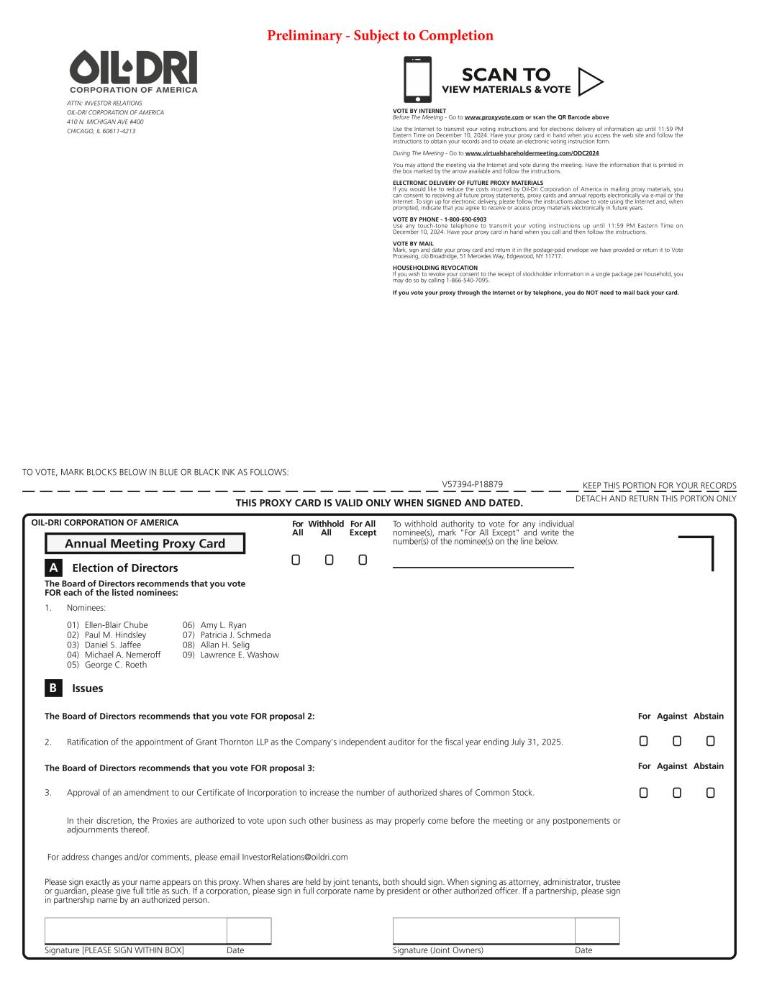
55
Signature [PLEASE SIGN WITHIN BOX] Date Signature (Joint Owners) Date TO VOTE, MARK BLOCKS BELOW IN BLUE OR BLACK INK AS FOLLOWS: KEEP THIS PORTION FOR YOUR RECORDS DETACH AND RETURN THIS PORTION ONLYTHIS PROXY CARD IS VALID ONLY WHEN SIGNED AND DATED. In their discretion, the Proxies are authorized to vote upon such other business as may properly come before the meeting or any postponements or adjournments thereof. V57394-P18879 ! ! ! For All Withhold All For All Except For Against Abstain For Against Abstain ! !! To withhold authority to vote for any individual nominee(s), mark "For All Except" and write the number(s) of the nominee(s) on the line below. ATTN: INVESTOR RELATIONS OIL-DRI CORPORATION OF AMERICA 410 N. MICHIGAN AVE #400 CHICAGO, IL 60611-4213 The Board of Directors recommends that you vote FOR each of the listed nominees: 01) Ellen-Blair Chube 02) Paul M. Hindsley 03) Daniel S. Jaffee 04) Michael A. Nemeroff 05) George C. Roeth 06) Amy L. Ryan 07) Patricia J. Schmeda 08) Allan H. Selig 09) Lawrence E. Washow A Election of Directors Annual Meeting Proxy Card 1. Nominees: OIL-DRI CORPORATION OF AMERICA The Board of Directors recommends that you vote FOR proposal 2: The Board of Directors recommends that you vote FOR proposal 3: 2. Ratification of the appointment of Grant Thornton LLP as the Company's independent auditor for the fiscal year ending July 31, 2025. 3. Approval of an amendment to our Certificate of Incorporation to increase the number of authorized shares of Common Stock. B Issues Please sign exactly as your name appears on this proxy. When shares are held by joint tenants, both should sign. When signing as attorney, administrator, trustee or guardian, please give full title as such. If a corporation, please sign in full corporate name by president or other authorized officer. If a partnership, please sign in partnership name by an authorized person. For address changes and/or comments, please email InvestorRelations@oildri.com ! !! SCAN TO VIEW MATERIALS & VOTEw VOTE BY INTERNET Before The Meeting - Go to www.proxyvote.com or scan the QR Barcode above Use the Internet to transmit your voting instructions and for electronic delivery of information up until 11:59 PM Eastern Time on December 10, 2024. Have your proxy card in hand when you access the web site and follow the instructions to obtain your records and to create an electronic voting instruction form. During The Meeting - Go to www.virtualshareholdermeeting.com/ODC2024 You may attend the meeting via the Internet and vote during the meeting. Have the information that is printed in the box marked by the arrow available and follow the instructions. ELECTRONIC DELIVERY OF FUTURE PROXY MATERIALS If you would like to reduce the costs incurred by Oil-Dri Corporation of America in mailing proxy materials, you can consent to receiving all future proxy statements, proxy cards and annual reports electronically via e-mail or the Internet. To sign up for electronic delivery, please follow the instructions above to vote using the Internet and, when prompted, indicate that you agree to receive or access proxy materials electronically in future years. VOTE BY PHONE - 1-800-690-6903 Use any touch-tone telephone to transmit your voting instructions up until 11:59 PM Eastern Time on December 10, 2024. Have your proxy card in hand when you call and then follow the instructions. VOTE BY MAIL Mark, sign and date your proxy card and return it in the postage-paid envelope we have provided or return it to Vote Processing, c/o Broadridge, 51 Mercedes Way, Edgewood, NY 11717. HOUSEHOLDING REVOCATION If you wish to revoke your consent to the receipt of stockholder information in a single package per household, you may do so by calling 1-866-540-7095. If you vote your proxy through the Internet or by telephone, you do NOT need to mail back your card. Preliminary - Subject to Completion

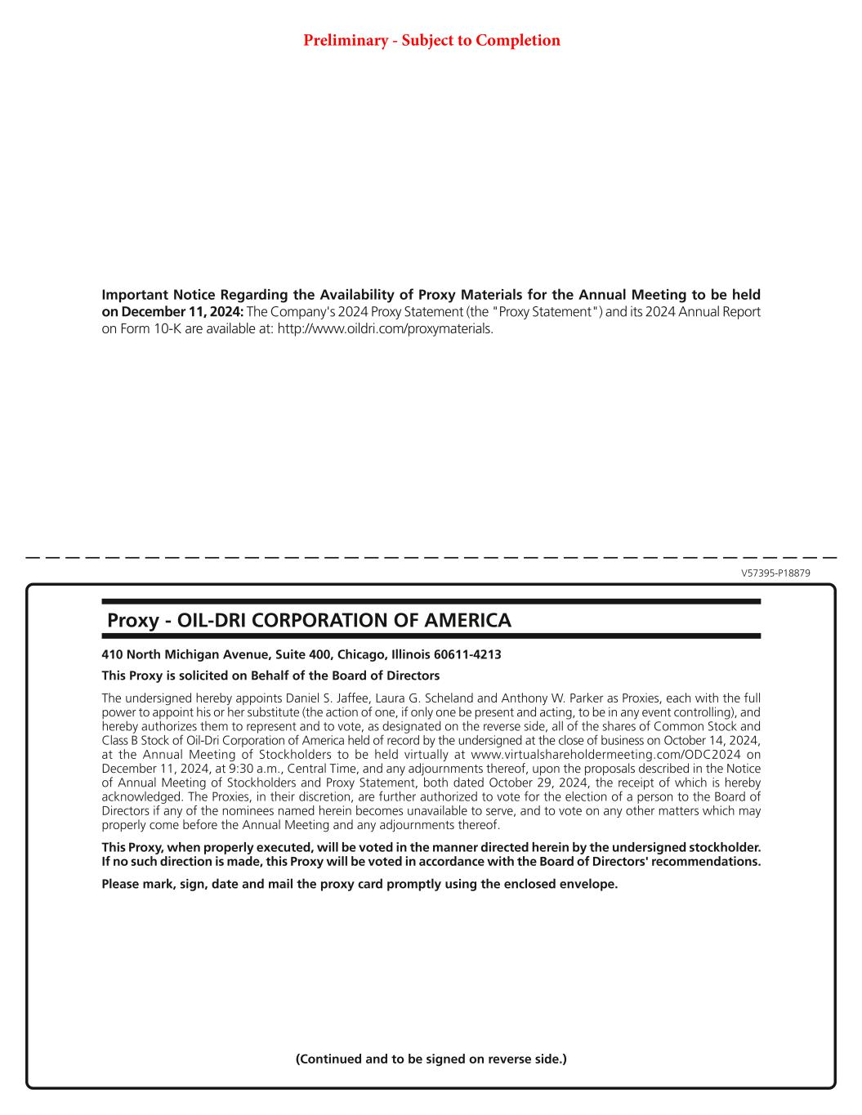
V57395-P18879 Important Notice Regarding the Availability of Proxy Materials for the Annual Meeting to be held on December 11, 2024: The Company's 2024 Proxy Statement (the "Proxy Statement") and its 2024 Annual Report on Form 10-K are available at: http://www.oildri.com/proxymaterials. 410 North Michigan Avenue, Suite 400, Chicago, Illinois 60611-4213 This Proxy is solicited on Behalf of the Board of Directors The undersigned hereby appoints Daniel S. Jaffee, Laura G. Scheland and Anthony W. Parker as Proxies, each with the full power to appoint his or her substitute (the action of one, if only one be present and acting, to be in any event controlling), and hereby authorizes them to represent and to vote, as designated on the reverse side, all of the shares of Common Stock and Class B Stock of Oil-Dri Corporation of America held of record by the undersigned at the close of business on October 14, 2024, at the Annual Meeting of Stockholders to be held virtually at www.virtualshareholdermeeting.com/ODC2024 on December 11, 2024, at 9:30 a.m., Central Time, and any adjournments thereof, upon the proposals described in the Notice of Annual Meeting of Stockholders and Proxy Statement, both dated October 29, 2024, the receipt of which is hereby acknowledged. The Proxies, in their discretion, are further authorized to vote for the election of a person to the Board of Directors if any of the nominees named herein becomes unavailable to serve, and to vote on any other matters which may properly come before the Annual Meeting and any adjournments thereof. This Proxy, when properly executed, will be voted in the manner directed herein by the undersigned stockholder. If no such direction is made, this Proxy will be voted in accordance with the Board of Directors' recommendations. Please mark, sign, date and mail the proxy card promptly using the enclosed envelope. Proxy - OIL-DRI CORPORATION OF AMERICA (Continued and to be signed on reverse side.) Preliminary - Subject to Completion

