UNITED STATES
SECURITIES AND EXCHANGE COMMISSION
Washington, D.C. 20549

FORM 8-K

CURRENT REPORT
Pursuant to Section 13 or 15(d) of the Securities Exchange Act of 1934
Date of Report (Date of earliest event reported) |  |  | May 1, 2024

OIL-DRI CORPORATION OF AMERICA
(Exact name of the registrant as specified in its charter)

Delaware |  |  |  |  |  |  |  |  | 001-12622 |  |  |  |  |  | 36-2048898
(State or other jurisdiction of incorporation or organization) |  |  |  |  |  |  |  |  | (Commission File Number) |  |  |  |  |  | (I.R.S. Employer Identification No.)
410 North Michigan Avenue, Suite 400 |  |  |  |  |  |  |  |  |  |  |  |  |  |  | 60611-4213
Chicago, Illinois |  |  |  |  |  |  |  |  |  |  |  |  |  |  | (Zip Code)
(Address of principal executive offices)
The registrant's telephone number, including area code: (312) 321-1515

(Former name or former address, if changed since last report.)

Check the appropriate box below if the Form 8-K filing is intended to simultaneously satisfy the filing obligation of the registrant under any of the following provisions (see General Instruction A.2. below):
 |  |  | ☐ |  |  | Written communications pursuant to Rule 425 under the Securities Act (17 CFR 230.425)
 |  |  | ☐ |  |  | Soliciting material pursuant to Rule 14a-12 under the Exchange Act (17 CFR 240.14a-12)
 |  |  | ☐ |  |  | Pre-commencement communications pursuant to Rule 14d-2(b) under the Exchange Act (17 CFR 240.14d-2(b))
 |  |  | ☐ |  |  | Pre-commencement communications pursuant to Rule 13e-4(c) under the Exchange Act (17 CFR 240.13e-4(c))

Securities registered pursuant to Section 12(b) of the Act:
Title of each class |  |  | Trading Symbol(s) |  |  | Name of each exchange on which registered
Common Stock, par value $0.10 per share |  |  | ODC |  |  | New York Stock Exchange

Indicate by check mark whether the registrant is an emerging growth company as defined in Rule 405 of the Securities Act of 1933 (§230.405 of this chapter) or Rule 12b-2 of the Securities Exchange Act of 1934 (§240.12b-2 of this chapter).
Emerging growth company ☐

If an emerging growth company, indicate by check mark if the registrant has elected not to use the extended transition period for complying with any new or revised financial accounting standards provided pursuant to Section 13(a) of the Exchange Act. ☐

 |  |  | Item 2.01 |  |  | Completion of Acquisition of Disposition of Assets.

As previously disclosed, on April 16, 2024, Oil-Dri Corporation of America, a Delaware corporation (the “Company”), entered into a Stock Purchase Agreement (the “Purchase Agreement”) with Ultra Pet, LLC, a Delaware limited liability company (“Seller”), Ultra Pet Company, Inc., a Delaware corporation (“Ultra Pet”), and certain equityholders of Seller set forth on the signature page thereto (“Seller’s Equityholders”), pursuant to which the Company agreed to purchase all of the issued and outstanding shares of capital stock of Ultra Pet (the “Shares”) from Seller (the “Transaction”).

On May 1, 2024, the Company completed the Transaction and acquired the Shares. At the closing of the Transaction (the “Closing”), the Company paid Seller an aggregate cash consideration of approximately $46 million, subject to certain adjustments set forth in the Purchase Agreement (as adjusted, the “Purchase Price”). A portion of the Purchase Price (approximately $3.3 million) was deposited in a specified escrow account for the purposes of satisfying any post-Closing indemnification claims made pursuant to the Purchase Agreement and certain post-Closing adjustments pursuant to the Purchase Price.

The foregoing description of the Purchase Agreement does not purport to be complete and is qualified in its entirety by reference to the Purchase Agreement, a copy of which was filed as Exhibit 2.1 to the Current Report on Form 8-K filed by the Company on April 16, 2024 and is incorporated herein by reference.

The Purchase Agreement has been provided solely to inform investors of its terms. The representations, warranties and covenants contained in the Purchase Agreement were made only for the purposes of such agreement and as of specific dates and were made solely for the benefit of the parties to the Purchase Agreement and may be intended not as statements of fact, but rather as a way of allocating risk to one of the parties if those statements prove to be inaccurate. In addition, such representations, warranties and covenants may have been qualified by disclosures not reflected in the text of the Purchase Agreement and may apply standards of materiality in a way that is different from what may be viewed as material by stockholders of, or other investors in, us. The Company’s stockholders and other investors are not third-party beneficiaries under the Purchase Agreement and should not rely on the representations, warranties and covenants or any descriptions thereof as characterizations of the actual state of facts or conditions of the Company, Seller, Seller’s Equityholders, or Ultra Pet or any of their subsidiaries or affiliates.

 |  |  | Item 2.03 |  |  | Creation of a Direct Financial Obligation or an Obligation under an Off-Balance Sheet Arrangement of a Registrant.

A portion of the Purchase Price was financed through a $10 million advance under the Company’s existing credit facility, as amended, with BMO Bank N.A., and through the issuance of $10 million in aggregate principal amount of 6.47% Series D Senior Notes due April 30, 2033 pursuant to the shelf facility provisions of the Company’s existing Amended and Restated Note Purchase and Private Shelf Agreement, as amended, with PGIM, Inc. (“Prudential”) and certain existing noteholders affiliated with Prudential.

 |  |  | Item 7.01 |  |  | Regulation FD Disclosure.

On May 1, 2024, the Company issued a press release (the “Press Release”) announcing (i) the Closing described in Item 2.01 above and (ii) the expected timing of the Company’s third quarter of fiscal 2024 earnings release and discussion. A copy of the Press Release is attached as Exhibit 99.1 to this Current Report on Form 8-K and is incorporated herein by reference.

The information in this Item 7.01 and Exhibit 99.1 shall not be deemed “filed” for purposes of Section 18 of the Securities Exchange Act of 1934, as amended (the “Exchange Act”), or otherwise subject to the liabilities of that section. This information shall not be deemed to be incorporated by reference in any filing under the Securities Act of 1933, as amended, or the Exchange Act, except as shall be expressly set forth by specific reference to such disclosure in this Form 8-K in such a filing.

Forward-Looking Statements

Certain statements in this Current Report on Form 8-K may contain forward-looking statements, within the meaning of the safe harbor provisions of the U.S. Private Securities Litigation Reform Act of 1995, that are based on the Company’s current expectations, estimates, forecasts and projections about the Company’s future performance, business, beliefs and management’s assumptions. In addition, the Company, or others on the Company’s behalf, may make forward-looking statements in other press releases or written statements, or in the Company’s communications and discussions with investors and analysts in the normal course of business through meetings, webcasts, phone calls and conference calls. Forward-looking statements can be

identified by words such as “expect,” “outlook,” “forecast,” “would,” “could,” “should,” “project,” “intend,” “plan,” “continue,” “believe,” “seek,” “estimate,” “anticipate,” “may,” “assume,” “potential,” “strive,” and similar references to future periods.

Such statements are subject to certain risks, uncertainties and assumptions that could cause actual results to differ materially, including, but not limited to, those described in Item 1A, “Risk Factors” of the Company’s Quarterly Report on Form 10-Q for the quarter ended January 31, 2024 and the Company’s most recent Annual Report on Form 10-K and from time to time in the Company’s other filings with the Securities and Exchange Commission. Should one or more of these or other risks or uncertainties materialize, or should underlying assumptions prove incorrect, actual results may vary materially from those anticipated, intended, expected, believed, estimated, projected, planned or otherwise expressed in any forward-looking statements. Investors are cautioned not to place undue reliance on these forward-looking statements, which speak only as of the date of this press release. Except to the extent required by law, the Company does not have any intention or obligation to update publicly any forward-looking statements after the distribution of this press release, whether as a result of new information, future events, changes in assumptions, or otherwise.

 |  |  | Item 9.01 |  |  | Financial Statements and Exhibits.

(d)Exhibits
Exhibit  Number |  |  |  |  |  | Description of Exhibits
2.1* |  |  |  |  |  | Stock Purchase Agreement, dated April 16, 2024, by and among the Oil-Dri Corporation of America, Ultra Pet, LLC, Ultra Pet Company, Inc., and certain equityholders of Ultra Pet, LLC set forth on the signature page thereto (incorporated by reference to Exhibit 2.1 to Oil-Dri Corporation of America’s Current Report on Form 8-K filed on April 16, 2024).
99.1 |  |  |  |  |  | Press Release of the Company, dated May 1, 2024.
104 |  |  |  |  |  | Cover Page Interactive Data File (the cover page XBRL tags are embedded within the iXBRL document).
* The schedules and similar attachments to this exhibit have been omitted pursuant to Item 601(a)(5) of Regulation S-K. The Company agrees to provide a copy of the omitted schedules and similar attachments on a supplemental basis to the Commission or its staff, if requested.

SIGNATURES

Pursuant to the requirements of the Securities Exchange Act of 1934, the Company has duly caused this report to be signed on its behalf by the undersigned hereunto duly authorized.

 |  |  | OIL-DRI CORPORATION OF AMERICA
 |  |  | By: |  |  | /s/ Laura G. Scheland
 |  |  |  |  |  | Laura G. Scheland
 |  |  |  |  |  | Chief Legal Officer
Date: May 1, 2024

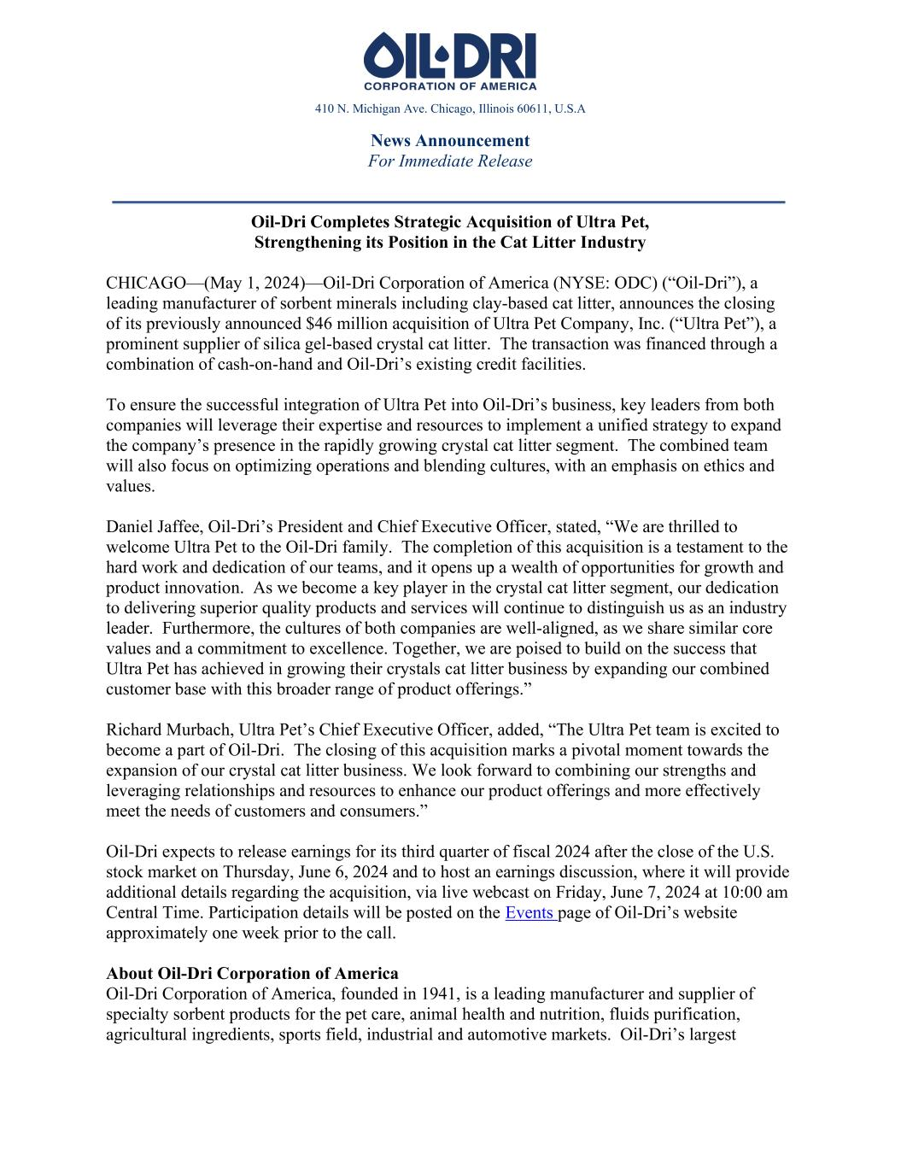

410 N. Michigan Ave. Chicago, Illinois 60611, U.S.A News Announcement For Immediate Release Oil-Dri Completes Strategic Acquisition of Ultra Pet, Strengthening its Position in the Cat Litter Industry CHICAGO—(May 1, 2024)—Oil-Dri Corporation of America (NYSE: ODC) (“Oil-Dri”), a leading manufacturer of sorbent minerals including clay-based cat litter, announces the closing of its previously announced $46 million acquisition of Ultra Pet Company, Inc. (“Ultra Pet”), a prominent supplier of silica gel-based crystal cat litter. The transaction was financed through a combination of cash-on-hand and Oil-Dri’s existing credit facilities. To ensure the successful integration of Ultra Pet into Oil-Dri’s business, key leaders from both companies will leverage their expertise and resources to implement a unified strategy to expand the company’s presence in the rapidly growing crystal cat litter segment. The combined team will also focus on optimizing operations and blending cultures, with an emphasis on ethics and values. Daniel Jaffee, Oil-Dri’s President and Chief Executive Officer, stated, “We are thrilled to welcome Ultra Pet to the Oil-Dri family. The completion of this acquisition is a testament to the hard work and dedication of our teams, and it opens up a wealth of opportunities for growth and product innovation. As we become a key player in the crystal cat litter segment, our dedication to delivering superior quality products and services will continue to distinguish us as an industry leader. Furthermore, the cultures of both companies are well-aligned, as we share similar core values and a commitment to excellence. Together, we are poised to build on the success that Ultra Pet has achieved in growing their crystals cat litter business by expanding our combined customer base with this broader range of product offerings.” Richard Murbach, Ultra Pet’s Chief Executive Officer, added, “The Ultra Pet team is excited to become a part of Oil-Dri. The closing of this acquisition marks a pivotal moment towards the expansion of our crystal cat litter business. We look forward to combining our strengths and leveraging relationships and resources to enhance our product offerings and more effectively meet the needs of customers and consumers.” Oil-Dri expects to release earnings for its third quarter of fiscal 2024 after the close of the U.S. stock market on Thursday, June 6, 2024 and to host an earnings discussion, where it will provide additional details regarding the acquisition, via live webcast on Friday, June 7, 2024 at 10:00 am Central Time. Participation details will be posted on the Events page of Oil-Dri’s website approximately one week prior to the call. About Oil-Dri Corporation of America Oil-Dri Corporation of America, founded in 1941, is a leading manufacturer and supplier of specialty sorbent products for the pet care, animal health and nutrition, fluids purification, agricultural ingredients, sports field, industrial and automotive markets. Oil-Dri’s largest

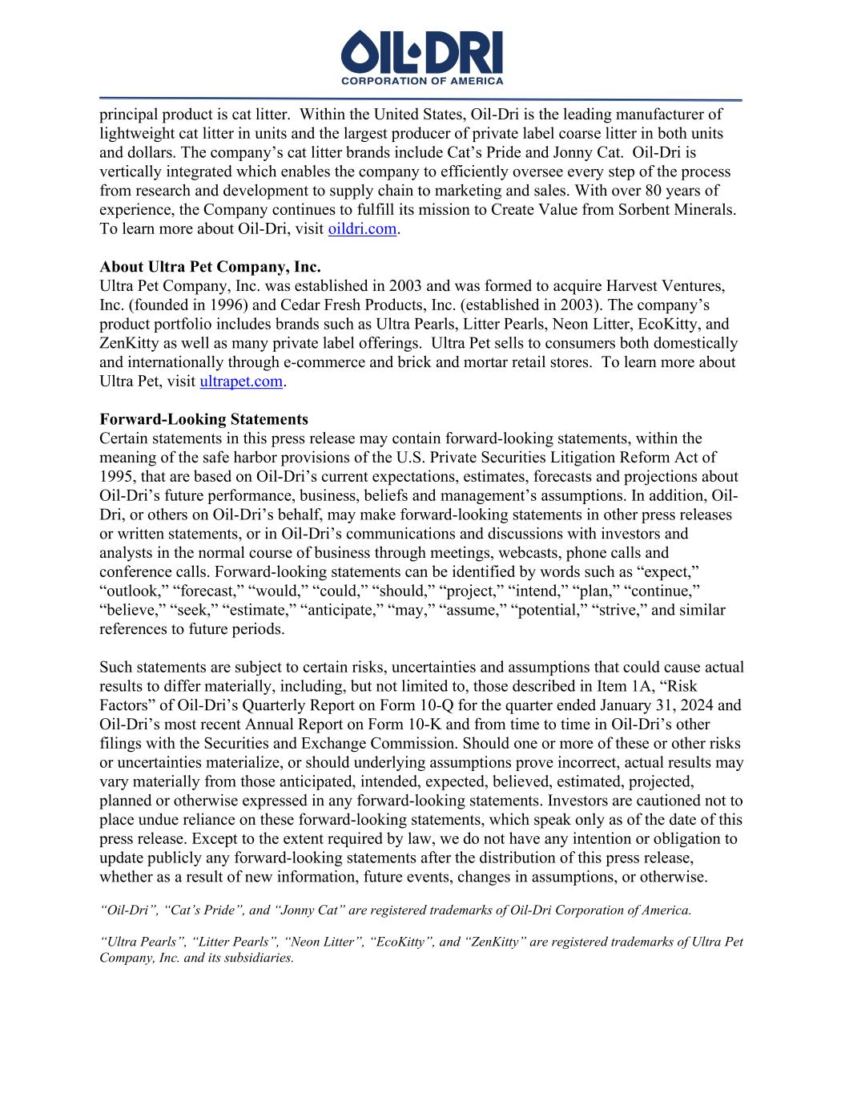
principal product is cat litter. Within the United States, Oil-Dri is the leading manufacturer of lightweight cat litter in units and the largest producer of private label coarse litter in both units and dollars. The company’s cat litter brands include Cat’s Pride and Jonny Cat. Oil-Dri is vertically integrated which enables the company to efficiently oversee every step of the process from research and development to supply chain to marketing and sales. With over 80 years of experience, the Company continues to fulfill its mission to Create Value from Sorbent Minerals. To learn more about Oil-Dri, visit oildri.com. About Ultra Pet Company, Inc. Ultra Pet Company, Inc. was established in 2003 and was formed to acquire Harvest Ventures, Inc. (founded in 1996) and Cedar Fresh Products, Inc. (established in 2003). The company’s product portfolio includes brands such as Ultra Pearls, Litter Pearls, Neon Litter, EcoKitty, and ZenKitty as well as many private label offerings. Ultra Pet sells to consumers both domestically and internationally through e-commerce and brick and mortar retail stores. To learn more about Ultra Pet, visit ultrapet.com. Forward-Looking Statements Certain statements in this press release may contain forward-looking statements, within the meaning of the safe harbor provisions of the U.S. Private Securities Litigation Reform Act of 1995, that are based on Oil-Dri’s current expectations, estimates, forecasts and projections about Oil-Dri’s future performance, business, beliefs and management’s assumptions. In addition, Oil- Dri, or others on Oil-Dri’s behalf, may make forward-looking statements in other press releases or written statements, or in Oil-Dri’s communications and discussions with investors and analysts in the normal course of business through meetings, webcasts, phone calls and conference calls. Forward-looking statements can be identified by words such as “expect,” “outlook,” “forecast,” “would,” “could,” “should,” “project,” “intend,” “plan,” “continue,” “believe,” “seek,” “estimate,” “anticipate,” “may,” “assume,” “potential,” “strive,” and similar references to future periods. Such statements are subject to certain risks, uncertainties and assumptions that could cause actual results to differ materially, including, but not limited to, those described in Item 1A, “Risk Factors” of Oil-Dri’s Quarterly Report on Form 10-Q for the quarter ended January 31, 2024 and Oil-Dri’s most recent Annual Report on Form 10-K and from time to time in Oil-Dri’s other filings with the Securities and Exchange Commission. Should one or more of these or other risks or uncertainties materialize, or should underlying assumptions prove incorrect, actual results may vary materially from those anticipated, intended, expected, believed, estimated, projected, planned or otherwise expressed in any forward-looking statements. Investors are cautioned not to place undue reliance on these forward-looking statements, which speak only as of the date of this press release. Except to the extent required by law, we do not have any intention or obligation to update publicly any forward-looking statements after the distribution of this press release, whether as a result of new information, future events, changes in assumptions, or otherwise. “Oil-Dri”, “Cat’s Pride”, and “Jonny Cat” are registered trademarks of Oil-Dri Corporation of America. “Ultra Pearls”, “Litter Pearls”, “Neon Litter”, “EcoKitty”, and “ZenKitty” are registered trademarks of Ultra Pet Company, Inc. and its subsidiaries.

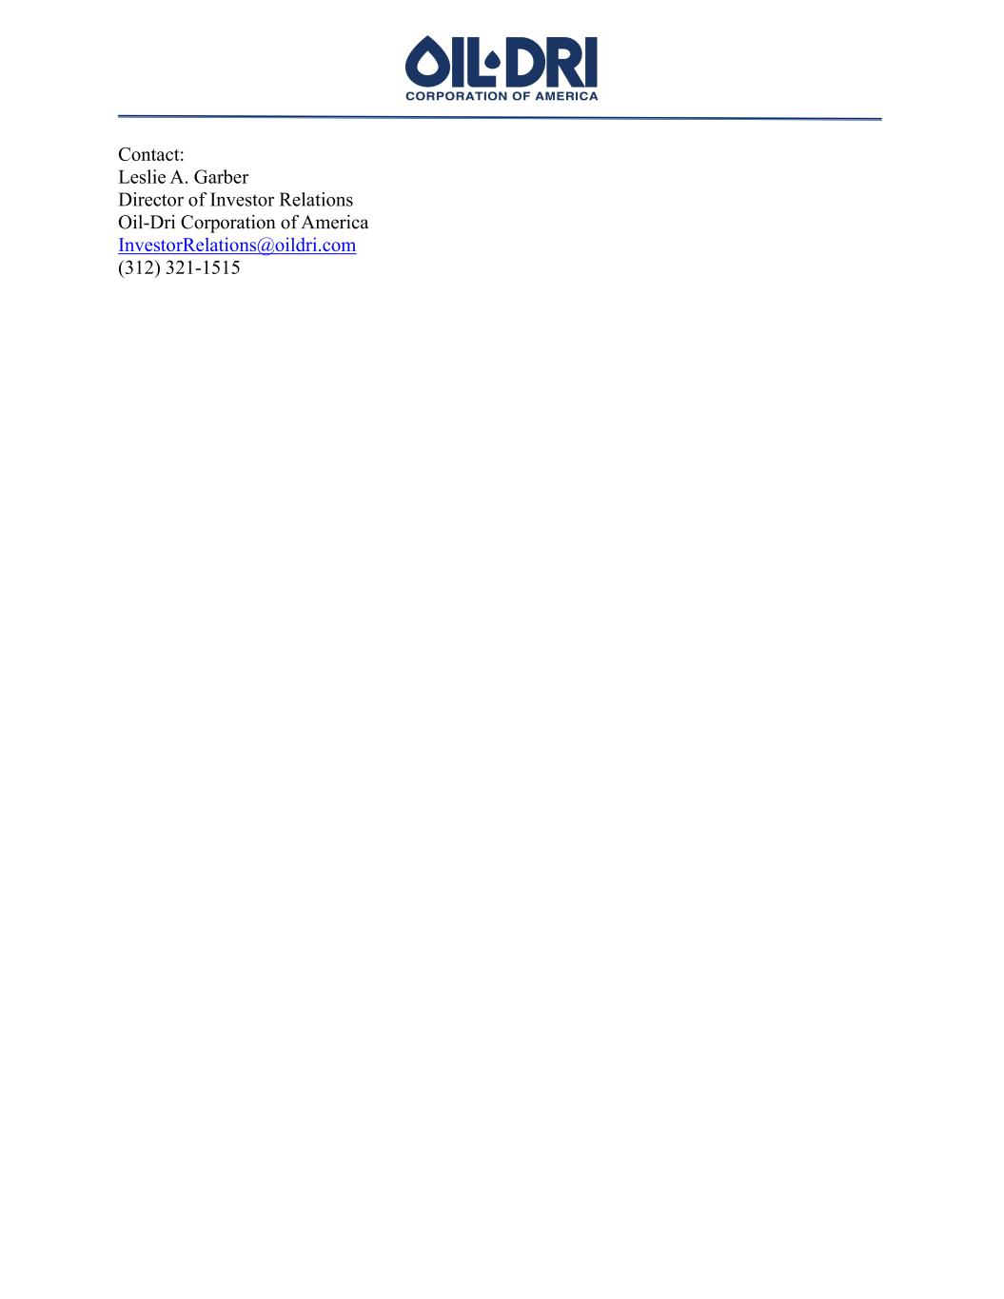
Contact: Leslie A. Garber Director of Investor Relations Oil-Dri Corporation of America InvestorRelations@oildri.com (312) 321-1515

