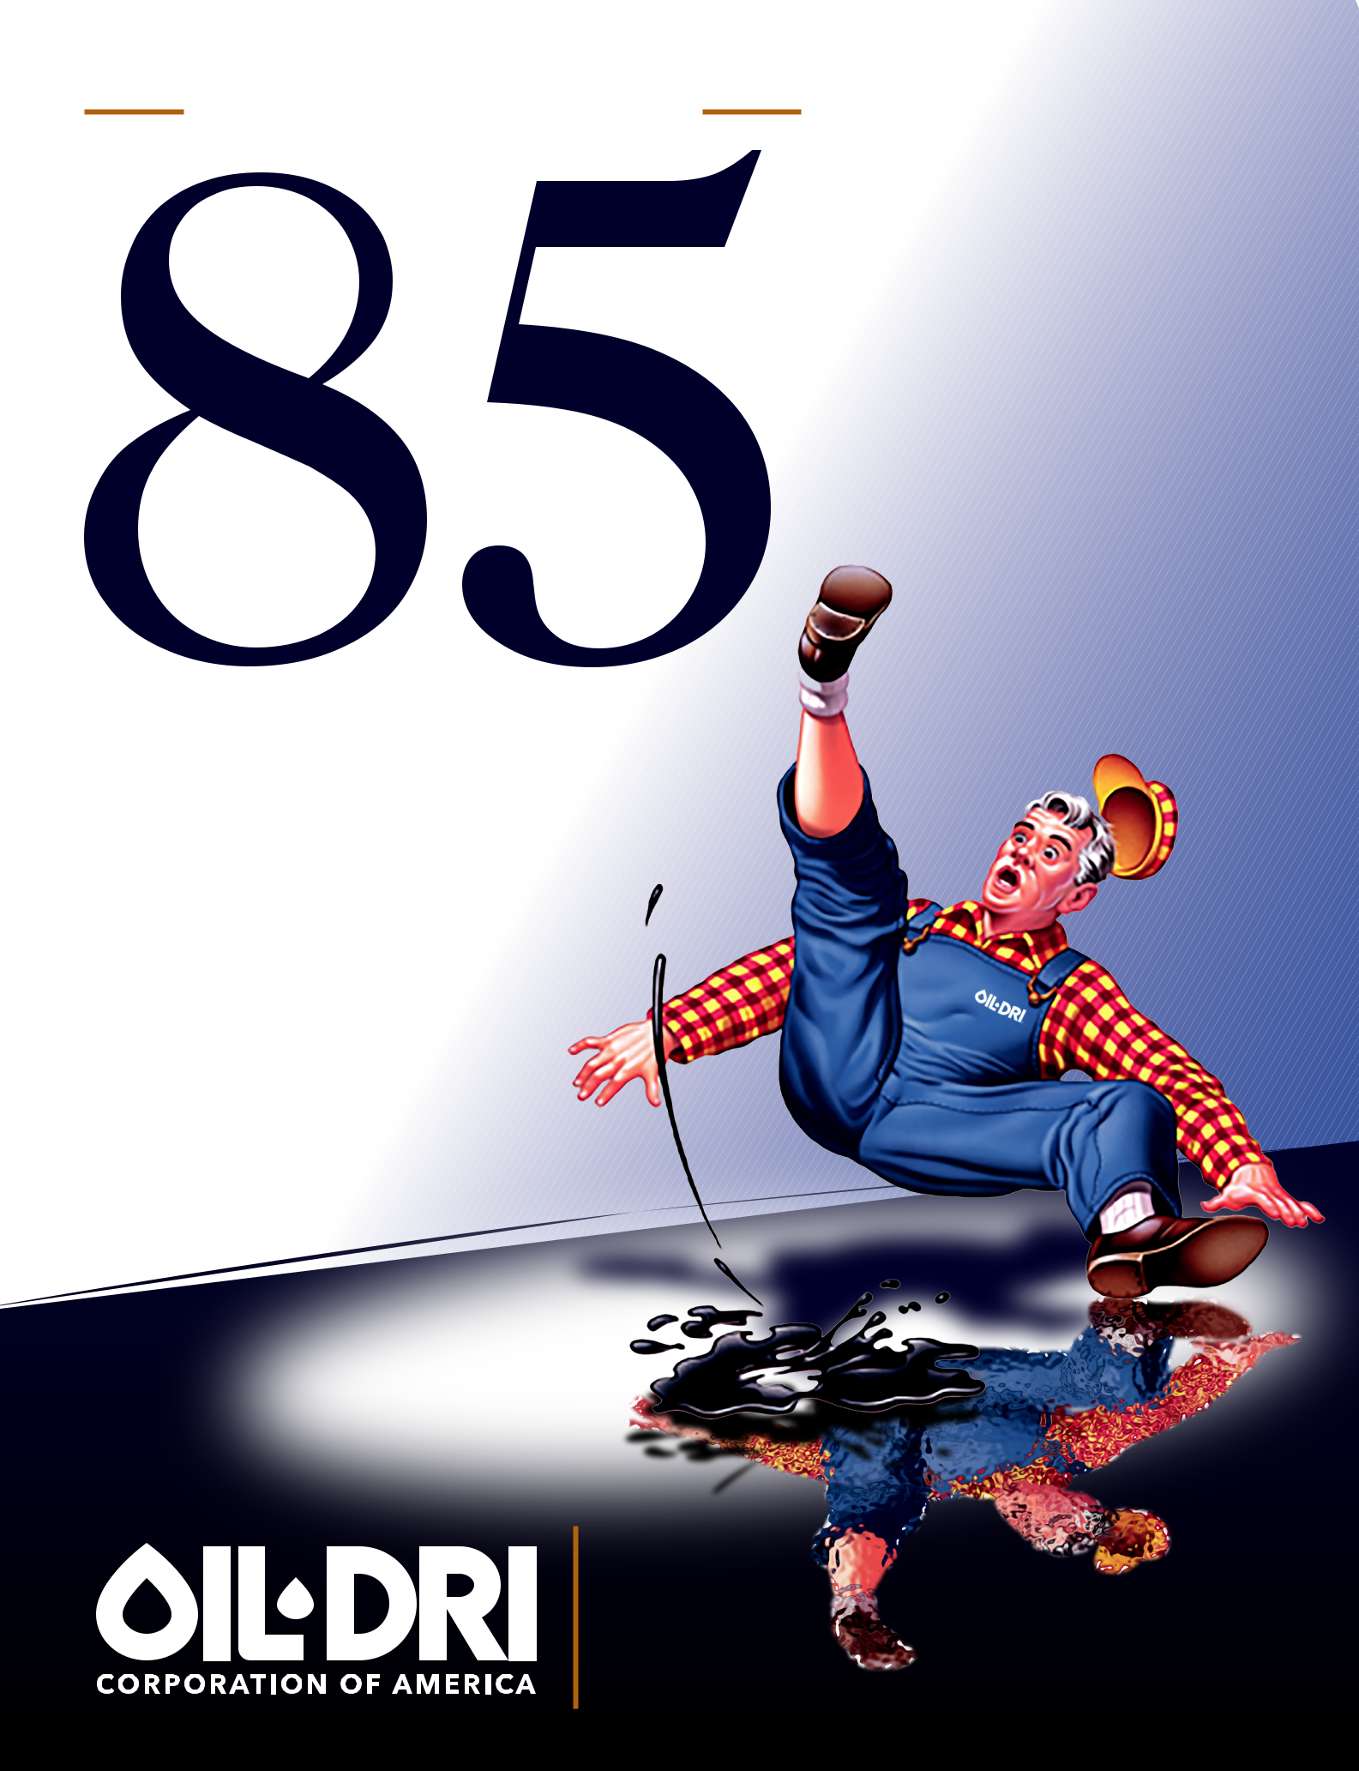
C E L E B R AT I N G

YEARS

1941-2026

2026

ANNUAL REPORT

85 YEARS OF CONTINUOUS IMPROVEMENT

1941 - 2026

Inspired by the remarkable properties of clay, Nick Jaffee introduced Fuller’s Earth as a nonflammable replacement for sawdust to absorb oil from factory floors and garages. This highly absorbent mineral became Oil-Dri’s legacy product. Since then, the Company has grown into a vertically integrated, leading manufacturer and supplier of sorbent minerals serving multiple markets around the world. For 85 years, the Company has expanded through innovation, strategic investments, and a commitment to creating value for customers, teammates, and shareholders.
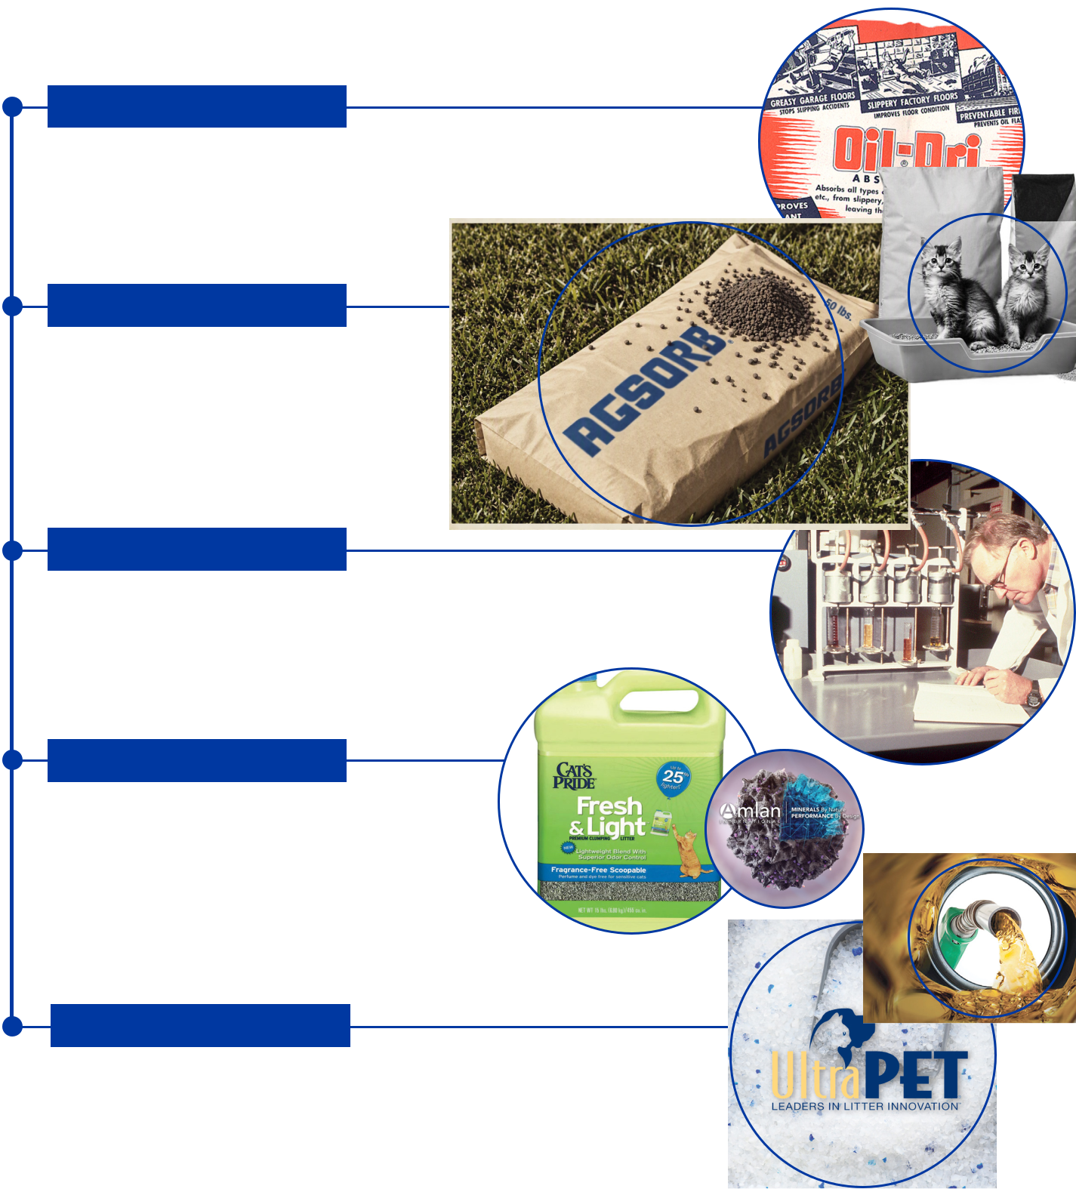
The milestones below highlight key moments that have shaped Oil-Dri’s history and established a strong foundation for future growth.

1940’s / 1950’s

1941: Oil-Dri Corporation of America (“ODC”) was founded.

1947: ODC entered the cat litter market.

1950: Nick Jaffee acquired a minority stake in two mineral

companies located in Georgia & Mississippi.

1960’s / 1970’s

1960: Dick Jaffee assumed the roles of President & CEO and led the Company’s journey to become 100% vertically integrated.

1965: ODC diversified into agricultural carrier products.

1971: ODC completed its initial public offering and was listed on NASDAQ.

1980’s / 1990’s

1986: ODC expanded into the fluids purification market.

1991: The Nick Jaffee Center for Innovation opened in Vernon Hills, IL.

1993: ODC moved its listing to the NYSE.

1995: Dan Jaffee became President.

2000’s / 2010’s

2001: A new mission statement was developed: Creating Value from Sorbent Minerals. ODC entered the sports field market.

2007: Amlan International was established as Oil-Dri’s animal health business.

2011: ODC invented the first Lightweight litter and revolutionized the cat litter industry.

2020’s

2020: ODC entered the renewable diesel purification market.

2024: Ultra Pet Company, Inc., a prominent supplier of crystal cat litter, was acquired.

2026: ODC achieved record annual consolidated net sales and net income.

All-time high share price drove market capitalization to unprecedented levels.

*AI generated image. .
Nick Jaffee (1941-1960), Dick Jaffee (1958-2017),
Dan Jaffee (1987-Present).
Three Generations of Family Leadership.
LETTER TO STAKEHOLDERS

Dear Oil-Dri Stakeholder,

Fiscal year 2026 marked our 85th year in business. I asked AI, “What percentage of businesses make it to their 85th year?” While there was no exact data, it estimated that “a few tenths of 1% or less of U.S. companies are still in operation after 85 years.” What makes this anniversary particularly remarkable is that Oil-Dri is celebrating not only its longevity, but also all-time record sales and net income. Our net income growth over the past 5 years speaks for itself:

Fiscal Year Net Income


2022 $ 5,674,000

2023 $29,551,000

2024 $39,426,000

2025 $53,996,000

2026 $56,969,000

This significant net income progression is a testament to the diversity of our businesses. During this five-year span, no division exceeded its budget every single year, and no division fell short of its budget every single year. In any given year, some were up and some were down, but net, net the combination of our different businesses delivered remarkable results year after year.

Gross margins were compressed in fiscal year 2026 due to higher manufacturing and freight costs, including increased depreciation associated with our accelerated capital investment program. As we completed our third consecutive year of capital expenditures in excess of $30 million, we invested close to $100 million in the business during that

time span. We expected to see margin tightening as our depreciation caught up to our actual spending. However, cash generation remained at an all-time high which enabled us not only to raise our dividend rate for the 23rd consecutive year, but to raise it twice during fiscal year 2026. We started the year with $50 million in cash and cash equivalents and finished the year with $74 million in cash and cash equivalents! The fact is that we had a great year from a cash generation standpoint.

In addition, our crystal litter business continued to gain momentum with 16% year-over-year growth, demonstrating the success of the Ultra Pet Company, Inc. acquisition in May of 2024. In fiscal year 2026, we expanded our offerings with the launch of new health monitoring crystal litter items, while continuing to realize synergies and increase distribution through our strong customer relationships. This progress reinforces the strategic value of the acquisition and our ability to strengthen our presence in the cat litter category.

During the year, we actively looked for acquisition opportunities that we believe could be accretive, and while we identified some opportunities that seemed to fit our mission of Creating Value from Sorbent Minerals, we ultimately determined that the costs would have exceeded the benefits. Therefore, we remained disciplined, choosing to pass, and intend to continue to look for the right fit. I am very proud of the Oil-Dri teammates who helped us analyze and value these opportunities. This experience will serve us well in fiscal year 2027 and beyond.

I want to thank our nearly 1,000 global Oil-Dri teammates, who not only helped us achieve these quantitative results, but more importantly, did so while embracing our core values which include ethics, continuous improvement, and respect. We were recognized by USA Today as a Top Workplace and, for the third year in a row, were named to Forbes Magazine’s list of America’s Most Successful Small-Cap Companies.

I also want to express my appreciation to our shareholders, many of whom have been with us for decades. We remain committed to doing our best every day to create value for you and to sharing our success with you each year.

In closing, I want to sincerely thank our customers. They rely on our quality and service at an all-in cost that helps them create value for their businesses. Our results are directly tied to our customers’ satisfaction and the trust they place in us. We are grateful for their support and for rewarding us with their ongoing orders.
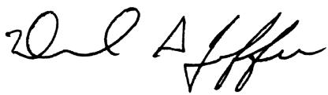

DANIEL S. JAFFEE

President & Chief Executive Officer

FORWARD-LOOKING STATEMENTS

This document contains forward-looking statements that are based on

current expectations, estimates, forecasts, and projections about our future

performance, our business, our beliefs, and our management’s assumptions.

See page 4 for cautionary language regarding such statements.

FINANCIAL HIGHLIGHTS

Fiscal Years End July 31

Dollar Amount in Thousands (Except Per Share Data)

KEY METRICS | 2024 | 2025 | 2026
Return on Average Assets | 12.3% | 14.5% | 13.9%
Return on Average Shareholder Equity | 20.3% | 23.0% | 20.5%
Return on Invested Capital | 14.3% | 17.3% | 15.3%
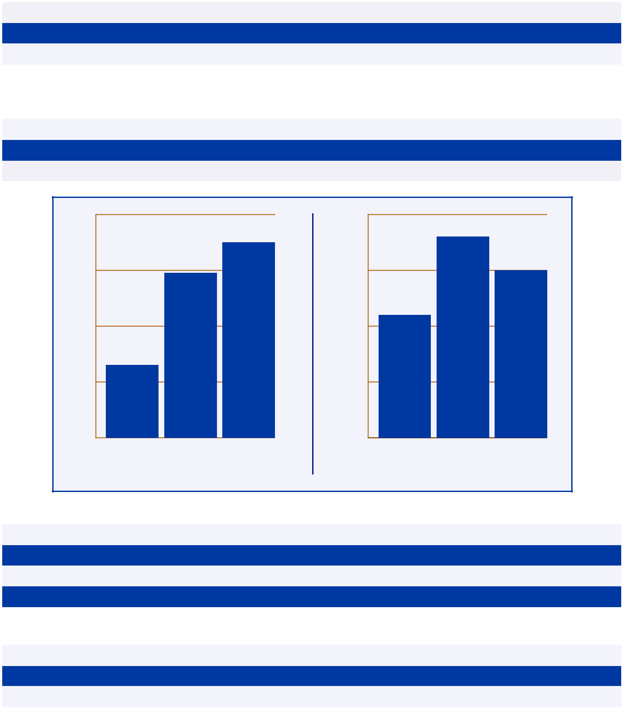

INCOME STATEMENT DATA | 2024 | 2025 | 2026
Net Sales | $437,587 | $485,572 | $493,844
Gross Profit | $125,094 | $143,083 | $137,510
Net Income | $39,426 | $53,996 | $56,969

$620

$610

$600
$599

$580

$566

$560

^{$540} 2024 2025 2026

NET SALES/TON

$180

$176

$170 | $170

_{$160} $162

$150

$140 | 2024 | 2025 | 2026

GROSS PROFIT/TON

BALANCE SHEET DATA | 2024 | 2025 | 2026
Cash and Cash Equivalents | $23,481 | $50,458 | $73,700
Total Assets | $354,605 | $392,224 | $428,786
Notes Payable | $50,774 | $39,817 | $38,857
Working Capital | $80,481 | $108,196 | $140,603

PER SHARE DATA* | 2024 | 2025 | 2026
Diluted Earnings per Share - Common Stock | $2.72 | $3.70 | $3.92
Paid Dividend per Share - Common Stock | $0.58 | $0.62 | $0.77
Book Value per Share† | $14.43 | $17.69 | $20.56

- Prior year per share data has been updated to reflect the 2-for-1 stock-split in January 2025. † Book Value per Share is based on total shares outstanding at the end of the fiscal year. Certain amounts in the prior period financial statements have been reclassified to conform to the presentation of the current period financial statements.

UNITED STATES

SECURITIES AND EXCHANGE COMMISSION

Washington, D.C. 20549

FORM 10-K

- ANNUAL REPORT PURSUANT TO SECTION 13 OR 15(d) OF THE SECURITIES EXCHANGE ACT OF 1934

For the fiscal year ended July 31, 2026

OR

- TRANSITION REPORT PURSUANT TO SECTION 13 OR 15 (d) OF THE SECURITIES EXCHANGE ACT OF

1934

For the Transition Period from _____ to _____

Commission File Number 001-12622

OIL-DRI CORPORATION OF AMERICA

(Exact name of the registrant as specified in its charter)

 |  | Delaware |  |  | 36-2048898
(State or other jurisdiction of incorporation or |  |  |  |  | (I.R.S. Employer Identification No.)
 |  | organization)
 | 410 North Michigan Avenue, Suite 400
 |  | Chicago, Illinois |  |  | 60611-4213
 | (Address of principal executive offices) |  |  |  | (Zip Code)

The registrant's telephone number, including area code: (312) 321-1515

Securities registered pursuant to Section 12(b) of the Act:

Title of Each Class | Trading Symbol(s) | Name of Each Exchange on Which
Title of Each Class | Trading Symbol(s) | Registered
Common Stock, par value $0.10 per | ODC | New York Stock Exchange
share | ODC | New York Stock Exchange

Securities registered pursuant to Section 12(g) of the Act: None

Indicate by check mark if the registrant is a well-known seasoned issuer, as defined in Rule 405 of the Securities Act. Yes ☐ No ☒

Indicate by check mark if the registrant is not required to file reports pursuant to Section 13 or Section 15(d) of the Act. Yes ☐ No ☒

Indicate by check mark whether the registrant (1) has filed all reports required to be filed by Section 13 or 15(d) of the Securities Exchange Act of 1934 during the preceding 12 months (or for such shorter period that the registrant was required to file such reports), and (2) has been subject to such filing requirements for the past 90 days.
Yes ☒ No ☐

Indicate by check mark whether the registrant has submitted electronically every Interactive Data File required to be submitted pursuant to Rule 405 of Regulation S-T (§232.405 of this chapter) during the preceding 12 months (or for such shorter period that the registrant was required to submit and post such files).
Yes ☒ No ☐

1

Indicate by check mark whether the registrant is a large accelerated filer, an accelerated filer, a non-accelerated filer, a smaller reporting company, or an emerging growth company. See the definitions of “large accelerated filer,” “accelerated filer,” “smaller reporting company,” and “emerging growth company” in Rule 12b-2 of the Exchange Act.

Large accelerated filer | ☐ | Smaller reporting company | ☐
Accelerated filer | ☒ | Emerging growth company | ☐
Non-accelerated filer | ☐

If an emerging growth company, indicate by check mark if the registrant has elected not to use the extended transition period for complying with any new or revised financial accounting standards provided pursuant to Section 13(a) of the Exchange Act.
o

Indicate by check mark whether the registrant has filed a report on and attestation to its management’s assessment of the effectiveness of its internal control over financial reporting under Section 404(b) of the Sarbanes-Oxley Act (15 U.S.C.

7262(b)) by the registered public accounting firm that prepared or issued its audit report. ☒

If securities are registered pursuant to Section 12(b) of the Act, indicate by check mark whether the financial statements of the registrant included in the filing reflect the correction of an error to previously issued financial statements. ☐

Indicate by check mark whether any of those error corrections are restatements that required a recovery analysis of incentive-based compensation received by any of the registrant’s executive officers during the relevant recovery period pursuant to §240.10D-1(b). ☐

Indicate by check mark whether the registrant is a shell company (as defined in Rule 12b-2 of the Exchange Act). Yes ☐ No ☒

The aggregate market value of the registrant’s Common Stock, par value $0.10 per share ("Common Stock") owned by non-affiliates as of January 31, 2026 was $589,276,172.

As of September 30, 2026, 10,245,493 shares of the registrant's Common Stock and 4,233,940 shares of the registrant's Class B Stock, par value $0.10 per share ("Class B Stock") were outstanding.

DOCUMENTS INCORPORATED BY REFERENCE

Portions of the registrant’s Definitive Proxy Statement for its 2026 Annual Meeting of Stockholders (“Proxy Statement”), which will be filed with the U.S. Securities and Exchange Commission (“SEC”) not later than November 28, 2026 (120 days after the fiscal year to which this report relates), are incorporated into Part III of this Annual Report on Form 10-K where indicated.

2

CONTENTS

Item Page


PART I

1 Business 5

1A. Risk Factors 14

1B. Unresolved Staff Comments 27

1C. Cybersecurity 27

2 Properties 28

3 Legal Proceedings 33

4 Mine Safety Disclosure 33

PART II

5 Market for Registrant's Common Equity, Related Stockholder Matters and Issuer 34
Purchases of Equity Securities .................................................................................

6 [Reserved] 35

7 Management's Discussion and Analysis of Financial Condition and Results of 36
Operations ................................................................................................................

8 Financial Statements and Supplementary Data 45

Management's Report on Internal Control Over Financial Reporting 75

Report of Independent Registered Public Accounting Firm, PCAOB ID: 248 76

9 Changes in and Disagreements with Accountants on Accounting and Financial 78
Disclosure .................................................................................................................

9A. Controls and Procedures 78

9B. Other Information 78

9C. Disclosure Regarding Foreign Jurisdictions that Prevent Inspections 78

PART III

10 Directors, Executive Officers and Corporate Governance 79

11 Executive Compensation 79

12 Security Ownership of Certain Beneficial Owners and Management and Related 79

13 Certain Relationships and Related Transactions, and Director Independence 80

14 Principal Accountant Fees and Services 80

PART IV

15 Exhibits and Financial Statement Schedule 81

Signatures 86

Schedule II - Valuation and Qualifying Accounts 88

3

FORWARD-LOOKING STATEMENTS

Certain statements in this report, including, but not limited to, under the heading "Management’s Discussion and Analysis of Financial Condition and Results of Operations," and elsewhere in this report and in other documents that we file with the SEC, may constitute forward-looking statements within the meaning of the safe harbor provisions of the U.S. Private Securities Litigation Reform Act of 1995. Our forward-looking statements include, but are not limited to, statements regarding our or our management team’s expectations, hopes, beliefs, intentions or strategies regarding the future. In addition, any statements that refer to projections, forecasts or other characterizations of future events or circumstances, including any underlying assumptions, are forward-looking statements. These forward-looking statements are based on management's current expectations, estimates, forecasts, assumptions and projections about future events, our future performance, the future of our business, our plans and strategies, projections, anticipated trends, the economy and other future developments and their potential effects on us. In addition, we, or others on our behalf, may make forward-looking statements in press releases or written statements, or in our communications and discussions with investors and analysts in the normal course of business through meetings, webcasts, phone calls and conference calls. Forward-looking statements can be identified by words such as "expect," “endeavor,” "outlook," "forecast," "would," "could," "should," "project," "intend," "plan," "continue," "believe," "seek," "estimate," "anticipate," "may," "assume," "potential," "foresee," "predict," "possible," "commit," "design," "strive," and variations of such words and similar references to future periods.

Such statements are subject to certain risks, uncertainties and assumptions that could cause actual results to differ materially from those anticipated, intended, expected, believed, estimated, projected, planned or otherwise expressed in any forward-looking statements, including, but not limited to, those described in Item 1A "Risk Factors" and elsewhere herein and from time to time in our other filings with the SEC. We believe that these factors include, but are not limited to:

- Our future financial performance and ability to be profitable;

- Our ability to compete in highly competitive markets;

- Our ability to continue our growth at or near historical rates;

- The effect of global events on the United States (“U.S.”) and global economies, our business, our employees, our results of operations, our financial condition, demand for our products, sales and implementation cycles, and the health of our clients’ and partners’ businesses;

- The successful assimilation or integration of the businesses, technologies, services, products, personnel or operations of acquired companies;

- Our ability to attract and retain customers;

- The effect of supply or logistics disruptions;

- Our ability to effectively operate our production facilities;

- The availability and quality of the clay we mine;

- Our ability to maintain, protect, and enhance our intellectual property rights;

- Our ability to attract and retain talent;

- The effect of new, and our ability to effectively manage current, legal and regulatory obligations; and

- Our ability to prevent and respond to technology failures, data breaches, unauthorized access to client data or other disruptions of our solutions.

Investors are cautioned not to place undue reliance on these forward-looking statements, which speak only as of the date hereof. Except to the extent required by law, we do not have any intention or obligation to update publicly any forward-looking statements after the distribution of this report, whether as a result of new information, future events, changes in assumptions or otherwise.

TRADEMARKS

This report contains references to trademarks, trade names and service marks belonging to us or other companies. We do not intend our use or display of other companies’ trade names, trademarks or service marks to imply a relationship with, or endorsement or sponsorship of us by, any other companies. Agsorb, Ambio, Amlan, Calibrin, Cat’s Pride, Flo-Fre, Jonny Cat, KatKit, Litter Pearls, MD-09, Metal-X, Metal-Z, NeoPrime, Oil-Dri, Pel-Unite, Perform, Pro Mound, Pro's Choice Sports Field Products, Pure-Flo, Rapid Dry, Saular, Select, Sorbiam, Ultra, Ultra-Clear, Varium and Verge are registered or common law trade names, trademarks or service marks of Oil-Dri Corporation of America or of its subsidiaries. Fresh Step is a registered trademark of The Clorox Pet Products Company.

4

PART I

ITEM 1 – BUSINESS

OVERVIEW OF BUSINESS

Except as otherwise indicated herein or as the context otherwise requires, references to “Oil-Dri,” the “Company,” “we,” “us” or “our” refer to Oil-Dri Corporation of America and its subsidiaries.

Oil-Dri is a leader in developing, manufacturing and/or marketing sorbent products. Our sorbent products are principally produced from hydrated aluminosilicate minerals, primarily consisting of calcium bentonite, attapulgite and diatomaceous shale, which we refer to collectively as our “clay,” our “minerals,” or “Fuller's Earth.” We surface mine our clay on leased or owned land near our manufacturing facilities in Mississippi, Georgia, Illinois and California. We produce both absorbent and adsorbent products from our clay. Absorbents, like sponges, draw liquids up into their many pores. Examples of our absorbent clay products are Cat’s Pride and Jonny Cat branded premium cat litter, as well as other private label cat litters. Additional examples are our Oil-Dri branded floor absorbents, Amlan branded animal health and nutrition solutions for livestock, and Agsorb and Verge agricultural chemical carriers. Adsorbent products attract impurities in liquids, such as metals and surfactants, and form low-level chemical bonds. Examples of our adsorbent products include Ultra-Clear, Pure-Flo, Supreme, Perform, Select, Metal-X and Metal-Z which act as purification mediums for edible and non-edible oils. We also sell nonclay-based products, such as our Oil-Dri synthetic sorbents used for automotive, industrial and marine cleanup, silica gel-based crystal cat litter, and plastic cat litter box liners. Our principal products are described in more detail below.

Oil-Dri Corporation of America was incorporated in Delaware in 1969 as the successor to an Illinois corporation incorporated in 1946 (which was the successor to a partnership that commenced business in 1941). For additional information on recent business developments, see “Management’s Discussion and Analysis of Financial Condition and Results of Operations,” in Part II, Item 7, incorporated herein by reference.

OPERATING SEGMENTS

We have two reportable operating segments for financial reporting derived from the different characteristics of our two major customer groups: the Retail and Wholesale Products Group and the Business to Business Products Group. The Retail and Wholesale Products Group customers include mass merchandisers, the farm & fleet channel, drugstore chains, pet specialty retail outlets, dollar stores, retail grocery stores, online retailers, co-packaged products customers, distributors of industrial cleanup and automotive products, environmental service companies and users of sports field products and sports turf materials. The Business to Business Products Group customers include processors and refiners of edible oils, renewable diesel, petroleum-based oils and biodiesel fuel; manufacturers of animal feed and agricultural chemicals; and distributors of animal health and nutrition products. Certain financial information on both segments is contained in Note 3 of the Notes to the Consolidated Financial Statements and is incorporated herein by reference.

PRINCIPAL PRODUCTS BY OPERATING SEGMENT

Retail and Wholesale Products Group

Cat Litter

We manufacture clay-based cat litter and supply crystal cat litter products. Both are designed for absorbency and odor control. Our clay-based offerings include scoopable and coarse non-clumping litters. Scoopable litters clump when exposed to moisture, allowing consumers to remove and dispose of only the used portion. These products are further differentiated into lightweight and heavyweight varieties, with lightweight scoopable litters providing strong performance along with the added convenience of easier carrying and pouring. Our crystal cat litter is made from synthetic silica-gel granules and, like lightweight clay-based litter, offers a lightweight format with superior odor control. Our crystal litter is 99.9% dust-free and provides long-lasting performance with minimal maintenance. We sell our cat litter products domestically and internationally through e-commerce platforms and brick-and-mortar retail stores.

Branded products. Our scoopable and non-clumping clay-based litters are sold under our Cat’s Pride and Jonny Cat brand names. Our Cat's Pride litters created the lightweight segment of the scoopable litter market. Our Cat’s Pride Antibacterial Clumping Litter was the first and is the only Environmental Protection Agency (“EPA”) approved antibacterial cat litter in the United States. In addition, we offer our non-clumping litter in a pre-packaged, disposable tray under the Cat’s Pride KatKit brand. Our crystal cat litters are sold under our Cat's Pride, Ultra and Litter Pearls brand names. Moreover, we offer litter box liners under the Cat's Pride and Jonny Cat product lines. These products are sold through independent food

5

brokers and by our sales force to major grocery, drug, dollar store, mass-merchandiser, farm & fleet, and pet outlets, as well as through online retailers.

Private label products. We produce private label scoopable and non-clumping clay-based cat litters as well as crystal

cat litter.

Co-packaged products. We have long-term supply agreements with A&M Products Manufacturing Company, a subsidiary of The Clorox Company ("Clorox"), under which we manufacture certain branded cat litter products. Under these agreements, we are responsible for manufacturing finished goods of certain Fresh Step cat litter products based on market demand.

Industrial and Automotive

We manufacture and market clay-based, polypropylene and recycled absorbent products used to absorb oil, water, chemicals and other liquids across industrial, automotive, marine, environmental, and residential applications. Our product portfolio includes floor absorbents, spill containment products, pads, rolls, socks, booms and spill kits sold under branded and private-label offerings. These products are distributed through industrial, automotive, safety, janitorial, chemical, and paper distributors as well as through retailers and e-commerce channels in domestic and international markets.

Sports

We manufacture and market Pro's Choice branded and private label sports field products used in the construction, maintenance, and improvement of natural turf athletic fields. Our product offerings include infield conditioners, soil conditioners, packing clays, and drying agents that enhance drainage, field performance, and playability. These products serve professional, collegiate, high school, and municipal sports facilities and are sold through multiple distribution channels.

Business to Business Products Group

Fluids Purification

We produce an array of adsorbent products for bleaching, purification and filtration applications that are used around the world by edible oil processors, as well as by refiners of renewable diesel, jet fuel, including sustainable aviation fuel, and other petroleum-based products. Bleaching clays are used by edible oil processors to adsorb soluble contaminants that promote oxidation problems. Our Pure-Flo and Perform bleaching clays remove impurities, such as trace metals, chlorophyll and color bodies, in various types of edible oils. Perform products provide increased activity for hard-to-bleach oils. Our Select adsorbents are used in a pre-treatment process to remove metals and trace soap in vegetable oil processing. Our Select adsorbents can also be used to pre-treat oil in the processing of biodiesel. Metal-X and Metal-Z are highly efficient adsorbents for the renewable diesel and sustainable aviation fuel markets. Our Ultra-Clear product is used as a purification and filtration medium for jet fuel and other petroleum-based products. These products are sold in the United States and in international markets by our team of technical sales employees, distributors and sales agents.

Agricultural and Horticultural

We manufacture granules and powders that enhance agricultural and horticultural products. Our mineral-based absorbents serve as carriers for biological and chemical active ingredients, drying agents, and growing media. Our brands include: Agsorb, an agricultural and horticultural carrier and drying agent; Verge, an engineered carrier and drying granule; and Flo-Fre, a highly absorbent microgranule designed to improve flowability.

Agsorb and Verge carriers support lawn and garden and row crop products that serve as alternatives to liquid sprays. Their mineral granules absorb active ingredients and deliver them directly into or onto the soil, enabling more targeted application. Verge carriers are spherical, uniformly sized granules with very low dust. Agsorb drying agents are blended into fertilizer-pesticide formulations to absorb moisture and improve flowability. Flo-Fre microgranules are used by grain processors and other bulk handlers to absorb excess moisture and prevent caking. These products are sold primarily in the United States through our technical sales force.

Animal Health and Nutrition

We produce, or use contract processors to produce, Amlan brand name and private label products that support good health and productivity of species in livestock industries. For example, our products, including our Calibrin, Varium and

6

NeoPrime products in our international markets, and Sorbiam, Ambio P and Ambio S products sold to customers in North America, provide a number of solutions for swine, poultry and dairy cattle livestock production. In addition, our MD-09 moisture manager product is a feed additive for the reduction of wet droppings in poultry and our Pel-Unite and Pel-Unite Plus products are specialized animal feed pellet binders.

Our animal health and nutrition products are sold both directly and through a network of distributors to livestock producers, feed mill operators, nutritionists and veterinarians in the United States, Latin America, Mexico, Asia and Africa. The sales force for our subsidiaries located in China, Mexico and Indonesia also sell these products, as further described in Foreign Operations below.

FOREIGN OPERATIONS

Our foreign operations located in Canada and the Netherlands are included in the Retail and Wholesale Products Group, while operations in the United Kingdom, China, Switzerland, Mexico and Indonesia are included in the Business to Business Products Group.

Our wholly-owned subsidiary, Oil-Dri Canada ULC, located in Canada, is a manufacturer, distributor and marketer of branded and private label cat litter in the Canadian marketplace. Among its leading brands are Saular, Cat’s Pride and Jonny Cat. Our Canadian business also manufactures or purchases and sells industrial granule floor absorbents, synthetic polypropylene sorbent materials and agricultural chemical carriers.

Our wholly-owned subsidiary, MBA Pet BV, located in the Netherlands, which was acquired on May 1, 2024 as part of the acquisition of Ultra Pet Company, Inc. ("Ultra Pet"), is a distributor of silica gel-based cat litter to the Europe region.

Our wholly-owned subsidiary, Oil-Dri (U.K.) Limited, located in the United Kingdom, is a manufacturer, distributor and marketer of bleaching earth, industrial floor absorbents and cat litter. These products are marketed in the United Kingdom and Western Europe. Oil-Dri (U.K.) Limited also sells synthetic polypropylene sorbent materials and plastic containment products.

Our wholly-owned subsidiaries, Amlan Trading (Shenzhen) Company, Ltd., located in China, and PT Amlan Perdagangan Internasional, located in Indonesia, are dedicated to our animal health business.

Our wholly-owned subsidiary, Oil-Dri SARL, located in Switzerland, performs various management, customer service and administrative functions for some of the international customers of our domestic operations.

Our wholly-owned subsidiary, Agromex Importaciones, S.A de C.V, located in Mexico, sells our international animal health and nutrition products.

Our foreign operations are subject to the normal risks of doing business in non-U.S. countries, such as currency fluctuations, restrictions on the transfer of funds and import/export duties; however, historically our operating results have not been materially impacted by these factors. Incorporated herein by reference are Item 1A "Risk Factors," which describes other risks that could impact our foreign operations, and Note 3 of the Notes to the Consolidated Financial Statements, which contains certain financial information about our foreign operations.

CUSTOMERS

Walmart Inc. (“Walmart”) is a customer in our Retail and Wholesale Products Group with whom we have a long-term relationship. Sales to Walmart and its affiliates accounted for approximately 18% and 19% of our total net sales for fiscal years 2026 and 2025, respectively. Sales to Walmart are comprised of a variety of products including but not limited to, multiple scoopable, coarse, and crystal cat litter items and accessories. There are no customers in the Business to Business Products Group with sales equal to or greater than 10% of our total sales. The degree of margin contribution of our significant customers in the Business to Business Products Group varies, with certain customers having a greater effect on our operating results. The loss of any customer other than those described in this paragraph would not be expected to have a material adverse effect on our business.

7

COMPETITION

Product performance, price, brand recognition, customer service, technical support, and distribution resources are the principal methods of competition in our markets and competition historically has been very vigorous. Advertising, promotion, merchandising and packaging also have a significant impact on retail consumer purchasing decisions, which primarily affects our Retail and Wholesale Products Group. Most of the principal competitors for our Retail and Wholesale Products Group have established brands as well as substantially greater financial resources or market presence than we do. These competitors may be able to spend more aggressively on advertising and promotional activities, introduce competing products more quickly and respond more effectively to changing business and economic conditions than us.

We have six principal competitors in our Retail and Wholesale Products Group, one of which is also our customer. Two of the principal competitors relate to our Industrial and Sports products while the other four relate to our cat litter products. The overwhelming majority of all cat litter is mineral based, including both scoopable and coarse non-clumping litter. Through our acquisition of Ultra Pet, we have expanded our footprint into the silica gel-based cat litter market, which is a growing cat litter market. Cat litters based on other alternatives, such as paper and various agricultural waste products, have niche positions. Scoopable products have a majority of the cat litter market share followed by coarse non-clumping litters.

There is significant competition to attract cat litter consumers across multi-outlet channels, including grocery, mass-merchandiser, dollar, pet and drug stores, as well as through online retailers. Competition for the scoopable litter market continues to be impacted by new product offerings and increased advertising and promotions by our competitors and by us. We provide our customers with product innovation, a nation-wide distribution network and strong customer service. Our exceptional sales and research and development teams, as well as our being vertically integrated, give us a further advantage over smaller and regional manufacturers. We also continue to expand our customer offerings, as evidenced by our recent entrance into the crystal cat litter market.

We currently have ten principal competitors in our Business to Business Products Group compared to nine reported in the prior year. This is due to a reassessment of principal competitors as a result of a competitor's increased product offerings. Our bleaching clay and fluids purification products are sold in a highly cost competitive global marketplace. The demand for these products has grown in recent years due to the use of our products in the filtration of renewable diesel. Performance is a primary competitive factor for these products. The animal health portion of this segment also operates in a global marketplace with price and performance competition from multi-national and local competitors. Competition for our crop protection products is primarily based on price, but competitor differentiation also exists in the ability to meet customer product specifications and enhancements in engineered granule technologies.

RESEARCH AND DEVELOPMENT

We develop new products and applications and improve existing products at our research and development ("R&D") facilities in Vernon Hills, Illinois, which are comprised of the Nick Jaffee Center for Innovation (the "Innovation Center") and the Richard M. Jaffee Laboratory for Applied Microbiology the "Microbiology Lab"). The Innovation Center includes a pilot plant that simulates the production processes of our customers and our manufacturing plants. The Microbiology Lab is dedicated primarily to the development of our animal health products while also supporting growth of our agriculture and horticulture and cat litter products. Our R&D team has experience in disciplines such as biology, microbiology, chemistry, physics, engineering, mathematics, geological and earth science, material science, geochemistry, physical catalysis, animal nutrition, and the animal sciences. The R&D team collaborates with manufacturing teams at all Oil-Dri plants as well as with our commercial teams. In the past several years, our research efforts and partnerships have resulted in several new sorbent products and processes. The R&D team produces prototype samples and tests new products for customer trial and evaluation across all Oil-Dri businesses. No significant R&D was customer sponsored, and all R&D costs are expensed in the period in which incurred. See Note 1 of the Notes to the Consolidated Financial Statements for further information about R&D expenses.

SEASONALITY

We consider our business, taken as a whole, to be moderately seasonal; however, business activities of certain customers, such as agricultural chemical manufacturers and edible oil producers, are subject to such seasonal factors as crop acreage planted, product formulation cycles and weather conditions. Additionally, demand for our sports products fluctuates depending on the time of year that certain sports, including baseball, softball, football, cricket, and soccer are played.

8

RESOURCES

Patents

We have obtained or applied for patents for certain of our processes and products sold to customers in both the Retail and Wholesale Products Group and the Business to Business Products Group. U.S. patents are currently granted for a term of 20 years from the date the patent application is filed, and our U.S. patents generally have durations of 15-20 years. The durations of patents issued outside of the United States vary from country to country, and generally have durations of 10-15 years. Our patents, particularly our U.S. patents, are highly important to our business and we assert our patent rights and vigorously protect our patents from apparent infringement where appropriate, although no single patent is considered material to the business as a whole. The risks associated with our patents (and intellectual property, generally), are discussed in Item 1A "Risk Factors."

Reserves

We mine our clay on leased or owned land near our manufacturing facilities in Mississippi, Georgia, Illinois and California, and we also have reserves in Nevada and Tennessee. We estimate that our proven mineral reserves as of July 31, 2026, were approximately 98.9 million tons in aggregate and our probable mineral reserves were approximately 129.6 million tons in aggregate, for a total of 228.5 million tons of mineral reserves. Based on our rate of consumption during fiscal year 2026, and without regard to any of our reserves in Nevada or Tennessee, we consider our proven and probable reserves adequate to supply our needs for over forty years. Although we consider these reserves to be extremely valuable to our business, we do not believe they have inherent value and only become valuable through the mining and manufacturing methods as further described in Item 2 "Properties".

It is our policy to attempt to maintain a minimum of forty years of proven and probable reserves of each type of clay at each location. We have an ongoing program of exploration for additional reserves, but we cannot provide assurance that additional reserves will continue to become available. Our use of these reserves, and our ability to explore for additional reserves, are subject to compliance with existing and future federal and state statutes and regulations regarding mining and environmental compliance. During fiscal year 2026, we utilized these reserves to produce substantially all of the sorbent products that we sold.

Proven reserves are those reserves for which (a) quantity is computed from dimensions revealed in outcrops, trenches, workings or drill holes; grade and/or quality are computed from results of detailed sampling, and (b) the sites for inspection, sampling and measurement are spaced so closely and the geologic character is so well defined that size, shape, depth and mineral content of reserves are well established. Probable reserves are computed from information similar to that used for proven reserves, but the sites for inspection, sampling and measurement are farther apart or are otherwise less adequately spaced. The degree of assurance, although lower than that for proven reserves, is high enough to assume continuity between points of observation. We use certified professional geologists and mineral specialists who estimate and evaluate existing and potential reserves in terms of quality, quantity and availability.

Mining Operations

We have continuously conducted mining operations in Ripley, Mississippi since 1963, in Ochlocknee, Georgia since 1968, in Blue Mountain, Mississippi since 1989, in Mounds, Illinois since 1998 and in Taft, California since 2002. Our clay is surface mined on a year-round basis, using large earth moving scrapers, bulldozers, or excavators and off-road trucks to strip off overburden (non-usable material atop desired clay). The desired clay is then loaded into dump trucks and transported to the processing facilities. The stripping, mining and hauling of our clay is performed in-house as well as by independent contractors. Our current operating mines range in distance from immediately adjacent to approximately eleven miles from the related processing plants. Processing facilities are generally accessed from the mining areas by private and public roads and in some instances by public highways. Each of our processing facilities maintains inventories of unprocessed clay for approximately one week of production requirements. All material permits have either been obtained by us, or approval is expected to be received in the normal course of business. See Item 2 “Properties” below for additional information regarding our mining properties and operations.

The following schedule summarizes the net book value of land, mining assets and other plant and equipment for each of our manufacturing facilities as of July 31, 2026 (in thousands). Of the mining assets, $0.8 million relates to mineral rights. Mineral rights as of July 31, 2026, were $0.3 million and $0.5 million for our properties in Illinois and California, respectively.

9

 |  | Land |  |  | Mining Assets, |  |  | Plant and
 |  | Land |  |  | Net |  | Equipment, Net
Taft, California ............................. | $ | 384 | $ |  | 899 | $ |  | 14,137
Ochlocknee, Georgia .................... | $ | 8,183 | $ |  | 4,132 | $ |  | 48,650
Mounds, Illinois............................ | $ | 321 | $ |  | 922 | $ |  | 19,548
Blue Mountain, Mississippi.......... | $ | 1,243 | $ |  | 81 | $ |  | 21,334
Ripley, Mississippi ....................... | $ | 1,855 | $ |  | 824 | $ |  | 24,475


Energy

We primarily use natural gas in the processing kilns to dry our clay products. We monitor gas market trends, and we may contract for a portion of our anticipated fuel needs using forward purchase contracts to mitigate the volatility of our kiln fuel prices.

HUMAN CAPITAL MANAGEMENT

Overview

As part of our efforts to drive continued growth and profitability, we are keenly focused on building an organization that attracts and retains top talent and develops the skills needed to differentiate our business. As of July 31, 2026, we had approximately 927 employees globally, who we refer to as our teammates, including 892 based in the U.S and 35 located internationally. We believe our corporate offices, research and development center and manufacturing facilities are currently adequately staffed, although there is no guarantee that this will always be possible. Approximately 65 of our U.S. teammates and 12 of our Canadian teammates are represented by labor unions under separate collective bargaining agreements. We consider our relations with union-represented teammates to be satisfactory.

Culture

Oil-Dri’s culture and values, along with its teammates, are our most valuable assets. We take pride in fostering a culture grounded in strong moral and ethical standards, honesty, integrity and a passion for excellence. Our approach emphasizes collaboration, communication, transparency, and an open, accessible corporate structure. We expect all teammates to conduct business ethically and fairly using our “WE CARE” values framework.

Oil-Dri's culture and business objectives are based on our “WE CARE” values, which serve as the foundation for how we conduct business and engage with our teammates, customers, vendors and other stakeholders. We reinforce these values through leadership, training, in-person collaboration, and recognition of positive behaviors. They are embedded into our Code of Ethics and Business Conduct, formal policies and procedures, workplace harassment training, governance structure, and teammate recognition process.

10

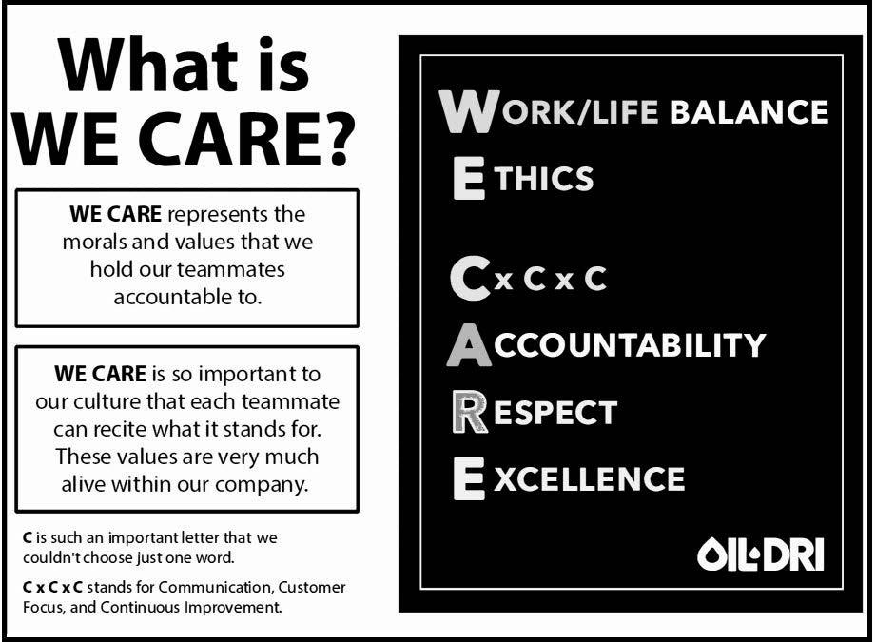

Our Code of Ethics and Business Conduct outlines how we uphold these standards. The first “E” in "WE CARE" represents Ethics. Oil-Dri’s ethical culture is one of our greatest strengths and a key focus of our Board of Directors ("Board") and management team. Our Chief Executive Officer ("CEO") has been asked to speak on this topic at local business schools, including the Kellogg School of Management at Northwestern and Marquette University. Our CEO regularly communicates expectations related to ethics, integrity, and compliance, helping to promote a strong tone at the top across the organization.

We have codified our compliance and ethics requirements through our Code of Ethics and Business Conduct, Human Rights Policy, Supplier Code of Conduct, and Whistleblower Response Policy.

Under the direction of the Vice President of Compliance, the Company’s compliance program ensures adherence to the highest ethical standards, regulatory requirements, and applicable public company obligations, including but not limited to the Foreign Corrupt Practices Act (FCPA), the Company’s Code of Ethics and Business Conduct, and Whistleblower Protection. As part of the focus on addressing potential risks and ensuring a global understanding of the various applicable policies and requirements, we have translated our Code of Ethics and Business Conduct and Supplier Code of Conduct into French, Mandarin and Spanish. Our Board annually attests to Oil-Dri’s Code of Ethics and Business Conduct. The Vice President of Compliance also conducts a thorough third-party due diligence process for new third-parties that includes the use of compliance software and our distributor and agent agreements include a mandatory anti-corruption regulatory compliance section.

Oil-Dri maintains policies and procedures addressing anti-corruption and conflicts of interest, including training and attestation requirements where appropriate. Oil-Dri is committed to whistleblower protection and uses a third-party anonymous hotline available by phone or online, where teammates or third parties worldwide may report concerns anonymously. The Company has procedures to protect whistleblowers' employment status as well as protection from harassment in the workplace. Anti-corruption training emphasizes these protections and is provided within the first few months of hire to new teammates in sales or leadership roles who interact with customers or teammates outside the U.S. Training is repeated annually at our Global Sales Meeting for participating sales teams, leaders and teammates in sales support roles.

As hotline cases are investigated, the Company's Vice President of Compliance works with Human Resources and any other involved teammates to maintain confidentiality and protect whistleblowers. Compliance training emphasizes that these protections are legally required and aligned with our "WE CARE" values. All cases are investigated to conclusion, with follow up provided anonymously through the third-party hotline where possible.

Ultimately, our strength comes from leveraging the uniqueness of all teammates and those in our communities. We strive to promote a diverse and inclusive workforce and foster a safe, collaborative, supportive and respectful environment that values diverse perspectives, mitigates unconscious bias and enables a culture where teammates can bring their authentic self to work. We believe Oil-Dri’s success is enhanced by attracting and retaining a workforce that reflects the communities and

11

countries where we live and work. We embrace all people, regardless of race, sex, gender identity, age, religion, nationality, physical ability or sexual orientation and are committed to cultivating a culture of inclusion.

Compensation

We believe our success largely depends on attracting and retaining highly skilled teammates. We invest in our teammates by providing market-competitive salaries and bonuses at all Company levels, aligned with role, skill level, experience, knowledge and geography. Our executive compensation programs include a deferred compensation plan, executive deferred bonuses, and equity ownership opportunities through our restricted stock program under our long-term incentive plan, aligning executive and shareholder interests. We also offer training and development and a benefits package that supports well-being, including health care, retirement plans, and paid time off. In the U.S., we provide a 401(k) savings plan with a Company match of 100% of each employee dollar contributed, up to six percent (6%) of earnings, with full vesting after two (2) years of employment. Outside of the U.S., employees are eligible for supplemental benefits based on local market practices. Our competitive compensation and benefits package supports strong employee retention.

Teammate Health and Wellness

Our business success is closely connected to teammates' well-being, maintaining health and wellness a top priority. We offer robust benefit programs to eligible teammates including health, prescription drug, dental, life and disability insurance. We also provide wellness resources, including no-cost smoking cessation programs and gym and weight loss reimbursement to encourage healthy lifestyles. Our employee assistance program offers face-to-face, telephonic and online counseling for a

variety of needs. Paid time off and sick days further support work/life balance as part of our "WE CARE" values framework.

Workplace Flexibility

During fiscal year 2026, Oil-Dri continued a hybrid work environment for many non-manufacturing teammates. Oil-Dri offers a range of full- and part-time employment opportunities that support our work/life balance values. Flexible workplace options help us attract and retain diverse talent across the Company.

Continuous Teammate Development

We encourage our teammates to reach their potential through continuous learning and improvement. All teammates have access to our online training and development library, including on-demand courses, webinars, books and podcasts. Teammates may attend conferences and programs or obtain certifications related to their positions at no cost. We also offer tuition reimbursement programs, at varying levels, after one year of employment. These programs provide financial support for educational goals and academic activities that directly relate to the organization’s identified knowledge, skills, and behaviors which support the mission, vision, and values of the Company.

Teammate Engagement

Oil-Dri maintains an open-door policy that encourages conversations across all levels. We promote two-way communication through newsletters, town halls, video announcements, meetings, new hire luncheons with our CEO and occasional anonymous online surveys. We also celebrate work anniversaries, birthdays, retirements and other special occasions.

Safety

Safety is a core value at Oil-Dri and is embedded in our decision-making processes. We view safety as the responsibility of every teammate, from senior management to frontline personnel. As part of our company-wide safety policies, it is expected that all teammates identify safety risks, implement interim controls, maintain controls, and recommend permanent solutions. As part of annual budget and capital planning, our businesses identify additional safety investments needed for training, education, equipment, and processes. We are committed to protecting the health and safety of our workforce and communities while making decisions consistent with long-term sustainability and stewardship.

Through our corporate safety department, we implemented a safety auditing program to assess adherence to local, state and federal safety standards and regulations including those of the Mine Safety and Health Administration ("MSHA") and the Occupational Safety and Health Administration ("OSHA"). Third-party consultants conduct annual global audits using rigorous assessments of regulatory standards, internal procedures and program performance. Audit scores currently indicate high levels

12

of compliance. The program reinforces the Company’s commitment to best management practices and continuous improvement.

GOVERNMENT AND ENVIRONMENTAL REGULATION AND COMPLIANCE

We are subject to a variety of federal, state, local and foreign laws and regulatory requirements relating to the environment and to health and safety matters. In particular, our mining and manufacturing operations and facilities in Georgia, Mississippi, California and Illinois are required to comply with state surface mining and environmental protection statutes as well as workplace safety requirements. These domestic locations and our Canadian operations are also subject to various federal, state, provincial and local statutes, regulations, ordinances, building codes, and permitting and licensing requirements which govern the discharge, storage and disposal of materials, water and waste into the environment, maintenance of our locations or otherwise regulate our operations. In recent years, regulation and enforcement have grown increasingly stringent, a trend that we expect will continue. We endeavor to be in compliance at all times and in all material respects with all applicable environmental, health, and safety requirements. As a result, compliance with the various statutes, regulations, ordinances, codes, and other requirements have required continuing management efforts and the expenditures relating to such compliance have varied over the years; however, these expenditures have not had a material adverse effect on our capital expenditures, earnings, or competitive position. As part of our ongoing environmental compliance activities, we also incur expenses related to reclaiming mining sites, which historically have not had a material effect on our cost of goods sold.

In addition to environmental, health and safety requirements related to our mining and manufacturing operations and facilities, there has been increased federal, state and international regulation with respect to the content, labeling, use, packaging, registration, trade compliance, advertising, and disposal of products that we sell. For example, in the United States, some of our operations, products, product claims, labeling and advertising are regulated by the Food and Drug Administration ("FDA"), the Consumer Product Safety Commission ("CPSC"), OSHA, MSHA, EPA and the Federal Trade Commission ("FTC"). Most states have agencies that regulate in parallel to these federal agencies. In addition, our international sales and operations are subject to regulation in each of the foreign jurisdictions in which we manufacture, distribute or sell our products. There is increasing federal and state regulation with respect to the content, labeling, use, and disposal after use of various products we sell. Throughout the world, but particularly in the United States and Europe, there is also increasing government scrutiny and regulation of the food chain and products entering or affecting the food chain. We endeavor to be in compliance at all times and in all material respects with those regulations and assist our customers with their compliance.

We cannot provide assurance that, despite all commercially reasonable efforts, we will always be in compliance in all material respects with all applicable environmental laws and requirements nor can we assure that from time to time enforcement of such requirements will not have a material adverse effect on our business. The imposition of more stringent standards or requirements under such regulations could result in increased expenditures. Additionally, we could be required to alter our operations in order to comply with any new standards or requirements under environmental laws or regulations. See Item 1A “Risk Factors - Risks Related to Regulatory Compliance” below for a discussion of the impact of government regulations on our business and other risks to our business.

AVAILABLE INFORMATION

This Annual Report on Form 10-K, as well as our Quarterly Reports on Form 10-Q, Current Reports on Form 8-K and any amendments to all of the foregoing reports, are made available free of charge on or through the “Investors” section of our website at www.oildri.com as soon as reasonably practicable after such reports are electronically filed with or furnished to the SEC. Information related to corporate governance at Oil-Dri, including its Code of Ethics and Business Conduct, information concerning executive officers, directors and Board committees, and transactions in Oil-Dri securities by directors and executive officers, is available free of charge on or through the “Investors” section of our website at www.oildri.com. The information on our website is not included as a part of, nor incorporated by reference into, this Annual Report on Form 10-K. The SEC also maintains a website, www.sec.gov, that contains reports, proxy and information statements and other information regarding issuers that file electronically with the SEC.

13

ITEM 1A – RISK FACTORS

We seek to identify, manage and mitigate risks to our business, but risk and uncertainty cannot be eliminated or necessarily predicted. You should consider the following factors carefully, in addition to other information contained in this Annual Report on Form 10-K, before making an investment decision with respect to our securities. The risks described below are not the only risks we face. Our business operations could also be affected by additional factors that are not presently known to us or that we currently consider to be immaterial in our operations.

Risks Related to Our Business

Our future growth and financial performance are meaningfully impacted by successful new product introductions.

A significant portion of our net sales comes from the sale of products in mature categories, some of which have, at times, experienced little or no volume growth or have had volume declines in recent fiscal years. A significant part of our future growth and financial performance will require that we successfully introduce new products or extend existing product offerings to meet emerging customer needs, technological trends and product market opportunities. We cannot be certain that we will achieve these goals. The development and introduction of new products generally require substantial and effective research, development and marketing expenditures, some or all of which may be unrecoverable if the new products do not gain market acceptance. New product development itself is inherently risky, as research failures, competitive barriers arising out of the contractual and intellectual property rights of others, launch and production difficulties, customer rejection and unexpectedly short product life cycles as well as other factors and events beyond our control may occur even after substantial effort and expense on our part. We may, at times, experience limitations on our ability to conduct plant tests with customers, which may impact our sales. Further, new product lines acquired as a result of business combinations may not produce the boost in profitability we initially expected. Even in the case of a successful launch of a new product, the ultimate benefit we realize may be uncertain if the new product “cannibalizes” sales of our existing products beyond expected levels. See “Government regulation imposes significant costs on us, and future regulatory changes (or related customer responses to regulatory changes) could increase those costs or limit our ability to produce and sell our products” for a discussion of additional risks associated with new product development and launches.

We face intense competition in our markets.

Our markets are highly competitive and we expect that both direct and indirect competition will increase in the future. Our overall competitive position depends on a number of factors including price, customer service, marketing, advertising and trade spending, technical support, product quality and delivery. Some of our competitors, particularly in the sale of cat litter (the largest product in our Retail and Wholesale Products Group), have substantially greater financial resources and market presence with established brands. We also face competition between our product lines, as some of our products are considered alternatives to other products that we offer. This competition in the future may, in some cases, lead to price reductions, increased promotional spending, or loss of market share or product distribution, any of which could materially and adversely affect our operating results and financial condition.

Our periodic results may be volatile.

Our operating results have varied on a quarterly basis during our operating history and are likely to fluctuate significantly in the future. Our expense levels are based, in part, on our expectations regarding future net sales, and many of our expenses are fixed, particularly in the short term. We may be unable to adjust spending in a timely manner to compensate for any unexpected revenue shortfall. Any significant shortfall of net sales in relation to our expectations could negatively affect our quarterly operating results. Our operating results may be below the expectations of our investors as a result of a variety of factors, many of which are outside our control. The Company has experienced growth in recent periods, which may not be sustainable or indicative of future growth. Factors that may affect our quarterly operating results include but are not limited to:

- fluctuating demand for our products and services;

- size and timing of sales of our products and services;

- the mix of products with varying profitability sold in a given quarter;

- our ability to anticipate and adapt to rapidly changing consumer behavior or other market conditions;

- our ability to successfully implement price increases and surcharges, particularly in a timely manner that corresponds with cost increases, as well as other changes in our pricing policies;
- variations in purchasing patterns by our customers, including due to weather conditions, inventory planning, or other factors outside of our control;

14

- the ability of major customers and other debtors to meet their obligations to us as they come due;

- disruptions in supply chains;

- an increase in the costs and availability of labor;

- changes in tariff rates and trade policies;

- the incurrence of restructuring, impairment or other charges; and

- general economic conditions and specific economic conditions in our industry and the industries of our customers.

To the extent these factors slow or change, consumer demand for our products may not be sustained or may decrease, and our results could be adversely affected. This variability and unpredictability could result in our failure to meet the expectations of research analysts or investors for any period, which could cause our stock price to decline. We believe that quarter-to-quarter comparisons of our operating results are not necessarily meaningful and encourage investors to not rely on the results of one quarter as an indication of our future performance.

Uncertainties in economic conditions and their impact on consumer spending patterns could adversely impact our business, financial condition, and results of operations.

The United States has from time to time experienced challenging economic conditions and the global financial markets have recently undergone and may continue to experience significant volatility and disruption. Our business, financial condition and results of operations may be materially adversely affected by factors beyond our control, including changes in consumer confidence, levels of unemployment, consumer debt levels, inflation, interest rates, tax rates, tariffs, adverse weather conditions and general uncertainty regarding the overall future economic environment. The keeping of pets and the purchase of pet-related products may constitute discretionary spending for some consumers and any material decline in the amount of consumer discretionary spending may reduce overall levels of pet ownership or spending on pets. As a result, a recession or slowdown in the economy may cause a decline in demand for our products. If economic conditions result in decreased spending on pets or have a negative impact on our retail customers and suppliers, our business, financial condition and results of operations may be materially adversely affected.

Acquisitions involve a number of risks, any of which could cause us not to realize the anticipated benefits.

As part of our business strategy we completed the Ultra Pet acquisition in May 2024 and intend, from time to time, to strategically explore potential additional opportunities to expand our operations and reserves through acquisitions. Identification of good acquisition candidates is difficult and highly competitive. If we are unable to identify attractive acquisition candidates, complete acquisitions, and successfully integrate the companies, businesses or properties that we acquire, our profitability may decline, and we could experience a material adverse effect on our business, financial condition, or operating results. Acquisitions involve a number of inherent risks, including but not limited to:

- uncertainties in assessing the value, strengths, and potential profitability of acquisition candidates, and in identifying the extent of all weaknesses, risks, contingent and other liabilities (including environmental, legacy product or mining safety liabilities) of those candidates;

- the potential loss of key customers, suppliers, management and employees of an acquired business;

- the ability to achieve identified operating and financial synergies anticipated to result from an acquisition;

- the diversion of management's attention from other business concerns;

- the incurrence of other significant charges, such as impairment of goodwill or other intangible assets, asset devaluation or restructuring charges;

- unforeseen difficulties encountered in operating in new geographic areas or other new markets;

- problems that could arise from the integration of the acquired business, its management or other unanticipated problems or liabilities;

- unanticipated changes in business, industry or general economic conditions that affect the assumptions underlying our rationale for pursuing the acquisition; and

- significant cash outflows or additional indebtedness required to complete acquisitions, which could raise liquidity concerns.

Any one or more of these factors could cause us not to realize the benefits we anticipate to result from an acquisition. Moreover, acquisition opportunities we pursue could materially affect our liquidity and capital resources and may require us to use a significant portion of our available cash, incur indebtedness, seek equity capital or a combination of these options, and there can be no assurances that we can obtain indebtedness or equity capital on terms acceptable to the Company. Using available cash and incurring indebtedness would result in a corresponding decrease in our liquidity. Increased borrowings

15

would correspondingly increase the Company's financial leverage and could result in lower credit ratings and increased future borrowing costs. These risks could also reduce the Company's flexibility to respond to changes in its industry or in general economic conditions. In addition, future acquisitions could result in our assuming more long-term liabilities relative to the value of the acquired assets than we have assumed in our previous acquisitions.

We depend on a limited number of customers for a large portion of our net sales.

A limited number of customers account for a large percentage of our net sales, as described in Item 1 “Business” above. The loss of, or a substantial decrease in the volume of, purchases by Walmart or any of our other top customers could harm our sales and profitability. In addition, an adverse change in the terms of our dealings with, or in the financial wherewithal or viability of, one or more of our significant customers could harm our business, financial condition and results of operations.

We expect that a significant portion of our net sales will continue to be derived from a small number of customers and that the percentage of net sales represented by these customers may increase. As a result, changes in the strategies of our largest customers may reduce our net sales. These strategic changes may include a reduction in the number of brands or variety of products they carry or a shift of shelf space to private label products or increased use of global or centralized procurement initiatives. In addition, our business is based primarily upon individual sales orders placed by customers rather than contracts with a fixed duration. Accordingly, most of our customers could reduce their purchasing levels or cease buying products from us on relatively short notice. While we do have long-term contracts with certain of our customers, even these agreements are subject to termination in certain circumstances. In addition, the degree of profit margin contribution of our significant customers varies. If a significant customer with a more favorable profit margin was to terminate its relationship with us or shift its mix of product purchases to lower-margin products, it would have a disproportionately adverse impact on our results of operations.

Our large customers also have significant purchasing leverage. Customers may demand lower pricing, special packaging, shorter lead times for the delivery of products or impose other requirements on product suppliers like us. These business demands may relate to inventory practices, logistics or other aspects of the customer-supplier relationship. If we do not effectively respond to the demands of our customers, they could decrease or eliminate their purchases from us. These risks could be exacerbated if such large customers consolidate, or if our smaller customers consolidate to become larger customers, which would increase their purchasing leverage. A reduction in the purchases of our products by customers or the costs of complying with customer business demands could have a material adverse effect on our business, financial condition and results of operations.

Price or trade concessions, or the failure to make them to retain customers, could adversely affect our sales and profitability.

The products we sell are subject to significant price competition and the prices of our products may fluctuate for a variety of reasons. From time to time, we may need to reduce the prices for some of our products to respond to competitive and customer pressures and to maintain market share. These pressures are often exacerbated during an economic downturn. Additionally, we have, from time to time, experienced customer-driven price deductions on our products as a result of delayed shipments of products. Any reduction in prices to respond to these pressures would reduce our profit margins. In addition, if our sales volumes fail to grow sufficiently to offset any reduction in margins, our results of operations would suffer. Because of the competitive environment facing many of our customers, particularly our high-volume mass merchandiser customers, these customers have increasingly sought to obtain price reductions, deductions, specialized packaging or other concessions from us. These business demands may relate to inventory practices, logistics or other aspects of the customer-supplier relationship. To the extent we provide these concessions, our profit margins are reduced. Further, if we are unable to maintain terms that are acceptable to our customers, these customers could reduce purchases of our products and increase purchases of products from our competitors, which would harm our sales and profitability.

Increases in energy, commodity, transportation, labor and other costs would increase our operating costs, and we may be unable to pass all these increases on to our customers in the form of higher prices and surcharges.

If our energy, commodity, transportation, labor and/or other costs increase disproportionately to our net sales, our earnings could be significantly reduced. Increases in our operating costs may reduce our profitability if we are unable to pass them on to our customers through price increases or surcharges. Sustained price increases, surcharges or price inflation (or inflation pressure generally), in turn, may lead to declines in volume, and while we seek to project tradeoffs between price increases, surcharges and inflation, on the one hand, and volume, on the other, there can be no assurance that our projections will prove to be accurate.

16

We are subject to volatility in the price and availability of natural gas, as well as other sources of energy. Such volatility could be intensified by geopolitical tensions, including war and terrorism, as well as other disruptions and market reactions to such events. We have purchased several forward fuel contracts to cover a portion of our fuel needs in Georgia and California and from time to time, we may use additional forward purchase contracts or financial instruments to moderate the volatility of a portion of our energy costs. The success or failure of any such transactions depends on a number of factors, including our ability to anticipate and manage volatility in energy prices, the general demand for fuel by the manufacturing sector, seasonality and global weather patterns.

The prices of other commodities such as paper, plastic resins, synthetic rubber, lumber, and steel significantly influence the costs of packaging, replacement parts and equipment we use in the manufacture of our products and the maintenance of our facilities. Prices of other non-commodity materials purchased also influence our costs of goods sold.

Increasingly competitive labor markets, changes in the availability of our workers, and labor shortages in our supply chain, could result in increased costs, such as increased wage rates to attract and retain employees, and could negatively affect our ability to efficiently operate our facilities and overall business.

Fluctuations in the availability of transportation options within the United States and internationally, including trucking and ocean freight, could increase costs. These could be exacerbated by volatile oil and gas markets as well as other global factors which could impact both the availability and cost of transportation. Additionally, issues in transportation could result in delayed customer shipments and increased customer deductions for late shipments, ultimately impacting our profitability.

To the extent that we experience increased costs in any of these areas, we may increase our prices, pass the increases along to customers, or otherwise take actions to offset the impact. However, competitive pressures and other factors may limit our ability to quickly raise prices in response to increased costs. Accordingly, we may not be able to timely offset increased costs fully or at all, and there can be no assurances that increasing prices will fully mitigate the impact of these increases, which could adversely impact our results.

Our business could be negatively affected by supply, labor, logistics and other disruptions or the costs incurred to avoid these disruptions.

Supply and logistics disruptions (which may be caused by a variety of factors, including public health crises such as outbreaks of diseases or illnesses, weather conditions, governmental controls, tariffs, national emergencies, natural or man-made disasters, other force majeure events, abrupt political change or other political, civil or social unrest or instability, mass or other physical violence (or threats thereof), including terrorist activity and armed conflict, or other similar events) or our failure to mitigate such disruptions could adversely affect our ability to manufacture, package or transport our products or require additional resources to maintain or restore our supply chain. Some of our products require raw materials and/or packaging that are provided by a limited number of suppliers and/or service providers, are demanded by other industries or are simply not available at times. The loss of any of these suppliers and/or service providers, or problems or delays experienced by these suppliers and/or service providers as a result of labor shortages or other events could lead to shortages in our production capacity, which could impact our ability to meet customer demand. In addition, as we grow or experience increased customer demand, our existing suppliers and/or service providers may not be able to meet our increasing demand, and we may need to find additional suppliers and/or service providers. We may not be able to secure suppliers and/or service providers who provide materials at, or services to, the specification, quantity and quality levels that we demand (or at all) or be able to negotiate acceptable fees and terms of services with any such suppliers and/or service providers. Additionally, such disruptions have resulted in challenges in addressing our backlogs and further backlog could develop in the event of continued disruptions. Disruptions arising from the foregoing or other events could adversely impact our results. See “Increases in energy, commodity, transportation, labor and other costs would increase our operating costs, and we may be unable to pass all these increases on to our customers in the form of higher prices and surcharges” for additional risks related to increased transportation costs and logistics disruptions.

Our production facilities are subject to operating risks and capacity limitations that may adversely affect our financial condition or results of operations.

We are dependent on the continued operation of our production facilities. Production facilities are subject to hazards associated with the manufacturing, handling, storage, and transportation of products, including fires, inclement weather and natural disasters, mechanical failure, unscheduled downtime, labor difficulties, transportation interruptions, and environmental

17

risks. Production facilities are also subject to governmental requirements that may, and during the Covid-19 pandemic did, affect our ability to operate. We maintain property, business interruption and casualty insurance but such insurance may not cover all risks associated with the hazards of our business and is subject to limitations, including deductibles and maximum liabilities covered. We may incur losses beyond the limits, or outside the coverage, of our insurance policies.

Further, some of our products are manufactured on equipment at or near its capacity thus limiting our ability to sell additional volumes of such products until more capacity is obtained. As with all manufacturing facilities, equipment and infrastructure age and become subject to increasing maintenance and repair costs which may be significant. We have experienced increased costs and shortages in repair parts. Our ability to procure components to repair equipment essential for our manufacturing processes could be negatively impacted by various restrictions or disruptions in supply chains. The disruption of our supply of components or services, or the extension of our lead times, could have a material adverse effect on our business, results of operations, or financial condition. In addition, if we are unable to effectively forecast our customers’ demand, it could affect our ability to successfully manage operating capacity limitations. These hazards, limitations, disruptions in supply and capacity constraints could adversely affect financial results.

We depend on our mining operations, and quality of the clay mined, for a majority of our supply of sorbent minerals.

Most of our principal raw materials are sorbent minerals mined by us or independent contractors on land that we own or lease. While our mining operations are conducted in surface mines, which do not present many of the risks associated with deep underground mining, our mining operations are nevertheless subject to many conditions beyond our control. Our mining operations are affected by weather events and natural disasters, power outages, equipment failures and other unexpected maintenance problems, variations in the amount of rock and soil overlying our reserves, variations in geological conditions, fires and other accidents, fluctuations in the price or availability of supplies, landowner disputes, permit requirements and other matters. Any of these risks could result in significant damage to our mining properties or processing facilities, personal injury to our employees, environmental damage, delays in mining or processing, losses or possible legal liability. We cannot predict whether or the extent to which we will suffer the impact of these and other conditions in the future.

Additionally, we are impacted by the clay quality in our mines. Although we use drilling and surveying to assess the expected composition of our clay, we cannot always predict with certainty the clay quality. Poor quality or unexpected differences in our clay composition could increase our processing costs, reduce production, or impact product performance.

We may not be successful in acquiring adequate additional reserves in the future.

We have an ongoing program of exploration for additional reserves on existing properties as well as through the potential acquisition of new owned or leased properties; however, there can be no assurance that our attempts to acquire additional reserves in the future will be successful. Our ability to acquire additional reserves in the future could be limited by competition by others to be used either for mining or other uses, the lack of suitable properties that can be acquired on terms acceptable to us or restrictions under our existing or future debt facilities. We may not be able to negotiate new leases or obtain mining contracts for properties containing additional reserves or renew our leasehold interests in properties on which operations are not commenced during the term of the lease. Also, requirements for environmental or other regulatory compliance may restrict exploration or use of lands that might otherwise be utilized as a source of reserves.

Failure to effectively utilize or successfully assert intellectual property rights, and the loss or expiration of such rights, could materially adversely affect our competitiveness. Infringement of third-party intellectual property rights could result in costly litigation and/or the modification or discontinuance of our products.

We rely on intellectual property rights based on trademark, trade secret, patent and copyright laws to protect our brands, products and packaging for our products. Although we maintain an enforcement program for the protection of our intellectual property rights, we cannot be certain that these intellectual property rights will be maximized or that they can be successfully asserted. There is a risk that we will not be able to obtain and perfect our own intellectual property rights or, where appropriate, license intellectual property rights necessary to support new product introductions. We cannot be certain that these rights, if obtained, will not later be invalidated, circumvented or challenged, and we could incur significant costs in connection with legal actions to assert our intellectual property rights or to defend those rights from assertions of invalidity. In addition, even if such rights are obtained in the United States or in other countries, the laws of some of the other countries in which our products are or may be sold may not protect intellectual property rights to the same extent as the laws of the United States. If other parties infringe our intellectual property rights, they may dilute the value of our brands in the marketplace, which could diminish the value that consumers associate with our brands and harm our sales. Accordingly, we have asserted that products

18

sold by our competitors infringe patents owned or licensed by us and may need to continue to take legal action in the future to protect our patents, trade secrets or know-how or to assert them against claimed infringement by others. Any legal action of that type could be costly and time consuming and no assurances can be made that any lawsuit will be successful. The failure to perfect or successfully assert our intellectual property rights could make us less competitive and could have a material adverse effect on our business, operating results, and financial condition. Trade secret protection requires specific agreements, policies and procedures to ensure the secrecy of information classified as a trade secret. If such agreements, policies and procedures are not effective to maintain the secrecy of our trade secrets, the loss of trade secret protection could have a material adverse effect on our business, financial condition or results of operations.

In addition, if our products are found to infringe intellectual property rights of others, the owners of those rights could bring legal actions against us claiming substantial damages for past infringement and seeking to enjoin manufacturing and marketing of the affected products. If these legal actions are successful, in addition to any potential liability for damages from past infringement, we could be required to obtain a license in order to continue to manufacture or market the affected products, potentially adding significant costs. We may not prevail in any action brought against us or we may be unsuccessful in securing any license for continued use and therefore have to discontinue the marketing and sale of a product. This could make us less competitive and could have a material adverse impact on our business, operating results and financial condition.

The loss of any key member of our senior management team and other key personnel may impede the implementation of our business plans in a timely manner.

The execution of our business plans depends in part upon the continued service of our senior management team and other key personnel, who possess unique and extensive industry knowledge and experience. Competition for management and key personnel is intense, and the pool of qualified candidates is limited. The loss or other unavailability of one or more of the key members of our senior management team or other key personnel could adversely impact our ability to manage our operations effectively, pursue our business strategy and/or lead to higher labor costs or the use of less-qualified personnel. Our operations also rely on skilled laborers using modern techniques and equipment to mine efficiently. We may be unable to train or attract the necessary number of skilled laborers to maintain our operating costs. No Company-owned life insurance coverage has been obtained on current team members.

Risks Related to Legal and Regulatory Compliance

Environmental, health and safety matters create potential compliance and other liability risks.

We are subject to a variety of federal, state, local and foreign laws and regulatory requirements relating to the environment and to health and safety matters. For example, our mining operations are subject to extensive governmental regulation on matters such as permitting and licensing requirements, workplace safety, plant and wildlife protection, wetlands and other environmental protection, reclamation and restoration of mining properties after mining is completed, the discharge, storage and disposal of materials in the environment, and the effects that mining has on air or groundwater quality and water availability. These laws and regulations have had, and will continue to have, a significant effect on our business. We believe we have obtained all material permits and licenses required to conduct our present operations. However, we will need additional permits and renewals of permits in the future.

The expense, liabilities and requirements associated with environmental, health and safety laws and regulations are costly and time-consuming and may delay commencement or continuation of exploration, mining or manufacturing operations. We have incurred, and will continue to incur, significant capital and operating expenditures and other costs, along with management focus and efforts, in complying with environmental, health and safety laws and regulations. Environmental requirements and the interpretation and enforcement of these requirements, change frequently and, in recent years, there has been an increase in regulation and enforcement of environmental, health and safety matters, a trend that we expect will continue. Substantial penalties and other costs may be imposed if we violate certain of these laws and regulations even if the violation was inadvertent or unintentional. Failure to maintain or achieve compliance with these laws and regulations or with the permits required for our operations could result in substantial operating costs and capital expenditures, in addition to fines and administrative, civil or criminal sanctions, third-party claims for property damage or personal injury, cleanup and site restoration costs, site modification (such as the modification to address capacity issues at our sole landfill located in Ochlocknee, Georgia), and liens, the issuance of injunctions to limit or cease operations, the suspension or revocation of permits and other enforcement measures that could have the effect of limiting our operations or otherwise requiring a change to our operations. Under the “joint and several” liability principle of certain environmental laws, we may be held liable for all remediation costs at a particular site and the amount of that liability could be material. In addition, future environmental laws and regulations could restrict our ability to expand our facilities or extract our existing reserves or could require us to acquire

19

costly equipment or to incur other significant expenses in connection with our business. Furthermore, our reputation could be adversely impacted by the failure (or perceived failure) to maintain high environmental, health and safety practices for operations or negative perceptions of these practices in our industry or for our operations or products. There can be no assurance that future events, including changes in any environmental requirements and the costs associated with complying with such requirements, will not have a material adverse effect on us.

Government laws and regulation impose significant costs on us, and future legal or regulatory changes (or related customer responses to such changes) could increase those costs or limit our ability to produce and sell our products.

In addition to the regulatory matters described above, our operations are subject to various federal, state, local and foreign laws and regulations relating to the mining, manufacture, packaging, labeling, content, storage, distribution and advertising of our products and the conduct of our business operations. For example, in the United States, some of our products, product claims, labeling and advertising are regulated by the FDA, CPSC, OSHA, MSHA, EPA and FTC. Most states have agencies that regulate in parallel to these federal agencies. In addition, our international sales and operations are subject to regulation in each of the foreign jurisdictions in which we manufacture, distribute or sell our products. There is increasing federal and state regulation with respect to the content, labeling, use, and disposal after use of various products we sell. Throughout the world, but particularly in the United States and Europe, there is also increasing government scrutiny and regulation of the food chain and products entering or affecting the food chain.

If we are found to be out of compliance with applicable laws and regulations in these or other areas, we could be subject to loss of customers and to civil remedies, including fines, injunctions, recalls or asset seizures, as well as potential criminal sanctions, any of which could have a material adverse effect on our business. Loss of or failure to obtain necessary permits and registrations could delay or prevent us from meeting product demand, introducing new products, building new facilities or acquiring new businesses and could adversely affect operating results. Further, if applicable laws or regulations are changed or interpreted differently in the future, it may become more difficult or expensive for us to comply. In addition, investigations or evaluations of our products by government agencies may require us to adopt additional labeling, safety measures or other precautions, or may effectively limit or eliminate our ability to market and sell these products. Accordingly, there can be no assurance that we will be able to obtain or renew required governmental permits and registrations in the future. Further, there can be no assurance that current or future legislation, governmental regulation or other rule-making will not have a material adverse effect on our business. Our efforts to comply with new requirements and regulations could result in increased general and administrative expenses and a diversion of substantial management time and attention from revenue-generating activities to compliance activities.

We are also experiencing increasing customer scrutiny of the content and manufacturing of our products, particularly our products entering or affecting the food chain, in parallel with the increasing government regulation discussed above. Our customers may impose product specifications, certifications or other requirements that are different from, and more onerous than, applicable laws and regulations. As a result, the failure of our products to meet these additional requirements may result in the loss of customers and decreased sales of our products even in the absence of any actual failure to comply with applicable laws and regulations. There can be no assurance that future customer requirements concerning the content or manufacturing of our products will not have a material adverse effect on our business.

We face risks to our domestic and international sales and business operations due to political, regulatory, economic and other conditions.

Unstable economic, political, regulatory and other conditions could adversely affect demand for our products or disrupt our operations in the United States and in international markets. The international nature of our operations subjects the Company to numerous risks, including political, civil and/or instability (including acts of terrorism, civil or social unrest, labor unrest, violence in connection with political or social events, trade tensions and reciprocal tariffs, outbreaks of war and pandemics or other disease outbreaks). Specifically, our reliance on certain suppliers based in China has resulted in additional risks concerning the country's current trade relations with the U.S. Both international and domestic operations are also subject to regulatory requirements and issues, including with respect to environmental matters. Any of these matters could result in sudden, and potentially prolonged, changes in domestic and international demand for our products. Further, ongoing developments in U.S. politics and government have introduced greater uncertainty with respect to tax policies, trade relations, tariffs and government regulations affecting trade between the U.S. and other countries. For instance domestic sales may be impacted by changes in government issued incentives, such as tax rebates and credits, for renewable diesel producers. In addition to considerations around U.S. politics and government, geopolitical concerns may also impact our business; for instance, international conflicts could increase the cost of raw and packaging materials and commodities (including the prices of

20

oil and natural gas), supply chain and logistics challenges and foreign currency volatility, and it is not possible to predict the broader or longer-term consequences of such conflicts. These developments, as well as the risks outlined above, could have a material adverse effect on the Company’s business, financial condition and results of operations.

In addition, our international sales and operations are subject to various economic-related risks. Our international sales and operations are, among other factors, subject to currency exchange fluctuations, fund transfer and trade restrictions and import/export duties. In some cases, we may have difficulty enforcing agreements and collecting accounts receivable through a foreign country’s legal system. Further, an increase in inflation rates could affect the Company’s profitability and cash flows, due to higher employment costs, higher operating costs, higher financing costs, and/or higher supplier prices. Inflation may also adversely affect foreign exchange rates. The Company may be unable to pass along such higher costs to its customers. In addition, inflation may adversely affect customers’ operations. Our financial results are negatively impacted when the foreign currencies in which our subsidiary offices operate weaken relative to the U.S. Dollar. We do not currently use instruments to hedge foreign currency risks, and thus are not protected against foreign currency fluctuations. Accordingly, our reported earnings may be affected by changes in foreign currency exchange rates. Moreover, any favorable impacts to profit margins or financial results from fluctuations in foreign currency exchange rates are likely to be unsustainable over time.

We may incur adverse safety events or product liability claims that may be costly, create adverse publicity and may result in regulatory action.

If any of the products that we sell cause, or appear to cause, harm to any of our customers or to consumers, we could be exposed to product liability lawsuits, heightened regulatory scrutiny, requirements for additional labeling, withdrawal of products from the market, indemnification obligations, imposition of fines or criminal penalties or other governmental actions. Product liability claims could result in negative publicity that could harm our sales and operating results. In addition, any such actions could result in material write-offs of inventory, material impairments of intangible assets, goodwill and fixed assets, material restructuring charges and other adverse impacts on our business operations. We cannot predict with certainty the eventual outcome of any pending or future litigation, and we could be required to pay substantial judgments or settlements against us, recall our products or change our product formulations in response to governmental action. If successful claims are asserted by regulatory agencies or third parties against us for non-compliance or uninsured liabilities or liabilities more than applicable limits of insurance coverage, our business, financial condition and results of operations may be adversely affected. Further, lawsuits can be expensive to defend, whether or not they have merit, and the defense of these actions may divert the attention of our management and other resources that would otherwise be engaged in managing our business and our reputation could suffer, any of which could harm our business. Additionally, our products may be associated with competitor products or other products in the same category that may be alleged to have caused harm to consumers. As a result of this association, we may be named in unwarranted legal actions. The potential costs to defend such claims may materially affect our business, financial condition and results of operations.

Goodwill, long-lived, and other intangible assets recorded as a result of our acquisitions could become impaired.

We review goodwill and other long-lived assets, including property, plant and equipment and identifiable amortizing intangible assets, for impairment whenever changes in circumstances or events may indicate that the carrying amounts are not recoverable. Factors which may cause an impairment of long-lived assets include lower share trading prices and the adverse impact of rising costs and additional expenses to mitigate supply chain disruptions, among other factors. We assess all existing goodwill at least annually for impairment on a reporting unit basis. The techniques used in our qualitative assessment and goodwill impairment tests incorporate a number of estimates and assumptions, including macroeconomic conditions, overall category growth rates, sales growth rates, cost containment and margin expansion and expense levels for advertising and promotions and general overhead, that are subject to change. Although we believe these estimates and assumptions are reasonable and reflect market conditions forecasted at the assessment date, any changes to these assumptions and estimates due to market conditions or otherwise may lead to an outcome where impairment charges would be required in future periods.

We may be subjected to increased taxes or fluctuating tax rates, which could adversely affect our results of operations and/ or cash flows.

As a corporation operating in various jurisdictions around the world, we are subject to income and other taxes based upon the jurisdictions in which we operate and where our sales and profits are determined to be earned and taxed. Federal, state, and foreign statutory tax rates and taxing regimes have been subject to significant change and continue to evolve. Further, significant uncertainties exist with respect to the application of the various taxes to the businesses in which we engage, often requiring that we make judgments in determining our tax liabilities and worldwide provision for income taxes.

21

Our interpretation of current tax laws and their applicability to our business, as well as any changes to existing laws, can significantly impact our effective tax rate. In particular, the U.S. as well as jurisdictions around the world are considering or have enacted changes in relevant tax regulations and interpretations. Changes in income tax laws and regulations, or their interpretation, could result in higher or lower income tax rates assessed or changes in the taxability of certain revenues or the

deductibility of certain expenses, thereby affecting our income tax expense and profitability. In the U.S., various proposals, if enacted, could raise the U.S. corporate tax rate and increase the tax on non-U.S. income. Such unfavorable tax legislation could create the potential for added volatility in our quarterly provision for income taxes and could have a significant adverse impact on our future income tax provision and tax rate. Further, a number of factors may cause our effective tax rate to fluctuate, including: changes in tax rates in various jurisdictions, unanticipated changes in the amount of profit in jurisdictions in which the statutory tax rates may be higher or lower than the U.S. tax rate, changes in the valuation of our deferred tax assets and liabilities, adjustments to income taxes upon finalization of various tax returns, increases in expenses not deductible for tax purposes, and changes in available tax credits or our ability to utilize foreign tax credits. Furthermore, new accounting pronouncements or new interpretations of existing accounting pronouncements, and/or any internal restructuring initiatives we may implement from time to time to streamline our operations, can have a material impact on our effective income tax rate. We could experience an effective tax rate significantly different from that of prior periods or current expectations, which could have an adverse effect on our results of operations or cash flows.

We are also subject to potential reviews, examinations, and audits by the Internal Revenue Service (the "IRS") and other taxing authorities with respect to taxes within and outside of the U.S. Although we believe our tax estimates are reasonable, unfavorable resolution of any tax audits and controversies could cause our tax liabilities to increase (including interest and penalties) and may have a significant adverse impact on our provision for income taxes and tax rate. Our effective tax rate is also influenced by the geography, timing, nature, and magnitude of transactions, such as acquisitions and divestitures, restructuring activities, and impairment charges.

Risks Related to Our Common Stock

We cannot guarantee that our share repurchases will enhance long-term shareholder value.

Our Board has previously authorized a share repurchase program for our Common Stock and our Class B Stock. Under these authorizations, the Company has authority to repurchase up to 750,000 shares of our Common Stock and up to 300,000 shares of our Class B Stock. The Company has undertaken repurchases of Common Stock on the open market (including pursuant to a 10b5-1 plan or otherwise) and is also authorized to undertake repurchases in private, negotiated transactions. The Company has no obligations to repurchase any specific dollar amount or to acquire any specific number of shares. The timing, number and manner of share repurchases is determined by management and may depend upon a number of factors, including the trading price, market conditions, and the Company’s liquidity needs and management of its spending. Further, the Company’s share repurchases may be limited, suspended or discontinued at any time without prior notice (subject to the terms and conditions of the repurchase plan(s) in place at such time). The existence of these share repurchase authorizations could cause our stock price to be higher than it would be in the absence of such a program and could potentially reduce the market liquidity for our stock or otherwise affect stock price and/or volatility. Additionally, our share repurchase authorizations could diminish our cash reserves, which may impact our ability to otherwise deploy such cash. There can be no assurance that these share repurchases will enhance shareholder value.

Our principal stockholders have the ability to control matters requiring a stockholder vote and could delay, deter or prevent a change in control of our company.

Under our Certificate of Incorporation, the holders of our Common Stock are entitled to one vote per share and the holders of our Class B Stock are entitled to ten votes per share; the two classes generally vote together without regard to class (except that any amendment to our Certificate of Incorporation changing the number of authorized shares or adversely affecting the rights of Common Stock or Class B Stock requires the separate approval of the class so affected as well as the approval of both classes voting together). As a result, the holders of our Class B Stock exert control over the Company and thus limit the ability of other stockholders to influence corporate matters. Beneficial ownership of Common Stock and Class B Stock by the Jaffee Investment Partnership, L.P. and its affiliates (including Daniel S. Jaffee, our President, CEO and Chairman of the Board) provides them with the ability to control the election of our Board and the outcome of most matters requiring the approval of our stockholders, including the amendment of certain provisions of our Certificate of Incorporation and By-Laws, the approval of any equity-based employee compensation plans and the approval of fundamental corporate transactions, including mergers and substantial asset sales. Through their concentration of voting power, our principal stockholders may be able to delay, deter or prevent a change in control of our company or other business combinations that might otherwise be beneficial to our other stockholders. It is possible that the interests of our principal stockholders may in some circumstances

22

conflict with our interests and the interests of our other stockholders. For example, the principal stockholders may have different tax positions or other differing incentives from other stockholders that could influence their decisions regarding whether and when to cause us to dispose of assets, incur new or refinance existing indebtedness, issue additional stock, or take other actions. Additionally, the holders of our Class B Stock may cause us to make strategic decisions or pursue acquisitions that could involve risks to holders of our Common Stock or may not be in the best interests of holders of our Common Stock.

We are a “controlled company” within the meaning of the New York Stock Exchange (“NYSE”) rules and, as a result, qualify for, and intend to rely on, exemptions from certain corporate governance requirements.

We are a “controlled company” under the New York Stock Exchange Corporate Governance Standards. As a controlled company, we may from time to time rely on exemptions from certain NYSE corporate governance requirements that otherwise would be applicable, including the requirements:

- that a majority of the board of directors consists of independent directors;

- that we have a nominating and governance committee comprised entirely of independent directors with a written charter addressing the committee’s purpose and responsibilities; and

- that we have a compensation committee comprised entirely of independent directors with a written charter addressing the committee’s purpose and responsibilities.

We have previously relied on these exemptions (although we are not currently relying on the first exemption listed above), and we intend to continue to rely on them in the future, as applicable. As a result, our stockholders do not have the same protections afforded stockholders of NYSE-listed companies that are subject to all of the NYSE corporate governance requirements.

The market price of our Common Stock may be volatile.

The market price of our Common Stock could fluctuate substantially in the future in response to a number of factors, including, but not limited to, the following:

- actual or anticipated fluctuations in our quarterly operating results or the operating results of our competitors;

- changes in general conditions in the economy, the financial markets, or the industries in which we operate;

- announcements of significant acquisitions, strategic alliances or joint ventures by us, our customers, suppliers or competitors;

- sales of our Common Stock by the Company, our officers or directors or unaffiliated third-party investors;

- introduction of new products or services;

- increases in the price of energy sources and other raw materials;

- departure of key management;

- regulatory or political developments; and

- other developments affecting us, our industries, customers or competitors.

In addition, the stock market may experience extreme price and volume fluctuations that have a significant effect on the market prices of securities issued by many companies, including the Company, for reasons unrelated to their operating performance. These broad market fluctuations may materially adversely affect our Common Stock price, regardless of our operating results. Given its relatively small public float, number of stockholders and average daily trading volume, our Common Stock may be relatively more susceptible to volatility arising from any of these factors. If we experience significant fluctuations in our stock price, we may be exposed to securities class action lawsuits, which could negatively affect our business. There can be no assurance that the price of our Common Stock will increase in the future or be maintained at its recent levels.

Future sales of our Common Stock could depress its market price.

Future sales of shares of our Common Stock could adversely affect its prevailing market price. If our officers, directors or significant stockholders sell a large number of shares, or if we issue a large number of shares, the market price of our Common Stock could significantly decline. Moreover, the perception in the public market that stockholders might sell shares of Common Stock could depress the market for our Common Stock. Our Common Stock’s relatively small public float and average daily trading volume may make it relatively more susceptible to these risks.

23

Furthermore, in response to recent public focus on dual class capital structures, certain stock index providers are implementing limitations on the inclusion of dual class share structures in their indices. If these restrictions increase, they may impact who buys and holds our stock.

Future dividends on our Common Stock may be restricted or eliminated.

Dividends are declared at the discretion of our Board, and future dividends will depend on our future earnings, cash flow, financial requirements and other factors, including market and economic conditions. We are not obligated to continue a dividend for any fixed period, and the payment of dividends could be suspended or discontinued at any time at our discretion and without prior notice. There can be no assurance that we will continue to pay dividends. The amount and timing of any future dividends may vary, and the payment of any dividend does not assure that we will pay dividends in the future.

General Risk Factors

Technology failures or cyber security breaches or other unauthorized access to our information technology systems or sensitive or proprietary information could have an adverse effect on the Company's business and operations.

We rely on information technology systems to process, transmit, store, and protect electronic information. For example, a significant portion of the communications between the Company's personnel, customers, suppliers and vendors depends on information technology and we rely on access to such information systems for our operations. Additionally, we rely on third-party service vendors to execute certain business processes and maintain certain information technology systems and infrastructure. We cannot guarantee that the security measures in place will prevent disruptions, failures, computer viruses or other malicious codes, malware or ransomware incidents, unauthorized access attempts, theft of intellectual property, trade secrets, or other corporate assets, denial of service attacks, phishing, hacking by common hackers, criminal groups or nation-state organizations or social activist organizations, and other cyber-attacks or other privacy or security breaches in the information technology, phone systems or other systems (whether due to third-party action, bugs or vulnerabilities, physical break-ins, employee error, malfeasance or otherwise) of the Company, our customers or third parties, which could adversely affect our communications and business operations. Further, events such as natural disasters, fires, power outages, systems failures, telecommunications failures, error or malfeasance of our employees, vendors, or other third parties, or other catastrophic events could similarly cause interruptions, disruptions or shutdowns, or exacerbate the risk of the failures described above. Increased use of remote working arrangements has further exacerbated these risks. We may not have the resources or technical sophistication to anticipate, prevent or detect rapidly-evolving types of cyber-attacks and other security risks. Attacks may be targeted at us, our customers, suppliers or vendors, or others who have entrusted us with information. Our co-packaged litter sales were impacted by a cyberattack on our customer which prevented it from placing and receiving orders during the first quarter of fiscal year 2024. To date, the Company has not experienced any material impacts to our business or operations resulting from that cyberattack or any other information or cybersecurity attacks. Because of the frequently changing attack techniques, including through the use of artificial intelligence, along with the increased volume, persistence and sophistication of the attacks, there is the potential for the Company to be adversely impacted. Because such techniques change frequently or may be designed to remain dormant until a predetermined event and often are not recognized until launched against a target, we may be unable to anticipate these techniques or implement sufficient control measures to defend against these techniques. Once a security incident is identified, we may be unable to remediate or otherwise respond to such an incident in a timely manner. While the Company has implemented a cybersecurity framework of policies, procedures, and tools, and has documented plans for incident response, disaster recovery, and business continuity to prevent or mitigate the effects of these potential disruptions or breaches, security breaches and other disruptions to information technology systems could interfere with our operations. Any failure to maintain, or disruption to, our information technology systems, whether as a result of cybersecurity attacks or otherwise, could damage our brands or reputation, subject the Company to legal claims and proceedings or remedial actions, create risks of violations of data privacy laws and regulations, and cause us to incur substantial additional costs. There can be no assurance that existing or emerging threats will not have an adverse impact on our systems or communications networks and, further, technological enhancements to prevent business interruptions could require increased spending. Furthermore, security breaches pose a risk to confidential data and intellectual property, which could result in damage to our competitiveness, brands and reputation. There can be no assurance that the costs, potential monetary damages, and operational consequences of responding to cyber incidents and implementing remediation measures would be covered by any insurance that we may carry from time to time. We cannot predict the degree of any impact that increased monitoring, assessing, or reporting of cybersecurity matters would have on operations, financial conditions and results.

Additionally, in connection with our global operations, we, from time to time, transmit data across national borders to conduct our business and, consequently, are subject to a variety of laws and regulations regarding privacy, data protection, and

24

data security, including those related to the collection, processing, storage, handling, use, disclosure, transfer, and security of personal data, including the European Union General Data Protection Regulation, Canadian Personal Information Protection and Electronic Documents Act, Quebec Private Sector Act, Personal Information Protection Law in China and similar regulations in states within the United States and in countries around the world. Our efforts to comply with privacy and data protection laws may impose significant costs and challenges that are likely to increase over time.

Our enterprise resource planning system (“ERP”) is designed to accurately maintain our books and records and provide information important to the operation of our business. Any potential disruptions with the ERP system could affect our ability to process orders, ship product and send invoices. These difficulties could, in turn, negatively impact our financial results including sales, earnings and cash flow. Further development and maintenance of the ERP system will continue to require investment in human and financial resources, which may cause increased costs and other difficulties. In addition, from time to time, we may implement new technology systems or replace and/or upgrade our current information technology systems. These upgrades or replacements may not improve our productivity to the levels anticipated and may subject us to inherent costs and risks associated with implementing, replacing, and updating these systems, including potential disruption of our internal control structure, substantial capital expenditures, demands on management time and other risks of delays or difficulties in transitioning to new systems or of integrating new systems into other existing systems.

Technology failures or cyber security breaches or other unauthorized access to information technology systems of our customers, suppliers or vendors could have an adverse effect on the Company's business and operations.

We rely on direct electronic interfaces with some of our key customers, suppliers and vendors. Cyber security breaches or technology failures at our customers could result in changes to timing and volume of orders. Additionally cyber security breaches or technology failures at our suppliers or vendors could impact the timing or availability of key materials that could negatively impact our ability to deliver products. We work closely with our key customers, suppliers and vendors to manage and mitigate the impact of any known threats once identified.

The use of artificial intelligence technologies exposes us to risks which could have a material adverse effect on our business, reputation and results of operations.

While we do not currently utilize artificial intelligence ("AI") technologies within our financial reporting or internal control over financial reporting functions, we utilize and intend to expand our use of AI technologies to support our business. While we believe the use of AI systems can present significant benefits, they also create risks and challenges and may produce inaccurate, biased, or incomplete outputs, which could lead to operational errors or unintentional impacts on business decisions. External vendors and third-party AI tools may expose us to similar risks, as well as vulnerabilities in underlying technologies or disruptions in service availability. AI development and use also requires security and proper governance of the data used. Use of AI tools, including third-party platforms, increases the risk of unauthorized disclosure, loss, or misuse of confidential, personal, or commercially sensitive information. In addition, there is a risk that employees or contractors could inadvertently input confidential company information or third-party proprietary data into AI systems, including systems not designed for secure handling of such information. These actions could result in violations of contractual obligations, data protection requirements, or intellectual property rights, and could expose us to legal, regulatory, or reputational harm. Evolving regulations related to AI use, transparency, safety, and accountability may require additional investment, changes to existing processes, or limitations on the development and application of these technologies. Rapid advances in AI may also create competitive pressures or require ongoing investment to maintain effectiveness, and failures to manage, govern, or deploy AI responsibly could impair our ability to achieve expected efficiencies or strategic objectives. While we will seek to develop and use AI responsibly, and will attempt to identify and mitigate ethical, privacy, legal or other issues presented by its use, there can be no assurance that we will be fully successful in doing so, and may be subject to data breaches, allegations of unauthorized access to, or use of, third-party data, information, or intellectual property rights, or other risks, which may lead to financial losses, legal liability, regulatory scrutiny and reputational damage.

Our business could be adversely affected by a widespread threat to public health.

Public health crises may create significant uncertainty on our business and could negatively affect our costs, customer orders, and collection of accounts receivable, which may be material. In addition, a public health crisis could result in the deterioration of worldwide economic conditions and impact the proper functioning of financial and capital markets, foreign currency exchange rates, and commodity and energy prices, as well as demand for our products.

25

In response to widespread public health threats, such as pandemics, countries and local governments may again implement quarantine or similar orders that restrict workforce and/or require closures of “non-essential” businesses along with restrictions on travel. Such restrictions could create significant volatility, uncertainty, and economic disruption to our business. There can be no assurances that we will not have to close facilities or experience other disruption in the future due to concerns over the health and well-being of our employees, or as a result of government directives. While historically widespread threats to public health had limited disruption and impact to our third-party business partners, suppliers, service providers, and customers, no assurances can be made that future threats to public health will not have a more significant impact on our operations or results.

We are subject to various legal and regulatory proceedings, including litigation in the ordinary course of business, which may adversely impact our business, financial condition and results of operations.

In the ordinary course of business, we are subject to various legal and regulatory proceedings, which may include but are not limited to those involving antitrust, tax, trade, environmental, intellectual property, data privacy and other matters, including general commercial litigation. Such claims and litigation are frequently expensive and time consuming (and could divert management’s attention and resources) to resolve and may result in substantial liability to us, which liability and related costs and expenses may not be recoverable through insurance or any other forms of reimbursement and could also result in higher insurance costs, the loss of insurance coverage, or the inability to obtain insurance at an acceptable cost. Additionally, the outcome of legal and regulatory proceedings may differ from our expectations because the outcomes of these proceedings are often difficult to predict reliably. Various factors and developments can lead to changes in our estimates of liabilities. A future adverse ruling, settlement or unfavorable development could result in charges that could have a material adverse effect on our results of operations in any particular period.

Failure to maintain effective internal control over financial reporting could have a material adverse effect on our business, operating results and stock price.

Section 404 of the Sarbanes-Oxley Act and related SEC rules require that we perform an annual management assessment of the design and effectiveness of our internal control over financial reporting and obtain an opinion from our independent registered public accounting firm on our internal control over financial reporting. Our assessment concluded that our internal control over financial reporting was effective as of July 31, 2026 and we obtained from our independent registered public accounting firm an unqualified opinion on our internal control over financial reporting; however, there can be no assurance that we will be able to maintain the adequacy of our internal control over financial reporting, as such standards are modified, supplemented or amended from time to time in future periods. Accordingly, we cannot provide assurance that we will be able to conclude on an ongoing basis that we have effective internal control over financial reporting in accordance with Section 404 of the Sarbanes-Oxley Act. Moreover, effective internal control is necessary for us to produce reliable financial reports and is important to help prevent financial fraud. If we cannot provide reliable financial reports or prevent fraud, our business and operating results could be harmed, investors could lose confidence in our reported financial information, and the trading price of our Common Stock could be negatively impacted.

Failure to maintain a level of corporate social responsibility could damage our reputation and could adversely affect our business, financial condition or results of operations.

In light of evolving expectations around corporate social responsibility, our reputation or brand could be adversely impacted by a failure (or perceived failure) to maintain a level of corporate responsibility. In today’s environment, an allegation or perception regarding quality, safety, or corporate social responsibility can negatively impact our reputation. This may include, without limitation: failure to maintain certain ethical, social and environmental practices for our operations and activities, or failure to require our suppliers or other third parties to do so; our environmental impact, including our mining operations and their impact on the environment; the practices of our employees, agents, customers, suppliers, or other third parties (including others in our industry) with respect to any of the foregoing, actual or perceived; the failure to be perceived as appropriately addressing matters of social responsibility; consumer perception of statements made by us, our employees and executives, agents, customers, suppliers, or other third parties (including others in our industry); or our responses to any of the foregoing. Further, we may be subject to rulemaking regarding corporate social responsibility and/or disclosure, as public awareness and focus on social and environmental issues have historically resulted in legislative and regulatory efforts to impose increased regulations and require further disclosure and may do so in the future. As a result, we may become subject to new or more stringent regulations, legislation or other governmental requirements, customer requirements or industry standards and/or an increased demand to meet voluntary criteria related to such matters. Increased regulations, customer requirements or industry standards, could subject us to additional costs and restrictions and require us to make certain changes to our manufacturing

26

practices and/or product designs, which could negatively impact our business, results of operations, financial condition and competitive position.

Our business could be adversely affected by labor disputes and an inability to renew collective bargaining agreements at acceptable terms.

A portion of our teammates in the U.S. and Canada are represented by labor unions, with whom we have entered into separate collective bargaining agreements. See “Item 1 – Business – Human Capital Management – Overview” above. We may experience labor disputes in the future, including protests and strikes, which could disrupt our business operations, increase wage rates and other costs of labor and have an adverse effect on our business and results of operation. We may also be unable to renegotiate collective bargaining agreements at acceptable terms, or we may be unable to maintain a satisfactory working relationship with our employees in the future. We may also be adversely affected by strikes and other labor disputes by the employees of our suppliers, customers, and other parties.

We may need to implement additional finance and accounting systems, procedures and controls as we grow our business and organization and to satisfy new reporting requirements.

Our systems, procedures and controls are still developing to match the complexity of our business. We are required to comply with a variety of reporting, accounting and other rules and regulations. Compliance with existing requirements is expensive. As a public company, we are required to comply with additional regulations and other requirements. These and future requirements may increase our costs and require additional management time and resources. We may need to implement additional finance and accounting systems, procedures and controls to satisfy our reporting requirements. If our internal control over financial reporting is determined to be ineffective, such failure could cause investors to lose confidence in our reported financial information, negatively affect the value of our business, subject us to regulatory investigations and penalties, and could have a material adverse effect on our business. In addition, as a result of our recent growth we no longer qualify as a smaller reporting company and, therefore, can no longer take advantage of scaled disclosure requirements and are subject to shorter filing deadlines. Complying with such requirements will require us to expend additional resources and to enhance the capabilities of our finance and accounting departments. If we are unable to comply with such requirements, our business and stock price may be adversely affected.

ITEM 1B – UNRESOLVED STAFF COMMENTS

None.

ITEM 1C – CYBERSECURITY

Cybersecurity Risk Management and Strategy

We recognize the importance of assessing, identifying, and managing material risks associated with cybersecurity threats, as such term is defined in Item 106(a) of Regulation S-K. These risks include, among other things: operational risks, intellectual property theft, fraud, extortion, harm to employees or customers and violation of data privacy or security laws. The emergence of AI and its role in accelerating cybersecurity attacks will only make this area of risk more dynamic and difficult to prevent. We have implemented cybersecurity processes, technologies, and controls to aid in our efforts to assess, identify, and manage such material risks.

Our cybersecurity risk management program is integrated into our overall enterprise risk management program, and shares common methodologies, reporting channels and governance processes that apply across the enterprise risk management program to other risk areas. We have also implemented a specific cybersecurity program which adopts a risk management approach to information security, requiring the identification, assessment, and appropriate mitigation of vulnerabilities and threats that can adversely impact our information assets. Our cybersecurity program is aligned with recognized industry standards and frameworks such as NIST SP 800-53, NIST SP 800-82, and the NIST Cybersecurity Framework 2.0. Our cybersecurity program includes:

- An Information Security Charter and supporting policies outline governance, define responsibilities, and help enforce our cybersecurity program;

- A risk assessment process designed to help identify material cybersecurity risks to our critical systems, information, services, and our broader enterprise IT environment;

27

- An information security team principally responsible for managing (1) our cybersecurity risk assessment processes, (2) our security controls, and (3) our response to cybersecurity incidents;

- The use of external service providers, where appropriate, to assess, test or otherwise assist with aspects of our security controls;

- Cybersecurity awareness training of our employees, incident response personnel, and senior management;

- A cybersecurity incident response plan that includes procedures for responding to cybersecurity incidents; and

- A third-party risk management process for customers, service providers, suppliers, and vendors.

In evaluating the risks identified as a part of the annual assessment process, the Company’s information security team considers the likelihood and severity of the respective risk and the potential impact of the risk on the Company, its customers, and its employees. These risks are then prioritized and monitored by the information security team.

The Company conducts periodic testing of software, hardware, defensive capabilities, and other information security systems to assess its cybersecurity readiness and maturity of the cybersecurity program. Tests are conducted by the information security team and reputable third-party consultants and auditors. In developing and evaluating the testing procedures, the Company considers both its individual risks and industry standards.

The cybersecurity program includes an incident response plan with a cross-functional team comprised of designated members of the information technology department, senior management, and other appropriate individuals. The team is responsible for assessing and managing the cybersecurity incident response process, as outlined within the incident response plan, and taking necessary corrective actions to mitigate and eliminate the issue.

As of the date of this report, the Company is not aware of any risks from cybersecurity threats, including as a result of any previous cybersecurity incidents, that have materially affected or are reasonably likely to materially affect the Company, including its business strategy, results of operations, or financial condition that are required to be reported in this Form 10-K. For further discussion of the risks associated with cybersecurity incidents and potential impact to the Company, see the cybersecurity risk factors within “Item 1A. Risk Factors” in this Form 10-K.

Cybersecurity Governance

Cybersecurity is an important part of our risk management processes and an area of focus for our Board and management. Our Audit Committee is responsible for the oversight of risks from cybersecurity threats. Members of the Audit Committee receive updates on a quarterly basis from management, including leaders from our information security and legal teams regarding matters of cybersecurity. This includes existing and new cybersecurity risks, status on how management is addressing and/or mitigating those risks, cybersecurity and data privacy incidents (if any) and status on key information security initiatives. Our Board members also engage in ad hoc conversations with management on cybersecurity-related news events and discuss any updates to our cybersecurity risk management and strategy programs.

Our cybersecurity risk management and strategy processes are overseen by leaders from our information security team, such as our Chief Information Officer, Director, Applications Delivery, and our Director of Information Technology. Such individuals have nearly 40, over 30, and over 20 years of experience, respectively, in various roles involving information technology, including infrastructure and operations, security, auditing, compliance, and application development. These individuals are informed about, and monitor the prevention, mitigation, detection and remediation of cybersecurity incidents through their management of, and participation in, the cybersecurity risk management and strategy processes described above, including the operation of our incident response plan, and report to the Audit Committee on any appropriate items.

28

ITEM 2 – PROPERTIES

Our corporate headquarters are located in Chicago, Illinois. The lease for this location expires in 2043. In addition to our corporate headquarters, we operate two research and development facilities in Vernon Hills, IL, one of which we own and the other of which we lease with a term expiring in 2027. We operate clay manufacturing and non-clay production facilities on the properties listed in “Mining Properties and Operations” below. We have no mortgages on any of the real property we own. We consider our properties to generally be in good condition, well maintained and suitable and adequate to carry on our business. As used in this Form 10-K, the terms “mineral resource,” “mineral reserve,” “proven mineral reserve” and “probable mineral reserve” are defined and used in accordance with Item 1300 of Regulation S-K.

Mining Properties and Operations

Facility Locations

We operate clay manufacturing and non-clay production facilities on property owned or leased by us as shown on the map and listed in the table below:
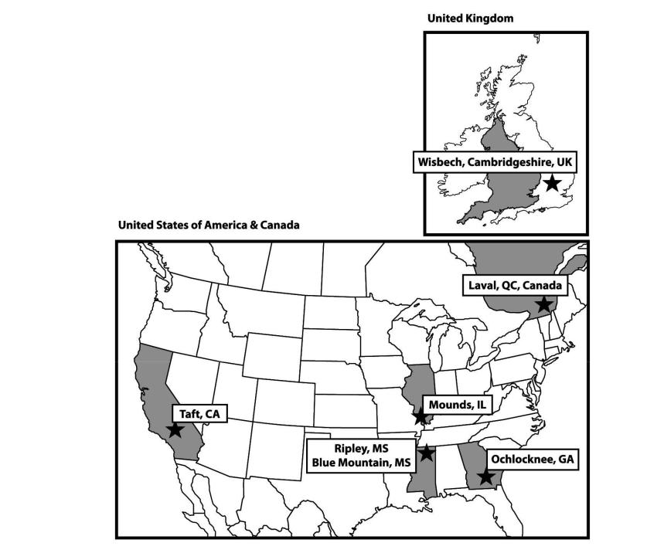

Location | Owned/Leased | Function
Blue Mountain, Mississippi | Owned | Manufacturing and packaging
Laval, Quebec, Canada | Owned | Non-clay manufacturing and clay and non-clay packaging, sales
Mounds, Illinois | Owned | Manufacturing and packaging
Ochlocknee, Georgia | Owned | Manufacturing and packaging
Ripley, Mississippi | Owned | Manufacturing and packaging
Taft, California | Owned | Manufacturing and packaging
Wisbech, United Kingdom | Leased* | Non-clay manufacturing and clay and non-clay packaging, sales,
 |  | customer service
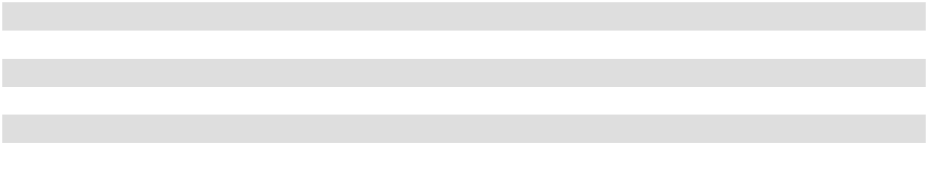

* The Wisbech lease expires in 2032.

29

Overview of Mining Properties and Operations

CLAY RESOURCES AND RESERVES

Our real property holdings and tons produced for each of the three fiscal years ended July 31, are as follows:

 |  |  | Real Property Holdings |  |  |  |  |  | Tons Produced
 | Land |  | Land |  | Land
Geographic Area | Land |  | Land |  | Unpatented |  | Total | 2026 |  | 2025 |  |  |  | 2024
Geographic Area | Owned |  | Leased |  | Claims |  | Total |  |  |  |  |  |  | 2024
 |  |  | (acres) |  |  |  |  |  | (thousands of tons)
California | 795 |  | — | 1,030 |  | 1,825 |  | 52 |  | 46 |  |  |  | 54
Georgia | 4,001 | 1,384 |  |  | — | 5,385 |  | 429 |  | 419 |  |  |  | 425
Illinois | 82 | 533 |  |  | — | 615 |  | 54 |  | 54 |  |  |  | 54
Mississippi | 2,202 | 993 |  |  | — | 3,195 |  | 267 |  | 262 |  |  |  | 260
Nevada | 535 |  | — |  | — | 535 |  |  | — |  | — |  |  | —
Tennessee | 178 |  | — |  | — |  | 178 |  | — |  | — |  |  | —
 | 7,793 | 2,910 |  | 1,030 |  | 11,733 |  | 802 |  | 781 |  |  |  | 793
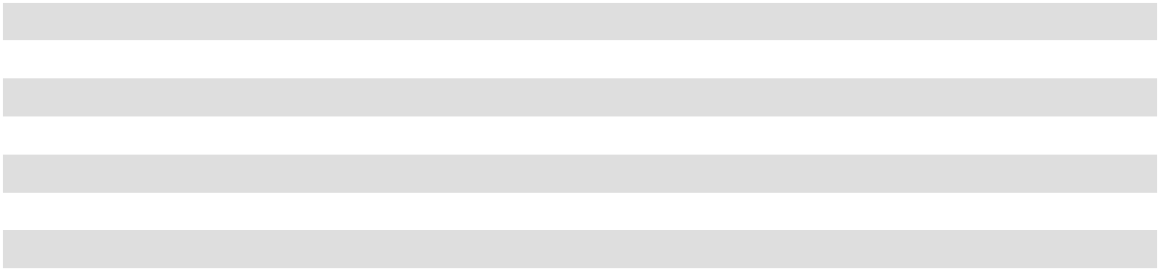

With the exception of our research and development center in Illinois, all of the properties that we own contain clay mineral reserves or are used in the processing of our clay. We mine sorbent minerals primarily consisting of calcium bentonite, attapulgite and diatomaceous shale. We use certified professional geologists and mineral specialists who prepared the estimated reserves of these minerals in the table above. See also Item 1 “Business” above for further information about our reserves. We, or our wholly owned subsidiaries, are the sole operators of our mines. We have a total of 69 mining properties in all stages of operation (exploration, development and production), with 3 mining properties in California, 38 mining properties in Georgia, 3 mining properties in Illinois, 23 mining properties in Mississippi, 1 mining property in Nevada, and 1 mining property in Tennessee. Parcels of such land are also sites of manufacturing facilities operated by us. In addition, we own approximately one acre of land in Laval, Quebec, Canada, which is the site of the processing, packaging and distribution facility for our Canadian subsidiary. While we have reserves at our mining properties in Nevada and Tennessee, we are not actively mining these properties.

Our mining operations are conducted on both owned and leased land. The Georgia, Illinois and Mississippi mining leases generally require that we pay a minimum monthly rent to continue the lease term. The rental payments are typically applied against a stated royalty related to the number of unprocessed, or in some cases processed, tons of minerals extracted from the leased property. Many of our mining leases have no stated expiration dates. Some of our leases, however, do have expiration dates ranging from 2026 to 2122. We would not experience a material adverse effect from the expiration or termination of any of these leases. We have a variety of access arrangements, some of which are styled as leases, for manufacturing at facilities that are not contiguous with the related mines. We would not experience a material adverse effect from the expiration or termination of any of these arrangements.

Certain of our land holdings in California are represented by unpatented mining claims we lease from the Bureau of Land Management. These leases generally give us the contractual right to conduct mining or processing activities on the land covered by the claims. The validity of title to unpatented claims, however, is dependent upon numerous factual matters. We believe the unpatented claims we lease are in compliance with all applicable federal, state and local mining laws, rules and regulations. Future amendments to existing federal mining laws, however, could have a prospective effect on mining operations on federal lands and include, among other changes, the imposition of royalty fees on the mining of unpatented claims, the elimination or restructuring of the patent system and an increase in fees for the maintenance of unpatented claims. To the extent that future proposals may result in the imposition of royalty fees on unpatented lands, the mining of our unpatented claims may become economically unfavorable. We cannot predict the form that any such amendments might take or whether or when such amendments might be adopted. In addition, the construction and operation of processing facilities on these sites would require the approval of federal, state and local regulatory authorities. See Item 1A “Risk Factors” above for a discussion of other risks to our business related to our mining properties.

30

Summary of Mineral Resources and Mineral Reserves

We operate a number of mines concentrated near our production facilities in California, Georgia, Illinois and Mississippi, although we have proven reserves in other states. Based upon the quantitative and qualitative factors applicable, we do not consider any of our mines to be individually material to our business or financial condition. As a result, we are only required to disclose summary information related to our mineral reserves. Our summary of mineral reserves as of July 31, 2026, have been prepared and certified by an employee of the Company who is a certified professional geologist who qualifies as a "qualified person" as such term is defined in Item 1300 of Regulation S-K. The reference point for our mineral reserves is in-situ, or in-place, material. Item 1303 of Regulation S-K requires the disclosure of mineral resources; however, we have no mineral resource estimates as all mineral accumulations of economic interest and with reasonable prospects for eventual economic extraction are either currently on production or subject to an economically viable future development plan and are classified as mineral reserves. Item 1303 of Regulation S-K also requires the disclosure of the grades/qualities of our mineral reserves; however, because there is no single size, chemical, or physical specification of our clay that fits all requirements for our various products, it is not practical or possible for us to provide information related to grades/qualities. Our summary of proven and probable reserves as of July 31, 2026, is as follows:

 | Mineral Reserves¹
 | Proven |  | Probable
 | Mineral |  | Mineral |  |  | Total
 | Reserves |  | Reserves |  |  | Total
 | (thousands of tons)
California | 5,260 | 19,745 |  |  |  | 25,005
Georgia | 26,525 | 13,656 |  |  |  | 40,181
Illinois | 5,305 | 796 |  |  |  | 6,101
Mississippi | 35,526 | 89,440 |  |  |  | 124,966
Nevada | 23,316 | 2,976 |  |  |  | 26,292
Tennessee | 3,000 |  | 3,000 |  |  | 6,000
 | 98,932 | 129,613 |  |  |  | 228,545
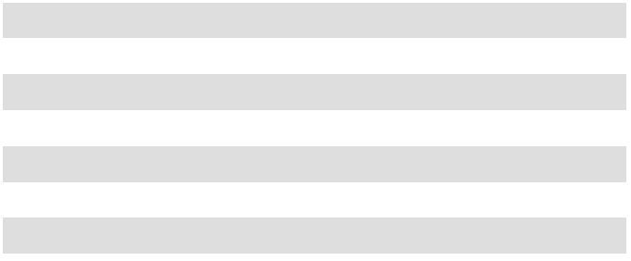
- Mineral reserves are based on the fiscal year 2026 average price of $572 per ton of our clay-based products.

We assess the economic viability of clay by conducting industry standard in-situ tests in order to determine reserves. The minimum quality threshold used in our determination of reserves is whether the clay could be used in one of our products. Once a determination is made, based on in-situ testing by exploratory drilling, that a measured resource of clay is usable in one of our products, we determine economic viability based on a variety of factors. These factors can differ from mine to mine but generally include the amount of clay at the mine; projected costs related to operating the mine; demand for the type or types of product the clay meets the specifications for; other geographical factors such as proximity to permanent structures or bodies of water; and environmental factors and regulations.

Based on our rate of consumption during fiscal year 2026, and without regard to any of our reserves in Nevada and Tennessee, where we do not actively mine, we consider our proven and probable reserves adequate to supply our needs for over forty years. Although we consider these reserves to be extremely valuable to our business, we consider our in-situ clay to have no inherent value and to only become valuable through the mining and manufacturing methods described below.

It is our policy to attempt to maintain a minimum of forty years of proven and probable reserves of each type of clay at each location. We have an ongoing program of exploration for additional reserves but we cannot provide assurance that additional reserves will continue to become available. Our use of these reserves, and our ability to explore for additional reserves, are subject to compliance with existing and future federal and state statutes and regulations regarding mining and environmental compliance. During fiscal year 2026, we utilized these reserves to produce substantially all of the sorbent products that we sold.

Proven reserves means the economically mineable part of a measured resource and can only result from conversion of a measured mineral resource. Further, proven reserves are those reserves for which (a) quantity is computed from dimensions revealed in outcrops, trenches, workings or drill holes; grade and/or quality are computed from results of detailed sampling, and
- the sites for inspection, sampling and measurement are spaced so closely and the geologic character is so well defined that size, shape, depth and mineral content of reserves are well established. Probable reserves are computed from information

31

similar to that used for proven reserves, but the sites for inspection, sampling and measurement are farther apart or are otherwise less adequately spaced. The degree of assurance, although lower than that for proven reserves, is high enough to assume continuity between points of observation. We use certified professional geologists and mineral specialists to estimate and evaluate existing and potential reserves in terms of quality, quantity and availability.

Internal Controls

We have internal controls for reviewing and documenting the information supporting the mineral reserve estimates and ensuring the validity of the estimates. Information that is utilized to compile mineral reserves is prepared and certified by a qualified person and is subject to internal review by our management.

Management also assesses risks inherent in mineral resource and reserve estimates, such as the accuracy of geological data that is used to support mine planning, identify hazards and inform operations of the presence of mineable deposits. Also, management is aware of risks associated with potential gaps in assessing the completeness of mineral extraction licenses, entitlements or rights, or changes in laws or regulations that could directly impact the ability to assess mineral resources and reserves or impact production levels. Risks inherent in overestimated reserves can impact financial performance when revealed, such as changes in amortization that are based on life of mine estimates. Our analysis of risks related to our reserves is integrated into our overall enterprise risk management program, and shares common methodologies, reporting channels and governance processes that apply across the enterprise risk management program to other risk areas. Refer to Item 1A “Risk Factors” for further discussion of risks associated with our mineral reserves.

MINING AND MANUFACTURING METHODS

Mining and Hauling

We mine clay in open-pit mines in Georgia, Mississippi, Illinois and California. The mining and hauling operations are similar throughout the Oil-Dri locations, with the exception of California. The land to be mined is first stripped. The stripping process involves removing the overburden and preparing the site to allow the excavators to reach the desired clay. We consider overburden to be waste, and it is generally visually distinguishable from the clay that we mine and process. Portions of clay or other materials within a mine that are unusable by us to produce our products are also considered waste and are not included in our calculation of mineral reserves. In addition to being visually distinguishable, the dividing line between the overburden and the clay is confirmed with survey-grade GPS equipment and verification testing is used to confirm whether clay is usable to produce our products. Verification testing is initially conducted on the samples of clay, overburden and other materials extracted through the process of exploratory drilling, and then on an on-going basis once extraction begins as we conduct regular application-specific testing on clay as it is mined. When stripping is completed, the excavators dig out and load the clay onto dump trucks. The trucks haul the clay directly to our processing plants where it is dumped in a clay yard and segregated by clay type if necessary. Generally, the mine sites are in close proximity to the processing plants; however, the maximum distance the clay is currently hauled to a plant is approximately eleven miles.

At our California mines, the clay is excavated and hauled to a hopper. An initial crushing and screening operation is performed at the mine site before the trucks are loaded for delivery to the processing plant.

Processing

The processing of our clay varies depending on the level of moisture desired in the clay after the drying process. The moisture level is referred to as regular volatile moisture (“RVM”) or low volatile moisture (“LVM”).

RVM Clay: A front end loader is used to load the clay from the clay yard into the primary crusher. The primary crusher reduces the clay chunks to 2.0 inches in diameter or smaller. From the crusher, the clay is transported via a belt conveyor into the clay shed. A clay shed loader feeds the clay into a disintegrator which reduces the clay to particles 0.5 inches in diameter or smaller. The clay then feeds directly into the RVM kiln. The RVM kiln reduces the clay’s moisture content. From the RVM kiln, the clay moves through a series of mills and screens which further size and separate the clay into the desired particle sizes. The sized clay is then conveyed into storage tanks. The RVM processed clay can then be packaged or processed into LVM material.

LVM Clay: RVM clay is fed from storage tanks into the LVM kiln where the moisture content is further reduced. The clay then proceeds to a screening circuit which separates the clay into the desired particle sizes.

32

In addition, certain other products may go through further processing or the application of fragrances and additives. For example, certain fluids purification and animal health products are processed into a powder form. We also use a proprietary process for our engineered granules to create spherical, uniform-sized granules.

Packaging

Once the clay has been dried to the desired level it will be sized and packaged. Our products have various package sizes and types ranging from bags, boxes, pails, and jugs of cat litter to railcars of agricultural products. We also package some of our products into bulk (approximately one ton) bags or into bulk trucks. The size and delivery configuration of our finished products is determined by customer requirements.

ITEM 3 – LEGAL PROCEEDINGS

From time to time, we may be subject to legal proceedings and claims in the ordinary course of business. We are not currently aware of any such proceedings or claims that we believe will have, individually or in the aggregate, a material adverse effect on our business, financial condition or results of operations.

ITEM 4 – MINE SAFETY DISCLOSURE

Our mining operations are subject to regulation by the Mine Safety and Health Administration under authority of the Federal Mine Safety and Health Act of 1977, as amended. Information concerning mine safety violations or other regulatory matters required by section 1503(a) of the Dodd-Frank Wall Street Reform and Consumer Protection Act and Item 104 of Regulation S-K is included in Exhibit 95 to this Annual Report on Form 10-K.

33

PART II

ITEM 5 – MARKET FOR REGISTRANT’S COMMON EQUITY, RELATED STOCKHOLDER MATTERS AND ISSUER PURCHASES OF EQUITY SECURITIES

Our Common Stock is traded on the NYSE under the symbol ODC. There is no established trading market for our Class B Stock. There are no shares of Class A Common Stock currently outstanding. See Exhibit 4.1 to this Annual Report on Form 10-K for a description of our Common Stock, Class B Stock and Class A Common Stock. The number of holders of record of Common Stock and Class B Stock on September 30, 2026 were 738 and 24, respectively, as reported by our transfer agent. In the last three fiscal years, we have not sold any securities which were not registered under the Securities Act of 1933, as amended (the “Securities Act”).

Dividends

Our Board determines the timing and amount of any dividends. Our Board may change its dividend practice at any time. The declaration and payment of future dividends, if any, will depend upon, among other things, our future earnings, capital requirements, financial condition, legal requirements, contractual restrictions and other factors that our Board deems relevant. Our Credit Agreement, dated as of January 27, 2006 (as previously amended, the "Credit Agreement"), with BMO Harris Bank N.A (“BMO Harris”), and certain of our domestic subsidiaries, and our Amended and Restated Note Purchase and Private Shelf Agreement (as amended, the "Note Agreement") with PGIM, Inc. ("Prudential") requires that we maintain a maximum debt to earnings ratio and a minimum fixed charge coverage ratio. To the extent that these balances are not attained, our ability to pay dividends may be impaired. See Note 4 of the Notes to the Consolidated Financial Statements for further information about our debt agreements.

Unregistered Sales of Equity Securities

None.

Issuer Repurchase of Equity Securities

The following chart summarizes our Common Stock purchases during the three months ended July 31, 2026. ISSUER PURCHASES OF EQUITY SECURITIES ^{1,2}
 |  | (a) |  | (b) |  | (c) |  | (d)
 |  |  |  |  |  | Total Number of |  | Maximum Number
For the Three |  |  |  |  |  | Shares Purchased as |  | of Shares that may
For the Three |  | Total Number of |  | Average Price Paid |  | Part of Publicly |  | yet be Purchased
Months Ended July |  | Total Number of |  | Average Price Paid |  | Announced Plans or |  | Under Plans or
31, 2026 |  | Shares Purchased³ |  | per Share |  | Programs |  | Programs⁴
May 1, 2026 to |  | — |  | $— |  | — | 172,261
May 31, 2026 |  | — |  | $— |  | —
June 1, 2026 to |  | — |  | $— |  | — | 172,261
June 30, 2026 |  | — |  | $— |  | —
July 1, 2026 to | 352 |  | $106.44 |  |  | — | 171,909
July 31, 2026 |  |  |  |  |  | —


1 The table summarizes repurchases of (and remaining authority to repurchase) shares of our Common Stock. Our Board authorized the repurchase of 300,000 shares of Class B Stock on March 21, 2018, however, there have been no repurchases of Class B Stock for the three months ended July 31, 2026 and the authorized Class B Stock is not included in the table above. Of this amount, 208,197 shares of Class B Stock remain authorized for repurchase as of July 31, 2026. No shares of our Class A Common Stock are currently outstanding. Descriptions of our Common Stock, Class B Stock and Class A Common Stock are contained in Exhibit 4.1 of this Annual Report on Form 10-K for the fiscal year ended July 31, 2026.

2 The figures in the table reflect transactions according to the settlement dates. For purposes of our Consolidated Financial Statements included in this Annual Report on Form 10-K, the impact of these repurchases is recorded according to the settlement dates.

3 All shares of Common Stock were surrendered by employees to pay taxes related to restricted stock awards. No shares of Common Stock or Class B Stock were repurchased pursuant to publicly announced programs.

4 Our Board of Directors authorized the repurchase of 750,000 shares of Common Stock on March 11, 2019. This authorization does not have a stated expiration date. The share numbers in this column indicate the number of shares of Common Stock that may yet be repurchased under this authorization. Repurchases may be made on the open market (pursuant to Rule 10b5-1 plans or otherwise) or in negotiated transactions. The timing and number of shares of Common Stock repurchased will be determined by our management.

34

Stock Performance Graph

The following graph compares the annual cumulative total stockholders’ returns for the five years ending July 31, 2026 on an assumed investment of $100 on July 31, 2021 in our Common Stock, the Russell 2000 Index and the Dow Jones US Basic Materials Index. Our Common Stock is included in the Russell 2000 Index, and we consider the Dow Jones US Basic Materials Index to be our peer group. The graph assumes all dividends were reinvested. The historical stock price performance of our Common Stock is not necessarily indicative of future stock performance, and we do not make or endorse any predictions as to future stockholder returns.

Comparative Five-Year Total Returns

(Performance results through July 31, 2026)

$700
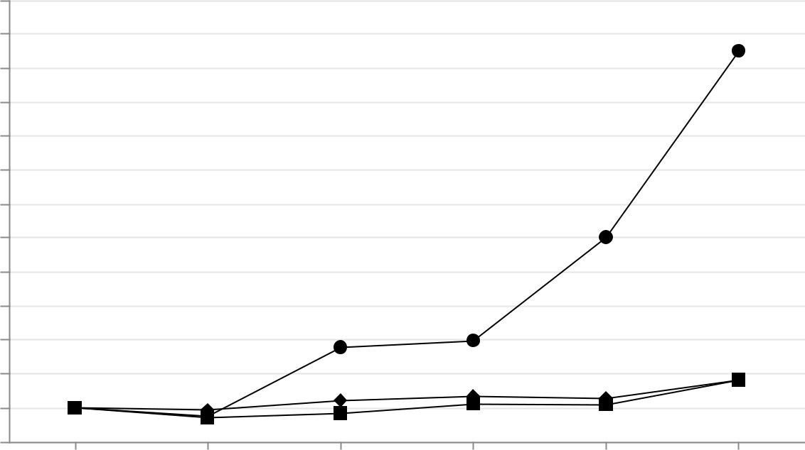

$650

$600

$550

$500

$450

$400

$350

$300

$250

$200

$150

$100

$50

2021 2022 2023 2024 2025 2026

Oil-Dri Corp. of America Total Return

Russell 2000 Total Return

Dow Jones US Basic Materials Index Total Return


 |  | 2021 |  | 2022 |  | 2023 |  | 2024 |  | 2025 |  | 2026
Oil-Dri Corp. of America Total Return | $ | 100.00 | $ | 88.00 | $ | 189.00 | $ | 199.00 | $ | 351.00 | $ | 625.00
Russell 2000 Total Return | $ | 100.00 | $ | 86.00 | $ | 92.00 | $ | 106.00 | $ | 105.00 | $ | 141.00
Dow Jones US Basic Materials Index Total Return | $ | 100.00 | $ | 97.00 | $ | 111.00 | $ | 117.00 | $ | 114.00 | $ | 141.00

This performance graph and accompanying disclosure shall not be deemed “soliciting material” or be deemed “filed” for purposes of Section 18 of the Exchange Act, or otherwise subject to the liabilities under that Section, and shall not be deemed to be incorporated by reference into any of our filings under the Securities Act, whether made before or after the date hereof and irrespective of any general incorporation language in any such filing.

ITEM 6 – [RESERVED]

35

ITEM 7 – MANAGEMENT’S DISCUSSION AND ANALYSIS OF FINANCIAL CONDITION AND RESULTS OF OPERATIONS

The following discussion and analysis of our financial condition and results of operations should be read together with the Consolidated Financial Statements and the related notes included elsewhere herein. This discussion contains forward-looking statements that involve risks and uncertainties. Our actual results may differ materially from the results discussed in the forward-looking statements. Factors that might cause a difference include those discussed under “Forward-Looking Statements” and in Item 1A “Risk Factors” in this Annual Report on Form 10-K.

OVERVIEW

We develop, mine, manufacture and market sorbent products principally produced from clay minerals, primarily consisting of calcium bentonite, attapulgite and diatomaceous shale. Our principal products include agricultural and horticultural chemical carriers, animal health and nutrition products, cat litter, fluids purification and filtration bleaching clays, industrial and automotive floor absorbents, and sports field products. Our products are sold to two primary customer groups, including customers who resell our products as originally produced to the end consumer and other customers who use our products as part of their production process or use them as an ingredient in their final finished product. We have two reportable operating segments based on the different characteristics of our two primary customer groups: the Retail and Wholesale Products Group and the Business to Business Products Group. Each operating segment is discussed individually below. Additional detailed descriptions of the operating segments are included in Item 1 “Business” above.

On October 9, 2024, the Company announced that our Board approved a two-for-one stock split in the form of a stock dividend. Stockholders of record as of the close of business on December 20, 2024 received a distribution of one additional share of Common Stock for each share of Common Stock held by such stockholder and one additional share of Class B Stock for each share of Class B Stock held by such stockholder as of the record date. The additional shares were distributed on January 3, 2025, and our Common Stock began trading on a post-split basis on January 6, 2025.

The stock split did not affect the par value of the Common Stock or Class B Stock, however, in order to implement the stock split we amended our Certificate of Incorporation on December 11, 2024 to increase the number of authorized shares of Common Stock from 15 million to 30 million. Proportionate adjustments were made to the number of shares that remain available for issuance pursuant to the Amended and Restated Oil-Dri Corporation of America 2006 Long Term Incentive Plan, as amended (the "2006 Plan"), as well as to the outstanding awards under the 2006 Plan.

While ongoing geopolitical tensions and conflict in the Middle East have contributed to broader market volatility in the second half of fiscal year 2026, these conditions did not have a direct, material impact on our results for the current fiscal year. However, continued uncertainty in the region may lead to increased input and transportation costs in future periods. The Company continues to closely monitor developments and assess potential impacts on operations and costs.

36

RESULTS OF OPERATIONS

FISCAL YEAR 2026 COMPARED TO FISCAL YEAR 2025

CONSOLIDATED RESULTS

 |  |  |  | For the Year Ended July 31,
(in thousands) |  | 2026 |  |  | 2025 |  |  | $ | %
(in thousands) |  | 2026 |  |  | 2025 |  |  | Change | Change
Consolidated Results
Net Sales | $ | 493,844 | $ |  | 485,572 | $ |  | 8,272 | 2%
Gross Profit | $ | 137,510 | $ |  | 143,083 | $ |  | (5,573) | (4)%
Operating Income | $ | 67,982 | $ |  | 68,220 | $ |  | (238) | —%
Net income | $ | 56,969 | $ |  | 53,996 | $ |  | 2,973 | 6%
Business to Business
Net Sales | $ | 180,198 | $ |  | 182,596 | $ |  | (2,398) | (1)%
Operating Income | $ | 55,348 | $ |  | 59,796 | $ |  | (4,448) | (7)%
Retail & Wholesale
Net Sales | $ | 313,646 | $ |  | 302,976 | $ |  | 10,670 | 4%
Operating Income | $ | 43,730 | $ |  | 44,137 | $ |  | (407) | (1)%
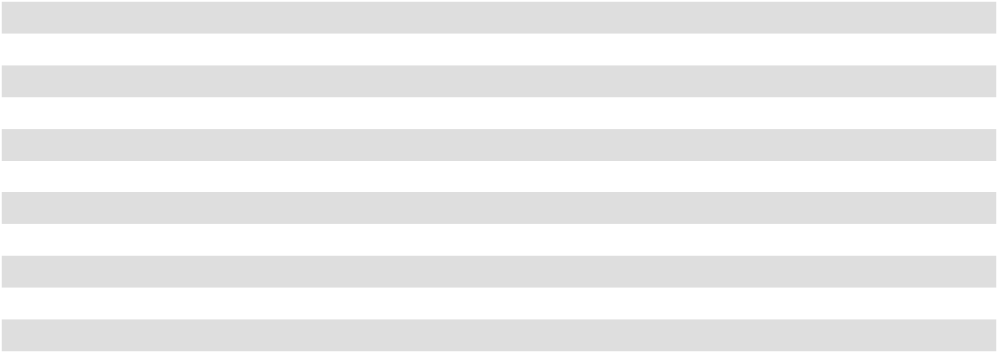

Fiscal year 2026 was another record year, with consolidated net sales and net income reaching all-time highs. Consolidated net sales in fiscal year 2026 were $493.8 million, up 2% from net sales of $485.6 million in fiscal year 2025 driven by favorable mix. The Retail and Wholesale operating segment drove the overall increase with higher cat litter volumes. Although Business to Business net sales declined slightly due to softer volumes in fluid purification and animal health products, the decrease was partially offset by growth in demand of agriculture products.

Cost of goods sold increased $13.8 million, or 4% in fiscal year 2026 compared with fiscal year 2025, as domestic per-ton costs rose 4% compared to fiscal year 2025. The increase was driven by higher per ton manufacturing and transportation costs. Per ton manufacturing costs increased 6% in fiscal 2026 as compared to fiscal 2025, primarily due to higher labor, materials and depreciation costs. Per ton transportation costs increased 3% mainly due to higher diesel costs and fourth-quarter trucking market impacts. Per ton packaging costs remained flat, as many packaging supply contracts are subject to periodic price adjustments, which lag changes in underlying commodity prices. These cost pressures resulted in a $5.6 million, or 4% decrease in consolidated gross profit in fiscal year 2026 compared to the prior fiscal year. Gross margin (defined as gross profit as a percentage of net sales) declined to 27.8% in fiscal year 2026 from 29.5% in fiscal year 2025.

Operating income remained relatively flat as the decrease in SG&A offset the decrease in gross profit. Total SG&A decreased $5.3 million, or 7% in fiscal year 2026 compared to fiscal year 2025. The decrease was driven by a $4.6 million reduction in corporate unallocated expenses and, to a lesser extent, by SG&A incurred by the operating segments. The decrease in corporate unallocated expenses in fiscal year 2026 as compared to fiscal year 2025 was primarily as a result of lower human resource costs attributed to corporate functions, lower incentive bonus and a reduction of outside services costs. SG&A expenses at the operating segments level are discussed below in the discussion of our segments' operating income.

Total other income, net for fiscal year 2026 was $1.5 million, a $3.5 million change from other expense, net of $2.0 million in fiscal year 2025. This gain was driven by a number of items including $1.0 million due to a reduction in the landfill modification costs recognized in fiscal year 2026 compared to an increase in the estimated cost recognized during fiscal year 2025 and $0.9 million in higher interest income in fiscal year 2026 compared to the prior fiscal year. The gain was also in part driven by the positive outcome of a confidential legal settlement in the matter of Oil-Dri Corporation of America vs. Entera Animal Health, et al.

Tax expense for fiscal year 2026 was $12.5 million compared to $12.2 million with an effective tax rate of 18% in both fiscal year 2026 and fiscal year 2025. Our effective tax rate is based on annual taxable income and our assessment of various tax adjustments, including depletion and discrete items. See Note 6 of the Notes to the Consolidated Financial Statements for additional information about our income taxes.

37

Consolidated net income for fiscal year 2026 was $57.0 million, or $3.92 per share of diluted Common Stock, compared to $54.0 million, or $3.70 per share of diluted Common Stock in fiscal year 2025.

Our Consolidated Balance Sheets as of July 31, 2026, and our Consolidated Statements of Cash Flows for fiscal year 2026 show an increase of $23.2 million in total cash and cash equivalents from fiscal year-end 2025. The increase is mainly due to cash flows from operating activities. Refer to the "Liquidity and Capital Resources" section below for additional information about our cash and cash equivalents.

BUSINESS TO BUSINESS PRODUCTS GROUP

(in thousands) |  |  |  |  | For the Year Ended July 31,
Business to Business Products Group |  |  | 2026 |  |  | 2025 |  |  | $ Change |  | % Change
Agricultural and Horticultural |  | $ | 49,232 | $ |  | 44,338 | $ |  | 4,894 | 11 %
Fluids Purification |  |  | 104,753 |  |  | 110,105 |  |  | (5,352) | (5)%
Animal Health & Nutrition |  |  | 26,213 |  |  | 28,153 |  |  | (1,940) |  | (7)%
Net Sales |  | $ | 180,198 |  | $ | 182,596 |  | $ | (2,398) |  | (1)%
Cost of Goods Sold |  | $ | (108,603) |  | $ | (106,691) |  |  | (1,912) |  | 2 %
Gross Profit |  | $ | 71,595 |  | $ | 75,905 |  | $ | (4,310) |  | (6)%
SG&A |  | $ | (16,247) |  | $ | (16,109) |  |  | (138) |  | 1 %
Operating Income |  | $ | 55,348 | $ |  | 59,796 | $ |  | (4,448) | (7)%
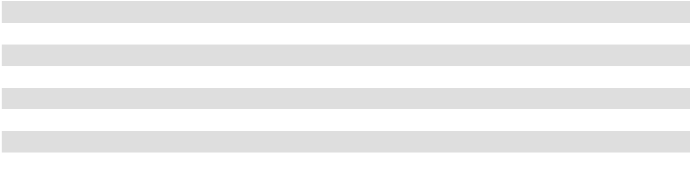

Net sales of the Business to Business Products Group for fiscal year 2026 were $180.2 million, a decrease of $2.4 million, or 1%, from net sales of $182.6 million in fiscal year 2025, driven primarily by a reduction in sales of our fluids purification and animal health products and partially offset by an increase in sales of agricultural and horticultural products. Net sales of fluids purification products decreased $5.4 million or 5% in fiscal year 2026 compared with fiscal year 2025, driven primarily by the decrease in demand for our products used in renewable diesel filtration, which was significantly higher in fiscal year 2025 when several new customers began operations in new plants. Net sales of our animal health and nutrition products decreased $1.9 million, or 7%, in fiscal year 2026 compared to the fiscal year 2025, due to lower volume primarily driven by the temporary loss of a key customer at one of our distributors. Net sales of our agricultural and horticultural products increased $4.9 million, or 11%, for fiscal year 2026 compared to fiscal year 2025 mainly as a result of stronger demand from key customers.

Gross profit and operating income decreased in fiscal year 2026 compared to fiscal year 2025, due to lower net sales and higher cost of goods sold and SG&A. Cost of goods sold increased $1.9 million, or 2%, mainly due to per ton cost of goods sold which increased 4% in the fiscal year 2026 compared to fiscal year 2025. This increase was primarily due to higher per ton manufacturing costs, including materials, which increased 6%. SG&A expenses for the Business to Business Products Group increased $0.1 million, or 1%, for fiscal year 2026 compared to fiscal year 2025.

38

RETAIL AND WHOLESALE PRODUCTS GROUP
 | (in thousands) |  |  |  |  | For the Year Ended July 31,
 | Retail and Wholesale Products Group |  |  | 2026 |  |  | 2025 |  |  | $ Change |  | % Change
 | Cat Litter |  | $ | 265,318 | $ |  | 255,926 | $ |  | 9,392 | 4 |  | %
 | Industrial and Sports |  |  | 48,328 |  |  | 47,050 |  |  | 1,278 |  | 3 | %
 | Net Sales |  | $ | 313,646 |  | $ | 302,976 |  | $ | 10,670 |  | 4 %
 | Cost of Goods Sold |  | $ | (247,731) |  | $ | (235,798) |  | $ | (11,933) |  | 5 | %
 | Gross Profit |  | $ | 65,915 |  | $ | 67,178 |  | $ | (1,263) |  | (2)%
 | SG&A |  | $ | (22,185) |  | $ | (23,041) |  | $ | 856 |  | (4) %
 | Operating Income |  | $ | 43,730 | $ |  | 44,137 | $ |  | (407) | (1)%
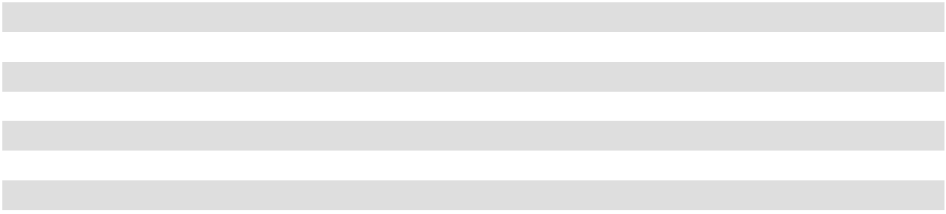

Net sales of the Retail and Wholesale Products Group for fiscal year 2026 were $313.6 million, an increase of $10.7 million, or 4%, from net sales of $303.0 million in fiscal year 2025, primarily driven by increased sales of our cat litter products. Net sales of co-packaged products increased 47% in fiscal year 2026 compared to fiscal year 2025, mainly due to higher volumes as we expanded our co-packaged offerings to include lightweight cat litter. Domestic cat litter net sales, excluding co-packaged cat litter, were $226.1 million for fiscal year 2026, which remained relatively flat when compared to fiscal year 2025. However, crystal cat litter sales increased $3.2 million due to higher volumes, while overall clay-based litter sales declined when compared to the prior fiscal year. The decrease in clay-based litter was driven by a $3.9 million decrease due to changes in private label distribution and a $1.7 million decrease related to the absence of non-recurring promotional activity from the prior year. These losses were partially offset by revenue gains with other customers. Net sales of our domestic industrial and sports products increased by $1.4 million, or 3%, compared to fiscal year 2025, primarily driven by higher pricing to offset increased costs including transportation costs. Net sales by our subsidiary in Canada increased $0.3 million in fiscal year 2026 compared to fiscal year 2025.

Gross profit and operating income decreased in fiscal year 2026 compared to fiscal year 2025, primarily due to higher cost of goods sold. Cost of goods sold increased $11.9 million, or 5%, driven by the per ton cost of goods sold which increased 4% in the fiscal year 2026 compared to fiscal year 2025. This increase was primarily driven by higher per ton manufacturing costs, including materials, which increased 6% and per ton transportation costs, which increased 7% when compared to fiscal year 2025. SG&A expenses for the Retail and Wholesale Products Group decreased $0.9 million in fiscal year 2026 compared to fiscal year 2025, primarily due to reduced advertising and R&D expenses.

FOREIGN SUBSIDIARIES

Foreign operations include our subsidiaries in Canada and the Netherlands, which are included in the Retail and Wholesale Products Group, and our subsidiaries in the United Kingdom, China, Mexico and Indonesia, which are included in the Business to Business Products Group. Net sales by our foreign subsidiaries during fiscal year 2026 were $19.8 million, a decrease of $0.3 million, or 1%, from net sales of $20.1 million during fiscal year 2025. The decrease in net sales was driven mainly by our subsidiaries in Mexico and the United Kingdom, partially offset by an increase in Canada. Net sales of our subsidiary in Mexico decreased $0.4 million, or 20%, during fiscal year 2026 compared to fiscal year 2025 primarily due decreased sales volumes and lower prices. Net sales of our subsidiary in the United Kingdom decreased $0.1 million, or 3% during fiscal year 2026 compared to fiscal year 2025, due primarily to lower volume. Net sales of our subsidiary in Canada in fiscal year 2026 increased by $0.3 million, or 2%, compared to net sales in fiscal year 2025, driven by higher sales of lightweight litter. Net sales by our foreign subsidiaries represented 4% of our consolidated net sales in both fiscal year 2026 and fiscal year 2025.

For fiscal year 2026, our foreign subsidiaries reported a pre-tax net income of $0.1 million, compared to $0.1 million of pre-tax net loss in fiscal year 2025. The increase was primarily driven by the foreign VAT assessment recognized in fiscal year 2025.

Identifiable assets of our foreign subsidiaries as of July 31, 2026, were $1.1 million compared to $1.2 million as of July 31, 2025.

39

FISCAL YEAR 2025 COMPARED TO FISCAL YEAR 2024

For a discussion of our fiscal year 2024 Results of Operations, including a discussion of our financial results for the fiscal year ended July 31, 2025 compared to the fiscal year ended July 31, 2024, refer to Part II, Item 7 of our annual report on Form 10-K filed with the SEC on October 9, 2025.

LIQUIDITY AND CAPITAL RESOURCES

Our principal liquidity needs are to fund our capital requirements, including funding working capital needs; purchasing and upgrading equipment, facilities, information systems, and real estate; supporting new product development; investing in infrastructure; repurchasing stock; paying dividends; and, from time to time, business acquisitions and funding our debt service requirements. During fiscal year 2026, we principally funded these short and long-term capital requirements using cash from current operations as well as cash generated from previous borrowings under our Credit Agreement and the Series B, C and D Senior Notes issued under the Note Agreement. On October 7, 2026, we amended the Note Agreement to increase the aggregate principal amount of Shelf Notes from $75 million to $150 million and the Credit Agreement to increase our line of credit from $45 million to $75 million, among other things, providing more financial flexibility. See Note 4 of the Notes to the Consolidated Financial Statements in this Annual Report on Form 10-K for further information relating to our existing borrowings.

We believe that cash flow from operations, availability under our Note Agreement and revolving credit facility under our Credit Agreement, current cash balances and our ability to obtain other financing, if necessary, will provide sufficient liquidity for foreseeable working capital needs, capital expenditures at existing facilities, deferred compensation payouts, dividend payments and debt service obligations for the foreseeable future.

We continually evaluate our liquidity position and anticipated cash needs, as well as the financing options available to obtain additional cash reserves. Our ability to fund operations, to make planned capital expenditures, to make scheduled debt payments and to remain in compliance with all financial covenants under debt agreements, including, but not limited to, the Credit Agreement, depends on our future operating performance, which, in turn, is subject to prevailing economic conditions and to financial, business and other factors. The timing and size of any new business ventures or acquisitions that we complete may also impact our cash requirements.

Cash and cash equivalents, including restricted cash, totaled $73.7 million and $50.5 million as of July 31, 2026, and 2025, respectively. The following table sets forth certain elements of our Consolidated Statements of Cash Flows for the fiscal year (in thousands):

 |  | 2026 |  |  | 2025
Net cash provided by operating activities ..................................... | $ | 80,106 | $ |  | 80,183
Net cash used in investing activities ............................................. |  | (32,875) |  |  | (32,526)
Net cash used in financing activities............................................. |  | (23,950) |  |  | (21,744)
Effect of exchange rate changes on cash and cash equivalents .... |  | (39) |  |  | 64
Net increase in cash and cash equivalents..................................... | $ | 23,242 | $ |  | 25,977
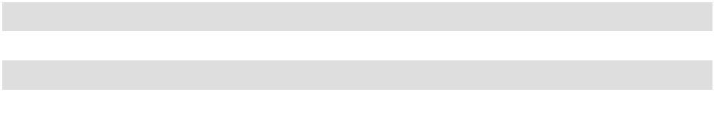

Net cash provided by operating activities

In addition to net income, as adjusted for depreciation and amortization and other non-cash operating activities, the primary sources and uses of operating cash flow for fiscal year 2026 were as follows:

Accounts receivables, less allowance for credit losses and cash discounts, were $5.8 million higher at fiscal year-end 2026 compared to fiscal year-end 2025. The increase in accounts receivable balances is primarily driven by the increase in net sales and timing of collections.

Inventories were $1.9 million higher at fiscal year-end 2026 compared to fiscal year-end 2025. The increase compared to fiscal 2025 is primarily due to an increase in purchases of additives and packaging to meet anticipated demand. See Note 1 of the Notes to the Consolidated Financial Statements for further information regarding our inventory.

40

Excluding the impact of payments related to capital expenditures, accounts payable at fiscal year-end 2026 were flat compared to fiscal year-end 2025. Changes in trade accounts payable in all periods are subject to normal fluctuations in the timing of payments, the cost of goods and services we purchased, production volume levels and vendor payment terms. In fiscal year 2026, there was a $0.7 million decrease in accounts payable related to capital expenditures which increased the cash used in investing activities as compared to fiscal year 2025.

Excluding the impact of payments related to capital expenditures, accrued expenses were $0.1 million lower at fiscal year-end 2026 compared to fiscal year-end 2025. In fiscal year 2026, there was a $0.5 million decrease in accrued expenses related to capital expenditures recognized as cash used in investing activities as compared to the fiscal year 2025. See Note 10 of the Notes to the Consolidated Financial Statements for further information regarding our accrued expenses.

Net cash used in investing activities

Cash used in investing activities was $32.9 million in fiscal year 2026. Cash used in investing activities primarily related to capital expenditures to expand our plant equipment and improve our facilities in order to support increased demand for our products.

Net cash used in financing activities

Cash used in financing activities was $24.0 million in fiscal year 2026, primarily driven by $12.6 million used for share repurchases and $10.4 million used for dividend payments.

Other

Total cash and investment balances held by our foreign subsidiaries were $5.1 million as of July 31, 2026, and $4.7 million as of July 31, 2025. See further discussion in the “Foreign Subsidiaries” section above.

As of July 31, 2026, we had remaining authority to repurchase 171,909 shares of Common Stock and 208,197 shares of Class B Stock under a repurchase plan approved by our Board. Repurchases may be made on the open market (pursuant to Rule 10b5-1 plans or otherwise) or in negotiated transactions. The timing and number of shares repurchased will be determined by our management pursuant to the repurchase plan approved by our Board. In fiscal years 2026 and 2025, we made repurchases of stock as further discussed in Item 5 "Market for Registrant's Common Equity, Related Stockholder Matters and Issuer Purchases of Equity Securities."

OFF BALANCE SHEET ARRANGEMENTS

We do not have any unconsolidated special purpose entities. As of July 31, 2026, we do not have any off-balance sheet arrangements that have or are reasonably likely to have a current or future effect on our financial condition, changes in financial condition, revenues or expenses, results of operations, liquidity, capital expenditures or capital resources that are material to investors. The term “off-balance sheet arrangement” generally means any transaction, agreement or other contractual arrangement to which an entity unconsolidated with us is a party, under which we have: (i) any obligation arising under a guarantee contract, derivative instrument or variable interest; or (ii) a retained or contingent interest in assets transferred to such entity or similar arrangement that serves as credit, liquidity or market risk support for such assets.

CRITICAL ACCOUNTING POLICIES AND ESTIMATES

Management’s discussion and analysis of the financial condition and results of operations are based upon our Consolidated Financial Statements, which have been prepared in accordance with the generally accepted accounting principles of the United States (“U.S. GAAP”). We review our financial reporting and disclosure practices and accounting policies annually to ensure that our financial reporting and disclosures provide accurate and transparent information relative to the current economic and business environment. See Note 1 of the Notes to the Consolidated Financial Statements for a discussion of our significant accounting policies.

The preparation of the financial statements in conformity with U.S. GAAP requires management to make estimates and assumptions that have had, or are reasonably likely to have, a material impact on the reported amounts. The critical accounting policies that reflect our more significant estimates include income taxes, trade promotion, reclamation, impairment of goodwill and other intangible assets, valuation of acquired goodwill and other intangible assets. Actual results could differ from these estimates.

41

Income Taxes. Our effective tax rate on earnings was based on income, statutory tax rates and tax planning opportunities available to us in various jurisdictions in which we operate. Significant judgment was required in determining our effective tax rate and in evaluating our tax positions, and in the calculation of tax credits, benefits, and deductions, and in the calculation of certain tax assets and liabilities that arise from differences in the timing of expenses for tax and financial statement purposes. Significant changes in these estimates may result in an increase or decrease to our tax provision in a subsequent period.

We determine our current and deferred taxes in accordance with Accounting Standards Codification (“ASC”) 740 Income Taxes. The tax effect of the expected reversal of tax differences was recorded at rates currently enacted for each jurisdiction in which we operate. To the extent that temporary differences will result in future tax benefits, we must estimate the timing of their reversal and whether taxable operating income in future periods will be sufficient to fully recognize any deferred tax assets.

We maintain valuation allowances where it is likely that all or a portion of a deferred tax asset will not be realized. Changes in valuation allowances from period to period are included in the income tax provision in the period of change. In determining whether a valuation allowance is warranted, we take into account such factors as prior earnings history, expected future earnings and other factors that could affect the realization of deferred tax assets. A change in the assessment of the realizability of deferred tax assets may materially impact our tax provision in the period in which a change of assessment occurs.

We recorded valuation allowances of $2.4 million and $2.8 million for the amount of the deferred tax benefit related to our foreign net operating loss carryforwards and certain state net operating loss carryforwards as of July 31, 2026 and 2025, respectively, because we believe it is unlikely we will realize the benefit of these tax attributes in the future.

In addition to valuation allowances, we may provide for uncertain tax positions when such tax positions do not meet certain recognition thresholds or measurement standards. Amounts for uncertain tax positions are adjusted when new information becomes available or when positions are effectively settled. We did not record a liability for unrecognized tax benefits at either July 31, 2026, or 2025. See Note 6 of the Notes to the Consolidated Financial Statements for further discussion.

Trade Promotions. We routinely commit to one-time or ongoing trade promotion programs in our Retail and Wholesale Products Group. Promotional reserves are provided for sales incentives made directly to consumers, such as coupons, and sales incentives made to customers, such as slotting, discounts based on sales volume, cooperative marketing programs and other arrangements. All such trade promotion costs are netted against sales. Promotional reserves are established based on our best estimate of the amounts necessary to settle future and existing claims on products sold as of the balance sheet date. To estimate trade promotion reserves, we rely on our historical experience of trade spending patterns and that of the industry, current trends and forecasted data. While we believe our promotional reserves are reasonable and that appropriate judgments have been made, estimated amounts could differ from future obligations. We have accrued liabilities at the end of each period for the estimated trade spending programs. We recorded liabilities of approximately $3.3 million and $3.1 million for trade promotions as of July 31, 2026, and 2025, respectively.

Reclamation. During the normal course of our mining process, we remove overburden and perform on-going reclamation activities. As overburden is removed from a mine site, it is hauled to a previously mined site and used to refill older sites. This process allows us to continuously reclaim older mine sites and dispose of overburden simultaneously, therefore minimizing the costs associated with the reclamation process. On an annual basis we evaluate our potential reclamation liability in accordance with ASC 410, Asset Retirement and Environmental Obligations. Reclamation assets are depreciated over the estimated useful lives of the various mines. Reclamation liabilities are increased based on a yearly accretion charge over the estimated useful lives of the mines. We have recorded an estimated net reclamation asset of $3.0 million as of July 31, 2026, and $3.1 million, as of July 31, 2025, and a corresponding estimated reclamation liability of $5.8 million as of July 31, 2026, and $5.9 million as of July 31, 2025. These values represent the discounted present value of the estimated future mining reclamation and landfill closure and monitoring costs at the production plants. In fiscal year 2026 we released a portion of our asset retirement obligation based on our annual evaluation of the future costs, resulting in a net decrease of the liability.

Accounting for reclamation obligations requires that we make estimates unique to each mine site of the future costs we will incur to complete the reclamation work required to comply with existing laws and regulations. These estimates are based on a variety of factors for each mine site such as, but not limited to, the size and unique nature of each property including the acreage and depth of our mines, costs for leveling, filling, and reseeding land, and the applicable laws and regulations the mine site is subject to. Actual future costs incurred could significantly differ from estimated amounts. Future changes to environmental laws and the length of the period between the estimate and incurrence of actual costs could increase the extent of

42

reclamation work required. Any such increases in future costs could materially impact the amount incurred for reclamation costs.

Impairment of goodwill and other intangible assets. We review carrying values of goodwill, trademarks and other indefinite-lived intangible assets periodically for possible impairment in accordance with ASC 350, Intangibles – Goodwill and Other. We first consider qualitative factors which include macro-economic conditions, industry-specific and company-specific considerations, legal and regulatory environments and historical performance. If it is determined that further quantitative assessment is required, it would be based on cash flow considerations and other approaches that would require significant judgment with respect to factors such as volume, revenue and expenses. Impairment occurs when the carrying value exceeds the fair value. Our impairment analysis is performed in the third quarter of the fiscal year and may be re-performed during the year when indicators such as unexpected adverse economic factors, unanticipated technological changes, competitive activities and acts by governments and courts indicate that an asset may become impaired. In fiscal year 2026 we had goodwill associated with both our Business to Business and Retail and Wholesale operating segments. Based on our qualitative assessment there were no indicators that required us to perform further quantitative assessment of the fair value of our goodwill or other indefinite-lived assets. Accordingly, no impairment of goodwill was identified in fiscal year 2026, however this could change in the future, as outlined under Item 1A "Risk Factors."

Valuation of acquired goodwill and intangible assets. We account for business combinations using the acquisition method of accounting in accordance with ASC 805, Business Combinations. The identifiable assets acquired, and liabilities assumed are recorded at their fair values on the date of acquisition. The difference in the fair value of consideration transferred over the fair values of the assets and liabilities is recorded as goodwill. We make significant estimates and assumptions when determining the fair values of assets and liabilities obtained through a business combination, especially regarding intangible assets. We utilize various approaches to establish the fair value of intangible assets acquired. The Company believes its estimates of the fair value of intangible assets to be reasonable. However, actual financial results may differ from the estimates because of the inherent uncertainty involved.

NEW ACCOUNTING PRONOUNCEMENTS

For recent accounting pronouncements, see Note 1 to our Consolidated Financial Statements in Part II, Item 8 of this Annual Report on Form 10-K.

43

ITEM 7A – QUANTITATIVE AND QUALITATIVE DISCLOSURES ABOUT MARKET RISK

We are exposed to market risks in the ordinary course of our business. These risks primarily include changes in commodity prices, interest rates, foreign currency exchange rates, and duties and tariffs, along with the impact of inflation. We do not engage in financial transactions for trading or speculative purposes.

Commodity Prices Risk. We are primarily exposed to fluctuations in market prices with respect to the commodities necessary for producing, packaging, and shipping our products, and in particular with respect to fuel. Factors that could influence the cost of natural gas used in the kilns to dry our clay include the creditworthiness of our natural gas suppliers, the overall general economy, developments in world events, general supply and demand for natural gas, seasonality and the weather patterns throughout the United States and the world. We monitor fuel market trends and, consistent with our past practice, we may contract for a portion of our anticipated fuel needs using forward purchase contracts to mitigate the volatility of our kiln fuel prices. During fiscal years 2026 and 2025, we purchased several forward fuel contracts in Georgia and California which will cover a portion of our needs through fiscal year 2029. These contracts totaled approximately $2.5 million in fiscal year 2026, and a 10% change in the market price for fuel would have resulted in an additional pretax gain or loss of approximately $0.3 million as the related inventory containing those inputs was sold.

Interest Rate Risk. The interest payable on amounts borrowed pursuant to our Credit Agreement is based on variable interest rates and is therefore affected by changes in interest rates. In addition, we have investments consisting of cash, cash equivalents and short-term investments which are also affected by changes in interest rates. Based on our current and expected levels of borrowing and investing, we do not expect changes in interest rates to have a material impact on our results of operations or financial position.

Foreign Currency Risk. We are exposed to foreign currency risk, primarily the U.S. dollar relative to the local currency in the foreign markets we do business in. This risk is related to our foreign subsidiaries' financial results, to certain accounts receivable and to our ability to sell in foreign markets. We are subject to the impact of currency fluctuation upon translation of our foreign subsidiaries’ financial statements from local currencies to U.S. dollars. In recent years, our foreign subsidiaries have not generated a substantial portion of our consolidated net sales or net income. In addition, the portion of our consolidated accounts receivable denominated in foreign currencies has not been significant. Finally, foreign net sales of our products may be influenced by the relative strength of the U.S. dollar compared to various other currencies, which makes our products relatively more or less expensive than our foreign competitors' products in local marketplaces. We do not enter into any hedge contracts to offset any adverse effect of changes in currency exchange rates. Foreign currency fluctuations did not have a material impact on our results of operations or financial position during any of the fiscal periods presented, and we do not expect changes in foreign currency rates to have a material impact on our results of operations or financial position.

Duties and Tariffs Market Risk. We are exposed to market risk with respect to duties and tariffs assessed on raw materials, component parts, and finished goods we import. Additionally, we are exposed to duties and tariffs on our finished goods that we export from our manufacturing plants. As these tariffs and duties increase, we determine whether a price increase to our customers to offset these costs is warranted. To the extent that an increase in these costs would have a material impact on our results of operations, we believe that our competitors would experience a similar impact.

Inflation Risk. Our results of operations and financial condition are presented based on historical cost. While it is difficult to accurately measure the impact of inflationary pressure, we believe any inflationary impact on our product and operating costs would be offset by our ability to increase selling prices, create operational efficiencies and seek lower cost alternatives.

Please also see Item 1A “Risk Factors” above for a discussion of these and other risks and uncertainties we face in our business.

44

ITEM 8 – FINANCIAL STATEMENTS AND SUPPLEMENTARY DATA
OIL-DRI CORPORATION OF AMERICA
CONSOLIDATED BALANCE SHEETS
 |  | July 31,
 |  | 2026 |  |  | 2025
ASSETS |  | (in thousands)
Current Assets
Cash and cash equivalents ................................................................................................... | $ | 73,700 | $ |  | 50,458
Accounts receivable, less allowance of $902 and $1,493 |  | 75,438 |  |  | 69,370
in 2026 and 2025, respectively ....................................................................................... |  | 75,438 |  |  | 69,370
Inventories, net..................................................................................................................... |  | 53,489 |  |  | 51,594
Prepaid and other current assets........................................................................................... |  | 6,020 |  |  | 5,961
Total Current Assets ........................................................................................... |  | 208,647 |  |  | 177,383
Property, Plant and Equipment
Land ..................................................................................................................................... |  | 13,914 |  |  | 13,549
Buildings and leasehold improvements ............................................................................... |  | 48,019 |  |  | 43,529
Machinery and equipment ................................................................................................... |  | 224,169 |  |  | 205,675
Office furniture and equipment............................................................................................ |  | 23,488 |  |  | 22,521
Vehicles ............................................................................................................................... |  | 29,215 |  |  | 25,902
Construction in progress ...................................................................................................... |  | 17,235 |  |  | 25,149
Mining assets ....................................................................................................................... |  | 10,787 |  |  | 10,893
Capital parts......................................................................................................................... |  | 9,984 |  |  | 8,861
Less accumulated depreciation and amortization ................................................................ |  | (216,596) |  |  | (206,375)
Total Property, Plant and Equipment, Net.......................................................... |  | 160,215 |  |  | 149,704
Other Assets
Goodwill .............................................................................................................................. |  | 16,017 |  |  | 16,017
Trademarks, trade names and patents, net of accumulated amortization |  | 6,576 |  |  | 6,603
of $751 and $693 in 2026 and 2025, respectively .......................................................... |  | 6,576 |  |  | 6,603
Customer list, net of accumulated amortization |  | 17,778 |  |  | 18,907
of $10,407 and $9,278 in 2026 and 2025, respectively ................................................... |  | 17,778 |  |  | 18,907
Deferred income taxes ......................................................................................................... |  | 225 |  |  | 1,838
Operating lease right-of-use assets ...................................................................................... |  | 13,026 |  |  | 14,219
Other .................................................................................................................................... |  | 6,302 |  |  | 7,553
Total Other Assets .............................................................................................. |  | 59,924 |  |  | 65,137
Total Assets................................................................................................................................ | $ | 428,786 | $ |  | 392,224
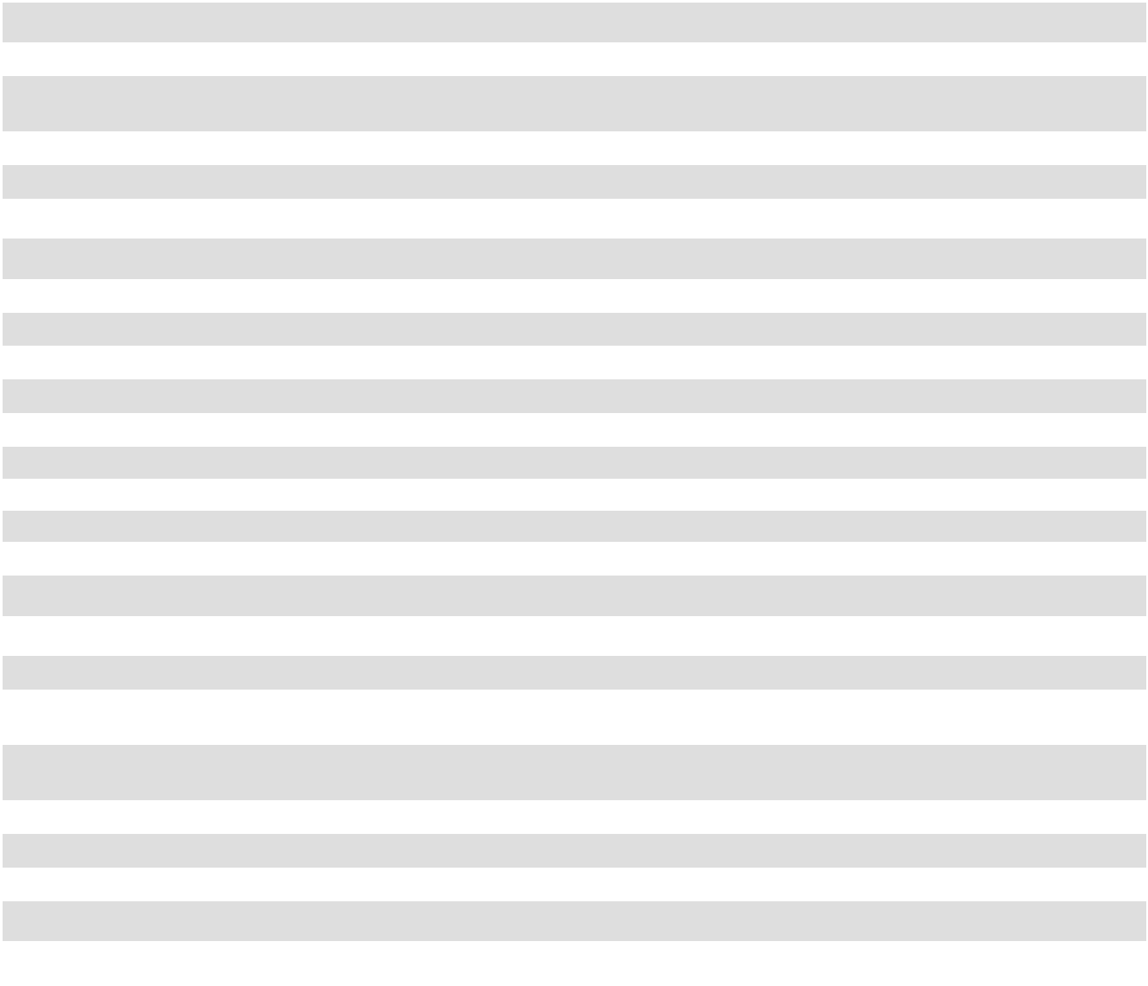

45

OIL-DRI CORPORATION OF AMERICA

CONSOLIDATED BALANCE SHEETS

(continued)

 |  | July 31,
 |  | 2026 |  |  | 2025
LIABILITIES AND STOCKHOLDERS’ EQUITY |  | (in thousands)
Current Liabilities
Current maturities of notes payable ..................................................................................... | $ | 1,000 | $ |  | 1,000
Accounts payable................................................................................................................. |  | 16,118 |  |  | 16,808
Dividends payable................................................................................................................ |  | 3,017 |  |  | 2,444
Operating lease liabilities..................................................................................................... |  | 3,651 |  |  | 4,071
Accrued expenses ................................................................................................................ |  | 44,258 |  |  | 44,864
Total Current Liabilities ..................................................................................... |  | 68,044 |  |  | 69,187
Noncurrent Liabilities
Long-term debt, net of unamortized debt issuance costs of $143 and $183 in 2026 and |  | 37,857 |  |  | 38,817
2025, respectively ................................................................................................................ |  | 37,857 |  |  | 38,817
Deferred compensation ........................................................................................................ |  | 5,924 |  |  | 5,777
Deferred income taxes ......................................................................................................... |  | 785 |  |  | 547
Long-term operating lease liabilities ................................................................................... |  | 11,064 |  |  | 11,296
Other .................................................................................................................................... |  | 7,382 |  |  | 7,540
Total Noncurrent Liabilities ............................................................................... |  | 63,012 |  |  | 63,977
Total Liabilities ......................................................................................................................... |  | 131,056 |  |  | 133,164
Commitments and Contingencies (See Note 11)
Stockholders’ Equity
Common Stock, par value $.10 per share, issued 15,349,811 shares in 2026 and |  | 1,535 |  |  | 1,528
15,276,261 shares in 2025 ................................................................................................... |  | 1,535 |  |  | 1,528
Class B Stock, convertible, par value $.10 per share, issued 4,650,484 shares in 2026 |  | 465 |  |  | 465
and 4,650,484 shares in 2025............................................................................................... |  | 465 |  |  | 465
Additional paid-in capital .................................................................................................... |  | 71,812 |  |  | 66,138
Retained earnings................................................................................................................. |  | 323,520 |  |  | 277,500
Accumulated other comprehensive income ......................................................................... |  | 908 |  |  | 969
Less treasury stock, at cost (5,103,568 Common and 416,544 Class B shares in 2026 |  | (100,510) |  |  | (87,540)
and 4,902,881 Common and 380,628 Class B shares in 2025) ........................................... |  | (100,510) |  |  | (87,540)
Total Stockholders’ Equity ...................................................................................................... |  | 297,730 |  |  | 259,060
Total Liabilities and Stockholders’ Equity............................................................................. | $ | 428,786 | $ |  | 392,224
The accompanying notes are an integral part of the Consolidated Financial Statements.
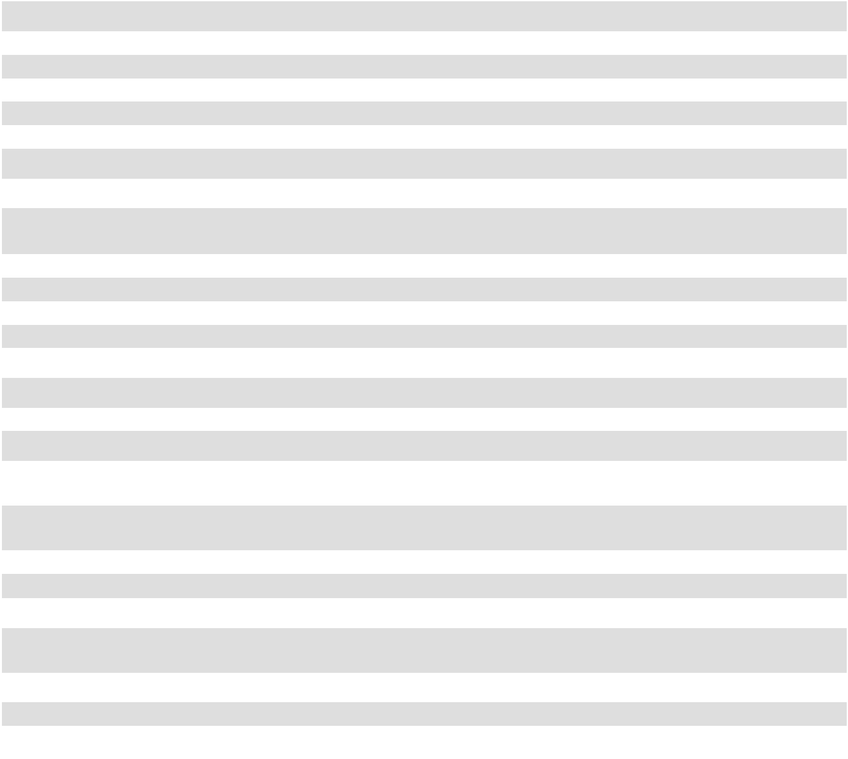

46

OIL-DRI CORPORATION OF AMERICA

CONSOLIDATED STATEMENTS OF OPERATIONS

 |  | Year Ended July 31,
 |  | 2026 |  |  | 2025 |  |  | 2024
 |  | (in thousands, except for per share data)
Net Sales........................................................................................................... | $ | 493,844 | $ |  | 485,572 | $ |  | 437,587
Cost of Goods Sold.......................................................................................... |  | (356,334) |  |  | (342,489) |  |  | (312,493)
Gross Profit ..................................................................................................... |  | 137,510 |  |  | 143,083 |  |  | 125,094
Selling, General and Administrative Expenses............................................ |  | (69,528) |  |  | (74,863) |  |  | (73,449)
Income from Operations ................................................................................ |  | 67,982 |  |  | 68,220 |  |  | 51,645
Other Income (Expense)
Interest income .......................................................................................... |  | 1,616 |  |  | 698 |  |  | 873
Interest expense ......................................................................................... |  | (2,199) |  |  | (2,434) |  |  | (1,804)
Foreign exchange loss ............................................................................... |  | (138) |  |  | (522) |  |  | (628)
Other, net ................................................................................................... |  | 2,222 |  |  | 249 |  |  | (435)
Total Other Income (Expense), Net ................................................... |  | 1,501 |  |  | (2,009) |  |  | (1,994)
Income Before Income Taxes......................................................................... |  | 69,483 |  |  | 66,211 |  |  | 49,651
Income Tax Expense....................................................................................... |  | (12,514) |  |  | (12,215) |  |  | (10,225)
Net Income....................................................................................................... | $ | 56,969 | $ |  | 53,996 | $ |  | 39,426
Net Income Per Share
Basic Common Stock ................................................................................ | $ | 4.23 |  | $ | 3.99 |  | $ | 2.92
Basic Class B Stock................................................................................... | $ | 3.18 |  | $ | 3.00 |  | $ | 2.20
Diluted Common Stock ............................................................................. | $ | 3.92 |  | $ | 3.70 |  | $ | 2.72
Diluted Class B Stock................................................................................ | $ | 3.18 | $ |  | 3.00 | $ |  | 2.20
Average Shares Outstanding
Basic Common Stock ................................................................................ |  | 9,876 |  |  | 9,889 |  |  | 9,771
Basic Class B Stock .................................................................................. |  | 4,038 |  |  | 3,994 |  |  | 3,952
Diluted Common Stock ............................................................................. |  | 13,914 |  |  | 13,883 |  |  | 13,723
Diluted Class B Stock................................................................................ |  | 4,038 |  |  | 3,994 |  |  | 3,952
Dividends Declared Per Share.......................................................................
Common Stock .......................................................................................... |  | 0.815 |  |  | 0.645 |  |  | 0.590
Class B Stock............................................................................................. |  | 0.609 |  |  | 0.485 |  |  | 0.444
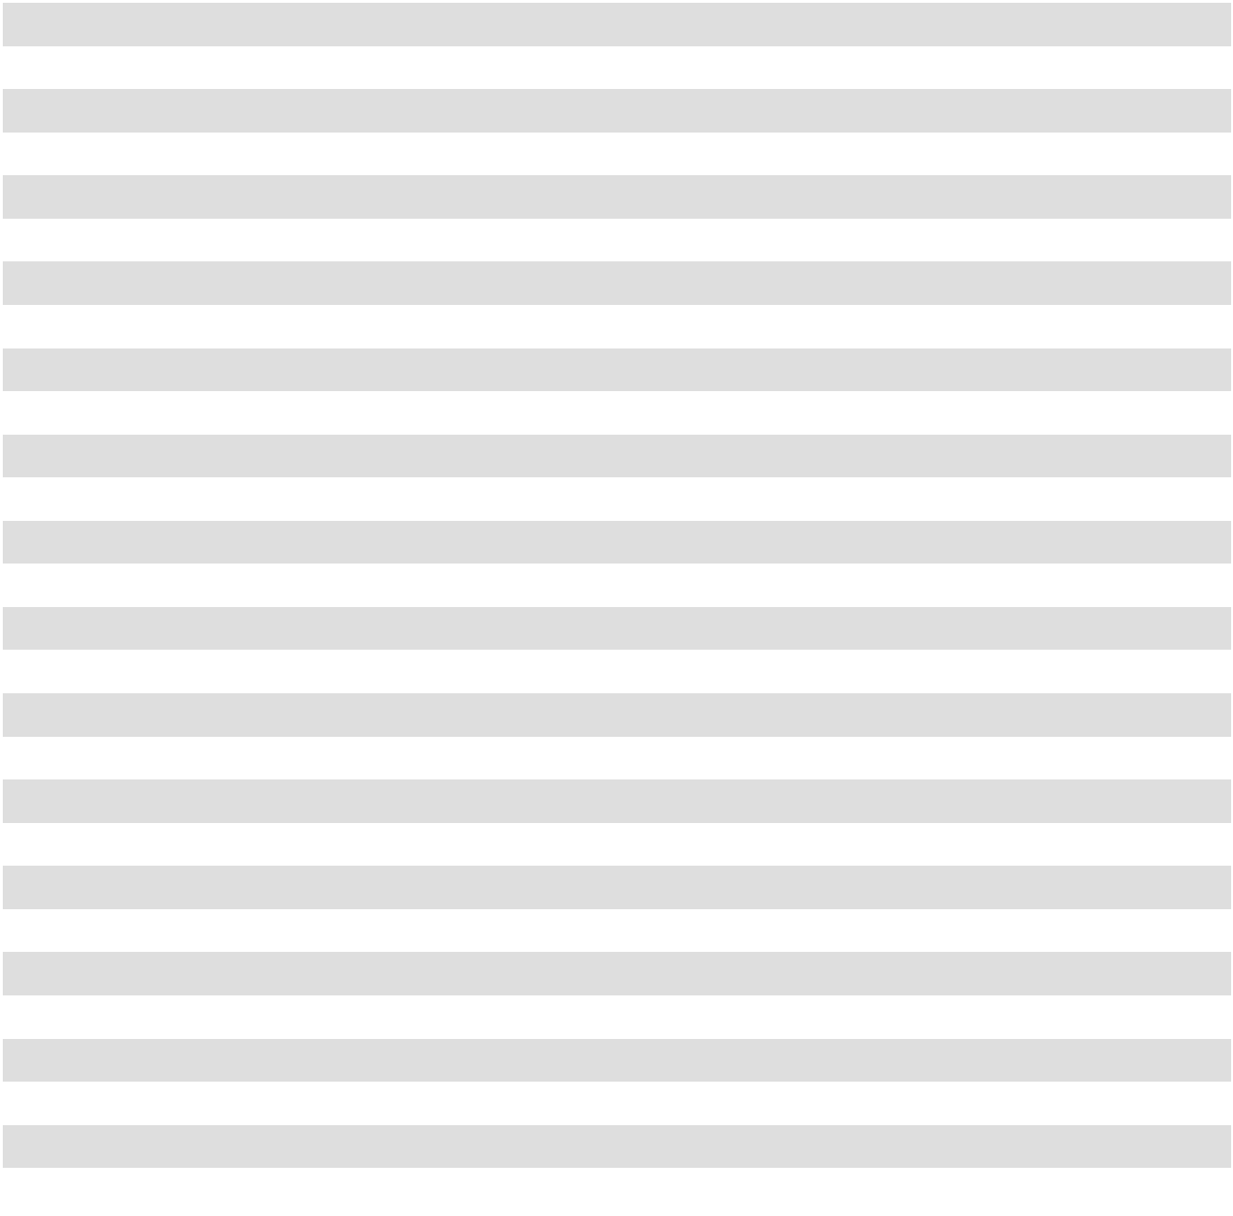

The accompanying notes are an integral part of the Consolidated Financial Statements.

47

OIL-DRI CORPORATION OF AMERICA

CONSOLIDATED STATEMENTS OF COMPREHENSIVE INCOME

 |  | Year Ended July 31,
 |  | 2026 |  |  | 2025 |  |  | 2024
 |  |  | (in thousands)
Net Income Attributable to Oil-Dri .............................................................. | $ | 56,969 | $ |  | 53,996 |  | $ | 39,426
Other Comprehensive Income (Loss):
Pension and postretirement benefits, net of tax......................................... |  | (10) |  |  | 129 |  |  | 64
Cumulative translation adjustment ............................................................ |  | (51) |  |  | 71 |  |  | (43)
Other Comprehensive (Loss) Income......................................................... |  | (61) |  |  | 200 |  |  | 21
Comprehensive Income.................................................................................. | $ | 56,908 | $ |  | 54,196 |  | $ | 39,447
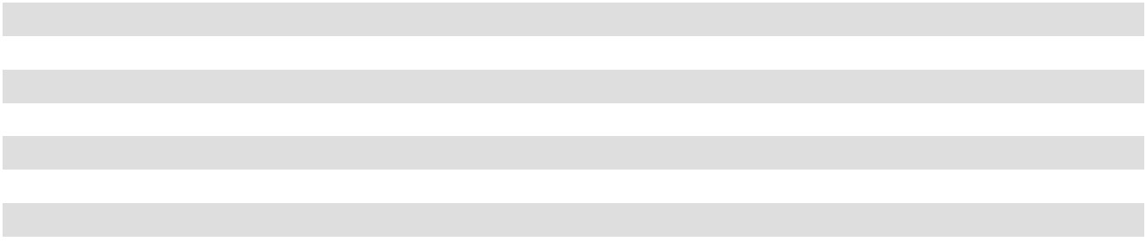

The accompanying notes are an integral part of the Consolidated Financial Statements.

48

OIL-DRI CORPORATION OF AMERICA

CONSOLIDATED STATEMENTS OF STOCKHOLDERS’ EQUITY

 | Number of Shares |  |  |  |  |  |  |  |  |  |  | (in thousands)
 | Common |  |  |  | Common |  |  | Additional |  |  |  |  |  |  |  |  |  | Accumulated |  |  | Total
 | Common |  | Treasury |  |  |  |  |  |  |  | Retained |  |  | Treasury |  |  |  | Other |  |  | Total
 | & Class B |  | Treasury |  | & Class B |  |  |  | Paid-In |  |  |  |  |  |  |  | Comprehensive |  |  | Stockholders’
 | Stock |  | Stock |  |  | Stock |  |  | Capital |  | Earnings |  |  |  | Stock |  | Income (Loss) |  |  |  | Equity
Balance, July 31, 2023 | 19,610,720 | (5,176,325) |  | $ |  | 1,961 | $ |  | 54,778 | $ |  | 200,796 | $ |  | (81,207) | $ |  | 748 | $ |  | 177,076
Net Income | — |  | — |  |  | — |  |  | — |  |  | 39,426 |  |  | — |  |  | — |  |  | 39,426
Other Comprehensive Income | — |  | — |  |  | — |  |  | — |  |  | — |  |  | — |  |  | 21 |  |  | 21
Dividends Declared | — |  | — |  |  | — |  |  | — |  |  | (7,975) |  |  | — |  |  | — |  |  | (7,975)
Purchases of Treasury Stock | — | (42,554) |  |  |  | — |  |  | — |  |  | — |  |  | (2,778) |  |  | — |  |  | (2,778)
Net Issuance of Stock Under Long-Term | 214,450 | (11,650) |  |  |  | 21 |  |  | 434 |  |  | — |  |  | (456) |  |  | — |  |  | (1)
Incentive Plan | 214,450 |  |  |  |  | 21 |  |  | 434 |  |  | — |  |  | (456) |  |  | — |  |  | (1)
Amortization of Restricted Stock | — |  | — |  |  | — | $ |  | 4,819 |  |  | — |  |  | — |  |  | — |  |  | 4,819
Balance, July 31, 2024 | 19,825,170 | (5,230,529) |  | $ |  | 1,982 | $ |  | 60,031 | $ |  | 232,247 | $ |  | (84,441) | $ |  | 769 | $ |  | 210,588
Net income | — |  | — |  |  | — |  |  | — |  |  | 53,996 |  |  | — |  |  | — |  |  | 53,996
Other comprehensive income | — |  | — |  |  | — |  |  | — |  |  | — |  |  | — |  |  | 200 |  |  | 200
Dividends declared | — |  | — |  |  | — |  |  | — |  |  | (8,743) |  |  | — |  |  | — |  |  | (8,743)
Purchases of treasury stock | — | (36,958) |  |  |  | — |  |  | — |  |  | — |  |  | (2,349) |  |  | — |  |  | (2,349)
Net issuance of stock under long-term | 101,575 | (16,022) |  |  |  | 11 |  |  | 739 |  |  | — |  |  | (750) |  |  | — |  |  | —
incentive plans | 101,575 |  |  |  |  | 11 |  |  | 739 |  |  | — |  |  | (750) |  |  | — |  |  | —
Amortization of restricted stock | — |  | — |  |  | — |  |  | 5,368 |  |  | — |  |  | — |  |  | — |  |  | 5,368
Balance, July 31, 2025 | 19,926,745 | (5,283,509) |  | $ |  | 1,993 | $ |  | 66,138 | $ |  | 277,500 | $ |  | (87,540) | $ |  | 969 | $ |  | 259,060
Net income | — |  | — |  |  | — |  |  | — |  |  | 56,969 |  |  | — |  |  | — |  |  | 56,969
Other comprehensive loss | — |  | — |  |  | — |  |  | — |  |  | — |  |  | — |  |  | (61) |  |  | (61)
Dividends declared | — |  | — |  |  | — |  |  | — |  |  | (10,949) |  |  | — |  |  | — |  |  | (10,949)
Purchases of treasury stock | — | (224,953) |  |  |  | — |  |  | — |  |  | — |  |  | (12,574) |  |  | — |  |  | (12,574)
Net issuance of stock under long-term | 73,550 | (11,650) |  |  |  | 7 |  |  | 388 |  |  | — |  |  | (396) |  |  | — |  |  | (1)
incentive plans | 73,550 |  |  |  |  | 7 |  |  | 388 |  |  | — |  |  | (396) |  |  | — |  |  | (1)
Amortization of restricted stock | — |  | — |  |  | — |  |  | 5,286 |  |  | — |  |  | — |  |  | — |  |  | 5,286
Balance, July 31, 2026 | 20,000,295 | (5,520,112) |  | $ |  | 2,000 | $ |  | 71,812 | $ |  | 323,520 | $ |  | (100,510) | $ |  | 908 | $ |  | 297,730
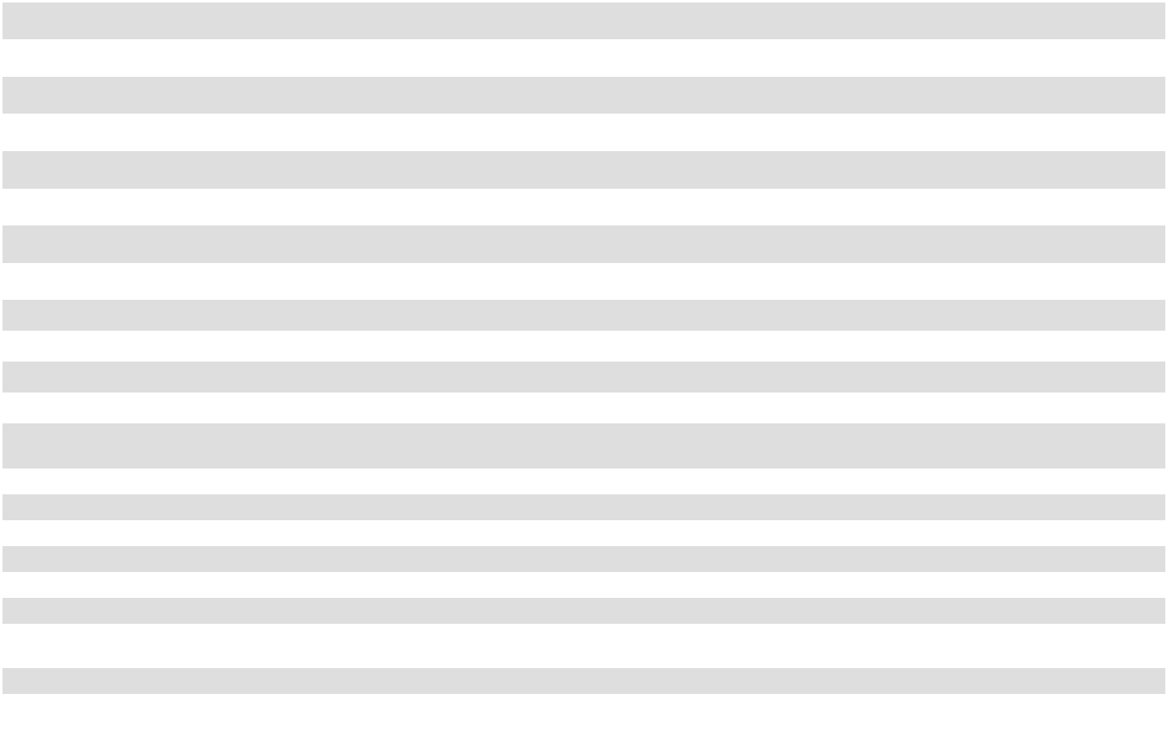

The accompanying notes are an integral part of the Consolidated Financial Statements.

49

OIL-DRI CORPORATION OF AMERICA

CONSOLIDATED STATEMENTS OF CASH FLOWS

 |  | Year-Ended July 31,
 |  | 2026 |  |  | 2025 |  |  | 2024
Cash Flows from Operating Activities |  |  | (in thousands)
Cash Flows from Operating Activities | $ | 56,969
Net income................................................................................................................... | $ | 56,969 | $ |  | 53,996 |  | $ | 39,426
Adjustments to reconcile net income to net cash provided by operating activities: |  | 23,200
Depreciation and amortization........................................................................ |  | 23,200 |  |  | 22,042 |  |  | 19,281
Non-cash stock compensation expense .......................................................... |  | 5,286 |  |  | 5,368 |  |  | 4,819
Deferred income tax expense.......................................................................... |  | 1,999 |  |  | 240 |  |  | 1,697
Net increase (decrease) to provision for bad debts and cash discounts .......... |  | (262) |  |  | 559 |  |  | (153)
Loss on impairment of patent applications..................................................... |  | — |  |  | 49 |  |  | —
Accretion for asset retirement obligation ....................................................... |  | 253 |  |  | 190 |  |  | 211
Gain from release of asset retirement obligation ........................................... |  | (417) |  |  | — |  |  | —
Loss (gain) on disposal of property, plant and equipment.............................. |  | 682 |  |  | (31) |  |  | 314
(Increase) decrease in: |  | (5,815)
Accounts receivable................................................................................. |  | (5,815) |  |  | (7,789) |  |  | 1,453
Inventories ............................................................................................... |  | (1,875) |  |  | 2,336 |  |  | (4,682)
Prepaid and other current assets .............................................................. |  | 55 |  |  | 191 |  |  | (2,431)
Deferred income tax, net.......................................................................... |  | (148) |  |  | 31 |  |  | (115)
Other assets.............................................................................................. |  | 4,423 |  |  | 4,095 |  |  | 3,404
Increase (decrease) in: |  | 6
Accounts payable..................................................................................... |  | 6 |  |  | 926 |  |  | (2,794)
Accrued expenses .................................................................................... |  | (104) |  |  | 2,384 |  |  | 2,449
Deferred compensation............................................................................ |  | 147 |  |  | 110 |  |  | 1,155
Other liabilities ........................................................................................ |  | (4,293) |  |  | (4,514) |  |  | (3,721)
............................................................................................TotalAdjustments |  | 23,137 |  |  | 26,187 |  |  | 20,887
Net Cash Provided by Operating Activities |  | 80,106 |  |  | 80,183 |  |  | 60,313
Cash Flows from Investing Activities |  | (34,209)
Capital expenditures ....................................................................................... |  | (34,209) |  |  | (32,562) |  |  | (32,000)
Proceeds from sale of property, plant and equipment .................................... |  | 5 |  |  | 151 |  |  | 182
Acquisition of business................................................................................... |  | — |  |  | (115) |  |  | (44,298)
Other investing activities ................................................................................ |  | 1,329 |  |  | — |  |  | —
.........................................NetCashUsedinInvestingActivities |  | (32,875) |  |  | (32,526) |  |  | (76,116)
Cash Flows from Financing Activities |  | —
Proceeds from issuance of notes payable ....................................................... |  | — |  |  | — |  |  | 20,000
Principal payments on notes payable.............................................................. |  | (1,000) |  |  | (11,000) |  |  | (1,000)
Payment of debt issuance costs....................................................................... |  | — |  |  | — |  |  | (90)
Dividends paid ................................................................................................ |  | (10,376) |  |  | (8,395) |  |  | (7,806)
Purchase of treasury stock .............................................................................. |  | (12,574) |  |  | (2,349) |  |  | (2,778)
.................NetCash(Usedin)ProvidedbyFinancingActivities |  | (23,950) |  |  | (21,744) |  |  | 8,326
...................................Effectofexchangeratechangesoncashandcashequivalents |  | (39) |  |  | 64 |  |  | 204
Net Increase (Decrease) in Cash and Cash Equivalents......................................... |  | 23,242 |  |  | 25,977 |  |  | (7,273)
Cash, Cash Equivalents and Restricted Cash, Beginning of Year ........................ |  | 50,458 |  |  | 24,481 |  |  | 31,754
..................................Cash,CashEquivalentsandRestrictedCash,EndofYear | $ | 73,700 |  | $ | 50,458 |  | $ | 24,481


The accompanying notes are an integral part of the Consolidated Financial Statements.

50

CONSOLIDATED STATEMENTS OF CASH FLOWS - CONTINUED
 |  |  | Year-Ended July 31,
 |  |  | 2026 |  |  |  | 2025 |  |  |  | 2024
 |  |  |  | (in thousands)
Supplemental disclosure:
Restricted Cash:
Beginning balance........................................................................................... | $ |  | — | $ |  |  | 1,000 |  |  | $ | —
(Decrease) increase to restricted cash ............................................................. | $ |  | — | $ |  |  | (885) |  |  | $ | 1,000
Final settlement of acquisition of Ultra Pet..................................................... | $ |  | — | $ |  |  | (115) |  |  | $ | —
Ending balance................................................................................................ | $ |  | — | $ |  |  | — |  |  | $ | 1,000
Other cash flows:
Interest payments, net of amounts capitalized ................................................ | $ |  | 1,657 | $ |  |  | 1,697 |  |  | $ | 1,089
Noncash investing and financing activities:
Change in capital expenditures in accounts payable........................................ | $ |  | (692) | $ |  |  | 876 |  |  | $ | 458
Change in capital expenditures in accrued expenses ....................................... | $ |  | (546) | $ |  |  | (1,553) |  |  | $ | 3,380
Cash dividends declared and accrued, but not paid ........................................ | $ |  | 3,017 | $ |  |  | 2,444 |  |  | $ | 2,096
Increase in reclamation asset and liability ...................................................... | $ |  | 84 | $ |  |  | 926 |  |  | $ | 79
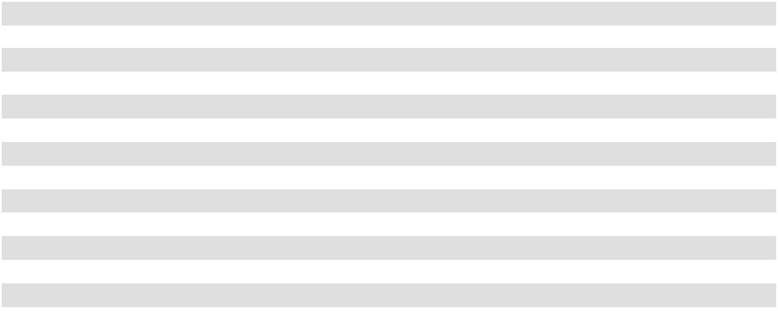

The accompanying notes are an integral part of the Consolidated Financial Statements.

51

OIL-DRI CORPORATION OF AMERICA

NOTES TO THE CONSOLIDATED FINANCIAL STATEMENTS

NOTE 1 – SUMMARY OF SIGNIFICANT ACCOUNTING POLICIES

NATURE OF OPERATIONS

We are a leader in developing, manufacturing and/or marketing sorbent products. Our sorbent products are principally produced from clay minerals. Our absorbent clay products include cat litter, industrial floor absorbents, agricultural chemical carriers and animal feed additives. Our adsorbent products include bleaching clays, which are used for filtration of edible oils, pre-treatment of renewable diesel, and for purification of petroleum-based oils. We also sell synthetic sorbents, which are used for industrial cleanup and cat litter.

PRINCIPLES OF CONSOLIDATION

The Consolidated Financial Statements include the accounts of Oil-Dri Corporation of America and its subsidiaries.

All significant intercompany balances and transactions have been eliminated from the Consolidated Financial Statements.

RECLASSIFICATION

Certain amounts in the prior period financial statements have been reclassified to conform to the presentation of the current period financial statements. These immaterial reclassifications had no effect on the previously reported net income or net cash flows.

MANAGEMENT'S USE OF ESTIMATES

The preparation of financial statements in conformity with U.S. GAAP requires management to make estimates and assumptions that affect the reported amounts of assets, liabilities, and disclosure of contingent assets and liabilities as of the date of the financial statements and the reported amounts of revenues and expenses during the reporting period as well as the related disclosures. Estimates and assumptions about future events cannot be made with certainty. All of our estimates and assumptions are revised periodically. Actual results could differ from these estimates.

CASH, CASH EQUIVALENTS AND RESTRICTED CASH

Cash equivalents are highly liquid investments with maturities of three months or less.

The following table provides a reconciliation of cash, cash equivalents and restricted cash as of July 31, 2026, and 2025 reported within the Consolidated Balance Sheets that sum to the total of the same such amounts shown in the Consolidated Statement of Cash Flows (in thousands):

 |  | 2026 |  |  | 2025 |  |  | 2024
Cash and cash equivalents.......................................................................... | $ | 73,700 | $ |  | 50,458 | $ |  | 23,481
Restricted cash included in prepaid expenses and other assets .................. |  | — |  |  | — |  |  | 1,000
Cash, cash equivalents, and restricted cash ............................................... | $ | 73,700 | $ |  | 50,458 | $ |  | 24,481

TRADE RECEIVABLES

We recognize trade receivables when control of finished products is transferred to our customers. We record an allowance for credit losses based on our expectations and a periodic review of our accounts receivable, including a review of the overall aging of accounts, consideration of customer credit risk and analysis of facts and circumstances about specific accounts. A customer account is determined to be uncollectible when it is probable that a loss will be incurred after we have completed our internal collection procedures, including termination of shipments, direct customer contact and formal demand of payment. We retain outside collection agencies to facilitate our collection efforts. Past due status is determined based on contractual terms and customer payment history. We also include an allowance for expected cash discounts to be taken by our customers. Accounts receivable was $75.4 million, $69.4 million, and $62.2 million as of July 31, 2026, July 31, 2025, and July 31, 2024, respectively.

52

INVENTORIES

The composition of inventories was as follows as of July 31 (in thousands):

 |  | 2026 |  |  | 2025
Finished goods ........................... | $ | 29,660 | $ |  | 29,401
Packaging................................... |  | 8,605 |  |  | 8,114
Spare parts.................................. |  | 6,875 | $ |  | 6,822
Other .......................................... |  | 8,349 |  |  | 7,257
Inventories, net........................... | $ | 53,489 | $ |  | 51,594
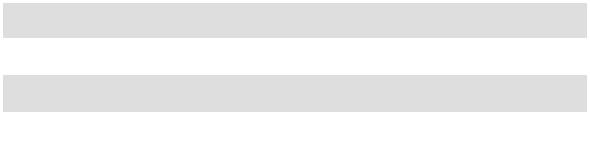

Inventories are valued at the lower of cost (first-in, first-out) or net realizable value. Inventory costs include the cost of raw materials, packaging supplies, labor and other overhead costs. We performed a detailed review of our inventory items to determine if an obsolescence reserve adjustment was necessary. The review surveyed all of our operating facilities and sales groups to ensure that both historical issues and new market trends were considered. The obsolescence reserve not only considers specific items but also takes into consideration the overall value of the inventory as of the balance sheet date. We recorded inventory reserves of $3.8 million as of July 31, 2026, and $3.7 million as of July 31, 2025. The other category of inventories includes a variety of items including clay, additives, fragrances and other supplies. Spare parts in inventory are recorded net of a valuation reserve based on aging.

TRANSLATION OF FOREIGN CURRENCIES

Assets and liabilities of foreign subsidiaries, where the local currency is the functional currency, are translated to U.S. dollars at the exchange rates in effect at period end. Income statement items are translated at the average exchange rate on a monthly basis. Resulting translation adjustments are recorded as a separate component of stockholders’ equity.

INTANGIBLES AND GOODWILL

Our intangible assets are mainly comprised of customer lists, patents, trademarks, trade names and goodwill. We amortize customer lists and patents on a straight-line basis over periods ranging from 18 to 20 years. During fiscal year 2024 we recorded additions of intangible assets of $37.4 million related to the acquisition of Ultra Pet, the components of which were customer list of $20.4 million amortized over a useful life of 18 years, $5.2 million of trade name and $11.8 million of goodwill.

Intangible amortization was $1.2 million in both fiscal years 2026 and 2025 and $0.5 million in fiscal year 2024.

Our estimated intangible amortization expense for the next five fiscal years is as follows (in thousands):


2027..................... | $ 1,199
2028..................... | $ 1,199
2029..................... | $ 1,199
2030..................... | $ 1,199
2031..................... | $ 1,196

The remaining weighted average amortization period of our intangibles subject to amortization is as follows (in years):

 | Weighted Average
 | Amortization Period
Patents........................................................................... | 7.9
Customer list................................................................. | 15.8
Total intangible assets subject to amortization............. | 15.5


Trademarks and trade names acquired through acquisitions were determined to have indefinite lives. We had $5.6 million in indefinite life trademarks and trade names as of both July 31, 2026, and 2025.

53

Goodwill by operating segment was as follows as of July 31 (in thousands):

 |  | 2026 |  |  | 2025
Business to Business.................. |  | 3,618 |  |  | 3,618
Retail and Wholesale ................. | $ | 12,399 |  |  | 12,399
Total ........................................... | $ | 16,017 | $ |  | 16,017


We review indefinite-lived intangibles and goodwill to assess for impairment on the first day of our fiscal fourth quarter, or more frequently if an event occurs or circumstances change that would more likely than not reduce the fair value of a reporting unit below its carrying value. We also perform a review for indicators of impairment each quarter to assess whether an interim impairment review is required for any reporting unit. Our review entails a qualitative analysis of triggering events and, if identified, a further analysis is performed based on cash flow considerations and other approaches that require significant judgment with respect to volume, revenue, expenses and allocations. Impairment occurs when the carrying value exceeds the fair value. We performed our impairment assessment and identified no triggering events that indicate the need for impairment of indefinite intangible assets or goodwill in either fiscal year 2026 or 2025.

PROPERTY, PLANT AND EQUIPMENT

Property, plant and equipment are depreciated using the straight-line method over their estimated useful lives. The useful lives for most of our depreciable assets range from 2 to 25 years, with some buildings ranging up to 30 years. Depreciation expense was $22.0 million, $20.8 million, and $18.8 million in fiscal years 2026, 2025, and 2024 respectively. Major improvements and betterments are capitalized, while maintenance and repairs that do not extend the useful life or increase functionality of the applicable assets are expensed as incurred. Interest expense may also be capitalized for assets that require a period of time to get them ready for their intended use. There was no capitalized interest in fiscal years 2026 and 2025.

Property, plant and equipment are carried at cost on the Consolidated Balance Sheets and are reviewed for possible impairment when circumstances indicate that an asset may be impaired. We take into consideration idle and underutilized equipment and review business plans for possible impairment. When impairment is indicated, an impairment charge is recorded for the difference between the carrying value of the asset and its fair market value. We recognized impairment for fixed assets of $0.3 million and $0.1 million in fiscal years 2026 and 2024, respectively. No impairment was recognized in fiscal year 2025. Impairment is included in cost of goods sold on the Consolidated Statement of Operations.

LAND AND MINING ASSETS

Our mining assets include mining properties, mineral rights and reclamation assets. We surface mine sorbent minerals on property that we either own or lease. A significant part of our mining cost is incurred during the process of removing the overburden from the mine site, thus exposing the sorbent material used in a majority of our production processes. Pre-production overburden removal costs associated with opening a new mine during the development phase are deferred and amortized when the sorbent material is removed from the mine and used to produce product for sale. There were no additional capitalized pre-production costs incurred in either fiscal year 2026 or 2025. The amount of development costs being amortized at the end of the year was $3.1 million and $3.5 million in 2026 and 2025, respectively. Stripping costs incurred during production are treated as a variable inventory production cost and are included in cost of goods sold. Stripping costs included in cost of goods sold were approximately $4.8 million, $4.7 million, and $5.4 million for fiscal years 2026, 2025, and 2024, respectively.

Additionally, it is our policy to capitalize the purchase cost of land and mineral rights, including associated legal, survey, and real estate fees. The costs of obtaining mineral rights, including legal fees and drilling expenses, are also capitalized. We had land of $13.9 million as of fiscal year ending July 31, 2026, and $13.5 million as of fiscal year ending and July 31, 2025. We had $2.2 million of gross mineral rights in both fiscal years ending July 31, 2026 and July 31, 2025. Any prepaid royalties that may be offset against future royalties due upon extraction of the mineral are also capitalized. Prepaid royalties included in current prepaid expenses and in non-current other assets on the Consolidated Balance Sheets were approximately $2.1 million as of July 31, 2026, and $2.4 million as of July 31, 2025.

RECLAMATION

We perform ongoing reclamation activities during the normal course of our overburden removal. As overburden is removed from a mine site, it is hauled to previously mined sites and is used to refill the older sites. This process allows us to

54

continuously reclaim older mine sites and dispose of overburden simultaneously, therefore minimizing the costs associated with the reclamation process.

On an annual basis we evaluate our potential reclamation liability in accordance with ASC 410, Asset Retirement and Environmental Obligations. Reclamation assets are depreciated over the estimated useful lives of the various mines. Reclamation liabilities are increased based on a yearly accretion charge over the estimated useful lives of the mines.

We recorded an estimated net reclamation asset of $3.0 million as of July 31, 2026, and $3.1 million as of July 31, 2025, and a corresponding estimated reclamation liability of $5.8 million as of July 31, 2026, and $5.9 million as of July 31, 2025. These values represent the discounted present value of the estimated future mining reclamation and landfill closure costs at the production plants. In fiscal year 2026, we released a portion of our asset retirement obligation based on our annual evaluation of the future costs, resulting in a net decrease of the liability.

TRADE PROMOTIONS

We routinely commit to one-time or ongoing trade promotion programs, primarily in our Retail and Wholesale Products Group. All such costs are netted against sales. We have accrued liabilities at the end of each period for the estimated expenses incurred but not yet paid for these programs. Promotional reserves are provided for sales incentives made directly to consumers, such as coupons, and sales incentives made to customers, including slotting, discounts based on sales volume, cooperative marketing programs and other arrangements. We rely on our historical experience of trade spending patterns and that of the industry, current trends and forecast data to record estimates of our trade spending liabilities.

FAIR VALUE OF FINANCIAL INSTRUMENTS

Non-derivative financial instruments included in the Consolidated Balance Sheets are cash and cash equivalents, short-term investments, credit facilities, and notes payable. These instruments, except for debt, were carried at amounts approximating fair value as of July 31, 2026, and 2025. See Note 5 of the Notes to the Consolidated Financial Statements for additional information regarding the fair value of our financial instruments, including notes payable.

REVENUE RECOGNITION

We recognize revenue when performance obligations under the terms of the contracts with customers are satisfied. Our performance obligation generally consists of the promise to sell finished products to wholesalers, distributors, retailers or consumers and our obligations have an original duration of one year or less. Control of the finished products are transferred upon shipment to, or receipt at, customers' locations, as determined by the specific terms of the contract. We have completed our performance obligation when control is transferred, and we recognize revenue accordingly. Taxes collected from customers and remitted to governmental authorities are excluded from net sales. Sales returns are not material nor are warranties or any related obligations.

We have an unconditional right to consideration under the payment terms specified in the contract upon completion of the performance obligation. We may require certain customers to provide payment in advance of product shipment. We recorded a liability of $0.2 million as of July 31, 2026, for these advance payments. There is $0.3 million liability for advance payments as of July 31, 2025. This liability is reported in Other Accrued Expenses on the Consolidated Balance Sheets. There is $0.3 million revenue recognized during fiscal year 2026 that was included in the liability for advance payments at the beginning of the year.

COST OF GOODS SOLD

Cost of goods sold consists of all manufacturing costs, including depreciation and amortization related to assets used in the manufacturing and distribution process, inbound and outbound freight, inspection costs, purchasing costs associated with materials and packaging used in the production process and warehouse and distribution costs. Natural gas forward contracts are accounted for as normal purchases. As of July 31, 2026 there were five outstanding natural gas forward contracts under which we are obligated for purchases of $1.9 million in fiscal year 2027, $1.2 million in fiscal year 2028 and $0.6 million in fiscal year 2029.

SHIPPING AND HANDLING COSTS

Shipping and handling costs are included in cost of goods sold and were approximately $67.2 million, $64.9 million, and $59.2 million for fiscal years 2026, 2025, and 2024, respectively.

55

SELLING, GENERAL AND ADMINISTRATIVE EXPENSES

Selling, general and administrative expenses include salaries, wages and benefits associated with staff outside the manufacturing and distribution functions, all marketing related costs, any miscellaneous trade spending expenses not required to be included in net sales, research and development costs, depreciation and amortization related to assets outside the manufacturing and distribution process and all other non-manufacturing and non-distribution expenses.

ADVERTISING

Advertising costs for the development of printed materials, television commercials, web-based digital banners, web-based social media and sales videos are deferred and expensed upon the first use of the materials. Costs paid for communicating advertising over a period of time, such as television air time, radio commercials and print media advertising space, are deferred and expensed on a pro-rata basis. All other advertising costs, including participation in industry conventions and shows and market research, are expensed when incurred. All advertising costs are part of selling, general and administrative expenses. Advertising expenses were approximately $7.0 million, $7.6 million, $9.0 million in fiscal years 2026, 2025, and 2024, respectively.

RESEARCH AND DEVELOPMENT

Research and development costs of approximately $2.1 million, $2.4 million, and $2.1 million were charged to expense as incurred for fiscal years 2026, 2025, and 2024, respectively, and are recorded in selling, general and administrative expenses.

STOCK-BASED COMPENSATION

We account for stock options and restricted stock issued under our long-term incentive plans in accordance with ASC 718, Compensation – Stock Compensation. The fair value of stock-based compensation is determined at the grant date. The related compensation expense is recognized over the appropriate vesting period. Forfeitures are recognized as they occur. See Note 8 of the Notes to the Consolidated Financial Statements for additional information.

INCOME TAXES

Deferred income tax assets and liabilities are recorded for the impact of temporary differences between the tax basis of assets and liabilities and the amounts recognized for financial reporting purposes. Deferred tax assets are reviewed, and a valuation allowance is established if management believes that it is more likely than not that some portion of our deferred tax assets will not be realized. Changes in valuation allowances from period to period are included in the tax provision in the period of change.

In addition to existing valuation allowances, we provide for uncertain tax positions, if necessary, when such tax positions do not meet the recognition thresholds or measurement standards prescribed by ASC 740, Income Taxes. Amounts for uncertain tax positions are adjusted when new information becomes available or when positions are effectively settled. We recognize interest and penalties accrued related to uncertain tax positions in income tax expense.

U.S. income tax expense and foreign withholding taxes are provided on remittances of foreign earnings and on unremitted foreign earnings that are not indefinitely reinvested. Where unremitted foreign earnings are indefinitely reinvested, no provision for federal or state tax expense is recorded. When circumstances change and we determine that some or all of the undistributed earnings will be remitted in the foreseeable future, a corresponding expense is accrued in the current period. See Note 6 of the Notes to the Consolidated Financial Statements for additional information about income taxes.

STOCK SPLIT

On October 9, 2024, we announced that our Board approved a two-for-one stock split in the form of a stock dividend. Stockholders of record as of the close of business on December 20, 2024 received a distribution of one additional share of Common Stock, for each share of Common Stock held by such stockholder and one additional share of Class B Stock for each share of Class B Stock held by such stockholder as of the record date. The additional shares were distributed on January 3, 2025, and our Common Stock began trading on a post-split basis on January 6, 2025.

56

The stock split did not affect the par value of the Common Stock or Class B Stock, however, in order to implement the stock split, we amended our Certificate of Incorporation on December 11, 2024 to increase the number of authorized shares of Common Stock from 15 million to 30 million. Proportionate adjustments were made to the number of shares that remain available for issuance pursuant to the 2006 Plan, as well as to the outstanding awards under the 2006 Plan.

Unless noted, all Common Stock and Class B Stock share and per share amounts contained in the Consolidated Financial Statements have been retroactively adjusted, where applicable, to reflect the stock split. The impact on the Consolidated Balance Sheets and Consolidated Statements of Stockholders' Equity herein was an increase of $0.8 million to Common Stock and Class B Stock, with an offsetting decrease in Additional Paid-In-Capital, which has been retroactively adjusted as if the stock split had occurred at the beginning of the earliest period presented. The change in treasury shares reflects the stock split on shares held by wholly owned subsidiaries which are presented as treasury shares on a consolidated basis.

EARNINGS PER SHARE

We utilize the two-class method to report our earnings per share ("EPS"). The two-class method is an earnings allocation formula that determines EPS for each class of common stock according to dividends declared and participation rights in undistributed earnings. Common Stock is entitled to cash dividends equal to at least 133.33% on a per share basis of the cash dividend paid on Class B Stock. In computing EPS, the Company has allocated dividends declared to shares of Common Stock and Class B Stock based on amounts declared for each class of stock and 33.33% more of the undistributed earnings have been allocated to shares of Common Stock than to shares of Class B Stock on a per share basis. Common Stock is entitled to one vote per share and Class B Stock is entitled to ten votes per share. Common Stock has no conversion rights. Class B Stock is convertible by the holders thereof on a share-by-share basis into Common Stock at any time and is subject to mandatory conversion under certain circumstances. Basic EPS is computed by dividing net earnings, reduced for any distributed and undistributed earnings allocated to unvested restricted shares, by the weighted-average number of shares outstanding during the period for each class of common stock. Diluted EPS for Common Stock is derived utilizing the most dilutive result of the if-converted, treasury stock and two-class methods. In our case, the if-converted method is more dilutive than the two-class method and because our unvested restricted stock participates in dividends and is therefore anti-dilutive the treasury stock method does not apply. For Class B Stock, diluted EPS is derived utilizing the two-class method since, as with our Common Stock, our unvested restricted stock participates in dividends and is therefore anti-dilutive, making the treasury stock method inapplicable. The reverse treasury stock method is also inapplicable to both classes as we have no obligation to repurchase our Common Stock or Class B Stock. In both the if-converted and two-class methods, diluted EPS is computed by dividing net earnings by the weighted-average number of shares and potential shares outstanding during the period, taking into consideration different potential shares outstanding based on the method used. Dilution for Common Stock takes into consideration the effect of both unvested restricted shares and convertible shares of Class B Stock, unless such shares are anti-dilutive, in which case they are not considered. Dilution for Class B Stock takes into consideration the effect of unvested restricted shares, unless such shares are anti-dilutive, in which case they are not considered.

57

Below is a reconciliation of the calculation of basic and diluted EPS.

 |  | For the year ended July 31, 2026
 |  | (in thousands, except for per share data)
 |  | Total |  |  | Common |  |  | Class B
Net income | $ | 56,969 | $ |  | 43,507 | $ |  | 13,462
Distributed and undistributed earnings on restricted shares |  | (2,400) |  |  | (1,764) |  |  | (636)
Income available to stockholders | $ | 54,569 |  | $ | 41,743 |  | $ | 12,826
Net Income (Numerator) |  |  | $ |  | 41,743 | $ |  | 12,826
Weighted Average Shares Outstanding (Denominator) |  |  |  |  | 9,876 |  |  | 4,038
Basic EPS |  |  |  | $ | 4.23 |  | $ | 3.18
Effect of dilution - Net Income ⁽¹⁾ |  |  | $ |  | 12,826 | $ |  | —
Net income assuming dilution (Numerator) |  |  | $ |  | 54,569 | $ |  | 12,826
Effect of dilution - Shares ⁽¹⁾ |  |  |  |  | 4,038 | $ |  | —
Shares assuming dilution (Denominator) |  |  |  |  | 13,914 | $ |  | 4,038
Diluted EPS |  |  |  | $ | 3.92 |  | $ | 3.18
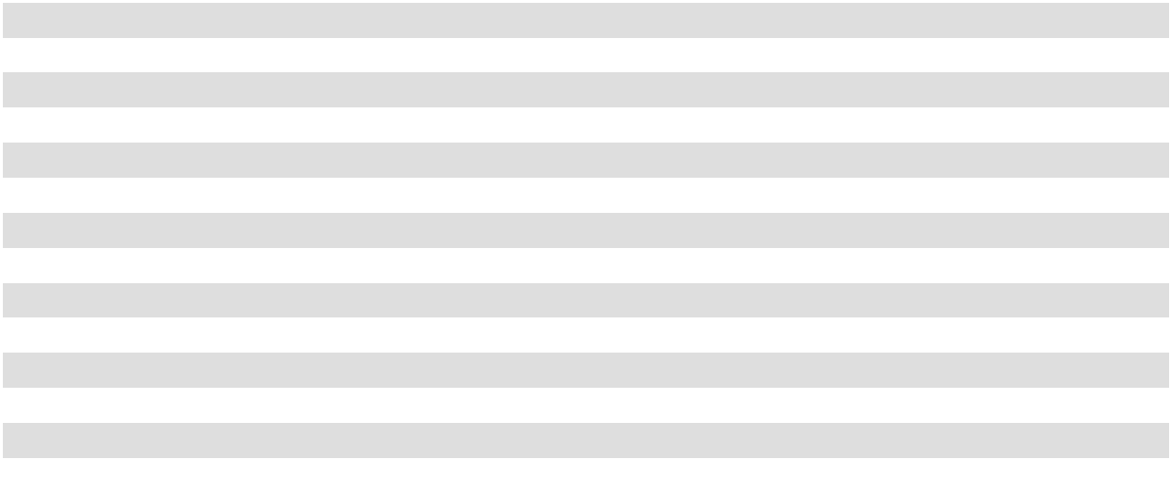

- The impact of 292,305 shares of unvested Common Stock and 140,150 shares of unvested Class B Stock, restricted stock was anti-dilutive therefore not included in the calculation of diluted EPS for the year ended July 31, 2026.

 |  | For the year ended July 31, 2025
 |  | (in thousands, except for per share data)
 |  | Total |  |  | Common |  |  | Class B
Net income | $ | 53,996 | $ |  | 41,173 | $ |  | 12,823
Distributed and undistributed earnings on restricted shares |  | (2,580) |  |  | (1,732) |  |  | (848)
Income available to stockholders | $ | 51,416 |  | $ | 39,441 |  | $ | 11,975
Net Income (Numerator) |  |  | $ |  | 39,441 | $ |  | 11,975
Weighted Average Shares Outstanding (Denominator) |  |  |  |  | 9,889 |  |  | 3,994
Basic EPS |  |  |  | $ | 3.99 |  | $ | 3.00
Effect of dilution - Net Income ⁽²⁾ |  |  | $ |  | 11,975 | $ |  | —
Net income assuming dilution (Numerator) |  |  | $ |  | 51,416 | $ |  | 11,975
Effect of dilution - Shares ⁽²⁾ |  |  |  |  | 3,994 | $ |  | —
Shares assuming dilution (Denominator) |  |  |  |  | 13,883 | $ |  | 3,994
Diluted EPS |  |  |  | $ | 3.70 |  | $ | 3.00

- The impact of 275,327 shares of unvested Common Stock and 139,484 shares of unvested Class B Stock, restricted stock was anti-dilutive therefore not included in the calculation of diluted EPS for the year ended July 31, 2025.

58

 |  | For the year ended July 31, 2024
 |  | (in thousands, except for per share data)
 |  | Total |  |  | Common |  |  | Class B
Net income | $ | 39,426 | $ |  | 29,981 | $ |  | 9,445
Distributed and undistributed earnings on restricted shares |  | (2,165) |  |  | (1,410) |  |  | (755)
Income available to stockholders | $ | 37,261 |  | $ | 28,571 |  | $ | 8,690
Net Income (Numerator) |  |  | $ |  | 28,571 | $ |  | 8,690
Weighted Average Shares Outstanding (Denominator) |  |  |  |  | 9,771 |  |  | 3,952
Basic EPS |  |  |  | $ | 2.92 |  | $ | 2.20
Effect of dilution - Net Income ⁽³⁾ |  |  | $ |  | 8,690 | $ |  | —
Net income assuming dilution (Numerator) |  |  | $ |  | 37,261 | $ |  | 8,690
Effect of dilution - Shares ⁽³⁾ |  |  |  |  | 3,952 | $ |  | —
Shares assuming dilution (Denominator) |  |  |  |  | 13,723 | $ |  | 3,952
Diluted EPS |  |  |  | $ | 2.72 |  | $ | 2.20

- The impact of 317,722 shares of unvested Common Stock and 108,740 shares of unvested Class B Stock, restricted stock was anti-dilutive therefore not included in the calculation of diluted EPS for the year ended July 31, 2024.

NEW ACCOUNTING PRONOUNCEMENTS

Recently Adopted Accounting Standards

In December 2023, the Financial Accounting Standards Board ("FASB") issued Accounting Standards Update ("ASU") No. 2023-09, "Income Taxes (Topic 740): Improvements to Income Tax Disclosures" ("ASU 2023-09"). These amendments primarily require enhanced disclosures and disaggregation of income tax information by jurisdiction in the annual income tax reconciliation and quantitative disclosures regarding income taxes paid. These amendments were adopted as of July 31, 2026 and have been applied retrospectively. Refer to Note 6 - Income Taxes of this Form 10-K for the enhanced disclosures updated as a result of the adoption of ASU 2023-09.

Recently Issued Accounting Standards Not Yet Adopted

In November 2024, the FASB issued ASU No. 2024-03, "Income Statement - Reporting Comprehensive Income - Expense Disaggregation Disclosures (Subtopic 220-40): Disaggregation of Income Statement Expenses" ("ASU 2024-03"). The pronouncement expands the disclosure requirements for expenses, specifically by providing more detailed information about the types of expenses in commonly presented expense captions. ASU 2024-03 is effective for fiscal years beginning after December 15, 2026, and interim periods within fiscal years beginning after December 15, 2027. We are currently evaluating the impact that ASU 2024-03 will have on the Company's consolidated financial statement disclosures.

In July 2025, the FASB issued ASU 2025-05, "Measurement of Credit Losses for Accounts Receivable and Contract Assets" ("ASU 2025-05"), which provides a practical expedient that assumes current conditions as of the balance sheet date remain unchanged when developing forecasts for estimating expected credit losses. Under ASU 2025-05, an entity is required to disclose that it has elected to use the practical expedient and the election should be applied prospectively. ASU 2025-05 is effective for fiscal years, and interim periods within those years, beginning after December 15, 2025, with early adoption permitted. We do not expect the amendment to have a material impact on the Company's consolidated financial statement disclosures, however we will continue to assess through the adoption period.

In September 2025, the FASB issued ASU 2025-06, "Intangibles—Goodwill and Other—Internal-Use Software (Subtopic 350-40): Targeted Improvements to the Accounting for Internal-Use Software" ("ASU 2025-06"), which provides clarification and improvements to the accounting for internal-use software costs under ASC 350-40, Intangibles – Goodwill and Other – Internal-Use Software. The guidance includes amendments related to capitalization of implementation costs, subsequent measurement, and related presentation and disclosure requirements. ASU 2025-06 is effective for fiscal years

59

beginning after December 15, 2027, including interim periods within those fiscal years. We are currently evaluating the impact that ASU 2025-06 will have on the Company's consolidated financial statement disclosures.

In December 2025, the FASB issued ASU 2025-10, "Government Grants (Topic 832): Accounting for Government Grants Received by Business Entities" ("ASU 2025-10"). This amendment establishes authoritative guidance on the recognition, measurement and presentation of government grants received by business entities. ASU 2025-10 is effective for fiscal years beginning after December 15, 2028, including interim periods within those years, with early adoption permitted. Given the nature of our existing government-related arrangements, we do not expect the amendment to have a material impact on the Company's consolidated financial statement disclosures, however we will continue to assess through the adoption period.

In December 2025, the FASB issued ASU 2025-11, "Interim Reporting (Topic 270): Narrow-Scope Improvements" ("ASU 2025-11"). These amendments are intended to improve the navigability of interim reporting guidance, clarify when ASC 270 applies, and provide a comprehensive list of required interim disclosures including a requirement for entities to disclose events that occur after the end of the most recent annual reporting period that have a material impact on the entity. ASU 2025-11 is effective for interim periods within fiscal years beginning after December 15, 2027, with early adoption permitted. We are currently evaluating the impact that ASU 2025-11 will have on the Company's consolidated financial statement disclosures.

In December 2025, the FASB issued ASU 2025-12, "Codification Improvements" ("ASU 2025-12") which includes amendments for technical corrections, clarifications and revisions to existing codification intended to improve consistency of application, remove ambiguity and enhance overall usability. These improvements do not introduce new accounting requirements and are not expected to result in significant changes to accounting practices. ASU 2025-12 is effective for annual periods beginning after December 15, 2026, including interim periods within those fiscal years. We are currently evaluating the impact that ASU 2025-12 will have on the Company's consolidated financial statement disclosures.

NOTE 2 – ACQUISITION

Ultra Pet acquisition

On May 1, 2024, pursuant to a Stock Purchase Agreement (the “Purchase Agreement”), dated April 16, 2024, we acquired all of the issued and outstanding shares of capital stock of Ultra Pet, in order to enter into the crystal cat litter segment. Ultra Pet became a wholly owned and consolidated subsidiary of Oil-Dri within the Retail and Wholesale Products Group operating segment, upon the closing of the acquisition on May 1, 2024.

The purchase was financed through cash on hand, a $10 million advance under the Credit Agreement, and the issuance of $10 million in aggregate principal amount of 6.47% Series D Senior Notes due April 30, 2033, pursuant to the shelf facility provisions of the Note Agreement. Debt issuance costs of $0.1 million were deferred and are being amortized over the life of the note. During fiscal year 2025, the $10 million advance under the Credit Agreement was repaid in full. Refer to Note 4 of the Consolidated Financial Statements for additional details regarding the debt used in funding the acquisition.

During fiscal year 2025, the Company completed the assessment to assign fair values to all tangible and intangible assets acquired and liabilities assumed. As a result, goodwill increased $0.6 million due to measurement period adjustments to inventory, accounts receivable, deferred tax and other assets and to account for the final purchase price adjustments. The following table summarizes the final consideration paid and fair value of the assets acquired, and liabilities assumed at the acquisition date.

60

Consideration |  | (in thousands)
Cash, net of cash acquired and restricted cash | $ | 44,413
Identifiable assets acquired and liabilities assumed
Accounts receivable |  | 4,246
Inventories |  | 6,751
Prepaid expenses and other assets |  | 877
Property, plant and equipment |  | 270
Trade name |  | 5,200
Customer list |  | 20,400
Operating lease right-of-use assets |  | 1,463
Trade and other liabilities |  | (1,663)
Operating lease right-of-use liabilities |  | (1,472)
Deferred tax liabilities |  | (4,058)
Total identifiable net assets |  | 32,014
Goodwill |  | 12,399
Total | $ | 44,413
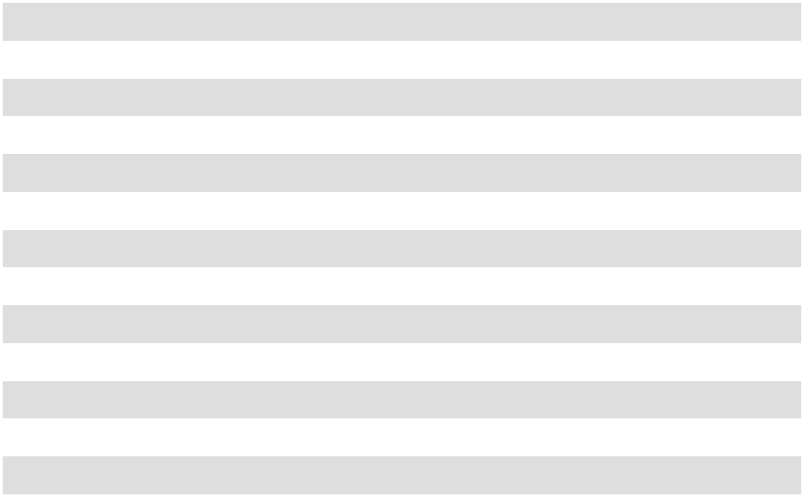

Various fair value methodologies were used for the valuation of identifiable intangibles including the 'excess earnings method' used for the valuation of the customer list and 'relief from royalty' method used for the valuation of the trade name. Our fair value was based on the projected financial information and unobservable inputs including revenue growth rate, weighted average cost of capital, royalty rate, and customer attrition rates. Finished goods inventory was valued using the net realizable value approach and approximate the selling price less disposal costs and allowance for a reasonable profit. The goodwill of $12.4 million arising from the acquisition consists largely of intangible assets that do not qualify for separate recognition and were fully assigned to our Retail and Wholesale Products Group. None of the goodwill recognized is expected to be deductible for income tax purposes.

Ultra Pet contributed net sales of $4.8 million and pre-tax income of $0.2 million for the period from May 1, 2024, to July 31, 2024, net of acquisition adjustments including non-cash inventory fair value step up amortization included in cost of goods sold and customer list amortization included in SG&A. The total fair value step up adjustment to inventory was $0.8 million of which $0.4 million was amortized in fiscal year 2024 and the remainder in fiscal year 2025. The following unaudited pro forma summary presents consolidated information of Oil-Dri as if the business combination had occurred on August 1, 2022.

(unaudited- in thousands) | Pro forma year ended
(unaudited- in thousands) | July 31, 2024
Net Sales | $455,139
Pre-Tax Net Income | $52,999


61

These pro forma amounts above have been calculated after applying Oil-Dri’s accounting policies and adjusting the results of Ultra Pet, including the following adjustments:

(unaudited- in thousands) | Pro forma year ended
(unaudited- in thousands) | July 31, 2024
Acquisition related expenses (a) | $1,172
Interest expense (b) | $(1,158)
Customer list amortization (c) | $(850)
Inventory step up adjustment (d) | $449
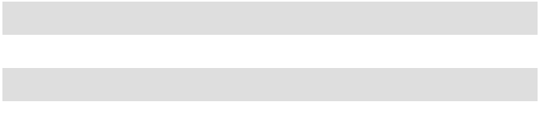

- Adjustment for acquisition related expenses reflects the reversal of legal and other professional fees and integration costs incurred in fiscal year 2024. These expenses are included in general and administrative expense on the Consolidated Statement of Operations.
- Interest expense adjustments reflect higher interest expense associated with financing the Ultra Pet acquisition assuming financing occurred August 1, 2022.

- Customer list amortization adjustment reflects additional amortization assuming amortization began on August 1, 2022.

- Inventory step up adjustment reflects the reversal of the amortization recognized in fiscal year 2024 as a result of the full step up adjustment recognized in fiscal year 2023.

NOTE 3 – OPERATING SEGMENTS

We have two reportable operating segments: (1) Retail and Wholesale Products Group and (2) Business to Business Products Group. These operating segments are managed separately, and each segment's major customers have different characteristics. The Retail and Wholesale Products Group customers include mass merchandisers, the farm and fleet channel, drugstore chains, pet specialty retail outlets, dollar stores, retail grocery stores, distributors of industrial cleanup and automotive products, environmental service companies, sports field product users and marketers of consumer products. Given the similar nature of products and customers, sales of our silica gel based crystal litter are included with our cat litter products and reported as part of the Retail and Wholesale Products Group segment. The Business to Business Products Group customers include processors and refiners of edible oils, renewable diesel, petroleum-based oils and biodiesel fuel; manufacturers of animal feed and agricultural chemicals; and distributors of animal health and nutrition products. Our operating segments are also our reportable segments. The accounting policies of the segments are the same as those described in Note 1 of the Notes to the Consolidated Financial Statements.

Net sales for our principal products by segment are as follows (in thousands):

 |  | Business to Business Products Group |  |  |  |  |  |  |  |  | Retail and Wholesale Products Group
 |  |  |  |  |  |  |  | Year Ended July 31,
Product |  | 2026 |  |  | 2025 |  |  | 2024 |  |  | 2026 |  |  | 2025 |  |  | 2024
Cat Litter | $ | — | $ |  | — | $ |  | — | $ |  | 265,318 | $ |  | 255,926 | $ |  | 241,884
Industrial and Sports |  | — |  |  | — |  |  | — |  |  | 48,328 |  |  | 47,050 |  |  | 45,232
Agricultural and Horticultural |  | 49,232 |  |  | 44,338 |  |  | 33,558 |  |  | — |  |  | — |  |  | —
Bleaching Clay and Fluids Purification |  | 104,753 |  |  | 110,105 |  |  | 92,464 |  |  | — |  |  | — |  |  | —
Animal Health and Nutrition |  | 26,213 |  |  | 28,153 |  |  | 24,449 |  |  | — |  |  | — |  |  | —
Net Sales | $ | 180,198 | $ |  | 182,596 | $ |  | 150,471 | $ |  | 313,646 | $ |  | 302,976 | $ |  | 287,116
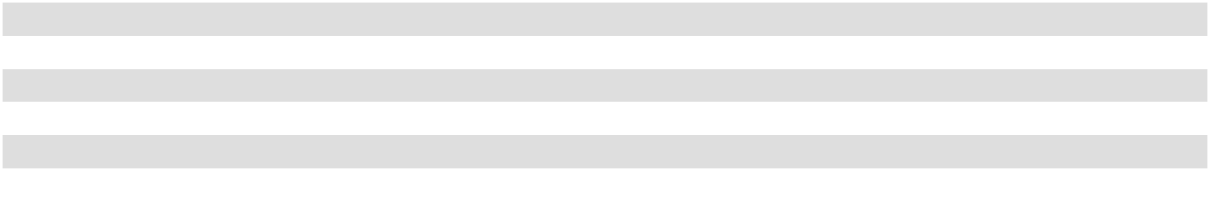

62

Our chief operating decision maker (“CODM”) is our President and CEO. The CODM regularly reviews net sales, gross profit, and operating income by segment to assess profitability and assist in the allocation of resources. Net sales and operating income for each segment are provided below, along with the Significant Segment Expense categories that are regularly provided and used by the CODM when assessing segment profitability and the allocation of resources. The significant amounts within the segment operating expenses include cost of goods sold, compensation and benefits, and advertising. The other operating expenses in the table below is comprised of all other SG&A expenses which include but are not limited to travel, research & development, technical service support, and amortization of intangibles. Our CODM reviews the performance of each segment regularly by analyzing financial results in conjunction with our internal financial forecasts.

The corporate expenses line in the table below represents certain unallocated expenses, including primarily salaries, wages and benefits, purchased services, rent, utilities and depreciation and amortization associated with corporate functions such as information systems, finance, legal, human resources and customer service. Corporate expenses also include the annual incentive plan bonus accrual.

 |  | Year Ended July 31, 2026
(in thousands) |  | Business to Business |  | Retail and Wholesale |  |  |  | Total
(in thousands) |  | Products Group |  |  | Products Group |  |  | Total
Net Sales................................................. | $ | 180,198 | $ |  | 313,646 | $ |  | 493,844
Cost of Goods Sold................................. |  | (108,603) |  |  | (247,731) |  |  | (356,334)
Gross Profit ........................................... |  | 71,595 |  |  | 65,915 |  |  | 137,510
Compensation and Benefits .................... |  | (9,644) |  |  | (8,516) |  |  | (18,160)
Advertising ............................................. |  | (1,078) |  |  | (5,969) |  |  | (7,047)
Other Operating Expenses ...................... |  | (5,525) |  |  | (7,700) |  |  | (13,225)
Operating Income ................................. |  | 55,348 |  |  | 43,730 |  |  | 99,078
Corporate Expenses ................................ |  |  |  |  |  |  |  | (31,096)
Income from Operations ...................... |  |  |  |  |  |  |  | 67,982
Total Other Income, Net ........................ |  |  |  |  |  |  |  | 1,501
Income Before Income Taxes .............. |  |  |  |  |  | $ |  | 69,483
Income Tax Expense .............................. |  |  |  |  |  |  | $ | (12,514)
Net Income ............................................ |  |  |  |  |  | $ |  | 56,969
 |  | Year Ended July 31, 2025
(in thousands) |  | Business to Business |  | Retail and Wholesale |  |  |  | Total
(in thousands) |  | Products Group |  |  | Products Group |  |  | Total
Net Sales................................................. | $ | 182,596 | $ |  | 302,976 | $ |  | 485,572
Cost of Goods Sold................................. |  | (106,691) |  |  | (235,798) |  |  | (342,489)
Gross Profit ........................................... |  | 75,905 |  |  | 67,178 |  |  | 143,083
Compensation and Benefits .................... |  | (8,748) |  |  | (8,366) |  |  | (17,114)
Advertising ............................................. |  | (1,115) |  |  | (6,439) |  |  | (7,554)
Other Operating Expenses ...................... |  | (6,246) |  |  | (8,236) |  |  | (14,482)
Operating Income ................................. |  | 59,796 |  |  | 44,137 |  |  | 103,933
Corporate Expenses ................................ |  |  |  |  |  |  |  | (35,713)
Income from Operations ...................... |  |  |  |  |  |  |  | 68,220
Total Other Expense, Net ....................... |  |  |  |  |  |  |  | (2,009)
Income Before Income Taxes............... |  |  |  |  |  | $ |  | 66,211
Income Tax Expense............................... |  |  |  |  |  |  | $ | (12,215)
Net Income............................................. |  |  |  |  |  | $ |  | 53,996
 |  | 63
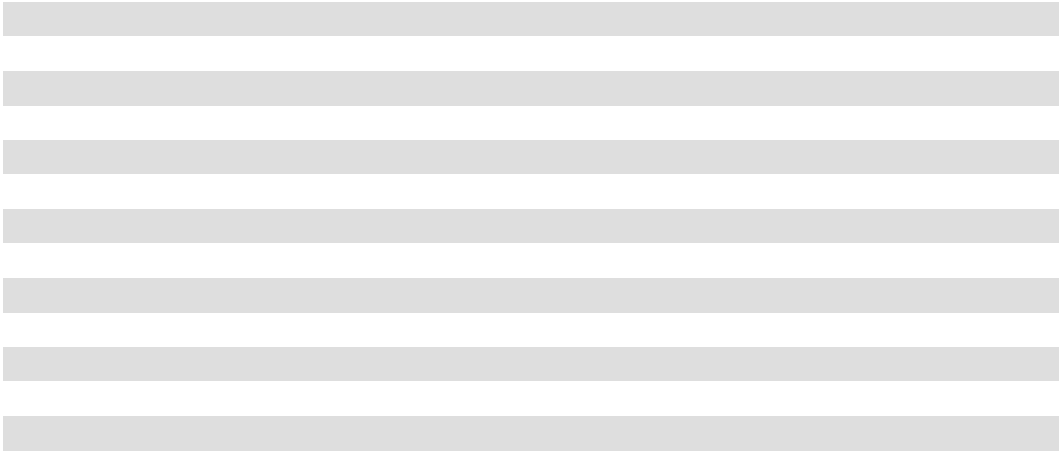
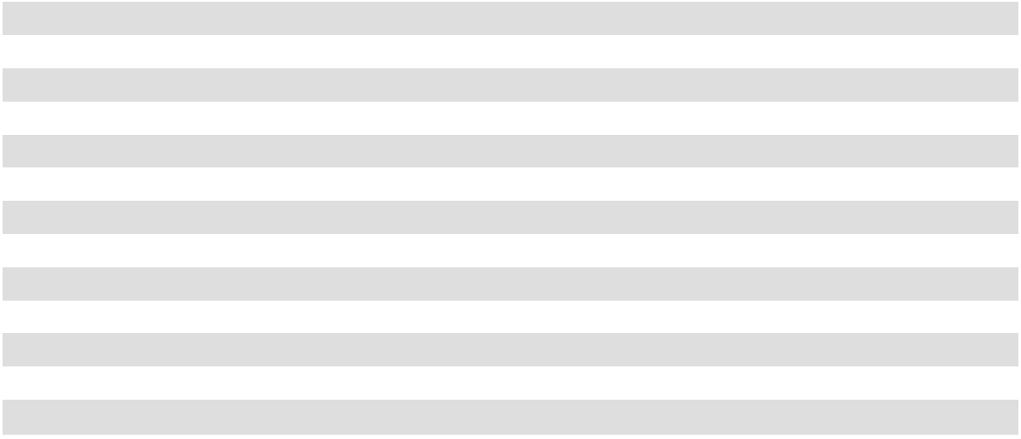

 |  | Year Ended July 31, 2024
(in thousands) |  | Business to Business |  | Retail and Wholesale |  |  |  | Total
(in thousands) |  | Products Group |  |  | Products Group |  |  | Total
Net Sales................................................. | $ | 150,471 | $ |  | 287,116 | $ |  | 437,587
Cost of Goods Sold................................. |  | (89,789) |  |  | (222,704) |  |  | (312,493)
Gross Profit ........................................... |  | 60,682 |  |  | 64,412 |  |  | 125,094
Compensation and Benefits .................... |  | (9,109) |  |  | (6,645) |  |  | (15,754)
Advertising ............................................. |  | (891) |  |  | (8,148) |  |  | (9,039)
Other Operating Expenses ...................... |  | (5,093) |  |  | (5,815) |  |  | (10,908)
Operating Income ................................. |  | 45,589 |  |  | 43,804 |  |  | 89,393
Corporate Expenses ................................ |  |  |  |  |  |  |  | (37,748)
Income from Operations ...................... |  |  |  |  |  |  |  | 51,645
Total Other Expense, Net ....................... |  |  |  |  |  |  |  | (1,994)
Income Before Income Taxes............... |  |  |  |  |  |  |  | 49,651
Income Tax Expense............................... |  |  |  |  |  |  |  | (10,225)
Net Income............................................. |  |  |  |  |  | $ |  | 39,426
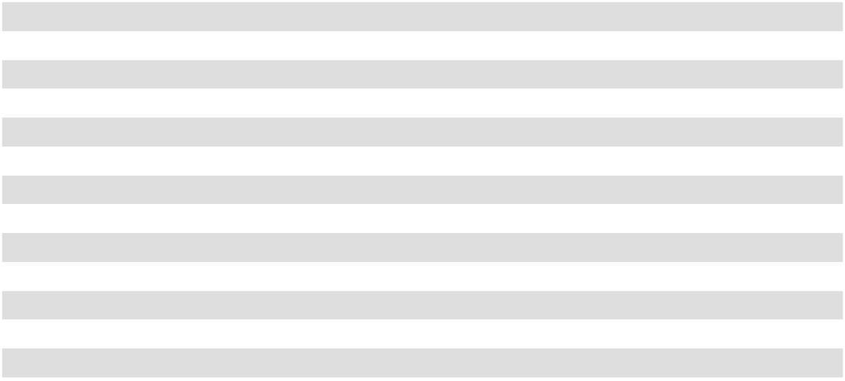

We do not rely on any operating segment asset allocations and do not consider them meaningful because of the shared nature of our production facilities; however, we have estimated the segment asset allocations below for those assets for which we can reasonably determine. The unallocated asset category is the remainder of our total assets. The asset allocation is estimated and is not a measure used by our chief operating decision maker about allocating resources to the operating segments or in assessing their performance.

 |  | As of July 31,
 |  | Assets
 |  | 2026 |  |  | 2025
 |  | (in | thousands)
Business to Business Products .................................................................................... | $ | 104,325 | $ |  | 104,857
Retail and Wholesale Products.................................................................................... |  | 217,787 |  |  | 200,644
Unallocated assets ...................................................................................................... |  | 106,674 |  |  | 86,723
................................................................................................................TotalAssets | $ | 428,786 | $ |  | 392,224
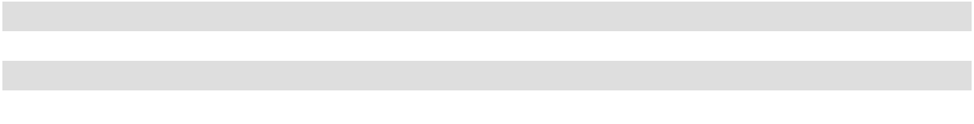

The following is a summary by fiscal year of financial information by geographic region (in thousands):

 |  | 2026 |  |  | 2025 |  |  | 2024
Sales to unaffiliated customers by:
Domestic operations................................ | $ | 474,077 | $ |  | 465,451 | $ |  | 416,603
Foreign subsidiaries ................................ | $ | 19,767 | $ |  | 20,121 | $ |  | 20,984
Sales or transfers between geographic areas:
Domestic operations................................. | $ | 6,204 | $ |  | 6,534 | $ |  | 6,102
Foreign subsidiaries ................................. | $ | — | $ |  | — | $ |  | —
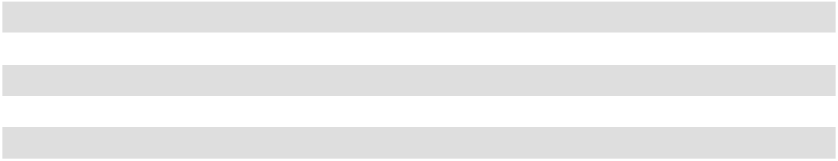

As of July 31, 2026, long-lived assets were $172.2 million and $1.1 million for domestic and foreign operations respectively. As of July 31, 2025, long-lived assets were $162.8 million and $1.2 million for domestic and foreign operations respectively.

64

Sales to our largest customer are $90.8 million, $90.6 million, and $86.5 million in fiscal years 2026, 2025, and 2024, respectively. These sales are included in our Retail and Wholesale Products Group. There are no other customers with sales equal to or greater than 10% of our total sales.

NOTE 4 – DEBT
The composition of long-term debt is as follows as of July 31 (in thousands):
 |  | 2026 |  |  | 2025
Amended and Restated Note Purchase and Private Shelf Agreement. Annual principal
installments on May 15: $1,000 in each fiscal year 2021 through 2030. Interest is payable | $ | 4,000 | $ |  | 5,000
semi-annually at an annual rate of 3.95% [Series B] .................................................................
Amended and Restated Note Purchase and Private Shelf Agreement. Annual principal
installments on Dec 15: $5,000 in each fiscal year 2028 through 2032. Interest is payable |  | 25,000 |  |  | 25,000
semi-annually at an annual rate of 3.25% [Series C].................................................................. |  | 25,000 |  |  | 25,000
Amended and Restated Note Purchase and Private Shelf Agreement. Annual principal
installments on April 30: $5,000 in each fiscal year 2032 through 2033. Interest is payable |  | 10,000 |  |  | 10,000
semi-annually at an annual rate of 6.47% [Series D] |  | 10,000 |  |  | 10,000
Less current maturities of notes payable .................................................................................... |  | (1,000) |  |  | (1,000)
Less unamortized debt issuance costs......................................................................................... |  | (143) |  |  | (183)
Long-term debt ........................................................................................................................... | $ | 37,857 | $ |  | 38,817
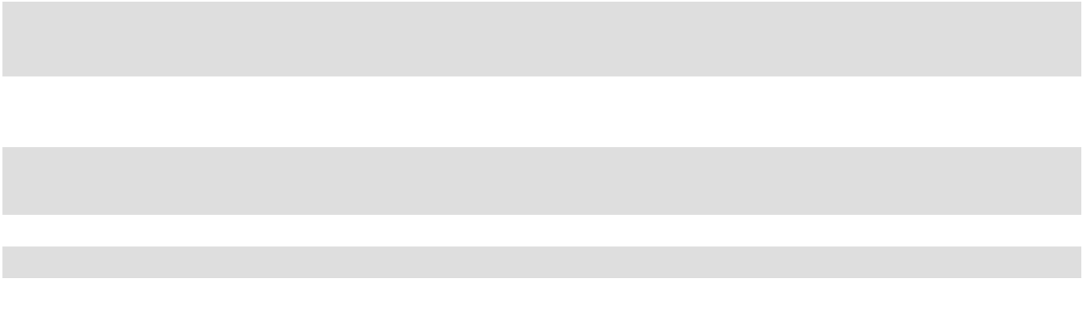

We are party to the Note Agreement with Prudential and certain existing noteholders and purchasers affiliated with Prudential named therein. Pursuant to the Note Agreement, (i) on May 15, 2020, we issued $10 million in aggregate principal amount of our 3.95% Series B Senior Notes due May 15, 2030 (the "Series B Senior Notes"), of which $4 million aggregate principal amount remained outstanding as of July 31, 2026, (ii) on December 16, 2021, we issued an additional $25 million in aggregate principal amount of our 3.25% Series C Senior Notes due December 16, 2031 (the "Series C Senior Notes"), all of which remained outstanding as of July 31, 2026, and (iii) on April 30, 2024 we issued $10 million in aggregate principal amount of our 6.47% Series D Senior Notes due April 30, 2033 (the "Series D Senior Notes"), all of which remained outstanding as of July 31, 2026. The Note Agreement also provides us with the ability to request, from time to time until September 21, 2026, that Prudential affiliate(s) purchase, at Prudential’s discretion and on an uncommitted basis, additional senior unsecured notes of Oil-Dri (the “Shelf Notes,” and collectively with the Series B Senior Notes, Series C Senior Notes, and Series D Senior Notes, the “Notes”) in an aggregate principal amount of up to $75 million minus the aggregate principal amount of Notes then outstanding and Shelf Notes that have been accepted for purchase. Interest payable on any Shelf Note agreed to be purchased under the Note Agreement will be at a rate determined by Prudential and will mature no more than fifteen years after the date of original issue of such Shelf Note.

On October 7, 2026, subsequent to the end of fiscal year 2026, the Company entered into Amendment No. 5 to the Note Agreement (the “Fifth Amendment”). The Fifth Amendment amends the Note Agreement to, among other things: (i) extend the time frame for issuing and selling Shelf Notes to October 7, 2029; (ii) increase the aggregate principal amount of Shelf Notes that may be purchased by Prudential affiliate(s), at Prudential’s discretion and upon our request, on the terms set forth in the Note Agreement from $75 million to $150 million, minus the aggregate principal amount of Notes then outstanding and Shelf Notes that have been accepted for purchase; and (iii) add certain restrictive covenants included in the Credit Agreement.

The following is a schedule by fiscal year of future principal maturities of notes payable as of July 31, 2026 (in thousands):
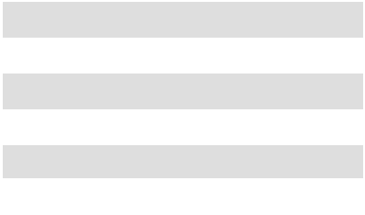

2027....................... | $ | 1,000
2028....................... |  | 6,000
2029....................... |  | 6,000
2030....................... |  | 6,000
2031....................... |  | 5,000
Thereafter .............. |  | 15,000

65

We are party to the Credit Agreement with BMO Harris, which, as of the end of fiscal 2026, provided for a $75 million unsecured revolving credit facility, including a maximum of $20 million for letters of credit.

The Credit Agreement contains restrictive covenants that, among other things and under various conditions, limit our ability to incur additional indebtedness or to dispose of assets. These restrictive covenants include certain financial covenants such as a covenant to maintain a maximum debt to earnings ratio and to maintain a certain fixed charge coverage ratio. On September 30, 2024, the Company entered into the Eighth Amendment to Credit Agreement (the “Eighth Amendment”). The Eighth Amendment amends the Credit Agreement to, among other things: (i) increase the amount the Company may borrow from BMO Harris from time to time pursuant to its revolving line of credit from up to $45 million to up to $75 million; (ii) increase the aggregate maximum amount of letters of credit from up to $10 million to up to $20 million; (iii) add an accordion provision to allow the Company to increase the revolving line of credit by up to an additional $50 million, subject to the terms and conditions set forth in the Eighth Amendment; (iv) extend the termination date to September 30, 2029; and (v) increase certain restrictive covenant thresholds, including but not limited to, an increase to the permitted acquisitions threshold in the restricted covenants from a cumulative total of $45 million to $100 million.

On October 7, 2026, subsequent to the end of fiscal year 2026, the Company entered into the Ninth Amendment to Credit Agreement (the “Ninth Amendment”). The Ninth Amendment amends the Credit Agreement to, among other things: (i) increase the amount the Company may borrow from BMO Harris from time to time pursuant to its revolving line of credit from up to $75 million to up to $100 million; (ii) amend the accordion provision to allow the Company to increase the revolving line of credit from up to an additional $50 million to up to the greater of (a) an additional $125 million and (b) 100% of Consolidated EBITDA (as defined in the Ninth Amendment), subject to the terms and conditions set forth in the Ninth Amendment; (iii) reduce pricing by expanding the debt to earnings ratio; (iv) extend the termination date to October 7, 2031;

- increase or remove certain restrictive covenant thresholds, including but not limited to the removal of the $100 million cumulative permitted acquisitions threshold; and (vi) add a restricted payments covenant restricting the Company's ability to pay dividends, make distributions, and repurchase shares or make other equity redemptions except (a) when the Company is not in default under the Credit Agreement and (b) under certain other circumstances set forth in the Ninth Amendment.

As of July 31, 2026, and July 31, 2025, we were in compliance with the restrictive covenants under the Credit Agreement. During fiscal year 2026, there were no new borrowings. As of July 31, 2026, we do not have any outstanding borrowings under the Credit Agreement. We had $0.3 million of letters of credit outstanding under the Credit Agreement as of July 31, 2026, and $3.0 million as of July 31, 2025.

The Credit Agreement states that we may select a variable interest rate based on either the Bank of Montreal ("BMO") prime rate or an adjusted SOFR-based rate, plus a margin that varies depending on our debt to earnings ratio, or a fixed rate as agreed between us and BMO. As of July 31, 2026, the variable rates would have been 6.75% for the BMO prime-based rate or 5.01% for the adjusted SOFR-based rate.

NOTE 5 – FINANCIAL INSTRUMENTS

Fair Value

Fair value is defined as the price that would be received to sell an asset or paid to transfer a liability in an orderly transaction between market participants at the measurement date. The inputs used to measure fair value are prioritized into one of three categories based on the lowest level of input that is significant to the fair value measurement. Categories in the hierarchy are as follows:

Level 1: Quoted market prices in active markets for identical assets or liabilities.

Level 2: Observable market-based inputs for similar assets or liabilities or valuation models whose inputs are observable, directly or indirectly.

Level 3: Unobservable inputs.

Cash equivalents are classified as Level 1 of the fair value hierarchy because they are valued using quoted market prices in active markets. These cash instruments are primarily money market funds and are included in cash and cash equivalents on the Consolidated Balance Sheets. We had $58.6 million cash equivalents as of July 31, 2026, and had $35.3 million cash equivalents as of July 31, 2025.

66

Balances of accounts receivable, short-term investments and accounts payable approximated their fair values on July 31, 2026, and July 31, 2025, due to the short maturity and nature of those balances.

Debt is reported at outstanding face value, less unamortized debt issuance costs. The estimated fair value of debt, including current maturities, was approximately $39.1 million as of July 31, 2026, and $40.3 million as of July 31, 2025. The fair value was estimated using the exit price notion of fair value and is classified as Level 2. See Note 4 of the Notes to the Consolidated Financial Statements for further information about such debt.

We apply fair value techniques on at least an annual basis associated with: (1) valuing potential impairment loss related to goodwill, trademarks and other indefinite-lived intangible assets and (2) valuing potential impairment loss related to long-lived assets. See Note 1 of the Notes to Consolidated Financial Statements for further information about goodwill and other intangible assets.

Concentration of Credit Risk

Financial instruments which potentially subject us to concentrations of credit risk consist principally of cash and accounts receivable. Our cash is held in banks which are covered by the Federal Deposit Insurance Corporation; however, our cash balances are in excess of the maximum amount that is insured. Concentrations of credit risk with respect to accounts receivable are subject to the financial condition of certain major customers, principally the customer referred to in Note 3 of the Notes to the Consolidated Financial Statements. We generally do not require collateral to secure customer receivables.

NOTE 6 – INCOME TAXES

We account for income taxes under the liability method. Under this method, deferred tax assets and liabilities are determined based on differences between financial reporting and tax reporting bases of assets and liabilities are are measured using enacted tax rates and laws that are expected to be in effect when the differences are expected to reverse. Realization of deferred tax assets is dependent upon future earnings, the timing and amount of which are uncertain.

We utilize a two-step approach to recognize and measure uncertain tax positions. The first step is to evaluate the tax position for recognition by determining if the weight of available evidence indicates that it is more likely than not that that position will be sustained upon tax authority examination, including resolution of related appeals or litigation processes, if any. The second step is to measure the tax benefit as the largest amount that is more than 50% likely of being realized upon ultimate settlement.

Income (loss) before provision for income taxes includes the following components (in thousands):

 |  | Year Ended July 31,
 |  | 2026 |  |  | 2025 |  |  | 2024
Domestic ................................................... | $ | 69,411 | $ |  | 66,285 | $ |  | 48,995
Foreign ...................................................... |  | 72 |  |  | (74) |  |  | 656
Income before income taxes ................... | $ | 69,483 | $ |  | 66,211 | $ |  | 49,651


67

The provision for income tax expense by fiscal year consists of the following (in thousands):

 |  | 2026 |  |  | 2025 |  |  | 2024
Current
Federal .............................................................. | $ | 8,609 | $ |  | 8,790 | $ |  | 6,059
State .................................................................. |  | 1,915 |  |  | 2,959 |  |  | 2,243
Foreign.............................................................. |  | (9) |  |  | 226 |  |  | 226
Current Income Tax Total ........................... |  | 10,515 |  |  | 11,975 |  |  | 8,528
Deferred
Federal .............................................................. |  | 2,057 |  |  | 433 |  |  | 934
State .................................................................. |  | 63 |  |  | (233) |  |  | 778
Foreign.............................................................. |  | (121) |  |  | 40 |  |  | (15)
Deferred Income Tax Total ......................... |  | 1,999 |  |  | 240 |  |  | 1,697
Total Income Tax Expense ................................. | $ | 12,514 | $ |  | 12,215 | $ |  | 10,225
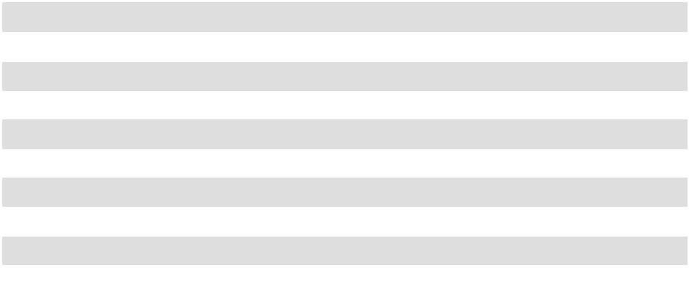

Income taxes paid (net of refunds) consists of the following (in thousands):

 |  | Year Ended July 31,
 |  | 2026 |  |  | 2025 |  |  | 2024
Federal ............................................................ | $ | 8,483 | $ |  | 9,275 | $ |  | 6,481
State ................................................................ |  | 1,661 |  |  | 2,877 |  |  | 3,516
Foreign............................................................ |  | 189 |  |  | 446 |  |  | 9
Total income taxes paid .......................... | $ | 10,333 | $ |  | 12,598 | $ |  | 10,006


Income taxes paid, net of refunds, exceeded 5 percent of total income taxes paid, net of refunds, in Mississippi; amounts paid were $0.1 million, $0.8 million, and $0.6 million in fiscal years 2026, 2025, and 2024 respectively. Additionally, income taxes paid, net of refunds, exceeded 5 percent of total income taxes paid, net of refunds, in Georgia in 2024; amounts paid were $0.6 million.

The Company has elected to retroactively adopt the guidance in ASU 2023-09, "Improvements to Income Tax Disclosures" ("ASU 2023-09"). The following table shows the principal reasons for the difference between the effective income tax rate and the statutory federal income tax rate for the year ended July 31, 2026 in accordance with ASU 2023-09:

68

 |  | 2026 |  |  |  | 2025 |  |  |  | 2024
 | Amount |  | % |  | Amount |  | % |  | Amount |  | %
U.S. federal income tax............................................ | $ | 14,591 | 21.0 % | $ |  | 13,904 | 21.0 % | $ |  | 10,427 | 21.0 %
State income tax expense, net of federal tax |  | 1,562 | 2.2 |  |  | 2,153 | 3.3 |  |  | 2,387 | 4.8
expense (a) ............................................................... |  | 1,562 | 2.2 |  |  | 2,153 | 3.3 |  |  | 2,387 | 4.8
Foreign tax effects.................................................... |  | (216) | (0.3) |  |  | 224 | 0.3 |  |  | 202 | 0.4
Effect of cross border tax laws
U.S tax impacts of foreign branch .................... |  | 12 | — |  |  | 249 | 0.4 |  |  | 658 | 1.3
Other ................................................................. |  | (397) | (0.6) |  |  | (695) | (1.1) |  |  | (560) | (1.1)
Tax credits................................................................. |  | (217) | (0.3) |  |  | (932) | (1.4) |  |  | (247) | (0.5)
Nontaxable or nondeductible items
Nondeductible officer compensation................. |  | 1,440 | 2.1 |  |  | 870 | 1.3 |  |  | 1,070 | 2.2
Depletion deductions allowed for mining.......... |  | (2,792) | (4.0) |  |  | (2,981) | (4.5) |  |  | (2,705) | (5.4)
Stock based compensation................................. |  | (1,737) | (2.5) |  |  | (693) | (1.0) |  |  | (1,022) | (2.1)
Other nontaxable or nondeductible item............ |  | 217 | 0.3 |  |  | 132 | 0.2 |  |  | 320 | 0.6
Other adjustments ..................................................... |  | 51 | 0.1 |  |  | (16) | (0.1) |  |  | (305) | (0.6)
Effective income tax ................................................. | $ | 12,514 | 18.0 % | $ |  | 12,215 | 18.4 % | $ |  | 10,225 | 20.6 %
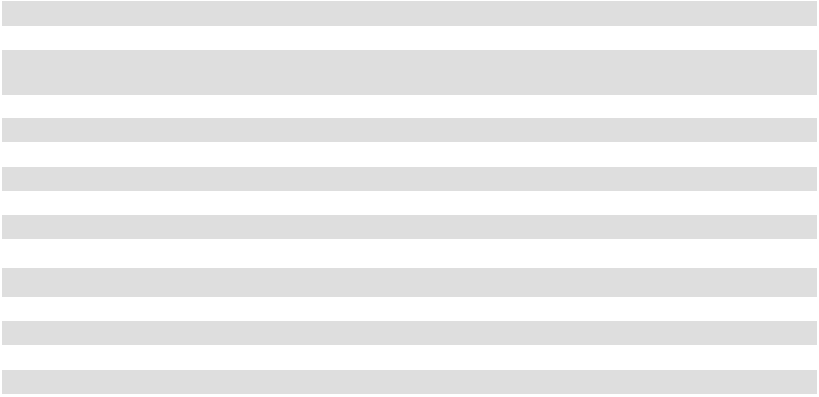

- The following jurisdictions made up a majority (greater than 50 percent) of the tax effect in this category for each of the respective fiscal years: California, Illinois, Pennsylvania and Indiana in fiscal year 2026; Georgia, Mississippi, Illinois and California in fiscal year 2025; and Georgia, Mississippi, Illinois and California in fiscal year 2024.

The Consolidated Balance Sheets included the following tax effects of cumulative temporary differences as of July 31 (in thousands):

 |  | 2026 |  |  |  |  |  | 2025
 |  | Assets |  | Liabilities |  |  |  | Assets |  | Liabilities
Amortization ....................................... | $ | — | $ |  | 5,590 | $ |  | — | $ |  | 5,863
Depreciation ........................................ |  | — |  |  | 6,613 |  |  | — |  |  | 6,237
Lease liabilities.................................... |  | 3,690 |  |  | — |  |  | 3,961 |  |  | —
Lease right of use assets...................... |  | — |  |  | 3,264 |  |  | — |  |  | 3,670
Accrued expenses................................ |  | 3,576 |  |  | — |  |  | 4,494 |  |  | —
Federal & State NOL carryforward |  | 2,011 |  |  | — |  |  | 2,470 |  |  | —
Stock-based compensation .................. |  | 2,239 |  |  | — |  |  | 2,214 |  |  | —
Foreign NOL carryforward ................. |  | 2,007 |  |  | — |  |  | 2,197 |  |  | —
Deferred compensation ....................... |  | 1,972 |  |  | — |  |  | 1,931 |  |  | —
Capitalized R&D................................. |  | 442 |  |  | — |  |  | 1,029 |  |  | —
Reclamation......................................... |  | 695 |  |  | — |  |  | 785 |  |  | —
Other assets ......................................... |  | 516 |  |  | — |  |  | 555 |  |  | —
Postretirement benefits........................ |  | 420 |  |  | — |  |  | 422 |  |  | —
Inventories........................................... |  | 172 |  |  | — |  |  | 185 |  |  | —
Depletion............................................. |  | — |  |  | 106 |  |  | — |  |  | 121
Allowance for credit losses ................. |  | 64 |  |  | — |  |  | 213 |  |  | —
Other liabilities.................................... |  | — |  |  | 383 |  |  | — |  |  | 428
Valuation allowance............................ |  | (2,408) |  |  | — |  |  | (2,846) |  |  | —
Total deferred taxes .......................... | $ | 15,396 | $ |  | 15,956 | $ |  | 17,610 | $ |  | 16,319
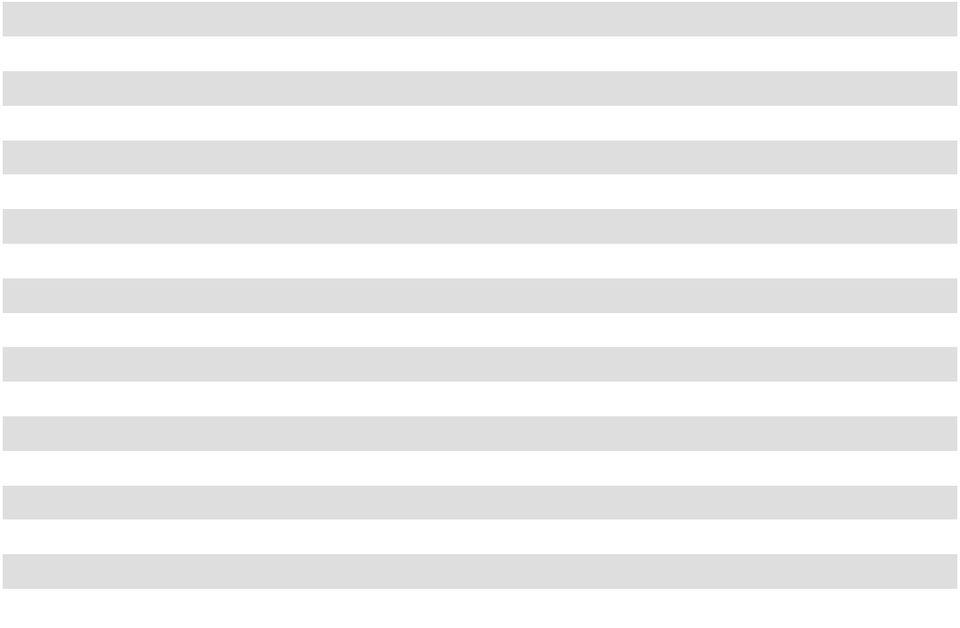

69

Deferred tax assets and liabilities related to leases decreased as leases expire.

We recorded a valuation allowance of $2.4 million and $2.8 million as of July 31, 2026 and July 31, 2025, respectively, for the amount of the deferred tax benefit related to our foreign net operating loss carryforwards and certain state net operating loss carryforwards since we believe it is unlikely we will realize the benefit of these tax attributes in the future. As of July 31, 2026, we have total net operating loss carryforwards from state jurisdictions of approximately $13.7 million. The carryforward expiration dates vary by state.

With the exception of our foreign subsidiary in Canada, none of our foreign subsidiaries have generated any untaxed foreign income, therefore we have not provided for any related income taxes for these subsidiaries.

We had no liabilities for unrecognized tax benefits based on tax positions related to the current and prior fiscal years as of July 31, 2026 and 2025; correspondingly, no related interest and penalties were recognized as income tax expense and there were no accruals for such items in either of these fiscal years.

We are subject to U.S. federal income tax as well as income tax in multiple state and foreign jurisdictions. We were audited by the Internal Revenue Service ("IRS") for fiscal year 2020 with no adjustments upon closure of the audit. The federal tax returns for fiscal years 2023-2025 remain open for examination and during fiscal year 2026 the IRS commenced an examination of the Company's U.S income tax returns for fiscal year 2024. Foreign and U.S. state jurisdictions have statutes of limitations generally ranging from 3 to 5 years. The state impact of any federal income tax changes remains subject to examination by various states for a period of up to one year after formal notification to the states. There are a limited number of open state, local and foreign income tax audits in which no material issues have been preliminarily identified. There are no material open or unsettled foreign income tax audits. We believe our accrual for tax liabilities is adequate for all open audit years.

NOTE 7 – ACCUMULATED OTHER COMPREHENSIVE INCOME (LOSS)

The following table summarizes the changes in accumulated other comprehensive income by component (in thousands):

 | Postretirement |  |  |  | Cumulative |  |  | Total Accumulated
 |  |  |  |  | Translation |  | Other Comprehensive
 | Health Benefits |  |  |  | Adjustment |  |  | (Loss) Income
Balance as of July 31, 2024 ............................. | $ | 1,076 | $ |  | (307) | $ |  | 769
Other comprehensive income (loss) before |  | 224 |  |  | 71 |  |  | 295
reclassifications, net of tax................................ |  | 224 |  |  | 71 |  |  | 295
Amounts reclassified from accumulated other |  | (95) |  |  | — |  |  | (95)
comprehensive income, net of tax .................... |  | (95) |  |  | — |  |  | (95)
Net current-period other comprehensive |  | 129 |  |  | 71 |  |  | 200
income (loss), net of tax.................................... |  | 129 |  |  | 71 |  |  | 200
Balance as of July 31, 2025 ............................. | $ | 1,205 | $ |  | (236) | $ |  | 969
Other comprehensive income (loss) before |  | 75 |  |  | (51) |  |  | 24
reclassifications, net of tax................................ |  | 75 |  |  | (51) |  |  | 24
Amounts reclassified from accumulated other |  | (85) |  |  | — |  |  | (85)
comprehensive income, net of tax .................... |  | (85) |  |  | — |  |  | (85)
Net current-period other comprehensive |  | (10) |  |  | (51) |  |  | (61)
income (loss), net of tax.................................... |  | (10) |  |  | (51) |  |  | (61)
Balance as of July 31, 2026 | $ | 1,195 | $ |  | (287) | $ |  | 908
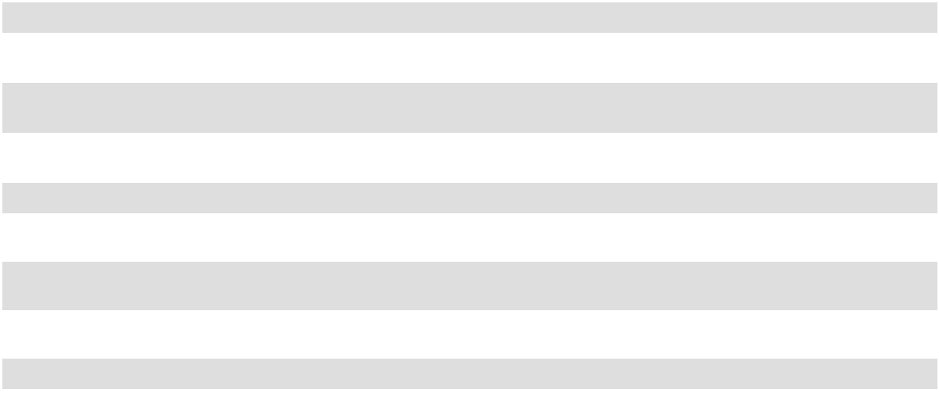

70

NOTE 8 – STOCK-BASED COMPENSATION

The 2006 Plan permits the grant of stock options, stock appreciation rights, restricted stock, restricted stock units, performance awards and other stock-based and cash-based awards. Our employees and outside directors are eligible to receive grants under the 2006 Plan. The total number of shares of stock subject to grants under the 2006 Plan may not exceed 3,439,000. As of July 31, 2026, there were 1,082,496 shares of Common Stock or Class B Stock available for future grants under this plan.

RESTRICTED STOCK

All non-vested restricted stock as of July 31, 2026, was issued under the 2006 Plan with vesting periods generally from one to five years. The fair value of restricted stock was determined by the closing market price of our Common Stock on the date of grant multiplied by the number of shares granted. Fair value of shares vested in fiscal years 2026, 2025, and 2024 is $12.3 million, $6.6 million, and $9.8 million, respectively as of their vesting dates.

A summary of restricted stock transactions under the plans is shown below.

 |  |  |  | Weighted
 |  |  | Weighted | Average
 | Number of |  | Weighted | Remaining | Unamortized
 | Number of |  | Average | Contractual
 | Shares | Grant Date |  | Term |  | Expense
 | (in thousands) | Fair Value |  | (Years) | (in thousands)
Non-vested restricted stock outstanding at July 31, 2023 ...... | 696 | $ | 16.48 | 2.3 | $ | 5,129
Granted |  | $ | 31.53
Granted | 429 | $ | 31.53
Vested.............................................................................. | (307) | $ | 15.68
Forfeited .......................................................................... | (23) | $ | 19.54
Non-vested restricted stock outstanding at July 31, 2024 ...... | 795 | $ | 24.82 | 3.4 | $ | 13,360
Granted |  | $ | 38.29
Granted | 143 | $ | 38.29
Vested.............................................................................. | (183) | $ | 20.17
Forfeited .......................................................................... | (27) | $ | 27.76
Non-vested restricted stock outstanding at July 31, 2025 ...... | 728 | $ | 28.52 | 3.0 | $ | 12,713
Granted |  | $ | 58.26
Granted | 74 | $ | 58.26
Vested ............................................................................. | (209) | $ | 21.40
Forfeited ......................................................................... | (12) | $ | 33.97
Non-vested restricted stock outstanding at July 31, 2026. | 581 | $ | 34.74 | 2.7 | $ | 11,316
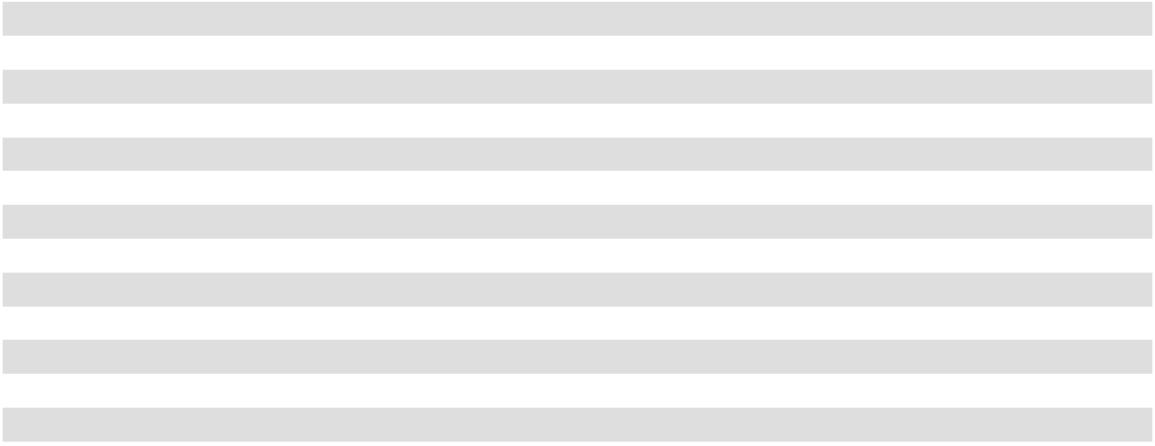

Stock-based compensation for restricted stock of $4.0 million, $4.1 million, and $3.7 million, net of related tax effect, was recognized in fiscal years 2026, 2025, and 2024, respectively. The total restricted stock compensation related tax benefit was $1.3 million, $1.3 million, and $1.2 million in fiscal years 2026, 2025, and 2024, respectively.

71

NOTE 9 – DEFERRED COMPENSATION

Oil-Dri's deferred compensation plans permit directors and certain management employees to defer portions of their compensation and to earn interest on the deferred amounts. Participants deferred $0.5 million, $0.6 million, and $0.3 million into these plans in fiscal years 2026, 2025, and 2024, respectively. We recorded interest expense of $0.3 million, $0.3 million, and $0.2 million related to these plans in fiscal years 2026, 2025, and 2024, respectively. Payments to participants were $0.3 million, $0.2 million, and $0.4 million in fiscal years 2026, 2025, and 2024, respectively, and the total liability recorded for deferred compensation was $6.1 million, $5.6 million, and $5.0 million as of July 31, 2026, 2025, and 2024, respectively.

The Oil-Dri Corporation of America Annual Incentive Plan provides certain executives with the opportunity to receive a deferred executive bonus award if certain financial goals are met. Deferred executive bonus awards of $1.0 million, $1.4 million, and $1.9 million were awarded for fiscal years 2026, 2025, and 2024, respectively as financial targets under the provisions of the plan were achieved. These awards will vest and accrue interest over a 3-year period.

Our deferred compensation plans are unfunded. We fund these benefits when payments are made, and the timing and amount of the payments are determined according to the plans' provisions and, for certain plans, according to individual employee agreements.

NOTE 10 - ACCRUED EXPENSES
Accrued expenses are as follows (in thousands):
 |  | July 31, |  |  | July 31,
 |  | 2026 |  |  | 2025
Salaries, wages, commissions and employee benefits .... | $ | 17,610 | $ |  | 20,532
Payables........................................................................... |  | 13,867 |  |  | 13,036
Freight ............................................................................. |  | 4,753 |  |  | 2,700
Trade promotions and advertising................................... |  | 3,287 |  |  | 3,105
Taxes ............................................................................... |  | 2,238 |  |  | 2,249
Georgia landfill modification reserve.............................. |  | — |  |  | 819
Other................................................................................ |  | 2,503 |  |  | 2,423
 | $ | 44,258 |  | $ | 44,864
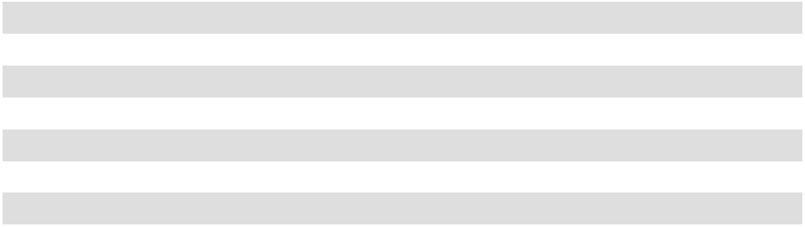

NOTE 11 – OTHER CONTINGENCIES

We are party to various legal actions that arise from time to time that are ordinary in nature and incidental to the operation of our business, including ongoing litigation. While it is not possible at this time to determine with certainty the ultimate outcome of these or other lawsuits, we believe that none of the pending proceedings will have a material adverse effect on our business, financial condition, results of operations or cash flows.

In fiscal year 2023, we recorded a reserve of $2.5 million for anticipated modification costs that we expected to incur to address capacity issues at our sole landfill located in Ochlocknee, Georgia. Reserves are recorded when it is probable that a liability has been incurred, and the amount of the liability can be reasonably estimated. The amount of the reserve represented management’s best estimate of the costs for the modification with respect to this matter, at the time. Work began on the modifications during fiscal year 2024. We increased the total estimated cost by $0.6 million and $0.7 million in fiscal years 2024 and 2025, respectively. In fiscal year 2026, we decreased the total estimated cost by $0.3 million resulting in a total $3.5 million expense related to this matter. The modification work was completed during fiscal year 2026.

NOTE 12 – LEASES

We have operating leases primarily for real estate properties, including corporate headquarters, customer service and sales offices, manufacturing and packaging facilities, warehouses, and research and development facilities, as well as for rail tracks, railcars and office equipment. Our leases for a shared warehouse, office facility, and railcars have options to extend which we are reasonably certain we will exercise and, accordingly, have been considered in the lease term used to recognize our ROU assets and lease liabilities. To determine the present value of the lease liability, we use an incremental borrowing rate,

72

which is defined as the rate of interest that the Company would have to pay to borrow (on a collateralized basis over a similar term) an amount equal to the lease payments in similar economic environments. As provided in ASC 842, we have elected not to apply these measurement and recognition requirements to short-term leases (i.e., leases with a term of 12 months or less). Short-term leases will not be recorded as ROU assets or lease liabilities on our Consolidated Balance Sheets, and the related lease payments will be recognized in net earnings on a straight-line basis over the lease term.

We have no material finance leases, and variable costs for operating leases are immaterial. Operating lease costs are included in Cost of Goods Sold or SG&A expenses based on the nature of the lease. The following table summarizes total lease costs for our operating leases (in thousands):

 |  | For the Twelve Months Ended July 31,
 | 2026 |  |  |  | 2025 |  |  | 2024
Operating lease cost | $ | 4,856 | $ |  | 5,320 | $ |  | 3,791
Short-term operating lease cost | $ | 1,694 | $ |  | 1,466 | $ |  | 1,993

Supplemental cash flow information related to leases was as follows (in thousands):

 |  | For the Twelve Months Ended July 31,
Other Information |  | 2026 |  |  | 2025 |  |  | 2024
Other Information | $ | 4,227
Cash paid for amounts included in the measurement of lease liabilities: | $ | 4,227 | $ |  | 4,515 | $ |  | 3,112
Right-of-use assets obtained in exchange for new operating lease liabilities |  | 3,007 |  |  | 1 |  |  | 11,471

Operating lease ROU assets and operating lease liabilities are separately presented on the Consolidated Balance Sheets. Other supplemental balance sheet information related to leases was as follows:

 | For the Twelve Months Ended July 31,
 | 2026 | 2025 |  | 2024
Weighted-average remaining lease term - operating leases........... | 8.4 years |  | 4.8 years |  | 5.4 years
Weighted-average discount rate - operating leases ........................ | 5.93% | 5.12% |  | 5.10%

During fiscal year 2026, we renegotiated our corporate office lease to extend the term by 10 years, resulting in a $0.4 million increase to the right-of-use asset and a $1.1 million increase to the right-of-use liability. The difference is due to lease incentives provided as part of the lease modification.

The following table summarizes scheduled minimum future lease payments due within twelve months for operating leases with terms longer than one year for which cash flows are fixed and determinable as of July 31, 2026 (in thousands):
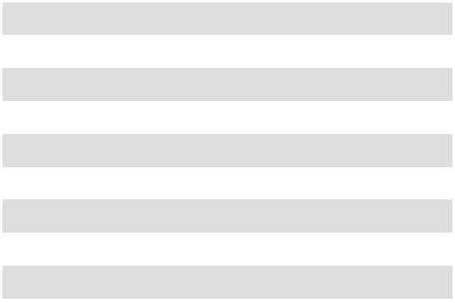

2027 .......................................... | $ |  | 4,398
2028 .......................................... |  |  | 3,507
2029 .......................................... |  |  | 2,641
2030 .......................................... |  |  | 1,371
2031 .......................................... |  |  | 638
Thereafter.................................. |  |  | 6,510
Total .......................................... |  |  | 19,065
Less: imputed interest ............... |  |  | (4,350)
Net lease obligation................... | $ |  | 14,715
 | 73

NOTE 13 – RELATED PARTIES

One member of our Board is currently the President and Chief Executive Officer of a vendor of ours. Total payments to this vendor for fees and cost reimbursements were $0.9 million, $1.6 million, and $2.0 million for fiscal years 2026, 2025, and 2024, respectively. There were no outstanding fees due to that vendor as of July 31, 2026 and July 31, 2025.

One member of our Board retired from the role of President and Chief Executive Officer of a customer of ours on September 28, 2019, and was party to a post-employment consulting agreement with the customer until September 30, 2025. Total sales to that customer, including sales to subsidiaries of that customer, were $0.3 million, $0.4 million, and $0.2 million for fiscal years 2026, 2025 and 2024, respectively. There were no outstanding amounts due from that customer as of July 31, 2026, or 2025.

74

MANAGEMENT’S REPORT ON INTERNAL CONTROL OVER FINANCIAL REPORTING

Our management is responsible for establishing and maintaining adequate internal control over financial reporting, as such term is defined in Exchange Act Rules 13a-15(f). Our internal control over financial reporting is a process designed to provide reasonable assurance regarding the reliability of financial reporting and the preparation of financial statements for external purposes in accordance with accounting principles generally accepted in the United States of America.

Under the supervision and with the participation of our management, including our principal executive officer and principal financial officer, we conducted an assessment of the effectiveness of our internal control over financial reporting based on the framework in Internal Control - Integrated Framework (2013 framework) issued by the Committee of Sponsoring Organizations of the Treadway Commission ("COSO"). Based on our assessment, our management concluded that our internal control over financial reporting was effective as of July 31, 2026.

Because of its inherent limitations, internal control over financial reporting may not prevent or detect misstatements. Also, projections of any evaluation of effectiveness to future periods are subject to the risk that controls may become inadequate because of changes in conditions, or that the degree of compliance with the policies or procedures may deteriorate.

The effectiveness of our internal control over financial reporting as of July 31, 2026 has been audited by Grant Thornton LLP, an independent registered public accounting firm, as stated in their report included below under the heading “Report of Independent Registered Public Accounting Firm.”

75

REPORT OF INDEPENDENT REGISTERED PUBLIC ACCOUNTING FIRM

Board of Directors and Stockholders

Oil-Dri Corporation of America

Opinions on the financial statements and internal control over financial reporting

We have audited the accompanying consolidated balance sheets of Oil-Dri Corporation of America (a Delaware corporation) and subsidiaries (the “Company”) as of July 31, 2026 and 2025, and the related consolidated statements of operations, comprehensive income, stockholders’ equity, and cash flows for each of the three years in the period ended July 31, 2026, and the related notes and financial statement schedule included under Item 15(a) (collectively referred to as the “consolidated financial statements”). We also have audited the Company’s internal control over financial reporting as of July 31, 2026, based on criteria established in the 2013 Internal Control—Integrated Framework issued by the Committee of Sponsoring Organizations of the Treadway Commission (“COSO”).

In our opinion, the consolidated financial statements referred to above present fairly, in all material respects, the financial position of the Company as of July 31, 2026 and 2025, and the results of its operations and its cash flows for each of the three years in the period ended July 31, 2026 in conformity with accounting principles generally accepted in the United States of America. Also in our opinion, the Company maintained, in all material respects, effective internal control over financial reporting as of July 31, 2026, based on criteria established in the 2013 Internal Control—Integrated Framework issued by COSO.

Basis for opinions

The Company’s management is responsible for these consolidated financial statements, for maintaining effective internal control over financial reporting, and for its assessment of the effectiveness of internal control over financial reporting, included in the accompanying Management’s Report on Internal Control Over Financial Reporting. Our responsibility is to express an opinion on the Company’s consolidated financial statements and an opinion on the Company’s internal control over financial reporting based on our audits. We are a public accounting firm registered with the Public Company Accounting Oversight Board (United States) (“PCAOB”) and are required to be independent with respect to the Company in accordance with the U.S. federal securities laws and the applicable rules and regulations of the Securities and Exchange Commission and the PCAOB.

We conducted our audits in accordance with the standards of the PCAOB. Those standards require that we plan and perform the audits to obtain reasonable assurance about whether the financial statements are free of material misstatement, whether due to error or fraud, and whether effective internal control over financial reporting was maintained in all material respects.

Our audits of the financial statements included performing procedures to assess the risks of material misstatement of the financial statements, whether due to error or fraud, and performing procedures that respond to those risks. Such procedures included examining, on a test basis, evidence regarding the amounts and disclosures in the financial statements. Our audits also included evaluating the accounting principles used and significant estimates made by management, as well as evaluating the overall presentation of the financial statements. Our audit of internal control over financial reporting included obtaining an understanding of internal control over financial reporting, assessing the risk that a material weakness exists, and testing and evaluating the design and operating effectiveness of internal control based on the assessed risk. Our audits also included performing such other procedures as we considered necessary in the circumstances. We believe that our audits provide a reasonable basis for our opinions.

Emphasis of matter

As discussed in Note 1 to the consolidated financial statements, the Company has adopted new accounting guidance in 2026 related to the accounting for the adoption of Accounting Standards Update (“ASU”) ASU No. 2023-09, "Income Taxes (Topic 740): Improvements to Income Tax Disclosures" ("ASU 2023-09"). The amendments in ASU 2023-09 were applied retrospectively for all periods presented in the financial statements.

Definition and limitations of internal control over financial reporting

A company’s internal control over financial reporting is a process designed to provide reasonable assurance regarding the reliability of financial reporting and the preparation of financial statements for external purposes in accordance with generally accepted accounting principles. A company’s internal control over financial reporting includes those policies and procedures that (1) pertain to the maintenance of records that, in reasonable detail, accurately and fairly reflect the transactions and

76

dispositions of the assets of the company; (2) provide reasonable assurance that transactions are recorded as necessary to permit preparation of financial statements in accordance with generally accepted accounting principles, and that receipts and expenditures of the company are being made only in accordance with authorizations of management and directors of the company; and (3) provide reasonable assurance regarding prevention or timely detection of unauthorized acquisition, use, or disposition of the company’s assets that could have a material effect on the financial statements.

Because of its inherent limitations, internal control over financial reporting may not prevent or detect misstatements. Also, projections of any evaluation of effectiveness to future periods are subject to the risk that controls may become inadequate because of changes in conditions, or that the degree of compliance with the policies or procedures may deteriorate.

Critical audit matters

Critical audit matters are matters arising from the current period audit of the financial statements that were communicated or required to be communicated to the audit committee and that: (1) relate to accounts or disclosures that are material to the financial statements and (2) involved our especially challenging, subjective, or complex judgments. We determined that there are no critical audit matters.

/s/ GRANT THORNTON LLP

We have served as the Company’s auditor since 2014.

Chicago, Illinois

October 8, 2026

77

ITEM 9 – CHANGES IN AND DISAGREEMENTS WITH ACCOUNTANTS ON ACCOUNTING AND FINANCIAL DISCLOSURE

None.

ITEM 9A – CONTROLS AND PROCEDURES

Evaluation of Disclosure Controls and Procedures

Management conducted an evaluation of the effectiveness of the design and operation of our disclosure controls and procedures as of the end of the period covered by this Form 10-K. The controls evaluation was conducted under the supervision and with the participation of management, including our CEO and Chief Financial Officer (“CFO”). Based upon the controls evaluation, our CEO and CFO have concluded that, as of the end of the period covered by this report, our disclosure controls and procedures were effective to provide reasonable assurance that information required to be disclosed in our Exchange Act reports is recorded, processed, summarized and reported within the time periods specified by the SEC, and that such information is accumulated and communicated to management, including the CEO and CFO, as appropriate to allow timely decisions regarding required disclosure.

Management’s Report on Internal Control Over Financial Reporting

Management’s Report on Internal Control Over Financial Reporting is set forth in Part II, Item 8 of this Annual Report on Form 10-K and is incorporated herein by reference.

Changes in Internal Control over Financial Reporting

There were no changes in our internal control over financial reporting (as defined in Rule 13a-15(f) under the Exchange Act) that occurred during the fiscal year ended July 31, 2026 that have materially affected, or are reasonably likely to materially affect, our internal control over financial reporting.

Inherent Limitations on Effectiveness of Controls

Our management, including the CEO and CFO, does not expect that our disclosure controls and procedures or our internal control over financial reporting will prevent or detect all errors and all fraud. A control system, no matter how well designed and operated, can provide only reasonable, not absolute, assurance that the control system’s objectives will be met. The design of a control system must reflect the fact that there are resource constraints, and the benefits of controls must be considered relative to their costs. Further, because of the inherent limitations in all control systems, no evaluation of controls can provide absolute assurance that misstatements due to error or fraud will not occur or that all control issues and instances of fraud, if any, within the Company have been detected. These inherent limitations include the realities that judgments in decision-making can be faulty and that breakdowns can occur because of simple error or mistake. Controls can also be circumvented by the individual acts of some persons, by collusion of two or more people, or by management override of the controls. The design of any system of controls is based in part on certain assumptions about the likelihood of future events, and there can be no assurance that any design will succeed in achieving its stated goals under all potential future conditions. Projections of any evaluation of controls effectiveness to future periods are subject to risks. Over time, controls may become inadequate because of changes in conditions or deterioration in the degree of compliance with policies or procedures.

ITEM 9B – OTHER INFORMATION

During the quarter ended July 31, 2026, none of our officers or directors adopted, modified, or terminated a "Rule 10b5-1 trading arrangement" or "non-Rule 10b5-1 trading arrangement" (each as defined in Item 408 of Regulation S-K).

ITEM 9C - DISCLOSURE REGARDING FOREIGN JURISDICTIONS THAT PREVENT INSPECTIONS

None.

78

PART III

ITEM 10 – DIRECTORS, EXECUTIVE OFFICERS AND CORPORATE GOVERNANCE

The information required by this Item (except as set forth below) will be included in Oil-Dri’s Proxy Statement for its 2026 annual meeting of stockholders under the captions “PROPOSALS - 1. Election of Directors,” “Executive Officers,” “CORPORATE GOVERNANCE MATTERS - Director Nominations,” “Board of Directors Committee Membership and Meetings,” (including the “Audit Committee” section thereunder) and “Corporate Governance Matters” and is incorporated herein by this reference.

The Company has adopted a Code of Ethics and Business Conduct (the “Code”) which applies to all of its directors, officers (including the Company’s CEO and senior financial officers) and employees. The Code imposes significant responsibilities on the CEO and the senior financial officers of the Company. The Code, the Company’s Corporate Governance Guidelines and the charter of its Audit Committee may be viewed on the Company’s website at www.oildri.com and are available in print to any person upon request to Investor Relations, Oil-Dri Corporation of America, 410 North Michigan Avenue, Suite 400, Chicago, Illinois 60611-4213, telephone (312) 321-1515 or e-mail to info@oildri.com. Any amendment to, or waiver of, a provision of the Code which applies to the Company’s CEO or senior financial officers and relates to the elements of a “code of ethics” as defined by the SEC will also be posted on the Company’s website. As allowed by the “controlled company” exemption to certain NYSE rules, the Company does not have a nominating/corporate governance committee (as defined by the NYSE rules) and its compensation committee does not have a charter.

ITEM 11 – EXECUTIVE COMPENSATION

The information required by this Item will be included in Oil-Dri’s Proxy Statement for its 2026 annual meeting of stockholders under the captions “Executive Compensation,” “CORPORATE GOVERNANCE MATTERS – Director Compensation,” and “Board of Directors Committee Membership and Meetings,” (including the “Compensation Committee” thereunder) and is incorporated herein by reference.

ITEM 12 – SECURITY OWNERSHIP OF CERTAIN BENEFICIAL OWNERS AND MANAGEMENT AND RELATED STOCKHOLDER MATTERS

Except as set forth herein, the information required by this Item will be included in Oil-Dri’s Proxy Statement for its 2026 annual meeting of stockholders under the captions “Principal Stockholders” and “Security Ownership of Management” and is incorporated herein by reference.

Equity Compensation Plan Information. The following table presents information about compensation plans under which our equity securities are authorized for issuance. There are no outstanding stock options as of July 31, 2026. See Note 8 of the Notes to the Consolidated Financial Statements for further information about these stock-based compensation plans.

Equity Compensation Plan Information as of July 31, 2026

 | Number of |  |  |  | Number of securities
 | Number of |  |  |  | remaining available for
 | securities to be |  |  |  | further issuance under
 | issued upon exercise |  | Weighted-average |  | equity compensation plans
 | of outstanding |  | Weighted-average |  | (excluding securities
 | options (in |  | exercise price of |  | reflected in column (a)) (in
Plan Category | thousands) |  | outstanding options |  | thousands)
Plan Category | (a) |  | (b) |  | (c)
Equity compensation plans approved by stockholders .. | — |  | $— | 1,082

The number of securities remaining in column (c) above includes, in accordance with the terms of the plan, shares that

were: 1) not vested or exercised in full due to expiration or termination, or 2) tendered or withheld for payment of the exercise

price or to satisfy tax withholding amounts.

79

ITEM 13 – CERTAIN RELATIONSHIPS AND RELATED TRANSACTIONS, AND DIRECTOR INDEPENDENCE

The information required by this Item will be included in Oil-Dri’s Proxy Statement for its 2026 annual meeting of stockholders under the captions “CORPORATE GOVERNANCE MATTERS – Certain Relationships and Related Party Transactions” and “Director Independence” and is incorporated herein by reference.

ITEM 14 – PRINCIPAL ACCOUNTANT FEES AND SERVICES

The information required by this Item will be included in Oil-Dri’s Proxy Statement for its 2026 annual meeting of stockholders under the caption “Other Matters Relating to the Independent Auditor - Auditor Fees” and is incorporated herein by reference.

80

PART IV

ITEM 15 – EXHIBITS AND FINANCIAL STATEMENT SCHEDULE

(a)(1) The following consolidated financial statements are contained herein.

Consolidated Balance Sheets as of July 31, 2026 and July 31, 2025.

Consolidated Statements of Operations for the fiscal years ended July 31, 2026, July 31, 2025 and July 31, 2024.

Consolidated Statements of Comprehensive Income for the fiscal years ended July 31, 2026, July 31, 2025 and July 31, 2024.

Consolidated Statements of Stockholders’ Equity for the fiscal years ended July 31, 2026, July 31, 2025 and July 31, 2024.

Consolidated Statements of Cash Flows for the fiscal years ended July 31, 2026, July 31, 2025 and July 31, 2024.

Notes to the Consolidated Financial Statements.

Report of Independent Registered Public Accounting Firm.

(a)(2) The following financial statement schedule is contained herein:

Schedule to Financial Statements, as follows:

Schedule II - Valuation and Qualifying Accounts, years ended July 31, 2026 and July 31, 2025.

All other schedules are omitted because they are inapplicable, not required under the instructions or the information is included in the consolidated financial statements or notes thereto.

(a)(3) |  | The following documents are exhibits to this Report:
Exhibit |  | Description
No.
2.1** |  | Stock Purchase Agreement, dated April 16, 2024,
 |  | by and among the Oil-Dri Corporation of America,
 |  | Ultra Pet, LLC, Ultra Pet Company, Inc., and
 |  | certain equity holders of Ultra Pet, LLC set forth
 |  | on the signature page thereto.
3.1 |  | Certificate of Incorporation of Oil-Dri, as amended
 |  | on December 11, 2024 .
3.2 |  | By-Laws of Oil-Dri Corporation of America, as
 |  | Amended and Restated on December 12, 2017.

SEC Document Reference

Incorporated by reference to Exhibit 2.1 to Oil-Dri's Current Report on Form 8-K (File No. 001-12622) filed on April 16, 2024.

Incorporated by reference to Exhibit 3.1 to Oil-Dri’s Quarterly Report on Form 10-Q filed on March 11, 2025.

Incorporated by reference to Exhibit 3 to Oil-Dri’s (file No. 001-12622) Quarterly Report on Form 10-Q filed on March 9, 2018.

4.1 Description of Capital Stock Filed herewith

81

Exhibit
No. Description

10.1 Credit Agreement, dated January 27, 2006 among Oil-Dri Corporation of America, certain subsidiaries of Oil-Dri Corporation of America and Harris N.A.

10.2 First Amendment, dated as of December 19, 2008 to Credit Agreement dated as of January 27, 2006.

10.3 Second Amendment, dated as of December 21,
2011 to Credit Agreement dated as of January 27,
2006.

10.4 Third Amendment, dated as of June 21, 2012 to Credit Agreement dated as of January 27, 2006.

10.5 Fourth Amendment, dated as of December 4, 2014 to Credit Agreement dated as of January 27, 2006.

10.6 Fifth Amendment, dated as of January 31, 2019 to Credit Agreement dated as of January 27, 2006.

10.7 Annex A to the Fifth Amendment to Credit Agreement dated as of January 27, 2006.

10.8 Oil-Dri BMO - Modification to BMO Harris Bank N.A. Credit Agreement.

10.9 Sixth Amendment to Credit Agreement dated as of August 30, 2022, between Oil-Dri Corporation of America and BMO Harris Bank N.A.

10.10 Seventh Amendment to Credit Agreement, dated April 16, 2024, by and between Oil-Dri Corporation of America and BMO Bank N.A.

10.11 Eighth Amendment to Credit Agreement, dated September 30, 2024, by and between Oil-Dri Corporation of America and BMO Bank N.A.

10.12 Ninth Amendment to Credit Agreement, dated October 7, 2026, by and between Oil-Dri Corporation of America and BMO Bank N.A.

10.13 $18,500,000 Note Agreement dated as of November 12, 2010 among Oil-Dri Corporation of America, The Prudential Insurance Company of America, Prudential Retirement Insurance and Annuity Company, Forethought Life Insurance Company, Physicians Mutual Insurance Company and BCBSM, Inc. dba Blue Cross and Blue Shield of Minnesota.

10.14 Amended and Restated Note Purchase and Private Shelf Agreement, dated as of May 15, 2020, among Oil-Dri Corporation of America, PGIM, Inc. and existing noteholders and purchasers named therein.

82

SEC Document Reference

Incorporated by reference to Exhibit 10.1 to Oil-Dri’s (File No. 001-12622) Current Report on Form 8-K filed on February 1, 2006.

Incorporated by reference to Exhibit 10.1 to Oil-Dri’s (File No. 001-12622) Quarterly Report on Form 10-Q for the quarter ended January 31, 2009.

Incorporated by reference to Exhibit 10 to Oil-Dri’s (File No. 001-12622) Current Report on Form 8-K filed on December 28, 2011.

Incorporated by reference to Exhibit 10.12 to Oil-Dri’s (File No. 001-12622) Annual Report on Form 10-K for the fiscal year ended July 31, 2012.

Incorporated by reference to Exhibit 10.1 to Oil-Dri’s (File No. 001-12622) Quarterly Report on Form 10-Q for the quarter ended October 31, 2014.

Incorporated by reference to Exhibit 10.1 to Oil-Dri’s (File No. 001-12622) Current Report on Form 8-K filed on January 31, 2019.

Incorporated by reference to Exhibit 10.2 to Oil-Dri’s (File No. 001-12622) Current Report on Form 8-K filed on January 31, 2019.

Incorporated by reference to Exhibit 10.1 to Oil-Dri’s (file No. 001-12622) Quarterly Report on Form 10-Q for the quarter ended April 30, 2022.

Incorporated by reference to Exhibit 10.1 to Oil-Dri's (file No. 001-12622) Current Report on Form 8-K filed on September 6, 2022.

Incorporated by reference to Exhibit 10.1 to Oil-Dri's Current Report on Form 8-K (File No. 001-12622) filed on April 16, 2024.

Incorporated by reference to Exhibit 10.1 to Oil-Dri's Current Report on Form 8-K (File No. 001-12622) filed on October 1, 2024.

Incorporated by reference to Exhibit 2.1 to Oil-Dri's Current Report on Form 8-K (File No. 001-12622) filed on October 8, 2026.

Incorporated by reference to Exhibit 10.1 to Oil-Dri’s (File No. 001-12622) Current Report on Form 8-K filed on November 16, 2010.

Incorporated by reference to Exhibit 10.1 to Oil-Dri's (file No. 001-12622) Current Report on Form 8-K filed on May 21, 2020.

Exhibit
No. Description

10.15 Amendment No. 1 dated December 16, 2021 to the Amended and Restated Note Purchase and Private Shelf Agreement among Oil-Dri Corporation of America, PGIM, Inc. and existing noteholders and purchasers named therein.

10.16 Amendment No. 2 to Amended and Restated Note Purchase and Private Shelf Agreement.

10.17 Amendment No. 3 to Amended and Restated Note Purchase and Private Shelf Agreement, dated August 30, 2022, among Oil-Dri Corporation of America, PGIM, Inc. and existing noteholders named therein.

SEC Document Reference

Incorporated by reference to Exhibit 10.1 to Oil-Dri's (file No. 001-12622) Current Report on Form 8-K filed on December 17, 2021.

Incorporated by reference to Exhibit 10.2 to Oil-Dri’s (file No. 001-12622) Quarterly Report on Form 10-Q for the quarter ended April 30, 2022.

Incorporated by reference to Exhibit 10.2 to Oil-Dri's (file No. 001-12622) Current Report on Form 8-K filed on September 6, 2022.

10.18 | Amendment No. 4 to Amended and Restated Note
 | Purchase and Private Shelf Agreement, dated
 | September 21, 2023 among Oil-Dri Corporation of
 | America, PGIM, Inc. and existing note holders
10.19 | Amendment No. 5 to Amended and Restated Note
 | Purchase and Private Shelf Agreement, dated
 | October 7, 2026 among Oil-Dri Corporation of
 | America, PGIM, Inc. and existing note holders
10.20 | Oil-Dri Corporation of America Deferred
 | Compensation Plan, as amended and restated
 | effective April 1, 2003.*
10.21 | First Amendment, effective as of January 1, 2007,
 | to Oil-Dri Corporation of America Deferred
 | Compensation Plan, as amended and restated
 | effective April 1, 2003.*
10.22 | Second Amendment, effective as of January 1,
 | 2008, to Oil-Dri Corporation of America Deferred
 | Compensation Plan, as amended and restated
 | effective April 1, 2003.*
10.23 | Oil-Dri Corporation of America Annual Incentive
 | Plan (as amended and restated effective January 1,
 | 2008).*
10.24 | Oil-Dri Corporation of America 2005 Deferred
 | Compensation Plan (as amended and restated
 | effective January 1, 2008)*
10.25 | First Amendment, effective July 1, 2020, to the
 | Oil-Dri Corporation of America 2005 Deferred
 | Compensation Plan (as amended and restated
 | effective January 1, 2008).*
10.26 | Second Amendment, effective April 3, 2026, to
 | the Oil-Dri Corporation of America 2005 Deferred
 | Compensation Plan (as amended and restated
 | effective January 1, 2008).*
10.27 | Amended and Restated Oil-Dri Corporation of
 | America 2006 Long Term Incentive Plan*

83

Incorporated by reference to Exhibit 10.1 to Oil-Dri's (file No. 001-12622) Current Report on Form 8-K filed on September 22, 2023.

Incorporated by reference to Exhibit 10.2 to Oil-Dri's (file No. 001-12622) Current Report on Form 8-K filed on October 8, 2026.

Incorporated by reference to Exhibit (10)(j)(1) to Oil-Dri’s (File No. 001-12622) Quarterly Report on Form 10-Q for the quarter ended April 30, 2003.

Incorporated by reference to Exhibit 10.1 to Oil-Dri’s (File No. 001-12622) Quarterly Report on Form 10-Q for the quarter ended January 31, 2008.

Incorporated by reference to Exhibit 10.2 to Oil-Dri’s (File No. 001-12622) Quarterly Report on Form 10-Q for the quarter ended January 31, 2008.

Incorporated by reference to Exhibit 10.4 to Oil-Dri’s (File No. 001-12622) Quarterly Report on Form 10-Q for the quarter ended January 31, 2008.

Incorporated by reference to Exhibit 10.3 to Oil-Dri’s (File No. 001-12622) Quarterly Report on Form 10-Q for the quarter ended January 31, 2008.

Incorporated by reference to Exhibit 10.24 to Oil-Dri's (File No. 001-12622) Annual Report on Form 10-K for the fiscal year ended July 31, 2020.

Incorporated by reference to Exhibit 10.1 to Oil-Dri Corporation of America’s Current Report on Form 8-K filed on April 3, 2026.

Incorporated by reference to Appendix A to Oil-Dri’s (File No. 001-12622) Definitive Proxy Statement on Schedule 14A filed on October 30, 2023.

Exhibit
No. Description

10.28 Oil-Dri Corporation of America 2006 Long Term Incentive Plan (as amended and restated effective July 28, 2006)*

10.29 First Amendment, effective as of January 1, 2008, to Oil-Dri Corporation of America 2006 Long Term Incentive Plan (as amended and restated effective July 28, 2006)*

10.3 Second Amendment, effective as of October 15, 2015, to Oil-Dri Corporation of America 2006 Long Term Incentive Plan (as previously amended and restated effective July 28, 2006)*

10.31 Third Amendment to Oil-Dri Corporation of America 2006 Long Term Incentive Plan*

10.32 Form of Oil-Dri Corporation of America 2006 Long Term Incentive Plan Employee Stock Option Agreement for Class A Common Stock.*

10.33 Form of Oil-Dri Corporation of America 2006 Long Term Incentive Plan Employee Stock Option Agreement for Common Stock.*

10.34 Form of Oil-Dri Corporation of America 2006 Long Term Incentive Plan Employee Stock Option Agreement for Class B Stock.*

10.35 Form of Oil-Dri Corporation of America 2006 Long Term Incentive Plan Director Stock Option Agreement for Common Stock.*

10.36 Form of Oil-Dri Corporation of America 2006 Long Term Incentive Plan Employee Restricted Stock Agreement for Class A Common Stock.*

10.37 Form of Oil-Dri Corporation of America 2006 Long Term Incentive Plan Employee Restricted Stock Agreement for Common Stock.*

10.38 Form of Oil-Dri Corporation of America 2006 Long Term Incentive Plan Employee Restricted Stock Agreement for Class B Stock.*

10.39 Form of Oil-Dri Corporation of America 2006 Long Term Incentive Plan Director Restricted Stock Agreement for Common Stock.*

14.1 Amended and Restated Code of Ethics

19.1 Insider Trading Policy

21.1 Subsidiaries of Oil-Dri Corporation of America

84

SEC Document Reference

Incorporated by reference to Appendix A to Oil-Dri’s (File No. 001-12622) Definitive Proxy Statement on Schedule 14A filed on November 3, 2006.

Incorporated by reference to Exhibit 10.5 to Oil-Dri’s (File No. 001-12622) Quarterly Report on Form 10-Q for the quarter ended January 31, 2008.

Incorporated by reference to Appendix A to Oil-Dri’s (File No. 001-12622) Definitive Proxy Statement on Schedule 14A filed on October 28, 2015.

Incorporated by reference to Appendix A of Oil-Dri's (File No. 001-12622) Definitive Proxy Statement on Schedule 14A filed on October 30, 2019

Incorporated by reference to Exhibit 10.2 to Oil-Dri’s (file No. 001-12622) Current Report on Form 8-K filed on December 11, 2006.

Incorporated by reference to Exhibit 10.3 to Oil-Dri’s (file No. 001-12622) Current Report on Form 8-K filed on December 11, 2006.

Incorporated by reference to Exhibit 10.4 to Oil-Dri’s (file No. 001-12622) Current Report on Form 8-K filed on December 11, 2006.

Incorporated by reference to Exhibit 10.5 to Oil-Dri’s (file No. 001-12622) Current Report on Form 8-K filed on December 11, 2006.

Incorporated by reference to Exhibit 10.2 to Oil-Dri Corporation of America’s Current Report on Form 8-K filed on April 3, 2026.

Incorporated by reference to Exhibit 10.3 to Oil-Dri Corporation of America’s Current Report on Form 8-K filed on April 3, 2026.

Incorporated by reference to Exhibit 10.4 to Oil-Dri Corporation of America’s Current Report on Form 8-K filed on April 3, 2026.

Incorporated by reference to Exhibit 10.5 to Oil-Dri Corporation of America’s Current Report on Form 8-K filed on April 3, 2026.

Available at Oil-Dri’s website at www.oildri.com or in print upon request to Investor Relations, Oil-Dri Corporation of America, 410 North Michigan Avenue, Suite 400, Chicago, IL 60611-4213, telephone (312) 321-1515 or e-mail to info@oildri.com.

Filed herewith.

Filed herewith.

Exhibit |  | Description |  | SEC Document Reference
No. |  | Description |  | SEC Document Reference
23.1 |  | Consent of Independent Registered Public |  | Filed herewith.
 |  | Accounting Firm
31.1 |  | Certifications pursuant to Rule 13a – 14(a). |  | Filed herewith.
32.1 |  | Certifications pursuant to Section 1350 of the |  | Filed herewith.
 |  | Sarbanes-Oxley Act of 2002.
95 |  | Mine Safety Disclosure |  | Filed herewith.
97 |  | Oil-Dri Corporation of America Compensation |  | Filed herewith.
 |  | Recovery Policy
101.INS |  | XBRL Taxonomy Instance Document |  | The instance document does not appear in the
 |  |  |  | Interactive Data File because its XBRL tags are
 |  |  |  | embedded within the Inline XBRL document.
101.SCH |  | XBRL Taxonomy Extension Schema Document |  | Filed herewith.
101.CAL |  | XBRL Taxonomy Extension Calculation Linkbase |  | Filed herewith.
 |  | Document
101.DEF |  | XBRL Taxonomy Extension Definition Linkbase |  | Filed herewith.
 |  | Document
101.LAB |  | XBRL Taxonomy Extension Labels Linkbase |  | Filed herewith.
 |  | Document
101.PRE |  | XBRL Taxonomy Extension Presentation |  | Filed herewith.
 |  | Linkbase
104 |  | Cover Page Interactive Data File (formatted as |  | Filed herewith.
 |  | inline XBRL and contained in Exhibit 101)

- Management contract or compensatory plan or arrangement.

- The schedules and similar attachments to this exhibit have been omitted pursuant to Item 601(a)(5) of Regulation S-K. The Company agrees to provide a copy of the omitted schedules and similar attachments on a supplemental basis to the Commission or its staff, if requested.

85

SIGNATURES

Pursuant to the requirements of Section 13 or 15(d) of the Securities Exchange Act of 1934, Oil-Dri has duly caused this report to be signed on its behalf by the undersigned, thereunto duly authorized.

OIL-DRI CORPORATION OF AMERICA

(Registrant)

By /s/ Daniel S. Jaffee

Daniel S. Jaffee

President and Chief Executive Officer, Director

Dated: October 8, 2026

Pursuant to the requirements of the Securities Exchange Act of 1934, this report has been signed below by the following persons on behalf of Oil-Dri and in the capacities and on the dates indicated:

/s/ Daniel S. Jaffee |  | October 8, 2026
Daniel S. Jaffee
President and Chief Executive Officer,
Chairman of the Board of Directors
(Principal Executive Officer)
/s/ Susan M. Kreh |  | October 8, 2026
Susan M. Kreh
Chief Financial Officer
(Principal Financial Officer)
/s/ Jonathan Blake |  | October 8, 2026
Jonathan Blake
Corporate Controller
(Principal Accounting Officer)
/s/ Ellen-Blair Chube |  | October 8, 2026
Ellen-Blair Chube
Director
/s/ Paul M. Hindsley |  | October 8, 2026
Paul M. Hindsley
Director
/s/ Michael A. Nemeroff |  | October 8, 2026
Michael A. Nemeroff
Director
/s/ George C. Roeth |  | October 8, 2026
George C. Roeth
Director
 | 86

/s/ Amy L. Ryan | October 8, 2026
Amy L. Ryan
Director
/s/ Patricia J. Schmeda | October 8, 2026
Patricia J. Schmeda
Director
/s/ Allan H. Selig | October 8, 2026
Allan H. Selig
Director
/s/ Lawrence E. Washow | October 8, 2026
Lawrence E. Washow
Director

87

SCHEDULE II

OIL-DRI CORPORATION OF AMERICA AND SUBSIDIARIES

VALUATION AND QUALIFYING ACCOUNTS
 |  | Year Ended July
 |  | 31,
 |  | 2026 |  |  | 2025
 |  | (in thousands)
Allowance for credit losses and cash discounts:
Balance, beginning of year ........................................... | $ | 1,493 | $ |  | 934
(Decrease) Increase charged to expense ...................... |  | (262) |  |  | 559
Write-offs .................................................................... |  | (329) |  |  | —
Balance, end of year...................................................... | $ | 902 | $ |  | 1,493
Valuation reserve for income taxes:
Balance, beginning of year ........................................... | $ | 2,846 | $ |  | 2,470
(Decrease) Increase....................................................... |  | (438) |  |  | 376
Balance, end of year...................................................... | $ | 2,408 | $ |  | 2,846
Inventory Reserve ...............................................................
Balance, beginning of year ........................................... | $ | 3,677 | $ |  | 3,772
Increase (Decrease) ................................................... | $ | 166 |  | $ | (95)
Balance, end of year...................................................... | $ | 3,843 | $ |  | 3,677
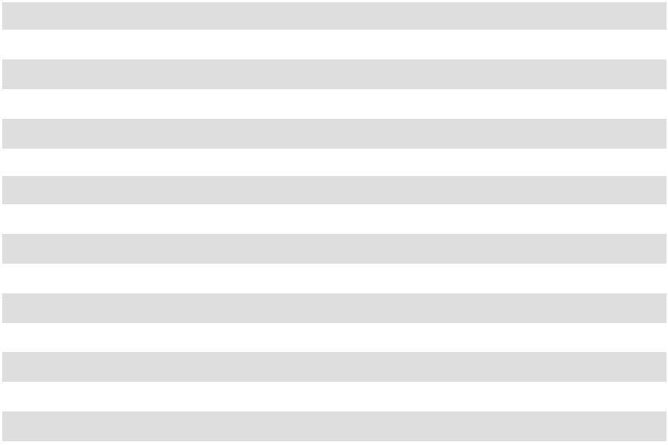

88

BOARD OF DIRECTORS

Daniel S. Jaffee

Chairman of the Board, President & Chief Executive Officer

Lawrence E. Washow

Vice Chairman of the Board, Chairman, Aspire Brands, Inc.

George C. Roeth

Lead Director of the Board, Director of Boyd Gaming Corporation

Ellen-Blair Chube

Former Managing Director

- Client Service Officer,

William Blair & Company

Paul M. Hindsley

Senior Director, Investment Banking William Blair & Company

Michael A. Nemeroff

President & Chief Executive Officer, Vedder Price P.C.

Amy L. Ryan

Founder & Chief Circular Economist, ESGStrategies

Patricia J. Schmeda

Global Chief Information Officer Wahl Clipper Corporation

Allan H. Selig

Commissioner Emeritus of Major League Baseball President & Chairman, Selig Leasing Company Inc. President, AHS Investments, LLC

EXECUTIVE OFFICERS

Daniel S. Jaffee

President & Chief Executive Officer

Susan M. Kreh

Chief Financial Officer

and Chief Information Officer

Christopher B. Lamson

Group Vice President of Business to Business & Strategic Growth Initiatives

Aaron V. Christiansen

Vice President of Operations

Laura G. Scheland

Vice President & General Manager of Consumer Products Division

W. Wade Robey, Ph.D.

Vice President of Agriculture, Oil-Dri Corporation of America and President of Amlan International

Anthony W. Parker

Vice President, General Counsel & Secretary



INDEPENDENT REGISTERED PUBLIC ACCOUNTING FIRM

Grant Thornton LLP

INVESTOR INQUIRIES

NYSE: ODC

Please direct all inquiries to:

Leslie A. Garber

- 321-1515 InvestorRelations@oildri.com

Oil-Dri Corporation of America Attention: Investor Relations 410 North Michigan Avenue Suite 400

Chicago, Illinois 60611-4213 www.oildri.com

Stockholders with inquiries regarding stock transfers, change of ownership, change of address or dividend payments should contact the company’s registrar and transfer agent:

Computershare Investor Services

P.O. Box 43006

Providence, RI 02940-3006

Courier Delivery:

150 Royall St., Suite 101 Canton, MA 02021 (888) 313-1476

VIRTUAL ANNUAL MEETING

On Tuesday, December 8, 2026, at 9:30am CT,

Oil-Dri Corporation of America will hold its 2026 Annual Meeting of Stockholders.

Please join our virtual meeting by visiting www.virtualshareholdermeeting.com/ODC2026

©2026 Oil-Dri Corporation of America



410 NORTH MICHIGAN AVENUE, SUITE 400 • CHICAGO, IL 60611

