UNITED STATES
SECURITIES AND EXCHANGE COMMISSION
Washington, D.C. 20549

FORM 8-K

CURRENT REPORT
Pursuant to Section 13 or 15(d) of the Securities Exchange Act of 1934

Date of Report (Date of earliest event reported) |  |  | March 12, 2026

OIL-DRI CORPORATION OF AMERICA
(Exact name of the registrant as specified in its charter)

Delaware |  |  |  |  |  |  |  |  | 001-12622 |  |  |  |  |  | 36-2048898
(State or other jurisdiction of incorporation or organization) |  |  |  |  |  |  |  |  | (Commission File Number) |  |  |  |  |  | (I.R.S. Employer Identification No.)
410 North Michigan Avenue, Suite 400
Chicago, Illinois |  |  |  |  |  |  |  |  |  |  |  |  |  |  | 60611-4213
(Address of principal executive offices) |  |  |  |  |  |  |  |  |  |  |  |  |  |  | (Zip Code)
The registrant's telephone number, including area code: (312) 321-1515

(Former name or former address, if changed since last report.)

Check the appropriate box below if the Form 8-K filing is intended to simultaneously satisfy the filing obligation of the registrant under any of the following provisions (see General Instruction A.2. below):
 |  |  | ☐ |  |  | Written communications pursuant to Rule 425 under the Securities Act (17 CFR 230.425)
 |  |  | ☐ |  |  | Soliciting material pursuant to Rule 14a-12 under the Exchange Act (17 CFR 240.14a-12)
 |  |  | ☐ |  |  | Pre-commencement communications pursuant to Rule 14d-2(b) under the Exchange Act (17 CFR 240.14d-2(b))
 |  |  | ☐ |  |  | Pre-commencement communications pursuant to Rule 13e-4(c) under the Exchange Act (17 CFR 240.13e-4(c))

Securities registered pursuant to Section 12(b) of the Act:
Title of each class |  |  | Trading Symbol(s) |  |  | Name of each exchange on which registered
Common Stock, par value $0.10 per share |  |  | ODC |  |  | New York Stock Exchange
Indicate by check mark whether the registrant is an emerging growth company as defined in Rule 405 of the Securities Act of 1933 (§230.405 of this chapter) or Rule 12b-2 of the Securities Exchange Act of 1934 (§240.12b-2 of this chapter).
Emerging growth company ☐

If an emerging growth company, indicate by check mark if the registrant has elected not to use the extended transition period for complying with any new or revised financial accounting standards provided pursuant to Section 13(a) of the Exchange Act. ☐

 |  |  | Item 8.01 |  |  | Other Events.

On March 12, 2026, the Company issued a press release announcing that, at its regular meeting on March 11, 2026, the Board of Directors of the Company declared quarterly cash dividends of $0.205 per share of Common Stock and $0.153 per share of Class B Stock. The dividends will be payable on May 22, 2026 to stockholders of record at the close of business on May 8, 2026.

A copy of the press release is attached as Exhibit 99.1, and the information contained therein is incorporated herein by reference.

 |  |  | Item 9.01 |  |  | Financial Statements and Exhibits.

(d)Exhibits
Exhibit
Number |  |  |  |  |  | Description of Exhibits
99.1 |  |  |  |  |  | Dividends Press Release of the Company dated March 12, 2026
104 |  |  |  |  |  | Cover Page Interactive Data File (the cover page XBRL tags are embedded within the iXBRL document)

SIGNATURES

Pursuant to the requirements of the Securities Exchange Act of 1934, the Registrant has duly caused this report to be signed on its behalf by the undersigned hereunto duly authorized.

 |  |  | OIL-DRI CORPORATION OF AMERICA
 |  |  | By: |  |  | /s/ Anthony W. Parker
 |  |  |  |  |  | Anthony W. Parker
 |  |  |  |  |  | Vice President, General Counsel & Secretary

Date: March 12, 2026

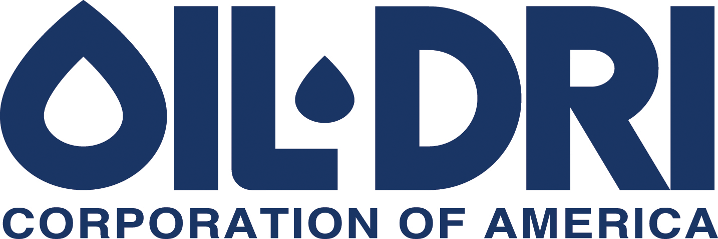

410 N. Michigan Ave. Chicago, Illinois 60611, U.S.A

News Announcement
For Immediate Release
Exhibit 99.1
Oil-Dri’s Board of Directors Declares Quarterly Dividends

CHICAGO—(March 12, 2026)—The Board of Directors of Oil-Dri Corporation of America (NYSE: ODC) yesterday declared quarterly cash dividends of $0.205 per share of the Company’s Common Stock and $0.153 per share of the Company’s Class B Stock.

The cash dividends will be payable on May 22, 2026 to stockholders of record at the close of business on May 8, 2026. Oil-Dri has paid cash dividends continuously each year since 1974 and has increased dividends annually for twenty-two consecutive years.

The Company’s press release outlining its performance for the third quarter of fiscal year 2026 will be issued after the close of the U.S. stock market on Monday, June 8, 2026. Oil-Dri will host an earnings discussion via a live webcast on Tuesday, June 9, 2026 at 10:00 a.m. Central Time. Participation details are posted on the Company’s website’s Events page.

About Oil-Dri Corporation of America
Oil-Dri Corporation of America (“Oil-Dri”) is a leading manufacturer and supplier of specialty sorbent products for the pet care, animal health and nutrition, fluids purification, agricultural ingredients, sports field, industrial and automotive markets. Oil-Dri is vertically integrated which enables the Company to efficiently oversee every step of the process from research and development to supply chain to marketing and sales. With over 80 years of experience, the Company continues to fulfill its mission to Create Value from Sorbent Minerals. To learn more about the Company, please visit oildri.com.

Forward-Looking Statements
Certain statements in this press release may constitute forward-looking statements within the meaning of the safe harbor provisions of the U.S. Private Securities Litigation Reform Act of 1995. Our forward-looking statements include, but are not limited to, statements regarding our or our management team’s expectations, hopes, beliefs, intentions or strategies regarding the future. In addition, any statements that refer to projections, forecasts or other characterizations of future events or circumstances, including any underlying assumptions, are forward-looking statements. These forward-looking statements are based on management’s current expectations, estimates, forecasts, assumptions and projections about future events, our future performance, the future of our business, our plans and strategies, projections, anticipated trends, the economy and other future developments and their potential effects on us. In addition, we, or others on our behalf, may make forward-looking statements in other press releases or written statements, or in our communications and discussions with investors and analysts in the

normal course of business through meetings, webcasts, phone calls and conference calls. Forward-looking statements can be identified by words such as “expect,” “outlook,” “forecast,” “would,” “could,” “should,” “project,” “intend,” “plan,” “continue,” “believe,” “seek,” “estimate,” “anticipate,” “may,” “assume,” “potential,” “strive,” and variations of such words and similar references to future periods.

Such statements are subject to certain risks, uncertainties and assumptions that could cause actual results to differ materially from those anticipated, intended, expected, believed, estimated, projected, planned or otherwise expressed in any forward-looking statements, including, but not limited to, those described in our most recent Annual Report on Form 10-K and from time to time in our other filings with the Securities and Exchange Commission. Investors are cautioned not to place undue reliance on these forward-looking statements, which speak only as of the date of this press release. Except to the extent required by law, we do not have any intention or obligation to update publicly any forward-looking statements after the distribution of this press release, whether as a result of new information, future events, changes in assumptions, or otherwise.

Contact:
Leslie A. Garber
Director of Investor Relations
Oil-Dri Corporation of America
InvestorRelations@oildri.com
(312) 321-1515

